CAMPUSRESERVE
Intelligent Campus Resource Booking, Maintenance & Utilisation Analytics System
A Mini Project Report
Submitted in partial fulfilment of the requirements for
BCSE302P — DATABASE SYSTEMS LAB
Submitted by:
DURLAV DANI
Registration Number: 24BCE2361
School of Computer Science and Engineering (SCOPE)
Vellore Institute of Technology, Vellore
Faculty: [INSERT FACULTY NAME]
Academic Year: 2026–2027
Fall Semester 2026–27
Date of Submission: [INSERT SUBMISSION DATE]
Individual Mini Project

Declaration of Originality
I, Durlav Dani (Registration Number 24BCE2361), a student of the School of Computer Science and Engineering (SCOPE), Vellore Institute of Technology, Vellore, hereby declare that the mini project report entitled “CampusReserve: Intelligent Campus Resource Booking, Maintenance & Utilisation Analytics System”, submitted in partial fulfilment of the requirements of the course BCSE302P — Database Systems Lab during the Fall Semester of the academic year 2026–2027, is a record of an individually developed academic project.
I further declare that:
- this project was carried out by me as an individual submission, and no team members or collaborators were involved;
- the database design, SQL and PL/SQL implementation, application integration, testing and this report were prepared for this course submission;
- every screenshot and every measured result presented as evidence in this report was produced from my own execution of the project;
- all sources of information, books, papers, documentation and software tools used have been acknowledged in the References;
- this work has not been submitted, in part or in full, for any other course, degree or diploma.
Tools disclosure: software development tools, including an AI-based coding assistant, were used during implementation and documentation. I have reviewed, executed and verified the work presented here.
Place: Vellore
Date: [INSERT SUBMISSION DATE] | Durlav Dani (24BCE2361)

Abstract
Shared campus resources such as laboratories, seminar halls, classrooms and portable equipment are frequently double-booked because spreadsheets and e-mail cannot enforce booking rules or serialise competing requests. CampusReserve is a database-centred reservation, maintenance and utilisation-analytics system built on Oracle Database to address this problem. The relational schema of thirteen tables is normalised to Boyce–Codd Normal Form and protected by primary-key, foreign-key, unique, check and default constraints. All booking and maintenance writes pass through PL/SQL stored procedures that lock the resource row with SELECT ... FOR UPDATE before checking for overlapping intervals, so concurrent requests are serialised inside the database. Functions compute booking duration, availability and utilisation; two packages provide reservation workflow and analytics using explicit cursors, cursor FOR loops, REF cursors and a pipelined function; triggers enforce status transitions, detect overlaps and write an append-only audit trail. A React front end communicates with the database through a Node.js REST API. The scope covers registration, role-based approval, cancellation, maintenance, audit and analytics, together with reproducible experiments on conflict prevention, concurrency, rollback and execution plans before and after indexing.

Contents

(Right-click here → Update Field → Update entire table to refresh the contents.)

1. Introduction

1.1 Problem Statement
A university shares a large number of expensive facilities between schools, clubs and research groups. In most departments these are reserved through e-mail requests, paper registers or shared spreadsheets. Such tools have four structural weaknesses:
- No conflict prevention. Nothing stops two people from reserving the same room for overlapping times, and the clash is discovered only when both groups arrive.
- No rule enforcement. Capacity limits, operating hours, minimum notice and approval requirements depend on people remembering them.
- No reliable history. Spreadsheet cells can be overwritten without trace, so it is impossible to establish who approved or cancelled a booking.
- No usage evidence. Administrators cannot tell which rooms are over-subscribed and which are idle, so maintenance and investment decisions are guesswork.
The first weakness is the hardest. An application that simply reads the bookings for a time slot and then inserts a new booking if it sees none is incorrect under concurrency: two requests that arrive at the same moment both see an empty slot and both succeed. Correctness therefore has to be guaranteed where the data lives, in the database.

1.2 Objectives
The objectives of this individual project are to:
- design a normalised relational schema (1NF to BCNF) for users, roles, departments, buildings, resources, bookings, approvals, maintenance, blackouts, notifications, audit logs and utilisation snapshots;
- enforce data integrity declaratively through primary-key, foreign-key, unique, check, not-null and default constraints;
- implement every booking and maintenance write in PL/SQL stored procedures that are transaction-safe and concurrency-safe;
- demonstrate functions, procedures, packages, triggers and cursors that are genuinely used by the application;
- build a web front end and REST API that use the database objects instead of duplicating their logic;
- verify the system with test cases, and measure the effect of indexing using execution plans; and
- answer the research question: How can relational database integrity constraints, row-level locking and indexing improve correctness and performance in shared-resource reservation systems?

1.3 Importance of a DBMS for this Problem
A database management system offers exactly the guarantees that the spreadsheet approach lacks [1, 2]. The relational model separates facts into relations linked by keys, which prevents update anomalies [4]. Constraints are checked by the DBMS for every client, so invalid data cannot enter through a forgotten code path. Transactions provide atomicity, consistency, isolation and durability: a booking and its notification are written together or not at all. Row-level locking allows many users to work concurrently while serialising only the operations that compete for the same resource [9]. Triggers make auditing automatic. Indexes and the cost-based optimiser make the same queries fast as the data grows. Finally, aggregate queries and views turn operational data into utilisation analytics without a separate system.

1.4 Scope
In scope: registration and sign-in, four roles (student, faculty, coordinator, administrator), resource discovery, a week calendar, booking creation, approval, rejection and cancellation, maintenance tickets that can take a resource out of service, blackout periods, notifications, an audit trail, analytics dashboards and an administrative interface. Out of scope: payment, recurring bookings, integration with the university’s timetable system, and any artificial-intelligence or machine-learning component; the word “intelligent” in the title refers only to rule-based scheduling checks and database analytics. All people and bookings in the database are synthetic demonstration data.

2. System Requirements

2.1 Hardware Requirements
Table 2.1: Hardware requirements
Component | Minimum for development and demonstration
Processor | 64-bit x86-64 or ARM64, 2 cores (4 recommended)
Memory | 8 GB RAM (Oracle Database Free uses up to 2 GB)
Storage | 15 GB free (database image, Node.js dependencies, LaTeX)
Network | Internet access for package installation and optional cloud deployment

2.2 Software Requirements
Table 2.2: Software, languages and tools
Layer | Choice
DBMS | Oracle Database 19c or later; developed for Oracle Database 23ai Free (local) and Oracle Autonomous Database (cloud). SQL BOOLEAN and DROP ... IF EXISTS are avoided for 19c compatibility.
Database languages | SQL, PL/SQL
Database tools | SQL Developer or SQLcl; DBMS_XPLAN, DBMS_STATS, DBMS_OUTPUT
Back end | Node.js 20+ (built with 22), Express 5, node-oracledb 6+ in Thin mode (no Oracle Client needed), bcryptjs, jsonwebtoken, helmet, express-rate-limit, zod
Front end | React 19, TypeScript, Vite, Tailwind CSS 4, React Router, Recharts, Lucide icons
Testing | Node.js test runner, Supertest, SQL test scripts
Documentation | XeLaTeX (this report), Mermaid (diagrams), Markdown
Deployment | GitHub, Netlify (front end), Render (API), Oracle Autonomous Database
Operating system | Windows 10/11, macOS or Linux

2.3 Functional Requirements
- Users can register, sign in and update their profile; new accounts are students.
- Users can search resources by text, category, building and capacity.
- Users can see a week calendar and hourly availability for any resource.
- Users can request a booking; the system accepts it only if the interval is valid, within operating hours, within the category’s maximum duration and notice period, within capacity, outside blackouts, and free of overlapping live bookings.
- Coordinators can approve or reject requests for resources managed by their department; administrators can decide any request.
- Requesters can cancel their own live bookings; approvers can cancel any.
- Any user can report a fault; staff can take a resource out of service; coordinators and administrators move tickets through their life cycle.
- Every booking, maintenance and resource-status change is recorded in an audit log that cannot be modified.
- Staff can view utilisation, trends, department usage and peak hours computed from the database.
- Administrators can manage resources, blackout periods and user roles.

2.4 Non-functional Requirements
Correctness under concurrency; security (hashed passwords, token authentication, role checks, bind variables, no secrets in the client); responsiveness on mobile, tablet and desktop; accessibility (keyboard navigation, focus indicators, contrast); and reproducibility (all scripts re-runnable, all measurements repeatable).

3. Database Design

3.1 System Architecture
Figure 3.1 shows the three tiers. The browser never talks to the database directly. The API authenticates the user, validates input, opens one transaction per request, sets the Oracle session CLIENT_IDENTIFIER to the user’s ID for auditing, and calls stored procedures, package functions and views. Business rules live in the database so that they hold for every client, including SQL*Plus sessions.
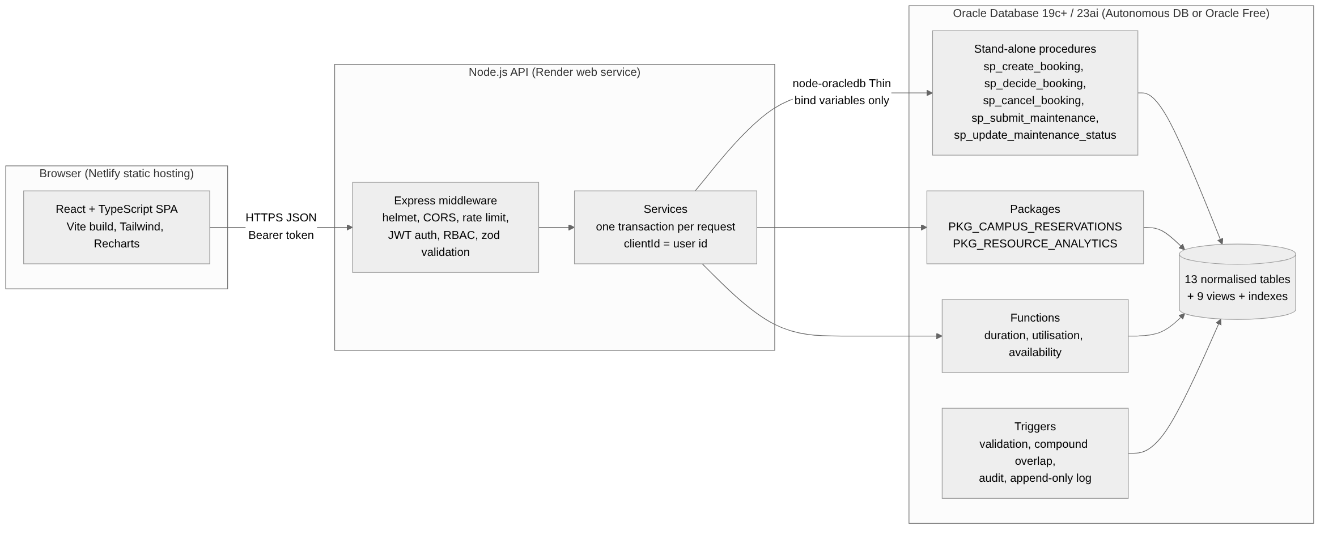
Figure 3.1: System architecture: React front end, Express API and Oracle database objects

3.2 Entities, Attributes and Relationships
Table 3.1 lists the thirteen relations and the reason each exists. The Entity–Relationship diagram in Figure 3.2 shows attributes, keys and cardinalities.
Table 3.1: Relations and their purpose
Relation | Purpose
ROLES | authorisation level; flags can_approve, can_administer
DEPARTMENTS | schools and offices that own users and resources
USERS | everyone who can sign in (bcrypt password hash, unique e-mail)
BUILDINGS | physical buildings
RESOURCE_CATEGORIES | booking policy shared by a class of resources (approval, maximum hours, notice)
RESOURCES | anything bookable: status, capacity, operating hours, JSON features
BOOKINGS | one reservation of one resource for one half-open interval [s, e)
BOOKING_APPROVALS | the single decision on a booking (one-to-one with BOOKINGS)
MAINTENANCE_REQUESTS | fault tickets; blocks_booking takes a resource out of service
RESOURCE_BLACKOUTS | scheduled unavailability (exams, holidays, servicing)
AUDIT_LOGS | append-only change history written only by triggers
NOTIFICATIONS | in-application messages
UTILISATION_SNAPSHOTS | dated output of the utilisation reporting cursor
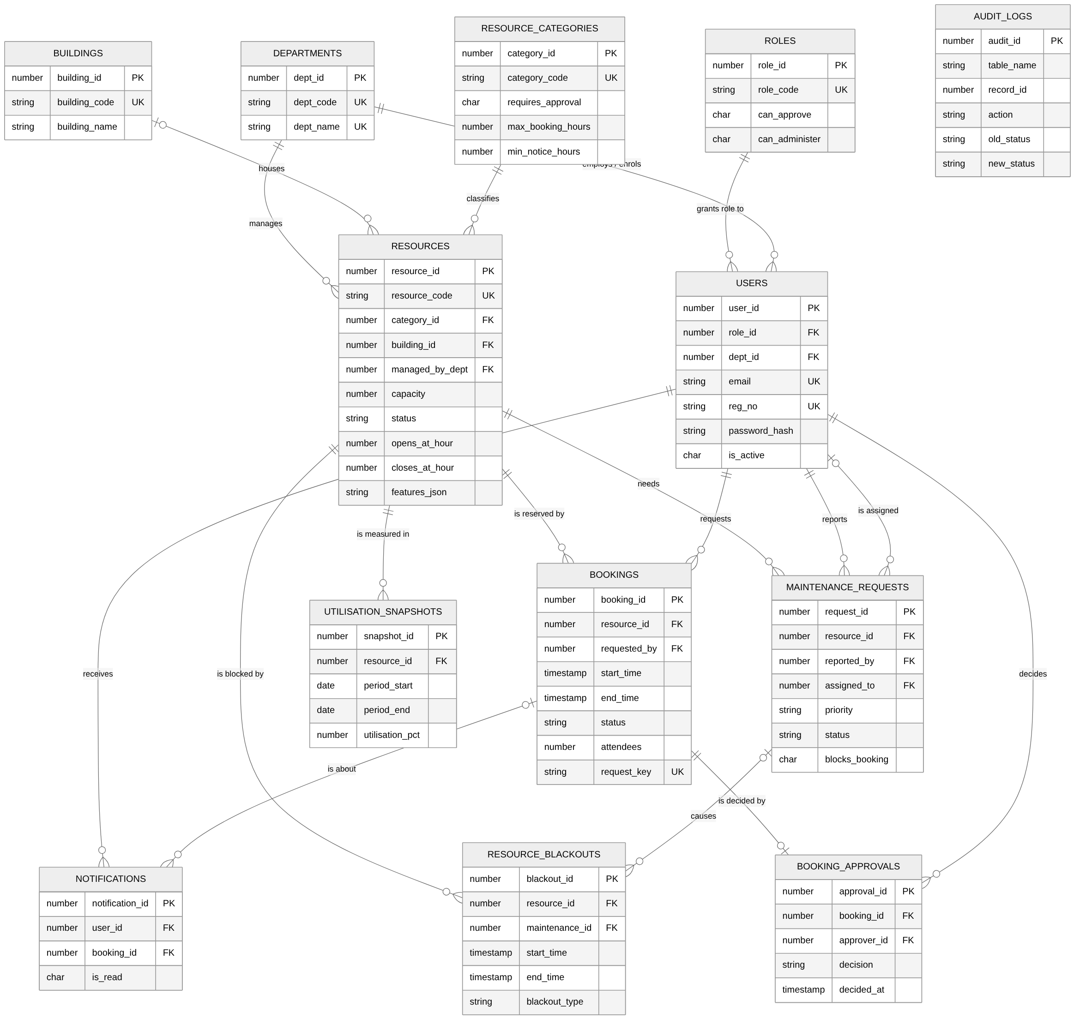
Figure 3.2: Entity–Relationship diagram of CampusReserve (crow’s-foot notation)
Key relationship decisions:
- BUILDINGS 0..1 to many RESOURCES. Portable equipment has no building, so building_id is nullable.
- BOOKINGS 1 to 0..1 BOOKING_APPROVALS. A unique constraint on booking_id guarantees at most one decision; re-deciding is impossible at the data level.
- USERS to MAINTENANCE_REQUESTS appears twice, as reporter (mandatory) and assignee (optional).
- AUDIT_LOGS has no foreign key. Audit rows must outlive the rows they describe and must never block a delete; they reference records through (table_name, record_id).

3.3 Mapping the ER Model to Relations
Each strong entity became a table with a surrogate identity primary key; natural codes (e-mail, resource code, department code) are kept as UNIQUE candidate keys. Each one-to-many relationship became a foreign key on the “many” side. The one-to-one decision relationship became a foreign key with a unique constraint. Multi-valued descriptive features of a resource (projector, GPU count) are stored in a validated JSON column because they are never joined or aggregated. Figure 3.3 shows the resulting relational schema.
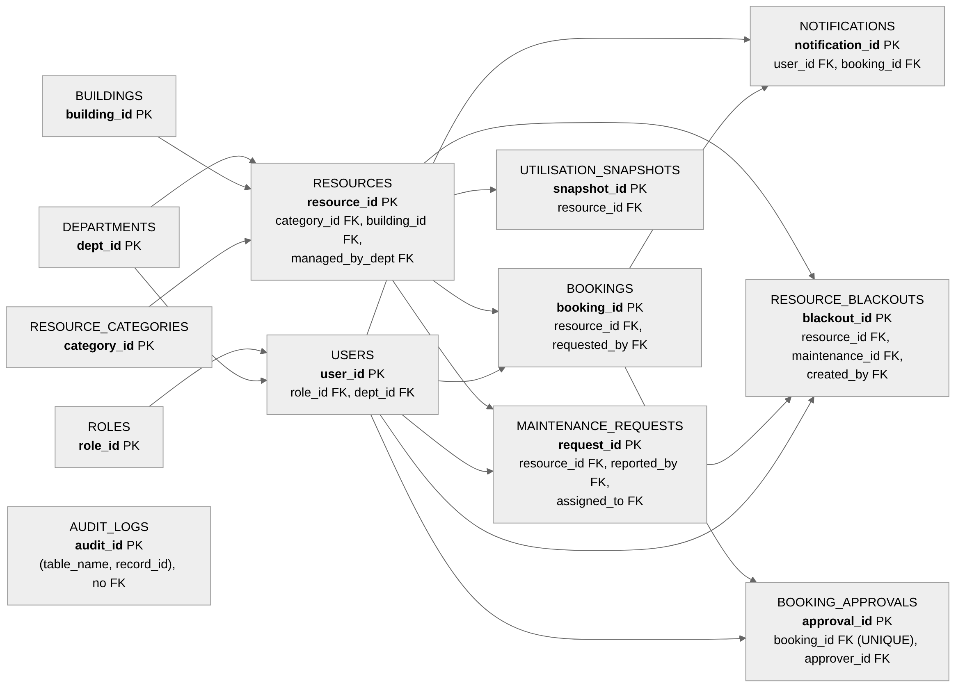
Figure 3.3: Relational schema: primary keys and foreign-key references between the thirteen tables

3.4 Schema Definitions with Constraints
Tables are created in 01_create_schema.sql with primary keys, NOT NULL and DEFAULT; all other constraints are added with ALTER TABLE in 02_constraints_indexes.sql, which exercises the full DDL syllabus (CREATE, ALTER, DROP). Listing 3.1 shows the central BOOKINGS table.
CREATE TABLE bookings (
booking_id NUMBER(12) GENERATED BY DEFAULT AS IDENTITY,
resource_id NUMBER(10) NOT NULL,
requested_by NUMBER(10) NOT NULL,
title VARCHAR2(150) NOT NULL,
attendees NUMBER(5) DEFAULT 1 NOT NULL,
start_time TIMESTAMP NOT NULL,
end_time TIMESTAMP NOT NULL,
status VARCHAR2(12) DEFAULT 'PENDING' NOT NULL,
request_key VARCHAR2(64), -- idempotency key
cancelled_at TIMESTAMP,
...
CONSTRAINT pk_bookings PRIMARY KEY (booking_id));
ALTER TABLE bookings ADD CONSTRAINT ck_bookings_interval CHECK (end_time > start_time);
ALTER TABLE bookings ADD CONSTRAINT ck_bookings_status
CHECK (status IN ('PENDING','APPROVED','REJECTED','CANCELLED'));
ALTER TABLE bookings ADD CONSTRAINT ck_bookings_cancel
CHECK ((status = 'CANCELLED' AND cancelled_at IS NOT NULL)
OR (status <> 'CANCELLED' AND cancelled_at IS NULL));
ALTER TABLE bookings ADD CONSTRAINT uq_bookings_request_key UNIQUE (request_key);
ALTER TABLE bookings ADD CONSTRAINT fk_bookings_resource
FOREIGN KEY (resource_id) REFERENCES resources (resource_id);
Table 3.2: Constraint inventory
Type | Count | Examples and purpose
PRIMARY KEY | 13 | one per table; identity columns except the fixed role IDs
FOREIGN KEY | 18 | named fk_*; ON DELETE CASCADE only for dependent data (approvals, notifications, snapshots), ON DELETE SET NULL for optional links
UNIQUE | 11 | e-mail, registration number, codes, request key, one decision per booking, one snapshot per resource and period
CHECK | 29 | interval order, status domains, cancelled ⇔ cancelled_at, resolved ⇔ resolved_at, operating hours, capacity ≥ 0, e-mail pattern (REGEXP_LIKE), features_json IS JSON
NOT NULL / DEFAULT | – | every mandatory column; defaults for statuses, flags and timestamps
Rules that depend on other rows — overlap, approval rights, maintenance state — cannot be expressed as CHECK constraints in Oracle. They are enforced by stored procedures and triggers (Chapter 4).

3.5 Normalisation
Figure 3.4 summarises the decomposition from an unnormalised booking register to the final schema.
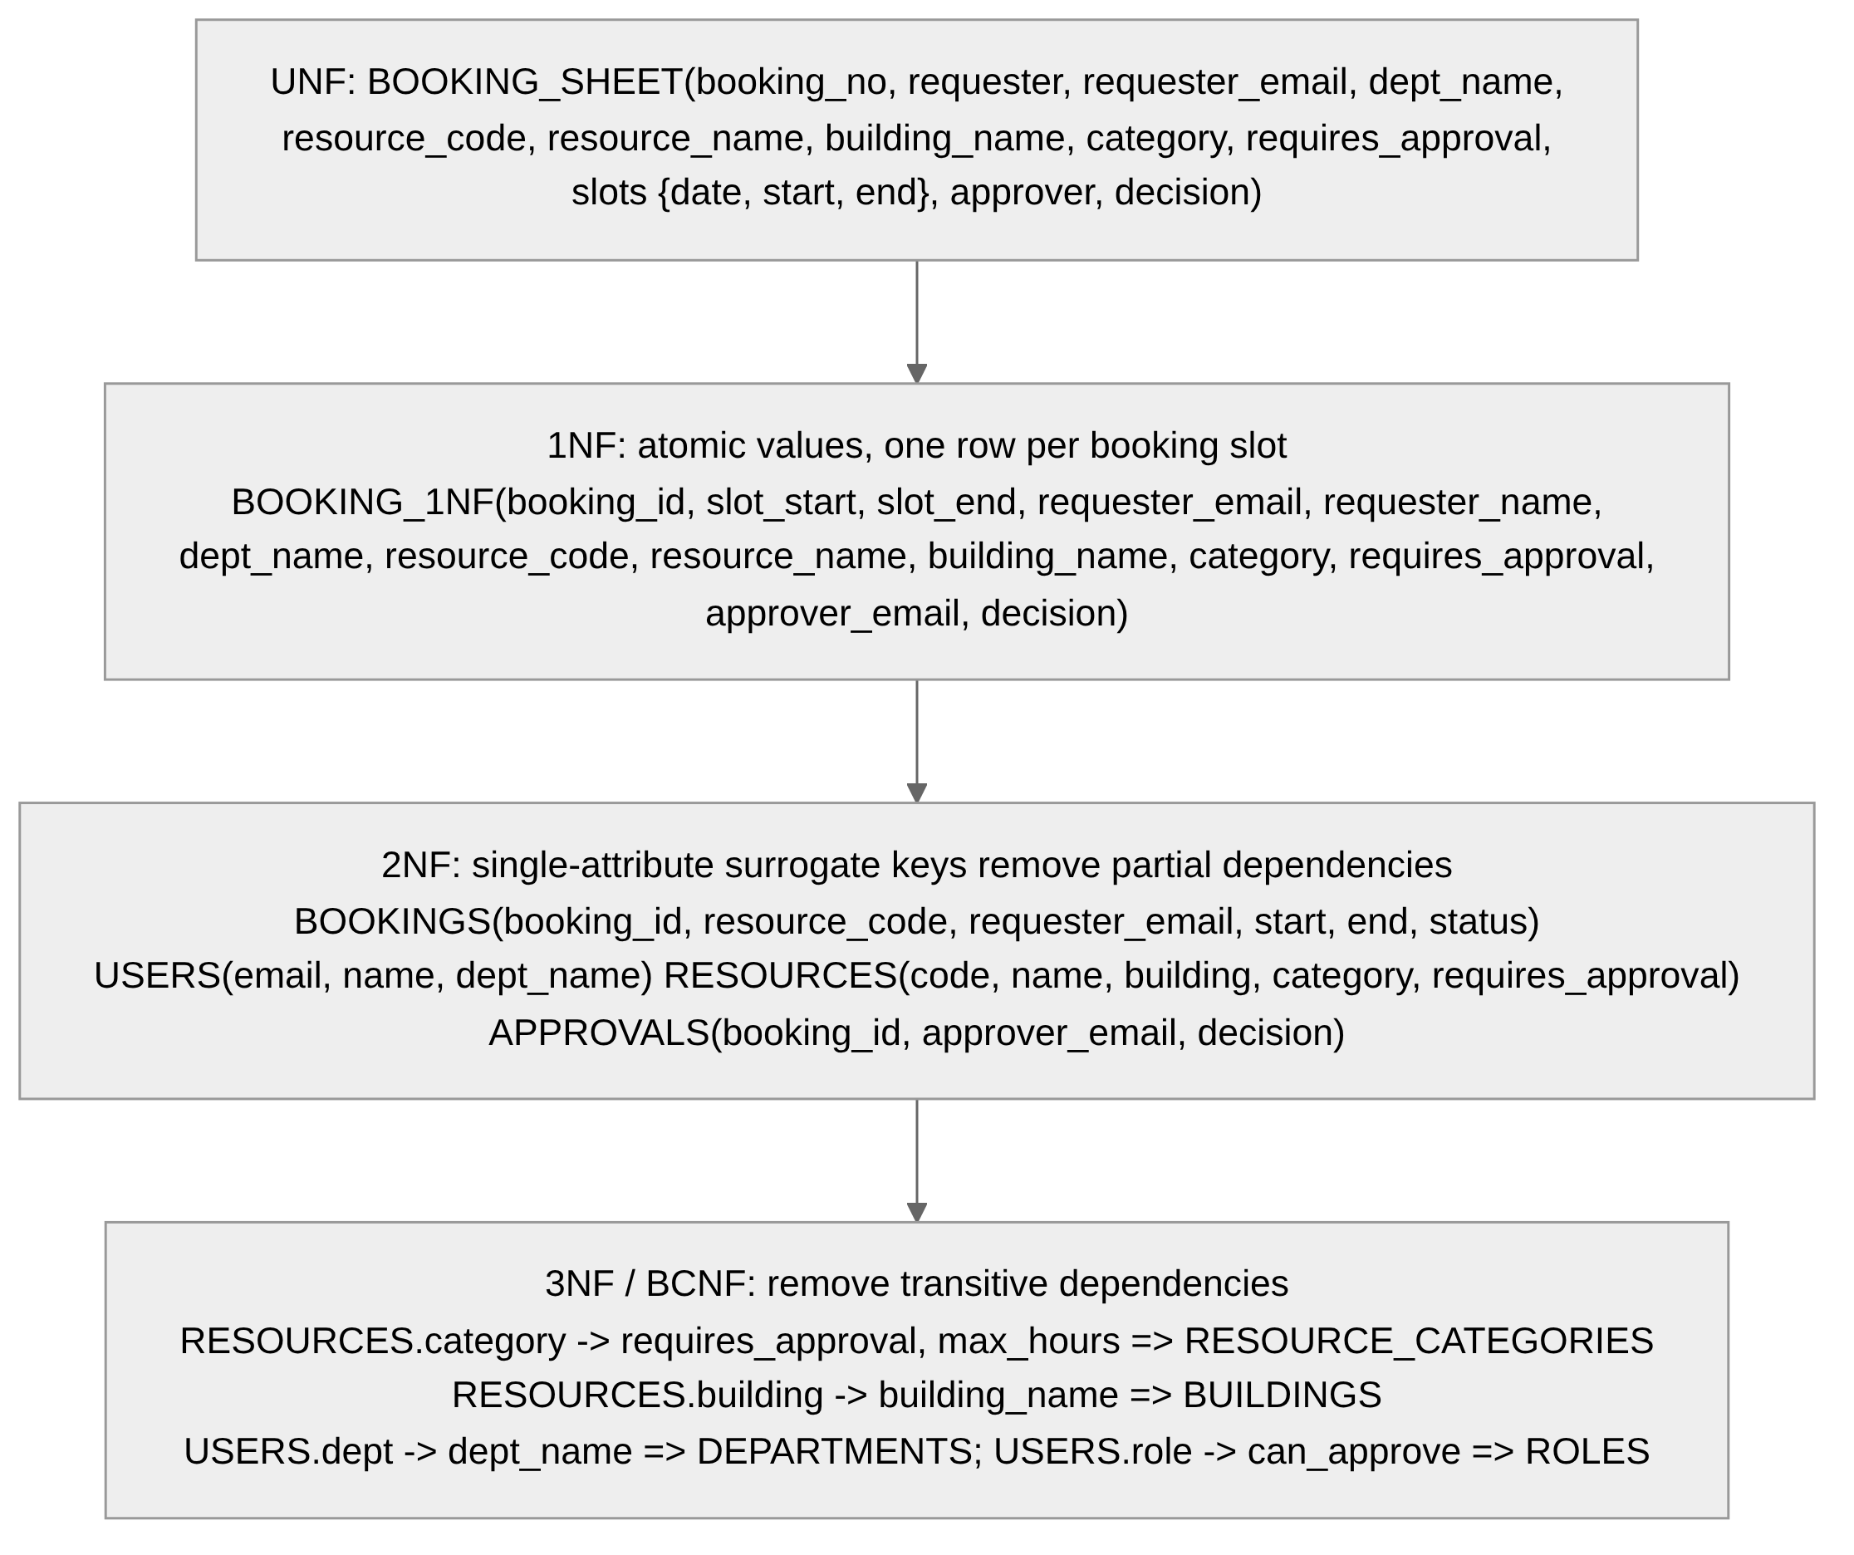
Figure 3.4: Normalisation steps from the unnormalised booking register to 3NF/BCNF

Unnormalised form
A typical paper or spreadsheet register records, per request, the requester’s name, e-mail and department, the resource code, name, building and category, the category’s approval rule, a list of requested dates and times, and the approver’s details and decision:
BOOKING_SHEET(booking_no, requester_name, requester_email, requester_dept, resource_code, resource_name, building_name, category, requires_approval, max_hours, {date, start, end}, approver_email, approver_name, decision)
The braces mark a repeating group.

First normal form
The repeating group is removed so that every attribute is atomic and each row describes exactly one interval; each interval becomes its own booking with key booking_id:
BOOKING_1NF(booking_id, start_time, end_time, requester_email, requester_name, requester_dept, dept_name, resource_code, resource_name, building_code, building_name, category, requires_approval, max_hours, approver_email, approver_name, decision)

Functional dependencies
Table 3.3: Functional dependencies identified in BOOKING_1NF
Determinant | Dependent attributes
booking_id | start_time, end_time, requester_email, resource_code, status, approver_email, decision
requester_email | requester_name, requester_dept, role
requester_dept | dept_name
role | can_approve, can_administer
resource_code | resource_name, building_code, category, capacity, operating hours, managing department
building_code | building_name, campus_zone
category | requires_approval, max_hours, min_notice_hours
approver_email | approver_name

Second normal form
With the single-attribute key booking_id there is no partial dependency, so BOOKING_1NF is formally in 2NF. Had the natural composite key (resource_code, start_time) been used, resource_name, building_code and category would depend on only part of it — a partial dependency. In both cases the entity data is separated into BOOKINGS, USERS, RESOURCES and APPROVALS, each with facts about one thing only.

Third normal form
Transitive dependencies (non-key determining non-key) remain in the 2NF relations and are removed by decomposition:
- resource_code → category → requires_approval, max_hours gives RESOURCE_CATEGORIES;
- resource_code → building_code → building_name gives BUILDINGS;
- email → dept → dept_name gives DEPARTMENTS;
- email → role → can_approve gives ROLES.
Without this step, changing a category’s approval rule would require updating every resource row (update anomaly), and a category with no resources could not be recorded (insertion anomaly).

Boyce–Codd normal form
A relation is in BCNF when every non-trivial determinant is a candidate key. In the final schema the only determinants are the surrogate keys and the declared unique keys (email, reg_no, resource_code, the reference-table codes, request_key, booking_id in BOOKING_APPROVALS and (resource_id, period_start, period_end) in UTILISATION_SNAPSHOTS), all of which are candidate keys. The pair (resource_id, start_time) is deliberately not unique: a cancelled or rejected booking may share a slot with a later live booking, so uniqueness of live slots is an overlap rule rather than a functional dependency. Every relation is therefore in BCNF. Derived values — duration and utilisation — are not stored; they are computed by functions and views to avoid update anomalies.

3.6 Indexes
Oracle does not create indexes for foreign keys automatically. An unindexed foreign key causes full scans on joins and can lead to table-level locks on the child table when the parent key is modified. Twenty-two explicit indexes cover every foreign key (checked by query V5 in 13_verification.sql) and the three most frequent access paths:
Table 3.4: Access-path indexes
Index | Query it serves
ix_bookings_res_time (resource_id, start_time, end_time) | overlap check inside the booking procedure; calendar; utilisation
ix_bookings_user_start (requested_by, start_time) | “My bookings”
ix_bookings_status_start (status, start_time) | approval queue; dashboard counts
ix_maint_status_priority, ix_maint_resource | maintenance board
ix_audit_record (table_name, record_id) | change history of one booking
ix_notif_user_read (user_id, is_read, created_at) | notification bell

4. Implementation
Table 4.1 lists every database object. The scripts are numbered in execution order and run_all.sql installs them and stops if any object is invalid.
Table 4.1: Database objects implemented
Type | Objects
Tables (13) | see Table 3.1
Views (9) | v_resource_catalog, v_booking_details, v_pending_approvals, v_active_bookings, v_maintenance_dashboard, v_resource_utilisation_30d, v_department_usage, v_booking_trend_daily, v_top_resources
Functions (5) | fn_booking_duration_hours, fn_resource_utilisation, fn_resource_availability; helpers fn_hours_between, fn_current_actor
Procedures (5) | sp_create_booking, sp_decide_booking, sp_cancel_booking, sp_submit_maintenance, sp_update_maintenance_status
Packages (2) | pkg_campus_reservations, pkg_resource_analytics (specification and body)
Triggers (9) | trg_users_biu, trg_resources_bu, trg_bookings_biu, trg_bookings_no_overlap (compound), trg_bookings_audit, trg_maintenance_biu, trg_maintenance_audit, trg_resources_status_audit, trg_audit_logs_immutable
Cursors | explicit (send_pending_digest), explicit FOR UPDATE SKIP LOCKED (expire_stale_pending), cursor FOR loops (escalate_stale_maintenance, sp_submit_maintenance, print_utilisation_report), parameterised cursor (build_utilisation_snapshot), REF cursors (seven package functions)

4.1 SQL Coverage of the Syllabus
The indicative experiments of the BCSE302P syllabus map to the implementation as shown in Table 4.2.
Table 4.2: Syllabus experiments and where they are demonstrated
Syllabus experiment | Demonstration in CampusReserve
1. DDL and DML | CREATE/ALTER/DROP (01, 02, 00); INSERT, UPDATE, DELETE (seed, procedures, tests); MERGE (snapshot procedure)
2. Constraints | Table 3.2; violation tests TC-17 and TC-18
3. Single-row functions | UPPER, LOWER, TRIM, NVL, NVL2, ROUND, TRUNC, LPAD, RPAD, SUBSTR, TO_CHAR, EXTRACT, CAST, GREATEST, LEAST, NUMTODSINTERVAL, REGEXP_LIKE, CASE
4. Operators and group functions | IN, BETWEEN, LIKE, comparison and interval operators; COUNT, SUM, AVG, MIN, MAX, COUNT(DISTINCT); GROUP BY/HAVING in v_department_usage; DENSE_RANK and COUNT(*) OVER() analytic functions
5. Subqueries, views and joins | scalar and correlated subqueries (v_resource_catalog, v_pending_approvals), NOT EXISTS (verification V5), inner, left outer, cross and self joins (overlap self-join V7), UNION ALL (resource_schedule), nine views
6. Procedures, functions, cursors, triggers | Sections 4.2–4.6
Listing 4.1 shows a view that combines a left outer join, aggregates and HAVING.
CREATE OR REPLACE VIEW v_department_usage AS
SELECT d.dept_code, d.dept_name,
COUNT(bk.booking_id) AS total_requests,
SUM(CASE WHEN bk.status = 'APPROVED' THEN 1 ELSE 0 END) AS approved,
ROUND(SUM(CASE WHEN bk.status = 'APPROVED'
THEN (CAST(bk.end_time AS DATE) - CAST(bk.start_time AS DATE)) * 24
ELSE 0 END), 1) AS approved_hours,
COUNT(DISTINCT bk.resource_id) AS distinct_resources
FROM departments d
JOIN users u ON u.dept_id = d.dept_id
JOIN bookings bk ON bk.requested_by = u.user_id
GROUP BY d.dept_id, d.dept_code, d.dept_name
HAVING COUNT(bk.booking_id) > 0;

4.2 Functions
Functions have no side effects so they can be called from SQL as well as PL/SQL.
Table 4.3: Functions: parameters and results
Function | Input | Output
fn_booking_duration_hours | p_booking_id | hours (2 dp); ORA-20010 if missing
fn_resource_utilisation | p_resource_id, p_from (incl.), p_to (excl.) | percentage of operating hours booked
fn_resource_availability | p_resource_id, p_start, p_end, p_ignore_booking | AVAILABLE, INVALID_INTERVAL, NOT_FOUND, MAINTENANCE, RETIRED, OUTSIDE_HOURS, BLACKOUT or CONFLICT
Utilisation logic. Approved hours are summed only for bookings that intersect the window, and each booking is clipped to the window with GREATEST/LEAST so that a booking straddling the boundary is counted only for the part inside. The denominator is the number of days in the window multiplied by the resource’s daily operating hours.
SELECT NVL(SUM(fn_hours_between(GREATEST(start_time, v_from_ts),
LEAST(end_time, v_to_ts))), 0)
INTO v_booked
FROM bookings
WHERE resource_id = p_resource_id AND status = 'APPROVED'
AND start_time < v_to_ts AND end_time > v_from_ts;
v_available := (TRUNC(p_to) - TRUNC(p_from)) * (v_close - v_open);
RETURN LEAST(100, ROUND(100 * v_booked / v_available, 2));
Availability logic. Two half-open intervals [s1, e1) and [s2, e2) overlap if and only if s1 < e2 AND s2 < e1 [7]. Using half-open intervals means a booking ending at 12:00 and another starting at 12:00 do not conflict, which test TC-06b checks. The function is advisory: it powers the live “This time is free” indicator in the booking form, but the final decision is always made by sp_create_booking under a lock.
Example. SELECT fn_resource_availability(1, TIMESTAMP ’2026-11-20 10:00:00’, TIMESTAMP ’2026-11-20 12:00:00’) FROM dual; is expected to return AVAILABLE on an empty slot and CONFLICT after a booking is placed there. Actual output: Figure 4.1.
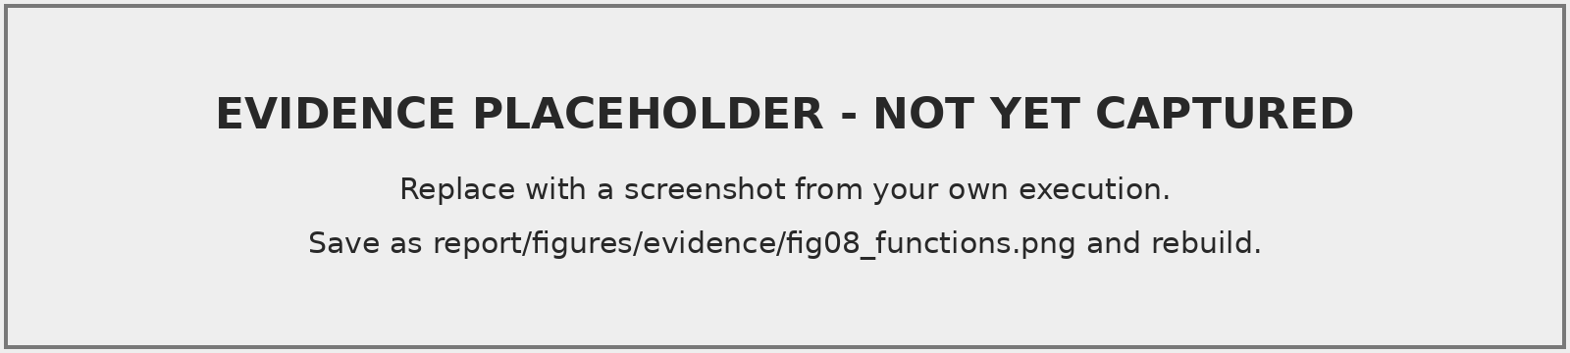
Figure 4.1: Function outputs from verification script section V8 (own execution)

4.3 Stored Procedures and Transaction-safe Booking
Table 4.4: Stored procedures
Procedure | IN parameters | OUT / effect
sp_create_booking | resource, user, title, purpose, attendees, start, end, request key | o_booking_id, o_status (PENDING/APPROVED), o_duplicate
sp_decide_booking | booking, approver, decision, remarks | status change, approval row, notification
sp_cancel_booking | booking, user, reason | CANCELLED, slot freed, notification
sp_submit_maintenance | resource, user, title, description, priority, blocks_booking | o_request_id; resource set to MAINTENANCE if blocking; holders notified
sp_update_maintenance_status | request, actor, new status, assignee, notes | ticket updated; resource status recomputed

Why a simple overlap check is not enough
A naive implementation runs SELECT COUNT(*) for overlapping bookings and inserts when the count is zero. Under Oracle’s default READ COMMITTED isolation each statement sees only data committed before it began. If sessions A and B both run the check before either commits, both see zero and both insert; the overlap is committed. This is the classic phantom problem described by Eswaran et al. [5] and analysed for SQL isolation levels by Berenson et al. [6]: the conflicting row does not yet exist, so there is nothing for an ordinary row lock to protect.

Concurrency-safe design
sp_create_booking serialises all writers per resource by locking the parent RESOURCES row before checking (Listing 4.3). The resource row acts as a lock object for the set of its bookings, standing in for the predicate lock that Oracle does not provide. The second session blocks at the SELECT ... FOR UPDATE; when the first commits, the second resumes, and its overlap query — a new statement — sees the committed booking and raises ORA-20005 (Figure 4.2). Requests for different resources never wait for each other. WAIT 5 turns an unusually long wait into ORA-20018 (“resource busy, retry”) instead of hanging the API.
-- (d) SERIALISATION POINT: lock the resource row.
SELECT r.status, r.capacity, r.opens_at_hour, r.closes_at_hour, ...
INTO v_res_status, v_capacity, v_open, v_close, ...
FROM resources r
JOIN resource_categories c ON c.category_id = r.category_id
WHERE r.resource_id = p_resource_id
FOR UPDATE OF r.status WAIT 5;
-- (e) resource rules: maintenance, capacity, hours, max duration, notice, blackout
IF v_res_status = 'MAINTENANCE' THEN
RAISE_APPLICATION_ERROR(-20003, v_res_name || ' is under maintenance ...');
END IF;
...
-- (f) overlap check, made while holding the lock
SELECT MIN(booking_id) INTO v_conflict_id
FROM bookings
WHERE resource_id = p_resource_id
AND status IN ('PENDING', 'APPROVED')
AND start_time < p_end AND end_time > p_start;
IF v_conflict_id IS NOT NULL THEN
RAISE_APPLICATION_ERROR(-20005, 'Time slot conflicts with booking #' || v_conflict_id || '.');
END IF;
-- (g) accept: no COMMIT here - the caller owns the transaction
INSERT INTO bookings (...) VALUES (...) RETURNING booking_id INTO o_booking_id;
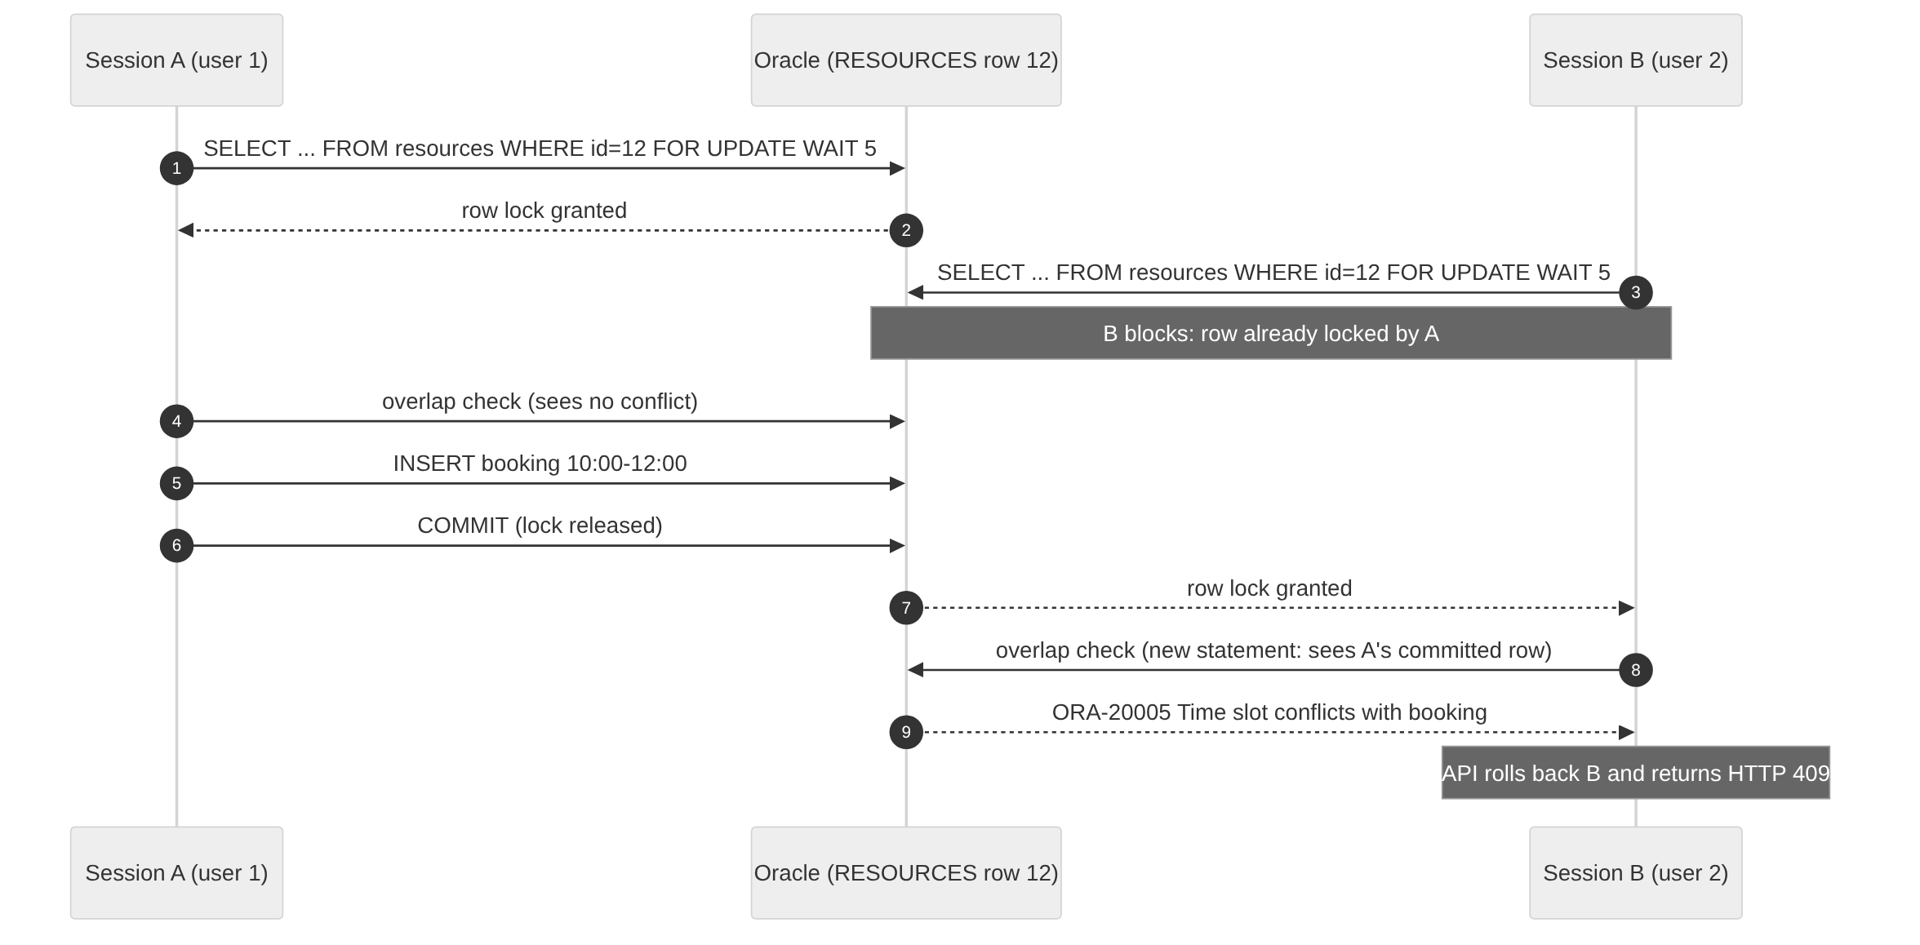
Figure 4.2: Two sessions competing for the same slot: the row lock serialises them
Further safeguards:
- Lock ordering. Every procedure locks RESOURCES before BOOKINGS or MAINTENANCE_REQUESTS, which removes the circular wait needed for a deadlock.
- No commits in procedures. The procedures never COMMIT or ROLLBACK. The API wraps each request in one transaction (Listing 4.4), so a multi-step operation is atomic and the SQL test scripts can roll back everything they do.
- Idempotency. The client sends a random Idempotency-Key; a retried request returns the original booking instead of creating a duplicate (TC-18g). A race between two retries is caught by the unique constraint (DUP_VAL_ON_INDEX).
- Authorisation in the database. sp_decide_booking checks that the approver’s role can approve and, for coordinators, that the resource belongs to their department.
export async function withTransaction(actorId, fn) {
const conn = await pool.getConnection();
conn.clientId = actorId ? String(actorId) : ''; // read by audit triggers
try {
const result = await fn(conn); // e.g. BEGIN sp_create_booking(...); END;
await conn.commit(); // one commit per API request
return result;
} catch (err) {
await conn.rollback(); // any failure undoes the whole unit
throw err;
} finally {
await conn.close();
}
}
Execution example (SQL*Plus).
VARIABLE id NUMBER
VARIABLE st VARCHAR2(12)
VARIABLE dup NUMBER
EXEC sp_create_booking(1, 7, 'DBMS project review', NULL, 12, -
TIMESTAMP '2026-11-20 10:00:00', TIMESTAMP '2026-11-20 12:00:00', NULL, :id, :st, :dup);
PRINT id st
Expected output: a new booking ID and status PENDING (computer laboratories require approval). Repeating the call returns ORA-20005. Actual output is part of the test-suite evidence in Chapter 6.

4.4 Packages
Each package has a separate specification (07_package_specifications.sql) and body (08_package_bodies.sql).
PKG_CAMPUS_RESERVATIONS holds the reservation workflow helpers: status constants; named exceptions bound to the application error codes with PRAGMA EXCEPTION_INIT (so PL/SQL callers can write WHEN pkg_campus_reservations.e_booking_conflict); the pipelined function day_slots that generates the hourly availability strip; the REF-cursor functions resource_schedule (calendar, using UNION ALL of bookings and blackouts) and pending_for_approver; and the cursor procedures send_pending_digest and expire_stale_pending.
PKG_RESOURCE_ANALYTICS computes everything shown on the analytics page: dashboard_summary, booking_trend (with a CONNECT BY row generator so days with no bookings still appear), top_resources, department_usage, resource_utilisation, peak_hours, plus build_utilisation_snapshot, escalate_stale_maintenance and print_utilisation_report.
CREATE OR REPLACE PACKAGE pkg_campus_reservations AS
c_pending CONSTANT VARCHAR2(12) := 'PENDING';
e_booking_conflict EXCEPTION; PRAGMA EXCEPTION_INIT(e_booking_conflict, -20005);
TYPE t_slot IS RECORD (slot_start TIMESTAMP, slot_end TIMESTAMP,
slot_state VARCHAR2(12), booking_id NUMBER);
TYPE t_slot_tab IS TABLE OF t_slot;
FUNCTION day_slots (p_resource_id IN NUMBER, p_day IN DATE,
p_slot_minutes IN NUMBER DEFAULT 60) RETURN t_slot_tab PIPELINED;
FUNCTION resource_schedule (p_resource_id IN NUMBER, p_from IN TIMESTAMP,
p_to IN TIMESTAMP) RETURN SYS_REFCURSOR;
FUNCTION pending_for_approver (p_approver_id IN NUMBER) RETURN SYS_REFCURSOR;
PROCEDURE send_pending_digest (p_approver_id IN NUMBER, o_pending_count OUT NUMBER);
PROCEDURE expire_stale_pending (p_actor_id IN NUMBER, o_expired OUT NUMBER);
END pkg_campus_reservations;
Execution example. SELECT * FROM TABLE(pkg_campus_reservations.day_slots(12, TRUNC(SYSDATE)+1, 60)); returns one row per hour with state FREE, BOOKED, PENDING, BLACKOUT, PAST or CLOSED; for a resource open 08:00–20:00 it returns 12 rows (TC-22).
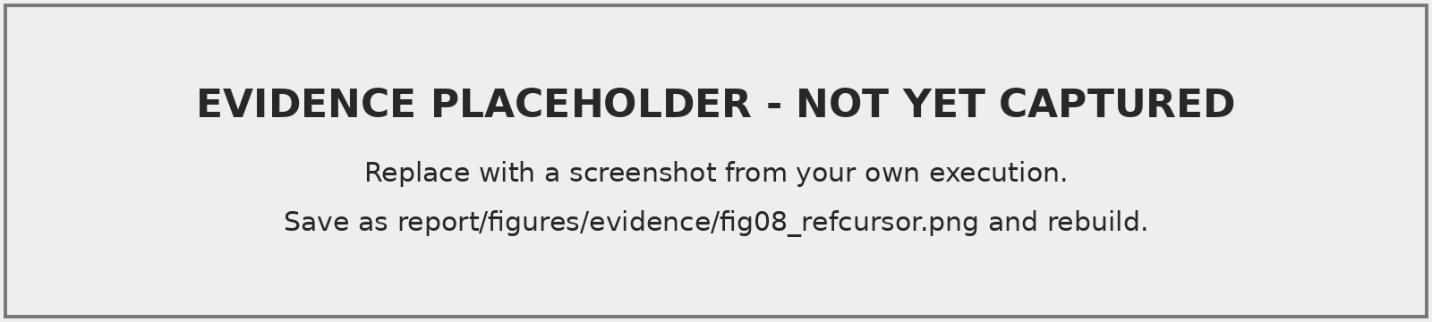
Figure 4.3: REF cursor output of pkg_resource_analytics.dashboard_summary and pipelined day_slots (own execution)

4.5 Triggers
Table 4.5: Triggers
Trigger | Timing | Purpose
trg_bookings_biu | before insert/update, row | new rows must be PENDING/APPROVED on an AVAILABLE resource within capacity; status state machine; sets cancelled_at; blocks rescheduling of final bookings
trg_bookings_no_overlap | compound | defence-in-depth overlap detection (below)
trg_bookings_audit | after insert/update/delete, row | audit row with old/new status and details
trg_maintenance_biu | before insert/update, row | ticket state machine; maintains resolved_at
trg_maintenance_audit | after insert/update, row | audit of status, priority and assignment
trg_resources_status_audit | after update of status, row, WHEN | audit of availability changes
trg_resources_bu, trg_users_biu | before, row | updated_at; lower-case e-mail
trg_audit_logs_immutable | before update/delete, statement | makes AUDIT_LOGS append-only
Avoiding mutating-table errors. A row-level trigger on BOOKINGS may not query BOOKINGS (ORA-04091). The overlap trigger is therefore a compound trigger: the row section only remembers the affected IDs, and the check runs in the AFTER STATEMENT section, when the table is no longer mutating (Listing 4.7). Row-level triggers only read other tables, which is permitted.
CREATE OR REPLACE TRIGGER trg_bookings_no_overlap
FOR INSERT OR UPDATE OF start_time, end_time, status, resource_id ON bookings
COMPOUND TRIGGER
TYPE t_ids IS TABLE OF bookings.booking_id%TYPE;
g_ids t_ids := t_ids();
AFTER EACH ROW IS
BEGIN
IF :NEW.status IN ('PENDING', 'APPROVED') THEN
g_ids.EXTEND; g_ids(g_ids.LAST) := :NEW.booking_id;
END IF;
END AFTER EACH ROW;
AFTER STATEMENT IS
v_conflict bookings.booking_id%TYPE;
BEGIN
FOR i IN 1 .. g_ids.COUNT LOOP
SELECT MIN(o.booking_id) INTO v_conflict
FROM bookings b JOIN bookings o
ON o.resource_id = b.resource_id AND o.booking_id <> b.booking_id
AND o.status IN ('PENDING','APPROVED')
AND o.start_time < b.end_time AND o.end_time > b.start_time
WHERE b.booking_id = g_ids(i);
IF v_conflict IS NOT NULL THEN
RAISE_APPLICATION_ERROR(-20017, 'Booking #' || g_ids(i) || ' overlaps #' || v_conflict);
END IF;
END LOOP;
END AFTER STATEMENT;
END trg_bookings_no_overlap;
This trigger catches overlaps written by any client, for example an ad-hoc INSERT (TC-18h). It cannot by itself stop two concurrent transactions, because each session’s check cannot see the other’s uncommitted row; that limitation is exactly why the procedure holds the resource lock, and it is demonstrated experimentally in Section 6.4.
Audit attribution. The API sets connection.clientId to the signed-in user’s ID; triggers read it through fn_current_actor (SYS_CONTEXT(’USERENV’,’CLIENT_IDENTIFIER’)) and fall back to the row’s own user column in SQL*Plus sessions.

4.6 Cursors
- Explicit cursor — pending approvals. send_pending_digest declares a parameterised cursor over the approver’s queue and uses OPEN, FETCH, %NOTFOUND, %ROWCOUNT and CLOSE to build one digest notification listing the first five requests (Listing 4.8). The exception handler closes the cursor if it is still open (%ISOPEN).
- Explicit cursor with FOR UPDATE SKIP LOCKED. expire_stale_pending rejects pending requests whose start time has passed, updating each row with WHERE CURRENT OF; rows another session is deciding at that moment are skipped rather than waited for.
- Cursor FOR loop — maintenance requests. escalate_stale_maintenance iterates over tickets left OPEN longer than n days, raises their priority with WHERE CURRENT OF and alerts administrators. sp_submit_maintenance uses an implicit cursor FOR loop to notify holders of upcoming bookings.
- Cursor-based reporting. build_utilisation_snapshot loops over a parameterised cursor that aggregates approved hours per resource and MERGEs one row per resource into UTILISATION_SNAPSHOTS; print_utilisation_report prints a formatted text report through DBMS_OUTPUT.
- REF cursors. Seven package functions return SYS_REFCURSOR; node-oracledb reads them as result sets.
CURSOR c_queue (cp_dept NUMBER, cp_is_admin CHAR) IS
SELECT p.booking_id, p.resource_code, p.start_time, p.requester_name
FROM v_pending_approvals p JOIN resources r ON r.resource_id = p.resource_id
WHERE cp_is_admin = 'Y' OR r.managed_by_dept = cp_dept
ORDER BY p.start_time;
v_rec c_queue%ROWTYPE;
BEGIN
OPEN c_queue(v_dept, v_is_admin);
LOOP
FETCH c_queue INTO v_rec;
EXIT WHEN c_queue%NOTFOUND;
IF c_queue%ROWCOUNT <= 5 THEN
v_message := v_message || CASE WHEN v_message IS NOT NULL THEN '; ' END
|| '#' || v_rec.booking_id || ' ' || v_rec.resource_code;
END IF;
END LOOP;
o_pending_count := c_queue%ROWCOUNT;
CLOSE c_queue;
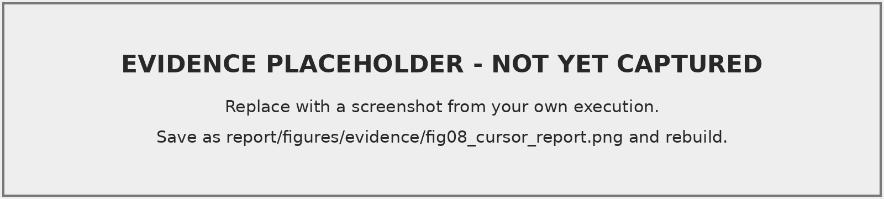
Figure 4.4: Cursor FOR loop utilisation report printed with DBMS_OUTPUT (own execution)

5. Front-End and Database Integration

5.1 Integration Architecture
The front end is a React and TypeScript single-page application built with Vite. It never contains database credentials and never builds SQL. It calls the REST API with a bearer token; the API maps each call onto a database object (Table 5.1), always with bind variables. Oracle application errors are translated into HTTP status codes and readable messages, so a conflict detected inside sp_create_booking reaches the user as “Time slot conflicts with booking #412”.
Table 5.1: Screens and the database objects behind them
Screen | Database object used
Sign-in / registration | USERS, ROLES, DEPARTMENTS (bcrypt check in API)
Overview dashboard | pkg_resource_analytics.dashboard_summary, booking_trend; v_booking_details
Find a space, resource detail | v_resource_catalog; fn_resource_utilisation
Availability calendar | pkg_campus_reservations.resource_schedule (REF cursor)
New booking | fn_resource_availability (live check), day_slots (pipelined), sp_create_booking
My bookings, booking detail | v_booking_details; AUDIT_LOGS history; sp_cancel_booking
Approvals | pending_for_approver; sp_decide_booking; send_pending_digest; expire_stale_pending
Maintenance board | v_maintenance_dashboard; sp_submit_maintenance; sp_update_maintenance_status
Analytics | resource_utilisation, top_resources, department_usage, peak_hours; build_utilisation_snapshot
Resource administration | RESOURCES, RESOURCE_BLACKOUTS
Users, audit history, profile | USERS; AUDIT_LOGS

5.2 Interface Design
The interface uses a restrained glass style: translucent panels over a soft mist background, Manrope headings and Inter body text with system-font fallbacks, a single teal action colour and consistent status colours (green approved, amber pending, red rejected, violet maintenance). The availability calendar draws bookings as frosted time blocks and pending requests with dashed borders, and the booking form highlights the requested interval. Every data view has loading, empty and error states; all controls are keyboard-accessible with visible focus rings; motion is disabled when the user prefers reduced motion. Layouts were checked at 390, 820 and 1440 pixel widths.

5.3 Screenshots
The following figures must be captured from your own running system (Evidence Capture Guide, §3).
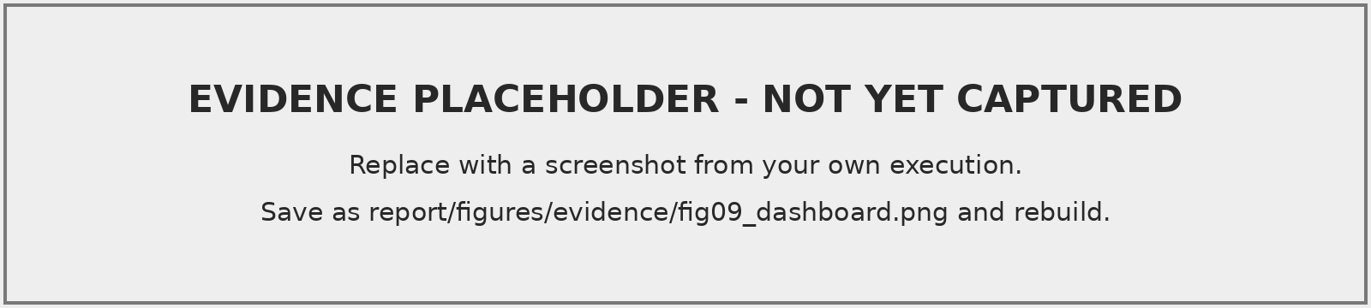
Figure 5.1: Overview dashboard with database-backed KPI tiles and booking trend
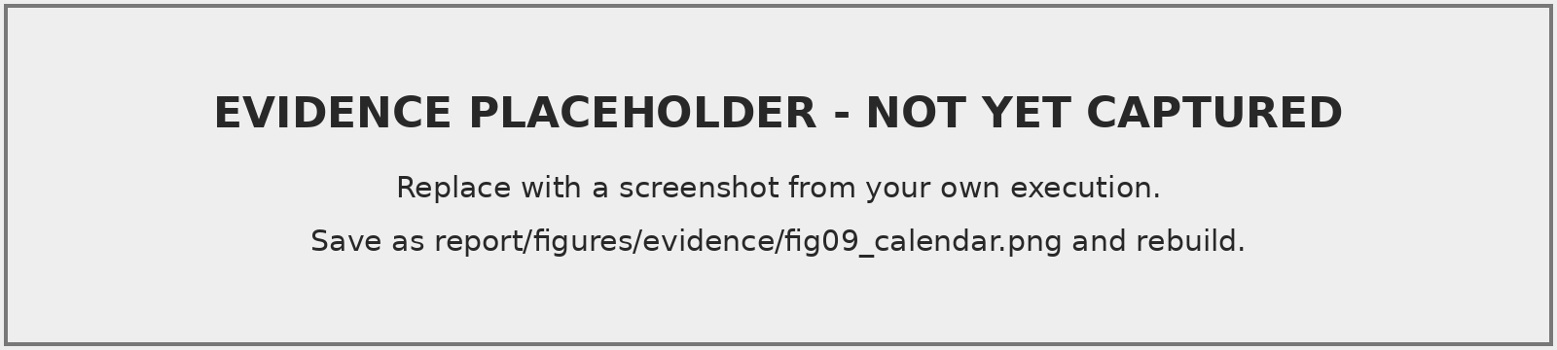
Figure 5.2: Availability calendar fed by the resource_schedule REF cursor
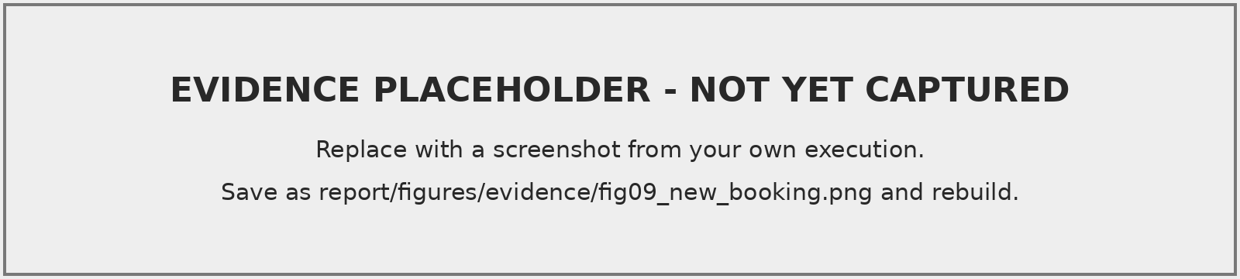
Figure 5.3: New booking form: live availability check and pipelined hourly slots
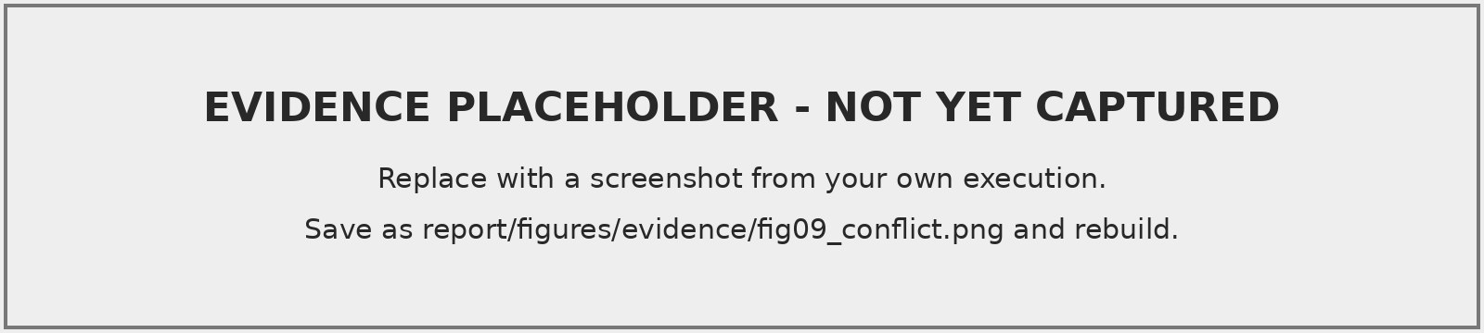
Figure 5.4: Overlap rejected by sp_create_booking and shown to the user (HTTP 409)
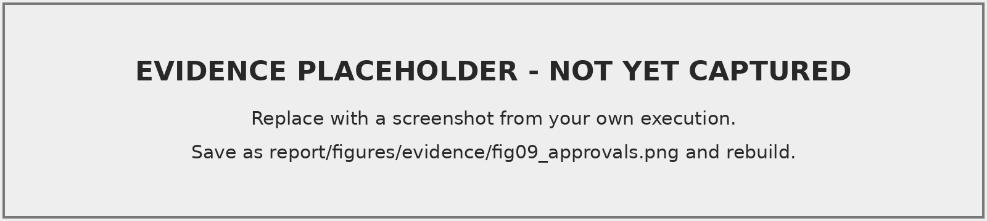
Figure 5.5: Approval queue for a coordinator
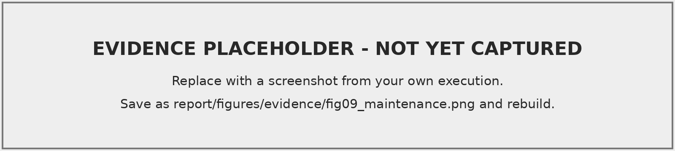
Figure 5.6: Maintenance board
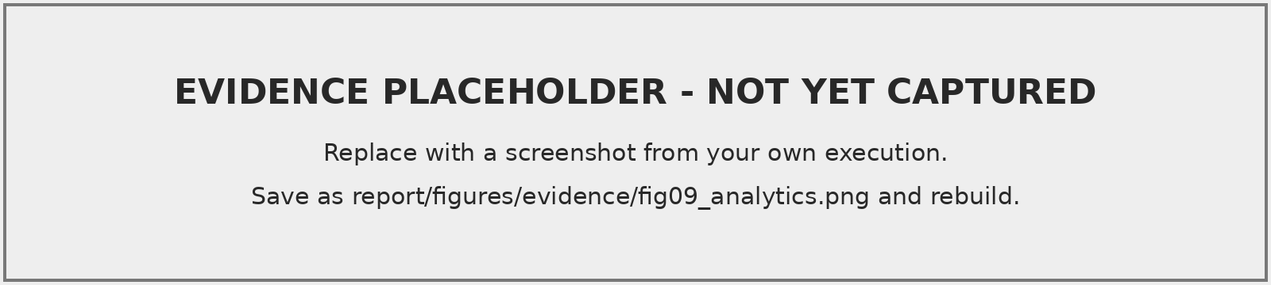
Figure 5.7: Analytics computed by PKG_RESOURCE_ANALYTICS
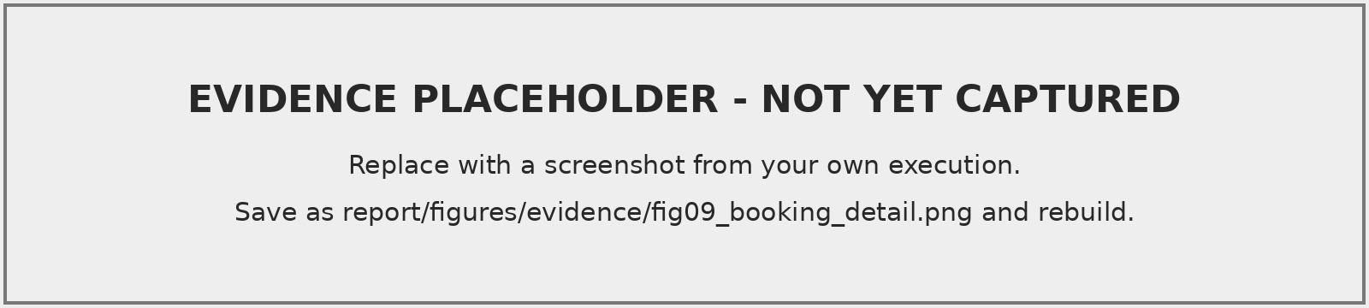
Figure 5.8: Booking detail with trigger-written change history
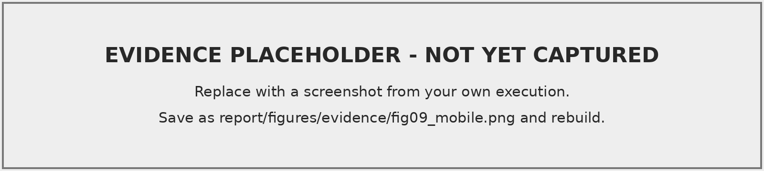
Figure 5.9: Responsive layout at 390 px width

6. Verification and Testing

6.1 Test Strategy
Testing is layered. (1) 10_test_cases.sql is a self-checking PL/SQL suite: each case prints PASS or FAIL with the observed result, and the whole run is rolled back so it can be repeated. (2) 12_transaction_tests.sql demonstrates statement atomicity, savepoints and multi-step rollback, and gives a two-session protocol for concurrency. (3) 11_query_optimization.sql records execution plans and timings before and after indexing. (4) The API has unit tests that need no database and an integration suite that runs against Oracle. (5) concurrency-experiment.js fires parallel sessions at one slot.

6.2 Execution Status
Table 6.1: Execution status of each test suite at the time of writing
Suite | Status
API unit and HTTP-layer tests (25) | executed: 25 passed, 0 failed
Front-end type check, lint, production build | executed: no errors
Database functional suite (TC-04 to TC-22) | Pending: run 10_test_cases.sql
Transaction and two-session tests | Pending: run 12_transaction_tests.sql
Execution-plan experiment | Pending: run 11_query_optimization.sql
API integration suite against Oracle | Pending: RUN_DB_TESTS=1 npm test
Concurrency experiment | Pending: node scripts/concurrency-experiment.js

6.3 Test Cases
In Table 6.2 the Actual column must contain only results observed in your own execution; until then it reads Pending.
Table 6.2: Functional test cases
ID | Objective / input | Expected result | Actual | Status
ID | Objective / input | Expected result | Actual | Status
TC-01 | Registration with valid data | 201, role STUDENT, token | Pending | –
TC-02 | Login, seeded user | 200, token, dashboard | Pending | –
TC-03 | Login, wrong password | 401 INVALID_CREDENTIALS | Pending | –
TC-04 | Create resource | row created, status AVAILABLE | Pending | –
TC-05 | Book free lab 10:00–12:00 | ID returned, PENDING, 2 h | Pending | –
TC-06 | Book 11:00–13:00 same lab | ORA-20005 / 409; 12:00–14:00 accepted | Pending | –
TC-07 | 10 simultaneous requests | locked path: exactly one success | Pending | –
TC-08 | Coordinator approves | APPROVED + approval row; re-decision ORA-20011 | Pending | –
TC-09 | Coordinator rejects with reason | REJECTED; slot available | Pending | –
TC-10 | Owner cancels | CANCELLED, slot free; non-owner ORA-20012 | Pending | –
TC-11 | Book resource under maintenance | ORA-20003 / 409 | Pending | –
TC-12 | Student approves / calls admin API | ORA-20012; HTTP 403 | HTTP layer: 403 returned in unit tests; DB: Pending | partly executed
TC-13 | Blocking maintenance ticket | OPEN; resource MAINTENANCE | Pending | –
TC-14 | Ticket to RESOLVED | resolved_at set; resource AVAILABLE; CLOSED→OPEN ORA-20011 | Pending | –
TC-15 | Audit generation; delete audit row | ≥4 ticket rows; ORA-20012 on delete | Pending | –
TC-16 | Utilisation function vs SQL | equal values | Pending | –
TC-17 | Invalid foreign key | ORA-02291 | Pending | –
TC-18 | Constraint violations (8 sub-cases) | ORA-02290, ORA-00001, -20001, -20006, -20008, -20007, idempotent retry, -20017 | Pending | –
TC-19 | Rollback to savepoint | row count unchanged | Pending | –
TC-20 | Plans before/after index | FULL scan → INDEX RANGE SCAN | Pending | –
TC-21 | Cursor procedures | counts printed; snapshot rows = resources | Pending | –
TC-22 | Pipelined slots | 12 slots for 08:00–20:00 | Pending | –
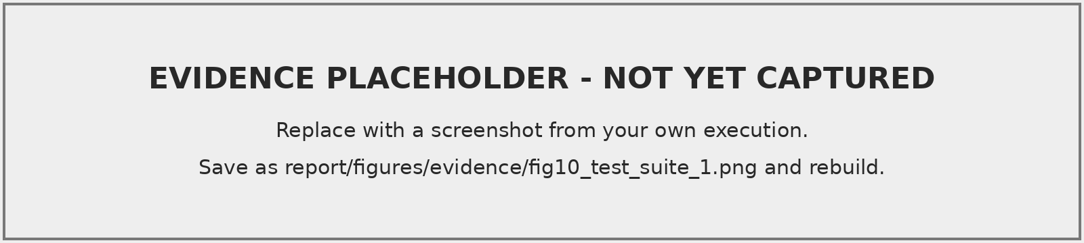
Figure 6.1: Output of 10_test_cases.sql: PASS/FAIL lines (part 1)
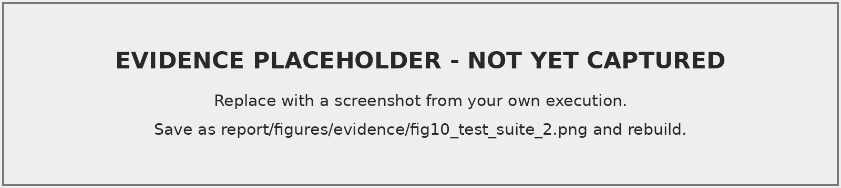
Figure 6.2: Output of 10_test_cases.sql: remaining cases and totals
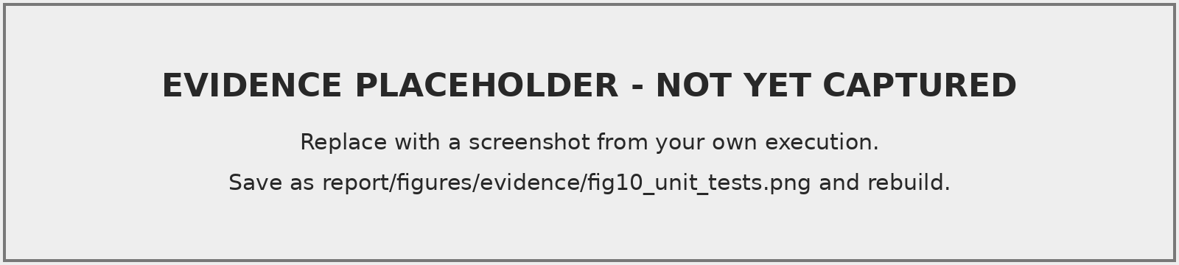
Figure 6.3: API unit tests (npm test) in the terminal

6.4 Experiment E2: Simultaneous Booking Attempts
Method. Ten independent database sessions attempt to book the same resource for the same interval at the same instant, first with a naive check-then-insert block (with a 0.5 s sleep between check and insert to widen the race window) and then through sp_create_booking. The script records how many sessions succeed and how many live rows end up in the slot. Each mode uses a separate empty slot, and all rows are cancelled afterwards.
Expected behaviour. Locked path: exactly one success, nine ORA-20005 conflicts, one live row. Naive path: more than one success is possible; some late sessions may be stopped by the compound trigger (ORA-20017) if an earlier session has already committed.
Table 6.3: Concurrency experiment results (record every run)
Mode | Run | Sessions succeeded | Live rows in slot | Elapsed (ms)
Naive | 1 | Pending | Pending | Pending
Naive | 2 | Pending | Pending | Pending
Naive | 3 | Pending | Pending | Pending
Locked | 1 | Pending | Pending | Pending
Locked | 2 | Pending | Pending | Pending
Locked | 3 | Pending | Pending | Pending
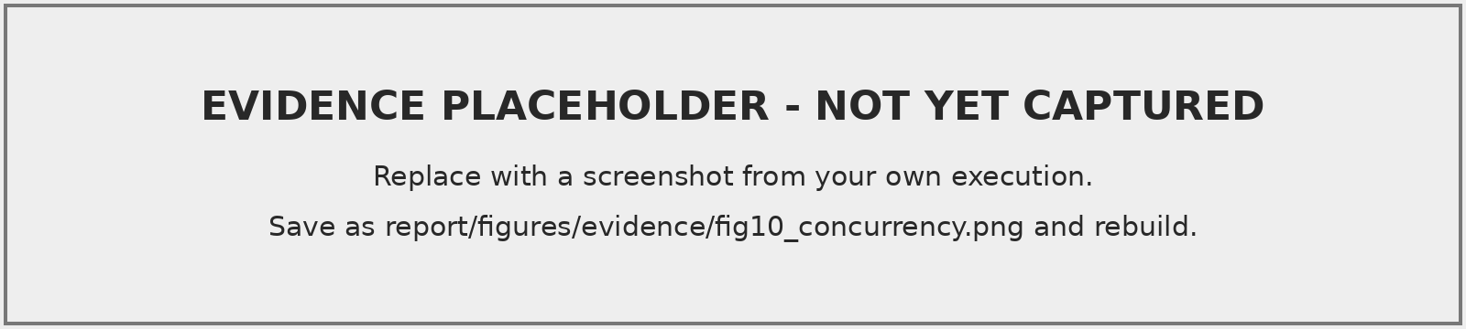
Figure 6.4: Output of concurrency-experiment.js (naive versus locked)
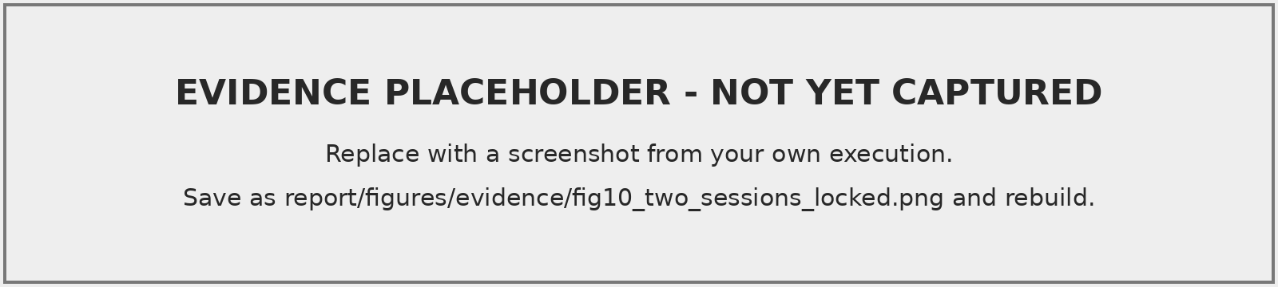
Figure 6.5: Two SQL sessions: session B blocks until A commits, then receives ORA-20005

6.5 Transaction Rollback
Part A of 12_transaction_tests.sql shows that (A1) a multi-row INSERT in which one row violates a unique constraint inserts nothing; (A2) ROLLBACK TO SAVEPOINT undoes a cancellation while keeping the earlier booking; and (A3) a two-step unit — submit a blocking maintenance ticket, then book the same hall — fails in step 2 and is rolled back completely, restoring the hall’s status.
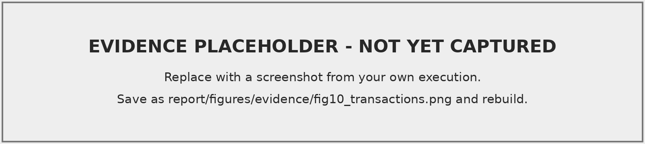
Figure 6.6: Transaction tests A1–A3

6.6 Experiment E3: Execution Plans Before and After Indexing
Method. A synthetic table BENCH_BOOKINGS of 300 000 rows (200 resources over two years) is created without indexes and analysed with DBMS_STATS. For three application queries — the overlap check, a user’s history and the approval queue — the script captures EXPLAIN PLAN output and the mean elapsed time of 200 executions with varying bind values. It then creates the same composite indexes the application uses, re-analyses, and repeats. The real BOOKINGS table is not touched.
Expected plan change. Without indexes, each query must read the whole table (TABLE ACCESS FULL). With (resource_id, start_time, end_time) the optimiser can use INDEX RANGE SCAN on the leading equality column and apply the time predicates within the index; similarly for (requested_by, start_time) and (status, start_time).
Table 6.4: Execution-plan experiment (fill in from your own output)
Query | Plan before | Cost before | Plan after | Cost after
Q1 overlap check | Pending | Pending | Pending | Pending
Q2 user history | Pending | Pending | Pending | Pending
Q3 approval queue | Pending | Pending | Pending | Pending
 | Mean time before (ms) |  | Mean time after (ms)
Q1 | Pending |  | Pending
Q2 | Pending |  | Pending
Q3 | Pending |  | Pending
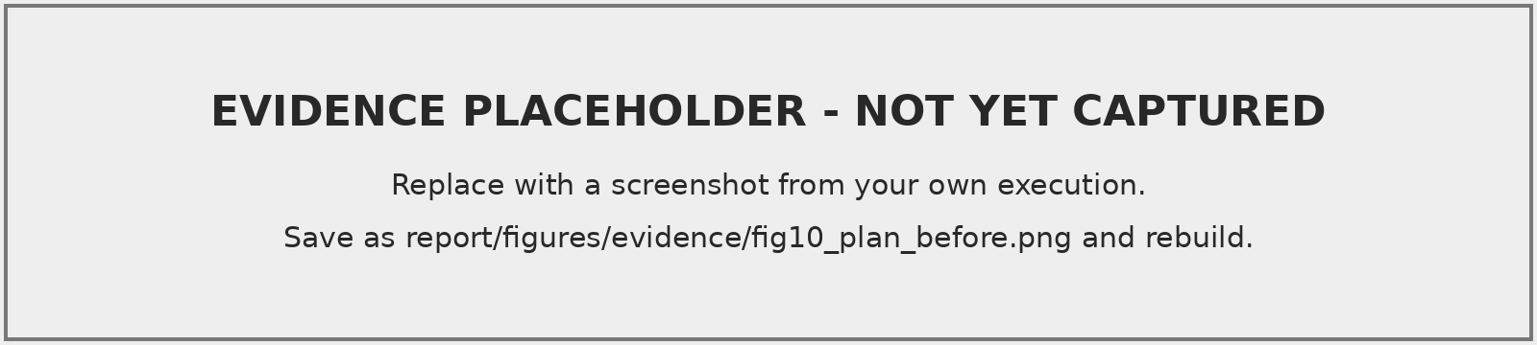
Figure 6.7: DBMS_XPLAN output for Q1 before indexing
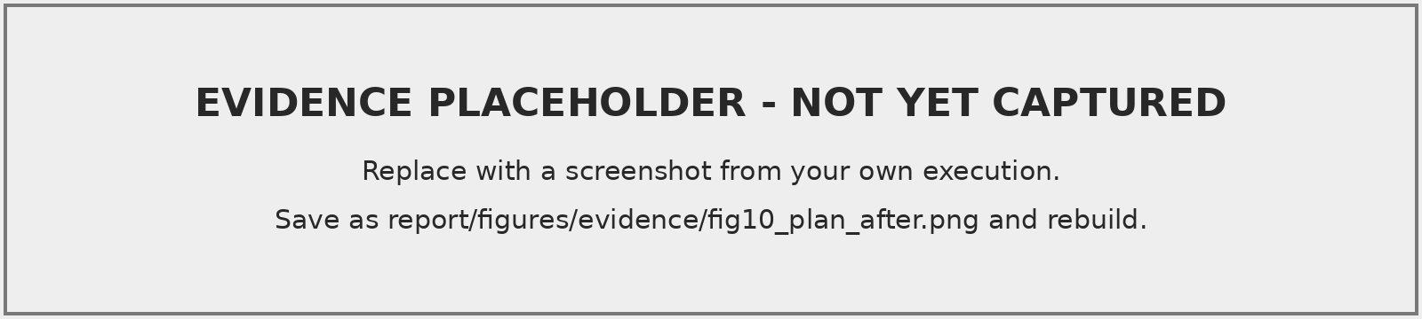
Figure 6.8: DBMS_XPLAN output for Q1 after indexing
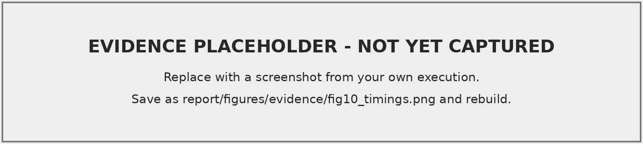
Figure 6.9: Timing harness output and plan cost summary

7. Results and Discussion

7.1 Achievements
- A thirteen-table schema in BCNF with 18 foreign keys, 11 unique and 29 named check constraints, and an index on every foreign key.
- A single write path for bookings and maintenance: five stored procedures that never commit, with all business rules and authorisation checks inside the database.
- Concurrency control by locking the parent resource row, with consistent lock ordering and a bounded wait.
- Defence in depth: a compound trigger that catches overlaps written outside the procedures without causing mutating-table errors.
- Two packages, five functions, nine triggers and six cursor techniques, each used by a screen or job rather than only demonstrated.
- An append-only audit trail with user attribution through the session client identifier.
- A responsive front end in which every number is computed by the database.
- Reproducible experiments for conflict prevention, concurrency, rollback and indexing.

7.2 Discussion of the Research Question
Integrity constraints make invalid states unrepresentable: an interval that ends before it starts, a cancelled booking without a cancellation time, a second decision for the same booking or a dangling reference is rejected by the DBMS for every client, including ad-hoc SQL (H2).
Row-level locking addresses what constraints cannot: the absence of a conflicting row is not a row that can be locked, so a check-then-insert sequence is vulnerable to the phantom problem [5, 6]. Locking the parent resource row turns the per-resource booking set into a serialised critical section while leaving other resources fully concurrent. Moving the logic into a stored procedure also shortens the critical section to a few statements inside the database, rather than several network round trips. Whether the naive path actually produced overlaps in your runs is reported in Table 6.3 Pending: insert observed result.
Indexing changes the access path from full scans to range scans for the queries the application issues most. The magnitude of the improvement must be read from Table 6.4 Pending: insert measured ratios; it depends on table size, selectivity and buffer-cache state.
Views and aggregate queries let analytics share the same source of truth as operations. Utilisation is computed on demand with interval clipping, and the snapshot procedure stores dated results only when a historical record is wanted.

7.3 Challenges Faced
- Mutating-table errors. A row trigger cannot read its own table; the overlap check was moved to the AFTER STATEMENT section of a compound trigger.
- Transaction ownership. Commits inside procedures would have made multi-step API operations non-atomic and the tests impossible to roll back; all commits were moved to the API.
- Time zones. Bookings are campus-local times stored in TIMESTAMP; the API requires ISO timestamps with an offset and runs in the Asia/Kolkata zone so that values are unambiguous.
- Version compatibility. Features new in 23ai (SQL BOOLEAN, IF EXISTS) were avoided, and INSERT ... SELECT was not combined with RETURNING, which earlier releases do not allow.

7.4 Limitations and Possible Improvements
- The overlap rule relies on every writer using the procedures (or accepting the trigger’s best-effort check). Oracle has no declarative exclusion constraint for intervals; a materialised-view or slot-table design could make it declarative at a storage cost.
- Bookings must fit within one day; recurring bookings are not supported.
- The JWT is kept in session storage; an HTTP-only cookie with CSRF protection would be stronger when front end and API share a domain.
- Notifications are in-app only; e-mail delivery could use Oracle Scheduler or a message queue.
- The performance study uses synthetic, uniformly distributed data on a single instance.

8. Conclusion

8.1 Learning Outcomes
Through this individual project I designed a relational schema from requirements, mapped an ER model to relations and justified each step of normalisation up to BCNF. I implemented DDL and DML, constraints, single-row and group functions, subqueries, joins and views, and used PL/SQL functions, procedures, packages, triggers and cursors for real application behaviour. I learned why application-level checks fail under concurrency, how Oracle’s read consistency and row locks interact, how to avoid mutating-table errors and deadlocks, and why transaction boundaries belong to the caller. I also learned to measure rather than assume the effect of indexes by reading execution plans. These outcomes correspond to the course outcomes of designing the structure and operation of the relational data model and examining real-world data requirements to design a database system.

8.2 Future Scope
Recurring and multi-day reservations; a waiting list that promotes the next request when a booking is cancelled; e-mail and calendar (iCalendar) integration; scheduled jobs with DBMS_SCHEDULER for expiry, escalation and snapshots; QR-code check-in to measure real occupancy rather than booked time; partitioning BOOKINGS by date for multi-year history; and Oracle Virtual Private Database policies so that row-level access rules are enforced in the database as well as in the API.
99
R. Elmasri and S. B. Navathe, Fundamentals of Database Systems, 7th ed. Boston, MA, USA: Pearson, 2016. A. Silberschatz, H. F. Korth, and S. Sudarshan, Database System Concepts, 7th ed. New York, NY, USA: McGraw-Hill, 2019. R. Ramakrishnan and J. Gehrke, Database Management Systems, 3rd ed. New York, NY, USA: McGraw-Hill, 2003. E. F. Codd, “A relational model of data for large shared data banks,” Commun. ACM, vol. 13, no. 6, pp. 377–387, Jun. 1970, doi: 10.1145/362384.362685. K. P. Eswaran, J. N. Gray, R. A. Lorie, and I. L. Traiger, “The notions of consistency and predicate locks in a database system,” Commun. ACM, vol. 19, no. 11, pp. 624–633, Nov. 1976, doi: 10.1145/360363.360369. H. Berenson, P. Bernstein, J. Gray, J. Melton, E. O’Neil, and P. O’Neil, “A critique of ANSI SQL isolation levels,” in Proc. ACM SIGMOD Int. Conf. Management of Data, San Jose, CA, USA, 1995, pp. 1–10, doi: 10.1145/223784.223785. J. F. Allen, “Maintaining knowledge about temporal intervals,” Commun. ACM, vol. 26, no. 11, pp. 832–843, Nov. 1983, doi: 10.1145/182.358434. Oracle Corporation, Oracle Database PL/SQL Language Reference, 19c. [Online]. Available: https://docs.oracle.com/en/database/oracle/oracle-database/19/lnpls/ Oracle Corporation, “Manual data locking,” in Oracle Database SQL Language Reference, 19c. [Online]. Available: https://docs.oracle.com/en/database/oracle/oracle-database/19/sqlrf/Manual-Data-Locking.html Oracle Corporation, Oracle Database Concepts, 19c (chapter “Data Concurrency and Consistency”). [Online]. Available: https://docs.oracle.com/en/database/oracle/oracle-database/19/cncpt/ Oracle Corporation, node-oracledb Documentation. [Online]. Available: https://node-oracledb.readthedocs.io/ Oracle Corporation, “Connect Node.js and other scripting languages without a wallet,” Oracle Autonomous Database Documentation. [Online]. Available: https://docs.oracle.com/en-us/iaas/autonomous-database-shared/doc/connecting-nodejs-tls.html Render, “Blueprint YAML reference.” [Online]. Available: https://render.com/docs/yaml-spec

Appendix A. Installation and Execution
# 1. Database: create user campus (see DEPLOYMENT_GUIDE.md), then
cd database && sql campus/<password>@localhost:1521/FREEPDB1 @run_all.sql
# 2. API
cd ../backend && cp ../.env.example .env && npm install && npm run dev
# 3. Front end
cd ../frontend && npm install && npm run dev # http://localhost:5173
# Demo accounts (synthetic): rohan.g@ / kiran.menon@ / coord.scope@ / admin@campusreserve.example
# Password for all demo accounts: Campus@2026

Appendix B. Application Error Codes
Table B.1: Application error codes raised by PL/SQL and their HTTP mapping
Code | Meaning | HTTP
-20001 | invalid interval | 400
-20002 | resource not found | 404
-20003 | resource under maintenance | 409
-20004 | resource retired | 409
-20005 | booking conflict | 409
-20006 | capacity exceeded | 400
-20007 | blackout period | 409
-20008 | outside operating hours | 400
-20009 | exceeds maximum duration | 400
-20010 | booking not found | 404
-20011 | invalid status transition | 409
-20012 | not authorised | 403
-20013 | user not found or inactive | 403
-20014 | maintenance request not found | 404
-20015 | start time in the past | 400
-20016 | invalid argument | 400
-20017 | overlap detected by trigger | 409
-20018 | resource busy (lock wait timeout) | 409
-20019 | insufficient notice | 400

Appendix C. Additional Diagrams and Evidence
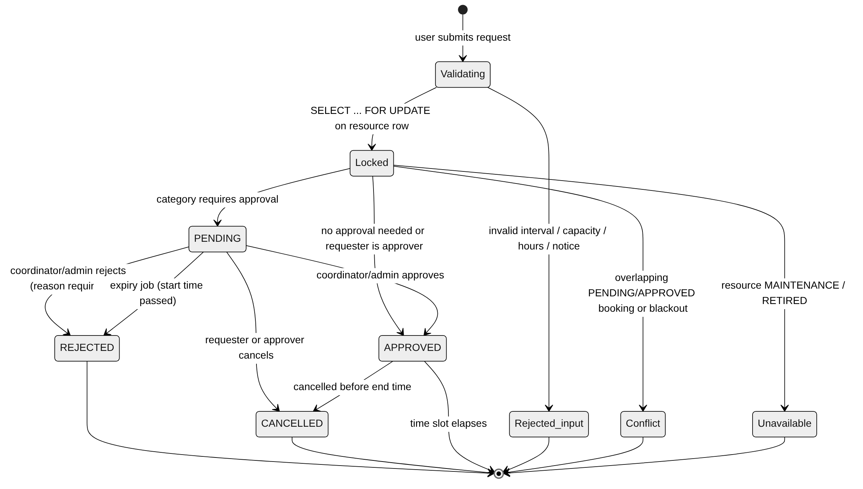
Figure C.1: Booking life cycle enforced by sp_create_booking and trg_bookings_biu
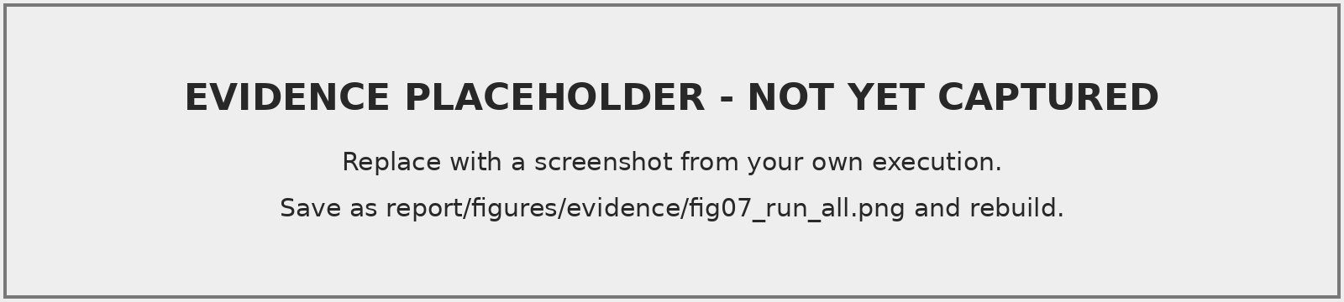
Figure C.2: run_all.sql completing with “All objects VALID”
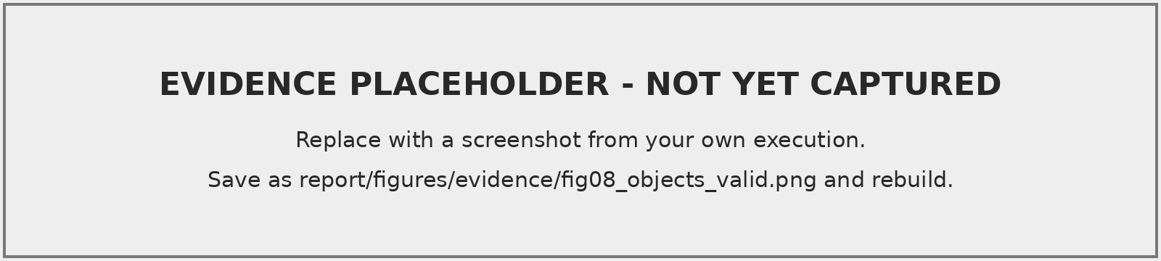
Figure C.3: Verification V1–V2: every object VALID, no compilation errors
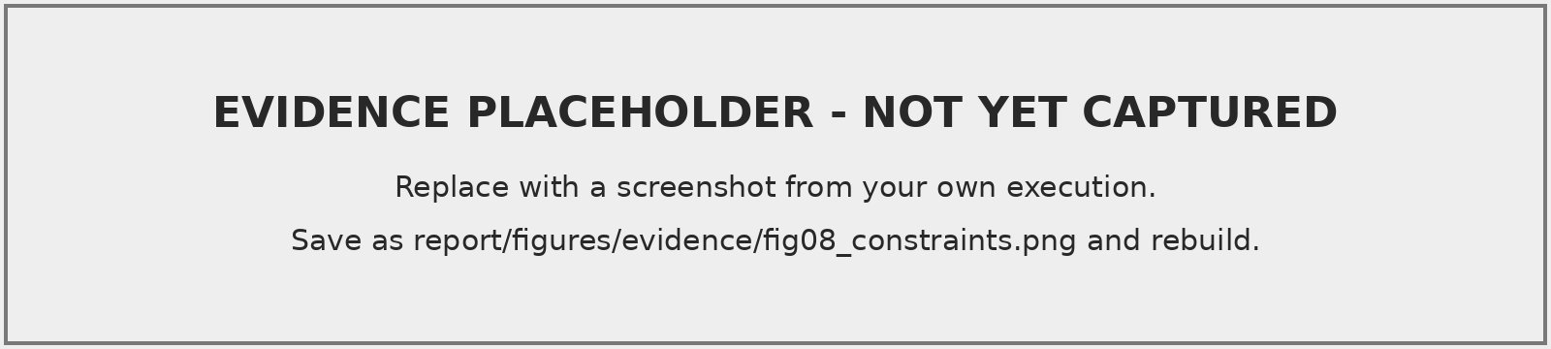
Figure C.4: Verification V4–V5: constraints per table; no unindexed foreign keys
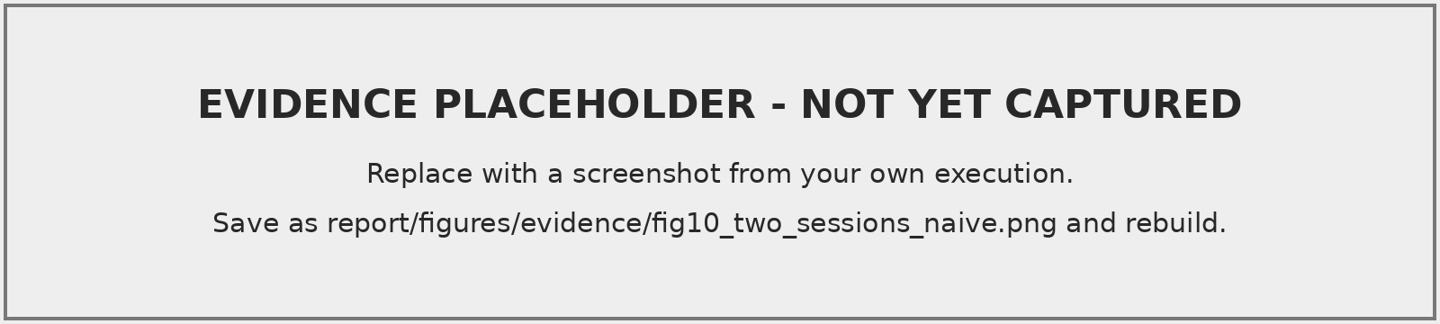
Figure C.5: Two-session naive check-then-insert and the resulting overlap query

Appendix D. Source Code
The complete source code (all SQL scripts, the API and the front end) is in the submission archive and the project repository. The stored procedures and triggers — the core of the concurrency and integrity design — are reproduced in full below; the functions and package specifications are shown in Chapter 4.

D.1 Stored procedures (06_procedures.sql)
--------------------------------------------------------------------------------
-- CampusReserve | 06_procedures.sql
-- PURPOSE : Stand-alone stored procedures - the ONLY write path the API uses
-- for bookings and maintenance.
--
-- TRANSACTION CONTRACT
-- None of these procedures COMMIT or ROLLBACK. The caller (the Node.js API,
-- or a SQL*Plus test script) owns the transaction and decides when to commit.
-- This keeps a multi-step API operation atomic and lets tests roll back.
--
-- CONCURRENCY CONTRACT
-- Every write that depends on the current state of a resource first locks
-- that resource row with SELECT ... FOR UPDATE WAIT 5. All writers therefore
-- queue on the same row, and the overlap check that follows sees every
-- committed competing booking. Lock order is always RESOURCE -> BOOKING /
-- MAINTENANCE_REQUEST to avoid deadlocks.
--
-- APPLICATION ERROR CODES (mapped to HTTP status codes by the API)
-- -20001 invalid interval -20011 invalid status transition
-- -20002 resource not found -20012 not authorised
-- -20003 resource in maintenance -20013 user not found / inactive
-- -20004 resource retired -20014 maintenance request not found
-- -20005 booking conflict -20015 start time in the past
-- -20006 capacity exceeded -20016 invalid argument
-- -20007 blackout period -20017 overlap caught by trigger
-- -20008 outside operating hours -20018 resource busy (lock timeout)
-- -20009 exceeds maximum duration -20019 insufficient notice
-- -20010 booking not found
--------------------------------------------------------------------------------
SET DEFINE OFF
-- 1. CREATE BOOKING ---------------------------------------------------------------
-- IN : p_resource_id, p_user_id, p_title, p_purpose, p_attendees, p_start, p_end,
-- p_request_key (optional idempotency key supplied by the client)
-- OUT: o_booking_id, o_status (PENDING | APPROVED), o_duplicate (1 = an earlier
-- request with the same key already exists and is returned unchanged)
CREATE OR REPLACE PROCEDURE sp_create_booking (
p_resource_id IN bookings.resource_id%TYPE,
p_user_id IN bookings.requested_by%TYPE,
p_title IN bookings.title%TYPE,
p_purpose IN bookings.purpose%TYPE,
p_attendees IN bookings.attendees%TYPE,
p_start IN bookings.start_time%TYPE,
p_end IN bookings.end_time%TYPE,
p_request_key IN bookings.request_key%TYPE,
o_booking_id OUT bookings.booking_id%TYPE,
o_status OUT bookings.status%TYPE,
o_duplicate OUT NUMBER
)
IS
e_lock_timeout EXCEPTION;
PRAGMA EXCEPTION_INIT(e_lock_timeout, -30006);
v_role_code roles.role_code%TYPE;
v_can_approve roles.can_approve%TYPE;
v_res_status resources.status%TYPE;
v_capacity resources.capacity%TYPE;
v_open resources.opens_at_hour%TYPE;
v_close resources.closes_at_hour%TYPE;
v_res_name resources.resource_name%TYPE;
v_res_dept resources.managed_by_dept%TYPE;
v_requires_appr resource_categories.requires_approval%TYPE;
v_max_hours resource_categories.max_booking_hours%TYPE;
v_notice_hours resource_categories.min_notice_hours%TYPE;
v_conflict_id bookings.booking_id%TYPE;
v_day_start TIMESTAMP;
v_count PLS_INTEGER;
BEGIN
o_duplicate := 0;
-- (a) Requester must exist and be active.
BEGIN
SELECT ro.role_code, ro.can_approve
INTO v_role_code, v_can_approve
FROM users u JOIN roles ro ON ro.role_id = u.role_id
WHERE u.user_id = p_user_id AND u.is_active = 'Y';
EXCEPTION
WHEN NO_DATA_FOUND THEN
RAISE_APPLICATION_ERROR(-20013, 'User ' || p_user_id || ' not found or inactive.');
END;
-- (b) Idempotency: a retried request returns the original booking.
IF p_request_key IS NOT NULL THEN
BEGIN
SELECT booking_id, status INTO o_booking_id, o_status
FROM bookings
WHERE request_key = p_request_key AND requested_by = p_user_id;
o_duplicate := 1;
RETURN;
EXCEPTION
WHEN NO_DATA_FOUND THEN NULL;
END;
END IF;
-- (c) Interval sanity (cheap checks before taking any lock).
IF p_start IS NULL OR p_end IS NULL OR p_end <= p_start THEN
RAISE_APPLICATION_ERROR(-20001, 'End time must be later than start time.');
END IF;
IF p_start <= SYSTIMESTAMP THEN
RAISE_APPLICATION_ERROR(-20015, 'Bookings must start in the future.');
END IF;
IF p_attendees IS NULL OR p_attendees < 1 THEN
RAISE_APPLICATION_ERROR(-20016, 'Attendees must be at least 1.');
END IF;
-- (d) SERIALISATION POINT: lock the resource row. A concurrent caller for the
-- same resource waits here (up to 5 s) until this transaction ends.
BEGIN
SELECT r.status, r.capacity, r.opens_at_hour, r.closes_at_hour, r.resource_name,
r.managed_by_dept, c.requires_approval, c.max_booking_hours, c.min_notice_hours
INTO v_res_status, v_capacity, v_open, v_close, v_res_name,
v_res_dept, v_requires_appr, v_max_hours, v_notice_hours
FROM resources r
JOIN resource_categories c ON c.category_id = r.category_id
WHERE r.resource_id = p_resource_id
FOR UPDATE OF r.status WAIT 5;
EXCEPTION
WHEN NO_DATA_FOUND THEN
RAISE_APPLICATION_ERROR(-20002, 'Resource ' || p_resource_id || ' does not exist.');
WHEN e_lock_timeout THEN
RAISE_APPLICATION_ERROR(-20018, 'Resource is busy with another booking; please retry.');
END;
-- (e) Resource-level rules (evaluated while holding the lock).
IF v_res_status = 'MAINTENANCE' THEN
RAISE_APPLICATION_ERROR(-20003, v_res_name || ' is under maintenance and cannot be booked.');
ELSIF v_res_status = 'RETIRED' THEN
RAISE_APPLICATION_ERROR(-20004, v_res_name || ' has been retired.');
END IF;
IF v_capacity > 0 AND p_attendees > v_capacity THEN
RAISE_APPLICATION_ERROR(-20006, 'Attendees (' || p_attendees || ') exceed capacity ('
|| v_capacity || ').');
END IF;
v_day_start := CAST(TRUNC(CAST(p_start AS DATE)) AS TIMESTAMP);
IF p_start < v_day_start + NUMTODSINTERVAL(v_open, 'HOUR')
OR p_end > v_day_start + NUMTODSINTERVAL(v_close, 'HOUR') THEN
RAISE_APPLICATION_ERROR(-20008, 'Bookings must fall within operating hours '
|| LPAD(v_open, 2, '0') || ':00-' || LPAD(v_close, 2, '0') || ':00 on one day.');
END IF;
IF fn_hours_between(p_start, p_end) > v_max_hours THEN
RAISE_APPLICATION_ERROR(-20009, 'Maximum booking length for this category is '
|| v_max_hours || ' hours.');
END IF;
IF v_can_approve = 'N'
AND p_start < SYSTIMESTAMP + NUMTODSINTERVAL(v_notice_hours, 'HOUR') THEN
RAISE_APPLICATION_ERROR(-20019, 'This resource needs at least ' || v_notice_hours
|| ' hours notice.');
END IF;
SELECT COUNT(*) INTO v_count
FROM resource_blackouts
WHERE resource_id = p_resource_id
AND start_time < p_end AND end_time > p_start;
IF v_count > 0 THEN
RAISE_APPLICATION_ERROR(-20007, 'The resource is blocked out during the requested time.');
END IF;
-- (f) Overlap check. [s1,e1) overlaps [s2,e2) iff s1 < e2 AND s2 < e1.
-- PENDING requests also hold the slot so two users cannot both queue for it.
SELECT MIN(booking_id) INTO v_conflict_id
FROM bookings
WHERE resource_id = p_resource_id
AND status IN ('PENDING', 'APPROVED')
AND start_time < p_end
AND end_time > p_start;
IF v_conflict_id IS NOT NULL THEN
RAISE_APPLICATION_ERROR(-20005, 'Time slot conflicts with booking #' || v_conflict_id || '.');
END IF;
-- (g) Accept. Approvers and categories without approval are auto-approved.
o_status := CASE WHEN v_requires_appr = 'N' OR v_can_approve = 'Y'
THEN 'APPROVED' ELSE 'PENDING' END;
INSERT INTO bookings (resource_id, requested_by, title, purpose, attendees,
start_time, end_time, status, request_key)
VALUES (p_resource_id, p_user_id, TRIM(p_title), p_purpose, p_attendees,
p_start, p_end, o_status, p_request_key)
RETURNING booking_id INTO o_booking_id;
IF v_requires_appr = 'Y' AND o_status = 'APPROVED' THEN
INSERT INTO booking_approvals (booking_id, approver_id, decision, remarks)
VALUES (o_booking_id, p_user_id, 'APPROVED', 'Auto-approved: requester holds approver role');
END IF;
INSERT INTO notifications (user_id, notif_type, title, message, booking_id)
VALUES (p_user_id, 'BOOKING',
CASE o_status WHEN 'APPROVED' THEN 'Booking confirmed' ELSE 'Booking submitted' END,
v_res_name || ': ' || TO_CHAR(p_start, 'DD-Mon HH24:MI') || '-' || TO_CHAR(p_end, 'HH24:MI')
|| CASE o_status WHEN 'PENDING' THEN ' is awaiting approval.' ELSE ' is confirmed.' END,
o_booking_id);
IF o_status = 'PENDING' THEN
-- Notify every approver who may decide this booking.
INSERT INTO notifications (user_id, notif_type, title, message, booking_id)
SELECT u.user_id, 'APPROVAL', 'Approval required',
'New request #' || o_booking_id || ' for ' || v_res_name || '.', o_booking_id
FROM users u JOIN roles ro ON ro.role_id = u.role_id
WHERE u.is_active = 'Y'
AND (ro.role_code = 'ADMIN'
OR (ro.role_code = 'COORDINATOR' AND u.dept_id = v_res_dept));
END IF;
EXCEPTION
WHEN DUP_VAL_ON_INDEX THEN
-- Two retries with the same key raced past step (b): return the winner.
IF p_request_key IS NULL THEN
RAISE;
END IF;
BEGIN
SELECT booking_id, status INTO o_booking_id, o_status
FROM bookings
WHERE request_key = p_request_key AND requested_by = p_user_id;
o_duplicate := 1;
EXCEPTION
WHEN NO_DATA_FOUND THEN
RAISE_APPLICATION_ERROR(-20016, 'This request key is already in use.');
END;
END sp_create_booking;
/
-- 2. APPROVE / REJECT BOOKING ---------------------------------------------------
-- IN : p_booking_id, p_approver_id, p_decision ('APPROVED' | 'REJECTED'), p_remarks
-- Authorisation: ADMIN may decide any booking; COORDINATOR only bookings of
-- resources managed by the coordinator's own department.
CREATE OR REPLACE PROCEDURE sp_decide_booking (
p_booking_id IN bookings.booking_id%TYPE,
p_approver_id IN users.user_id%TYPE,
p_decision IN booking_approvals.decision%TYPE,
p_remarks IN booking_approvals.remarks%TYPE
)
IS
e_lock_timeout EXCEPTION;
PRAGMA EXCEPTION_INIT(e_lock_timeout, -30006);
v_role_code roles.role_code%TYPE;
v_appr_dept users.dept_id%TYPE;
v_resource_id bookings.resource_id%TYPE;
v_res_dept resources.managed_by_dept%TYPE;
v_res_status resources.status%TYPE;
v_res_name resources.resource_name%TYPE;
v_status bookings.status%TYPE;
v_start bookings.start_time%TYPE;
v_end bookings.end_time%TYPE;
v_requester bookings.requested_by%TYPE;
v_conflict_id bookings.booking_id%TYPE;
BEGIN
IF p_decision NOT IN ('APPROVED', 'REJECTED') OR p_decision IS NULL THEN
RAISE_APPLICATION_ERROR(-20016, 'Decision must be APPROVED or REJECTED.');
END IF;
IF p_decision = 'REJECTED' AND TRIM(p_remarks) IS NULL THEN
RAISE_APPLICATION_ERROR(-20016, 'A reason is required when rejecting a booking.');
END IF;
BEGIN
SELECT ro.role_code, u.dept_id INTO v_role_code, v_appr_dept
FROM users u JOIN roles ro ON ro.role_id = u.role_id
WHERE u.user_id = p_approver_id AND u.is_active = 'Y' AND ro.can_approve = 'Y';
EXCEPTION
WHEN NO_DATA_FOUND THEN
RAISE_APPLICATION_ERROR(-20012, 'User ' || p_approver_id || ' is not allowed to approve bookings.');
END;
-- Find the resource without locking, then lock in the global order RESOURCE -> BOOKING.
BEGIN
SELECT resource_id INTO v_resource_id FROM bookings WHERE booking_id = p_booking_id;
EXCEPTION
WHEN NO_DATA_FOUND THEN
RAISE_APPLICATION_ERROR(-20010, 'Booking ' || p_booking_id || ' does not exist.');
END;
BEGIN
SELECT managed_by_dept, status, resource_name INTO v_res_dept, v_res_status, v_res_name
FROM resources WHERE resource_id = v_resource_id
FOR UPDATE WAIT 5;
SELECT status, start_time, end_time, requested_by
INTO v_status, v_start, v_end, v_requester
FROM bookings WHERE booking_id = p_booking_id
FOR UPDATE WAIT 5;
EXCEPTION
WHEN e_lock_timeout THEN
RAISE_APPLICATION_ERROR(-20018, 'Booking is being modified by another user; please retry.');
END;
IF v_role_code = 'COORDINATOR' AND v_appr_dept <> v_res_dept THEN
RAISE_APPLICATION_ERROR(-20012, 'Coordinators may only decide bookings for their own department''s resources.');
END IF;
IF v_status <> 'PENDING' THEN
RAISE_APPLICATION_ERROR(-20011, 'Only PENDING bookings can be decided (current: ' || v_status || ').');
END IF;
IF p_decision = 'APPROVED' THEN
IF v_start <= SYSTIMESTAMP THEN
RAISE_APPLICATION_ERROR(-20015, 'Cannot approve a booking whose start time has passed.');
END IF;
IF v_res_status <> 'AVAILABLE' THEN
RAISE_APPLICATION_ERROR(-20003, v_res_name || ' is not available (' || v_res_status || ').');
END IF;
-- Defensive re-check: no other APPROVED booking may overlap.
SELECT MIN(booking_id) INTO v_conflict_id
FROM bookings
WHERE resource_id = v_resource_id AND status = 'APPROVED'
AND booking_id <> p_booking_id
AND start_time < v_end AND end_time > v_start;
IF v_conflict_id IS NOT NULL THEN
RAISE_APPLICATION_ERROR(-20005, 'Conflicts with approved booking #' || v_conflict_id || '.');
END IF;
END IF;
UPDATE bookings SET status = p_decision WHERE booking_id = p_booking_id;
INSERT INTO booking_approvals (booking_id, approver_id, decision, remarks)
VALUES (p_booking_id, p_approver_id, p_decision, p_remarks);
INSERT INTO notifications (user_id, notif_type, title, message, booking_id)
VALUES (v_requester, 'APPROVAL',
'Booking ' || LOWER(p_decision),
v_res_name || ' on ' || TO_CHAR(v_start, 'DD-Mon HH24:MI') || ' was ' || LOWER(p_decision)
|| CASE WHEN p_remarks IS NOT NULL THEN ': ' || SUBSTR(p_remarks, 1, 200) END,
p_booking_id);
END sp_decide_booking;
/
-- 3. CANCEL BOOKING --------------------------------------------------------------
-- The requester may cancel their own booking; approvers/admins may cancel any.
-- Cancelling frees the slot immediately because the overlap check only
-- considers PENDING and APPROVED rows.
CREATE OR REPLACE PROCEDURE sp_cancel_booking (
p_booking_id IN bookings.booking_id%TYPE,
p_user_id IN users.user_id%TYPE,
p_reason IN bookings.cancel_reason%TYPE
)
IS
e_lock_timeout EXCEPTION;
PRAGMA EXCEPTION_INIT(e_lock_timeout, -30006);
v_can_approve roles.can_approve%TYPE;
v_requester bookings.requested_by%TYPE;
v_status bookings.status%TYPE;
v_end bookings.end_time%TYPE;
v_start bookings.start_time%TYPE;
v_resource_id bookings.resource_id%TYPE;
BEGIN
BEGIN
SELECT ro.can_approve INTO v_can_approve
FROM users u JOIN roles ro ON ro.role_id = u.role_id
WHERE u.user_id = p_user_id AND u.is_active = 'Y';
EXCEPTION
WHEN NO_DATA_FOUND THEN
RAISE_APPLICATION_ERROR(-20013, 'User ' || p_user_id || ' not found or inactive.');
END;
BEGIN
SELECT resource_id INTO v_resource_id FROM bookings WHERE booking_id = p_booking_id;
-- Same lock order as booking creation: resource first.
SELECT resource_id INTO v_resource_id FROM resources
WHERE resource_id = v_resource_id FOR UPDATE WAIT 5;
SELECT requested_by, status, start_time, end_time
INTO v_requester, v_status, v_start, v_end
FROM bookings WHERE booking_id = p_booking_id FOR UPDATE WAIT 5;
EXCEPTION
WHEN NO_DATA_FOUND THEN
RAISE_APPLICATION_ERROR(-20010, 'Booking ' || p_booking_id || ' does not exist.');
WHEN e_lock_timeout THEN
RAISE_APPLICATION_ERROR(-20018, 'Booking is being modified by another user; please retry.');
END;
IF v_requester <> p_user_id AND v_can_approve = 'N' THEN
RAISE_APPLICATION_ERROR(-20012, 'You can only cancel your own bookings.');
END IF;
IF v_status NOT IN ('PENDING', 'APPROVED') THEN
RAISE_APPLICATION_ERROR(-20011, 'Booking is already ' || v_status || '.');
END IF;
IF v_end <= SYSTIMESTAMP THEN
RAISE_APPLICATION_ERROR(-20011, 'A booking that has already ended cannot be cancelled.');
END IF;
UPDATE bookings
SET status = 'CANCELLED',
cancelled_at = SYSTIMESTAMP,
cancel_reason = NVL(TRIM(p_reason), 'No reason given')
WHERE booking_id = p_booking_id;
IF v_requester <> p_user_id THEN
INSERT INTO notifications (user_id, notif_type, title, message, booking_id)
VALUES (v_requester, 'BOOKING', 'Booking cancelled by staff',
'Your booking #' || p_booking_id || ' on ' || TO_CHAR(v_start, 'DD-Mon HH24:MI')
|| ' was cancelled: ' || SUBSTR(NVL(p_reason, 'no reason given'), 1, 200),
p_booking_id);
END IF;
END sp_cancel_booking;
/
-- 4. SUBMIT MAINTENANCE REQUEST -----------------------------------------------
-- p_blocks_booking = 'Y' takes the resource out of service immediately; only
-- staff (faculty, coordinators, admins) may do that. Holders of upcoming
-- bookings on the resource are notified through a cursor FOR loop.
CREATE OR REPLACE PROCEDURE sp_submit_maintenance (
p_resource_id IN maintenance_requests.resource_id%TYPE,
p_user_id IN maintenance_requests.reported_by%TYPE,
p_title IN maintenance_requests.title%TYPE,
p_description IN maintenance_requests.description%TYPE,
p_priority IN maintenance_requests.priority%TYPE,
p_blocks_booking IN maintenance_requests.blocks_booking%TYPE,
o_request_id OUT maintenance_requests.request_id%TYPE
)
IS
v_role_code roles.role_code%TYPE;
v_res_name resources.resource_name%TYPE;
v_res_dept resources.managed_by_dept%TYPE;
v_blocks CHAR(1) := NVL(UPPER(p_blocks_booking), 'N');
BEGIN
IF NVL(UPPER(p_priority), 'X') NOT IN ('LOW','MEDIUM','HIGH','CRITICAL') THEN
RAISE_APPLICATION_ERROR(-20016, 'Priority must be LOW, MEDIUM, HIGH or CRITICAL.');
END IF;
IF v_blocks NOT IN ('Y', 'N') THEN
RAISE_APPLICATION_ERROR(-20016, 'blocks_booking must be Y or N.');
END IF;
BEGIN
SELECT ro.role_code INTO v_role_code
FROM users u JOIN roles ro ON ro.role_id = u.role_id
WHERE u.user_id = p_user_id AND u.is_active = 'Y';
EXCEPTION
WHEN NO_DATA_FOUND THEN
RAISE_APPLICATION_ERROR(-20013, 'User ' || p_user_id || ' not found or inactive.');
END;
IF v_blocks = 'Y' AND v_role_code = 'STUDENT' THEN
RAISE_APPLICATION_ERROR(-20012, 'Only staff can take a resource out of service.');
END IF;
BEGIN
SELECT resource_name, managed_by_dept INTO v_res_name, v_res_dept
FROM resources WHERE resource_id = p_resource_id
FOR UPDATE WAIT 5;
EXCEPTION
WHEN NO_DATA_FOUND THEN
RAISE_APPLICATION_ERROR(-20002, 'Resource ' || p_resource_id || ' does not exist.');
END;
INSERT INTO maintenance_requests (resource_id, reported_by, title, description,
priority, status, blocks_booking)
VALUES (p_resource_id, p_user_id, TRIM(p_title), p_description,
UPPER(p_priority), 'OPEN', v_blocks)
RETURNING request_id INTO o_request_id;
IF v_blocks = 'Y' THEN
UPDATE resources SET status = 'MAINTENANCE', updated_at = SYSTIMESTAMP
WHERE resource_id = p_resource_id AND status = 'AVAILABLE';
-- Cursor FOR loop: warn everyone holding an upcoming booking.
FOR b IN (SELECT booking_id, requested_by, start_time
FROM bookings
WHERE resource_id = p_resource_id
AND status IN ('PENDING', 'APPROVED')
AND end_time > SYSTIMESTAMP)
LOOP
INSERT INTO notifications (user_id, notif_type, title, message, booking_id)
VALUES (b.requested_by, 'MAINTENANCE', 'Resource under maintenance',
v_res_name || ' was taken out of service. Your booking on '
|| TO_CHAR(b.start_time, 'DD-Mon HH24:MI') || ' may be affected.',
b.booking_id);
END LOOP;
END IF;
-- Alert the staff responsible for the resource.
INSERT INTO notifications (user_id, notif_type, title, message)
SELECT u.user_id, 'MAINTENANCE', 'New maintenance request',
'[' || UPPER(p_priority) || '] ' || v_res_name || ': ' || SUBSTR(p_title, 1, 100)
FROM users u JOIN roles ro ON ro.role_id = u.role_id
WHERE u.is_active = 'Y'
AND (ro.role_code = 'ADMIN' OR (ro.role_code = 'COORDINATOR' AND u.dept_id = v_res_dept));
END sp_submit_maintenance;
/
-- 5. UPDATE MAINTENANCE STATUS -----------------------------------------------------
-- Moves a ticket through OPEN -> IN_PROGRESS -> RESOLVED -> CLOSED (transition
-- rules are enforced by TRG_MAINTENANCE_BIU) and then recomputes the resource
-- status: MAINTENANCE while any blocking ticket is open, otherwise AVAILABLE.
CREATE OR REPLACE PROCEDURE sp_update_maintenance_status (
p_request_id IN maintenance_requests.request_id%TYPE,
p_actor_id IN users.user_id%TYPE,
p_new_status IN maintenance_requests.status%TYPE,
p_assigned_to IN maintenance_requests.assigned_to%TYPE,
p_notes IN maintenance_requests.resolution_notes%TYPE
)
IS
v_can_approve roles.can_approve%TYPE;
v_resource_id maintenance_requests.resource_id%TYPE;
v_reporter maintenance_requests.reported_by%TYPE;
v_title maintenance_requests.title%TYPE;
v_res_status resources.status%TYPE;
v_open_blocks PLS_INTEGER;
BEGIN
IF NVL(UPPER(p_new_status), 'X') NOT IN ('OPEN','IN_PROGRESS','RESOLVED','CLOSED') THEN
RAISE_APPLICATION_ERROR(-20016, 'Unknown maintenance status: ' || p_new_status);
END IF;
BEGIN
SELECT ro.can_approve INTO v_can_approve
FROM users u JOIN roles ro ON ro.role_id = u.role_id
WHERE u.user_id = p_actor_id AND u.is_active = 'Y';
EXCEPTION
WHEN NO_DATA_FOUND THEN
RAISE_APPLICATION_ERROR(-20013, 'User ' || p_actor_id || ' not found or inactive.');
END;
IF v_can_approve = 'N' THEN
RAISE_APPLICATION_ERROR(-20012, 'Only coordinators and administrators manage maintenance.');
END IF;
BEGIN
SELECT resource_id INTO v_resource_id
FROM maintenance_requests WHERE request_id = p_request_id;
EXCEPTION
WHEN NO_DATA_FOUND THEN
RAISE_APPLICATION_ERROR(-20014, 'Maintenance request ' || p_request_id || ' does not exist.');
END;
-- Lock order: resource, then ticket.
SELECT status INTO v_res_status FROM resources
WHERE resource_id = v_resource_id FOR UPDATE WAIT 5;
SELECT reported_by, title INTO v_reporter, v_title
FROM maintenance_requests WHERE request_id = p_request_id FOR UPDATE WAIT 5;
UPDATE maintenance_requests
SET status = UPPER(p_new_status),
assigned_to = NVL(p_assigned_to, assigned_to),
resolution_notes = NVL(p_notes, resolution_notes)
WHERE request_id = p_request_id;
SELECT COUNT(*) INTO v_open_blocks
FROM maintenance_requests
WHERE resource_id = v_resource_id
AND blocks_booking = 'Y'
AND status IN ('OPEN', 'IN_PROGRESS');
IF v_open_blocks > 0 AND v_res_status = 'AVAILABLE' THEN
UPDATE resources SET status = 'MAINTENANCE', updated_at = SYSTIMESTAMP
WHERE resource_id = v_resource_id;
ELSIF v_open_blocks = 0 AND v_res_status = 'MAINTENANCE' THEN
UPDATE resources SET status = 'AVAILABLE', updated_at = SYSTIMESTAMP
WHERE resource_id = v_resource_id;
END IF;
INSERT INTO notifications (user_id, notif_type, title, message)
VALUES (v_reporter, 'MAINTENANCE', 'Maintenance update',
'Your request "' || SUBSTR(v_title, 1, 80) || '" is now ' || UPPER(p_new_status) || '.');
END sp_update_maintenance_status;
/

D.2 Triggers (09_triggers.sql)
--------------------------------------------------------------------------------
-- CampusReserve | 09_triggers.sql
-- PURPOSE : Row-level validation, a COMPOUND trigger for overlap detection,
-- and audit triggers.
--
-- MUTATING-TABLE SAFETY
-- A row-level trigger on BOOKINGS may not query BOOKINGS (ORA-04091). The
-- overlap check therefore runs in the AFTER STATEMENT section of a compound
-- trigger, when the table is no longer mutating. Row-level triggers only read
-- OTHER tables (RESOURCES), which is allowed.
--
-- ACTOR ATTRIBUTION
-- The API sets the Oracle CLIENT_IDENTIFIER to the signed-in user's ID on every
-- call (node-oracledb: connection.clientId). Audit triggers read it with
-- SYS_CONTEXT('USERENV','CLIENT_IDENTIFIER') (via FN_CURRENT_ACTOR) and fall back to the row's own
-- user column when it is not set (e.g. SQL*Plus sessions).
--------------------------------------------------------------------------------
SET DEFINE OFF
-- 1. USERS: normalise e-mail so UNIQUE(email) is effectively case-insensitive
CREATE OR REPLACE TRIGGER trg_users_biu
BEFORE INSERT OR UPDATE OF email, full_name ON users
FOR EACH ROW
BEGIN
:NEW.email := LOWER(TRIM(:NEW.email));
:NEW.full_name := TRIM(:NEW.full_name);
END;
/
-- 2. RESOURCES: maintain updated_at
CREATE OR REPLACE TRIGGER trg_resources_bu
BEFORE UPDATE ON resources
FOR EACH ROW
BEGIN
:NEW.updated_at := SYSTIMESTAMP;
END;
/
-- 3. BOOKINGS: row validation and status state machine
-- INSERT : new rows must be PENDING or APPROVED; resource must be AVAILABLE;
-- attendees must fit the room.
-- UPDATE : PENDING -> APPROVED | REJECTED | CANCELLED
-- APPROVED -> CANCELLED
-- REJECTED / CANCELLED are final.
CREATE OR REPLACE TRIGGER trg_bookings_biu
BEFORE INSERT OR UPDATE ON bookings
FOR EACH ROW
DECLARE
v_res_status resources.status%TYPE;
v_capacity resources.capacity%TYPE;
BEGIN
:NEW.updated_at := SYSTIMESTAMP;
IF INSERTING THEN
IF :NEW.status NOT IN ('PENDING', 'APPROVED') THEN
RAISE_APPLICATION_ERROR(-20011, 'New bookings must be PENDING or APPROVED.');
END IF;
SELECT status, capacity INTO v_res_status, v_capacity
FROM resources WHERE resource_id = :NEW.resource_id;
IF v_res_status = 'MAINTENANCE' THEN
RAISE_APPLICATION_ERROR(-20003, 'Resource is under maintenance.');
ELSIF v_res_status = 'RETIRED' THEN
RAISE_APPLICATION_ERROR(-20004, 'Resource has been retired.');
END IF;
IF v_capacity > 0 AND :NEW.attendees > v_capacity THEN
RAISE_APPLICATION_ERROR(-20006, 'Attendees exceed resource capacity.');
END IF;
END IF;
IF UPDATING THEN
IF :OLD.status <> :NEW.status THEN
IF NOT ( (:OLD.status = 'PENDING' AND :NEW.status IN ('APPROVED','REJECTED','CANCELLED'))
OR (:OLD.status = 'APPROVED' AND :NEW.status = 'CANCELLED')) THEN
RAISE_APPLICATION_ERROR(-20011, 'Illegal booking status change '
|| :OLD.status || ' -> ' || :NEW.status || '.');
END IF;
END IF;
IF :NEW.status = 'CANCELLED' AND :NEW.cancelled_at IS NULL THEN
:NEW.cancelled_at := SYSTIMESTAMP;
END IF;
-- Time / resource can only be edited while the booking is still live.
IF ( :OLD.start_time <> :NEW.start_time
OR :OLD.end_time <> :NEW.end_time
OR :OLD.resource_id <> :NEW.resource_id)
AND :OLD.status NOT IN ('PENDING', 'APPROVED') THEN
RAISE_APPLICATION_ERROR(-20011, 'A ' || :OLD.status || ' booking cannot be rescheduled.');
END IF;
END IF;
END;
/
-- 4. BOOKINGS: defence-in-depth overlap detection (COMPOUND trigger)
-- Catches overlaps created by ANY writer (ad-hoc SQL, a buggy script), not
-- just SP_CREATE_BOOKING. It cannot by itself stop two *concurrent*
-- transactions (each sees only its own uncommitted row) - that is what the
-- resource row lock in SP_CREATE_BOOKING is for. See 12_transaction_tests.sql.
CREATE OR REPLACE TRIGGER trg_bookings_no_overlap
FOR INSERT OR UPDATE OF start_time, end_time, status, resource_id ON bookings
COMPOUND TRIGGER
TYPE t_ids IS TABLE OF bookings.booking_id%TYPE;
g_ids t_ids := t_ids();
AFTER EACH ROW IS
BEGIN
IF :NEW.status IN ('PENDING', 'APPROVED') THEN
g_ids.EXTEND;
g_ids(g_ids.LAST) := :NEW.booking_id;
END IF;
END AFTER EACH ROW;
AFTER STATEMENT IS
v_conflict bookings.booking_id%TYPE;
BEGIN
FOR i IN 1 .. g_ids.COUNT LOOP
SELECT MIN(o.booking_id) INTO v_conflict
FROM bookings b
JOIN bookings o
ON o.resource_id = b.resource_id
AND o.booking_id <> b.booking_id
AND o.status IN ('PENDING', 'APPROVED')
AND o.start_time < b.end_time
AND o.end_time > b.start_time
WHERE b.booking_id = g_ids(i);
IF v_conflict IS NOT NULL THEN
RAISE_APPLICATION_ERROR(-20017, 'Booking #' || g_ids(i)
|| ' overlaps booking #' || v_conflict || '.');
END IF;
END LOOP;
g_ids.DELETE;
END AFTER STATEMENT;
END trg_bookings_no_overlap;
/
-- 5. BOOKINGS: audit trail
CREATE OR REPLACE TRIGGER trg_bookings_audit
AFTER INSERT OR UPDATE OR DELETE ON bookings
FOR EACH ROW
DECLARE
v_actor NUMBER := fn_current_actor;
v_details VARCHAR2(1000);
BEGIN
IF INSERTING THEN
INSERT INTO audit_logs (table_name, record_id, action, new_status, changed_by, details)
VALUES ('BOOKINGS', :NEW.booking_id, 'INSERT', :NEW.status, NVL(v_actor, :NEW.requested_by),
'resource=' || :NEW.resource_id
|| '; slot=' || TO_CHAR(:NEW.start_time, 'YYYY-MM-DD HH24:MI')
|| '..' || TO_CHAR(:NEW.end_time, 'HH24:MI')
|| '; attendees=' || :NEW.attendees);
ELSIF UPDATING THEN
IF :OLD.status <> :NEW.status THEN
v_details := 'status changed';
END IF;
IF :OLD.start_time <> :NEW.start_time OR :OLD.end_time <> :NEW.end_time THEN
v_details := v_details || CASE WHEN v_details IS NOT NULL THEN '; ' END
|| 'rescheduled from ' || TO_CHAR(:OLD.start_time, 'YYYY-MM-DD HH24:MI');
END IF;
IF :NEW.status = 'CANCELLED' AND :OLD.status <> 'CANCELLED' THEN
v_details := v_details || '; reason=' || SUBSTR(:NEW.cancel_reason, 1, 300);
END IF;
INSERT INTO audit_logs (table_name, record_id, action, old_status, new_status, changed_by, details)
VALUES ('BOOKINGS', :NEW.booking_id, 'UPDATE', :OLD.status, :NEW.status,
NVL(v_actor, :NEW.requested_by), NVL(v_details, 'fields updated'));
ELSE
INSERT INTO audit_logs (table_name, record_id, action, old_status, changed_by, details)
VALUES ('BOOKINGS', :OLD.booking_id, 'DELETE', :OLD.status, v_actor,
'row deleted; resource=' || :OLD.resource_id);
END IF;
END;
/
-- 6. MAINTENANCE_REQUESTS: validation and ticket state machine
-- OPEN -> IN_PROGRESS | RESOLVED | CLOSED
-- IN_PROGRESS -> OPEN | RESOLVED | CLOSED
-- RESOLVED -> CLOSED | OPEN (re-open)
-- CLOSED is final.
CREATE OR REPLACE TRIGGER trg_maintenance_biu
BEFORE INSERT OR UPDATE ON maintenance_requests
FOR EACH ROW
BEGIN
:NEW.updated_at := SYSTIMESTAMP;
IF INSERTING AND :NEW.status <> 'OPEN' THEN
RAISE_APPLICATION_ERROR(-20011, 'New maintenance requests must start as OPEN.');
END IF;
IF UPDATING AND :OLD.status <> :NEW.status THEN
IF NOT ( (:OLD.status = 'OPEN' AND :NEW.status IN ('IN_PROGRESS','RESOLVED','CLOSED'))
OR (:OLD.status = 'IN_PROGRESS' AND :NEW.status IN ('OPEN','RESOLVED','CLOSED'))
OR (:OLD.status = 'RESOLVED' AND :NEW.status IN ('CLOSED','OPEN'))) THEN
RAISE_APPLICATION_ERROR(-20011, 'Illegal maintenance status change '
|| :OLD.status || ' -> ' || :NEW.status || '.');
END IF;
END IF;
-- Keep resolved_at consistent with status (also enforced by ck_maint_resolved).
IF :NEW.status IN ('RESOLVED', 'CLOSED') AND :NEW.resolved_at IS NULL THEN
:NEW.resolved_at := SYSTIMESTAMP;
ELSIF :NEW.status IN ('OPEN', 'IN_PROGRESS') THEN
:NEW.resolved_at := NULL;
END IF;
END;
/
-- 7. MAINTENANCE_REQUESTS: audit trail
CREATE OR REPLACE TRIGGER trg_maintenance_audit
AFTER INSERT OR UPDATE ON maintenance_requests
FOR EACH ROW
DECLARE
v_actor NUMBER := fn_current_actor;
v_details VARCHAR2(1000);
BEGIN
IF INSERTING THEN
INSERT INTO audit_logs (table_name, record_id, action, new_status, changed_by, details)
VALUES ('MAINTENANCE_REQUESTS', :NEW.request_id, 'INSERT', :NEW.status,
NVL(v_actor, :NEW.reported_by),
'resource=' || :NEW.resource_id || '; priority=' || :NEW.priority
|| '; blocks_booking=' || :NEW.blocks_booking);
ELSE
IF :OLD.priority <> :NEW.priority THEN
v_details := 'priority ' || :OLD.priority || ' -> ' || :NEW.priority;
END IF;
IF NVL(:OLD.assigned_to, -1) <> NVL(:NEW.assigned_to, -1) THEN
v_details := v_details || CASE WHEN v_details IS NOT NULL THEN '; ' END
|| 'assigned_to ' || NVL(TO_CHAR(:OLD.assigned_to), 'none')
|| ' -> ' || NVL(TO_CHAR(:NEW.assigned_to), 'none');
END IF;
INSERT INTO audit_logs (table_name, record_id, action, old_status, new_status, changed_by, details)
VALUES ('MAINTENANCE_REQUESTS', :NEW.request_id, 'UPDATE', :OLD.status, :NEW.status,
v_actor, NVL(v_details, CASE WHEN :OLD.status <> :NEW.status
THEN 'status changed' ELSE 'fields updated' END));
END IF;
END;
/
-- 8. RESOURCES: audit availability changes
CREATE OR REPLACE TRIGGER trg_resources_status_audit
AFTER UPDATE OF status ON resources
FOR EACH ROW
WHEN (OLD.status <> NEW.status)
BEGIN
INSERT INTO audit_logs (table_name, record_id, action, old_status, new_status, changed_by, details)
VALUES ('RESOURCES', :NEW.resource_id, 'UPDATE', :OLD.status, :NEW.status,
fn_current_actor,
'resource availability changed');
END;
/
-- 9. AUDIT_LOGS: append-only
CREATE OR REPLACE TRIGGER trg_audit_logs_immutable
BEFORE UPDATE OR DELETE ON audit_logs
BEGIN
RAISE_APPLICATION_ERROR(-20012, 'AUDIT_LOGS is append-only.');
END;
/

