PROPOSAL
Local LLM-Based Dynamic Report Generation System
An AI Reporting Assistant that turns plain-language requests into secure, metered, on-demand reports
Prepared by: Durray Shahwar Zehra
Date: 14 October 2026

Contents
Executive Summary
Background and Problem Statement
Objectives and Success Criteria
Proposed Solution Overview
System Architecture
Architecture Workflow: one request, end to end
Model Selection
Hardware and Infrastructure Requirements
Data Pipeline and SAP / Database Integration
Document Capture: Purchase Orders, Purchase Requests and Item Creation
Security, Data Isolation and Governance
Token Metering and Monetization
Implementation Plan
Team
Risks and Mitigations
Answers to the Team's Action Items
Client Answers and Remaining Questions
Next Steps
Sources

Executive Summary
We propose an AI Reporting Assistant: a chat agent inside our web portals that turns a client's plain-language request into a finished report on demand, without a developer ticket. It runs on an open-weight LLM hosted on our own servers.
Today every new custom report needs a ticket, developer time and an extra fee. The assistant removes that bottleneck. It works by converting the request into a safe, read-only database query (Text-to-SQL), running it only against that client's data, and presenting the result as a table, chart and short summary.
Every request is metered in tokens and logged against the client's account from the first test. Pricing and billing rules will be agreed once the system runs in a test environment and real usage can be measured.
The same platform will also read purchase orders, purchase requests and item-creation documents (digital PDFs and scans uploaded in the portal), extract their details and create drafts in the existing approval workflow. After a person approves them, the existing workflow posts them to SAP.
We recommend a phased rollout: a proof of concept on one module, perfected before the next module is added (the client may choose which module goes first), then a pilot with 2–3 clients, then the remaining modules one at a time.

Background and Problem Statement
Our software suite (web portals, banking and inventory modules) ships with a fixed set of about five predefined reports. Part of the data comes from external integrations such as SAP.
When a client needs a report outside that set, the process is:
- The client submits a manual request.
- Our development team designs, builds and tests the report.
- The client waits and pays an additional fee.

This creates three problems:
- Slow for clients: they wait days or weeks for information they need now.
- Costly for us: developers spend time on repetitive report work instead of product features.
- Limited revenue model: custom reports are billed one by one, so income does not scale with how much clients use their data.

Objectives and Success Criteria
The project succeeds when clients can build most new reports themselves, safely, and we can bill for it.
Objective | Success measure (target for pilot)
Self-service reporting | Every benchmark question for the first module returns a correct report, or a clear request to rephrase, without developer help
Speed | Table and chart shown first; the summary may follow around 10 seconds later (agreed with the client)
Data isolation | Zero access across clients or beyond a user's role in security testing
Accuracy | 100% of benchmark questions for a module return the agreed correct result before that module is released; no wrong report is shown as correct (see below)
Usage metering | 100% of requests logged with input and output token counts
Business value | Fewer custom-report tickets to the dev team; new recurring revenue from AI tiers
Document capture | No document reaches SAP without passing the checks and the existing approval workflow; field accuracy measured on real samples

The client expects 100% accuracy, because the data is sensitive banking and financial information and no false results are acceptable. The design below is built around that expectation.
How accuracy will be judged
- Questions: 200 real questions taken from past custom-report tickets, spread across modules and from simple to complex. Questions are in English; Arabic will be added in a later phase.
- Correct answers: for each question, our data engineer writes the correct SQL and expected result. A business analyst from the product or support team, who knows these reports, checks each one. For the pilot, a key user at each pilot client signs off a sample.
- Scoring: a question counts as correct when the generated query returns the same rows and values as the correct answer (column and row order ignored unless the question asks for a sort). A script compares them automatically; borderline cases are reviewed by hand.
- Pass mark: every benchmark question for the module correct (100%), with zero access across clients or beyond a user's role. A module is released only when it passes, and work on the next module starts only after that.
- Honest limit: no current AI model can guarantee 100% on every possible question. So the system is designed so that a wrong report is never shown as correct:
- Confirm before running: for new or unclear requests, the assistant restates what it understood in plain words (for example "stock on hand by warehouse, 1–30 September 2026") and the user confirms or corrects it.
- Ask or decline instead of guessing: if a question is unclear or outside the tested patterns, the assistant asks a clarifying question or says it cannot answer and passes the request to the support team.
- Verified report library: reports checked by our team are saved, and repeated questions reuse the verified query instead of writing a new one.
- Flag a wrong result: users can flag a result; it goes to the development team and is added to the benchmark.

Proposed Solution Overview
A client types a question in the portal's chat panel and receives a ready report. The LLM never connects to the database. To write the query it sees only a description of the tables. To write the summary it does see results, but only totals or a few sample rows, never the full result set. Our own code runs every query on that client's own database, under the user's role.
Example: "Show me last month's inventory breakdown by warehouse."
- Ask: the client types the request in the chat panel of any portal.
- Identify: the system reads the login session and fixes the user, their client (and so their client database) and their role.
- Understand: the LLM receives the question plus a short description of the tables the user's role may use (the schema, not the data).
- Confirm: for new or unclear requests, the assistant restates what it understood (measure, filters, date range) and the user confirms before it runs.
- Generate: the LLM writes a read-only SQL query.
- Check: a validator confirms the query is SELECT-only, uses allowed tables, and is limited to that client.
- Run: the query executes on a read-only reporting copy of the client's own SQL Server database (including synced SAP data).
- Present: results appear as a table and chart first, followed by a short summary from the LLM written from the totals or a few sample rows. The client can refine ("only the main warehouse"), download Excel/PDF, or save it as a reusable report.
- Meter: input and output tokens are counted and logged to the client's account.

Saved reports become a growing library, so popular custom reports can later be offered to all clients.

System Architecture
All traffic passes through one Report Service that we write and control. The LLM server is a separate component that only turns questions into SQL and summaries.
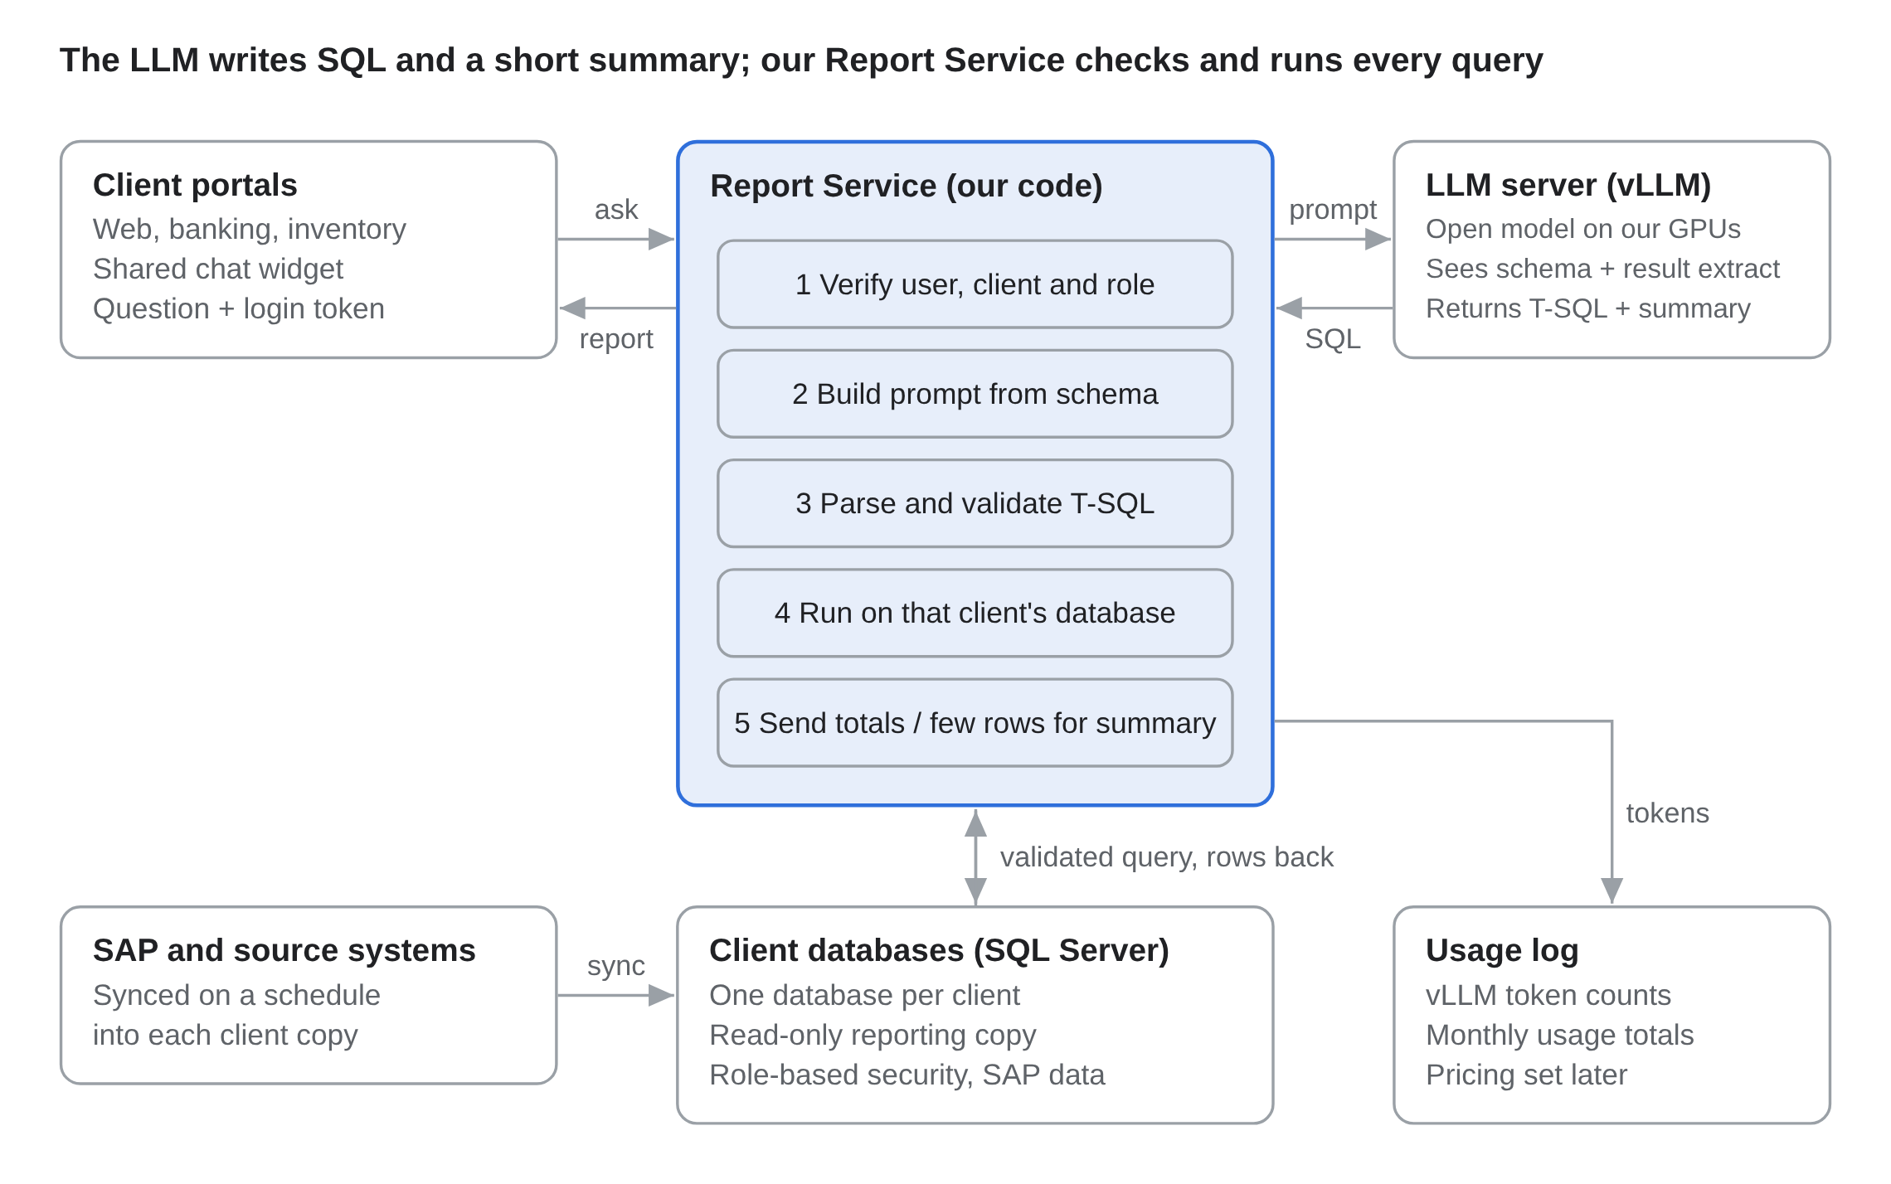
Figure 1. System architecture
The portal sends the question with the login token; the Report Service builds the prompt, gets T-SQL from the LLM, validates it, runs it on that client's own database under the user's role, sends only totals or a few rows back to the LLM for the summary, and logs vLLM's token counts before returning the report.

Architecture Workflow: one request, end to end
A request passes three checks before a client sees any data: quota, SQL safety and successful execution.
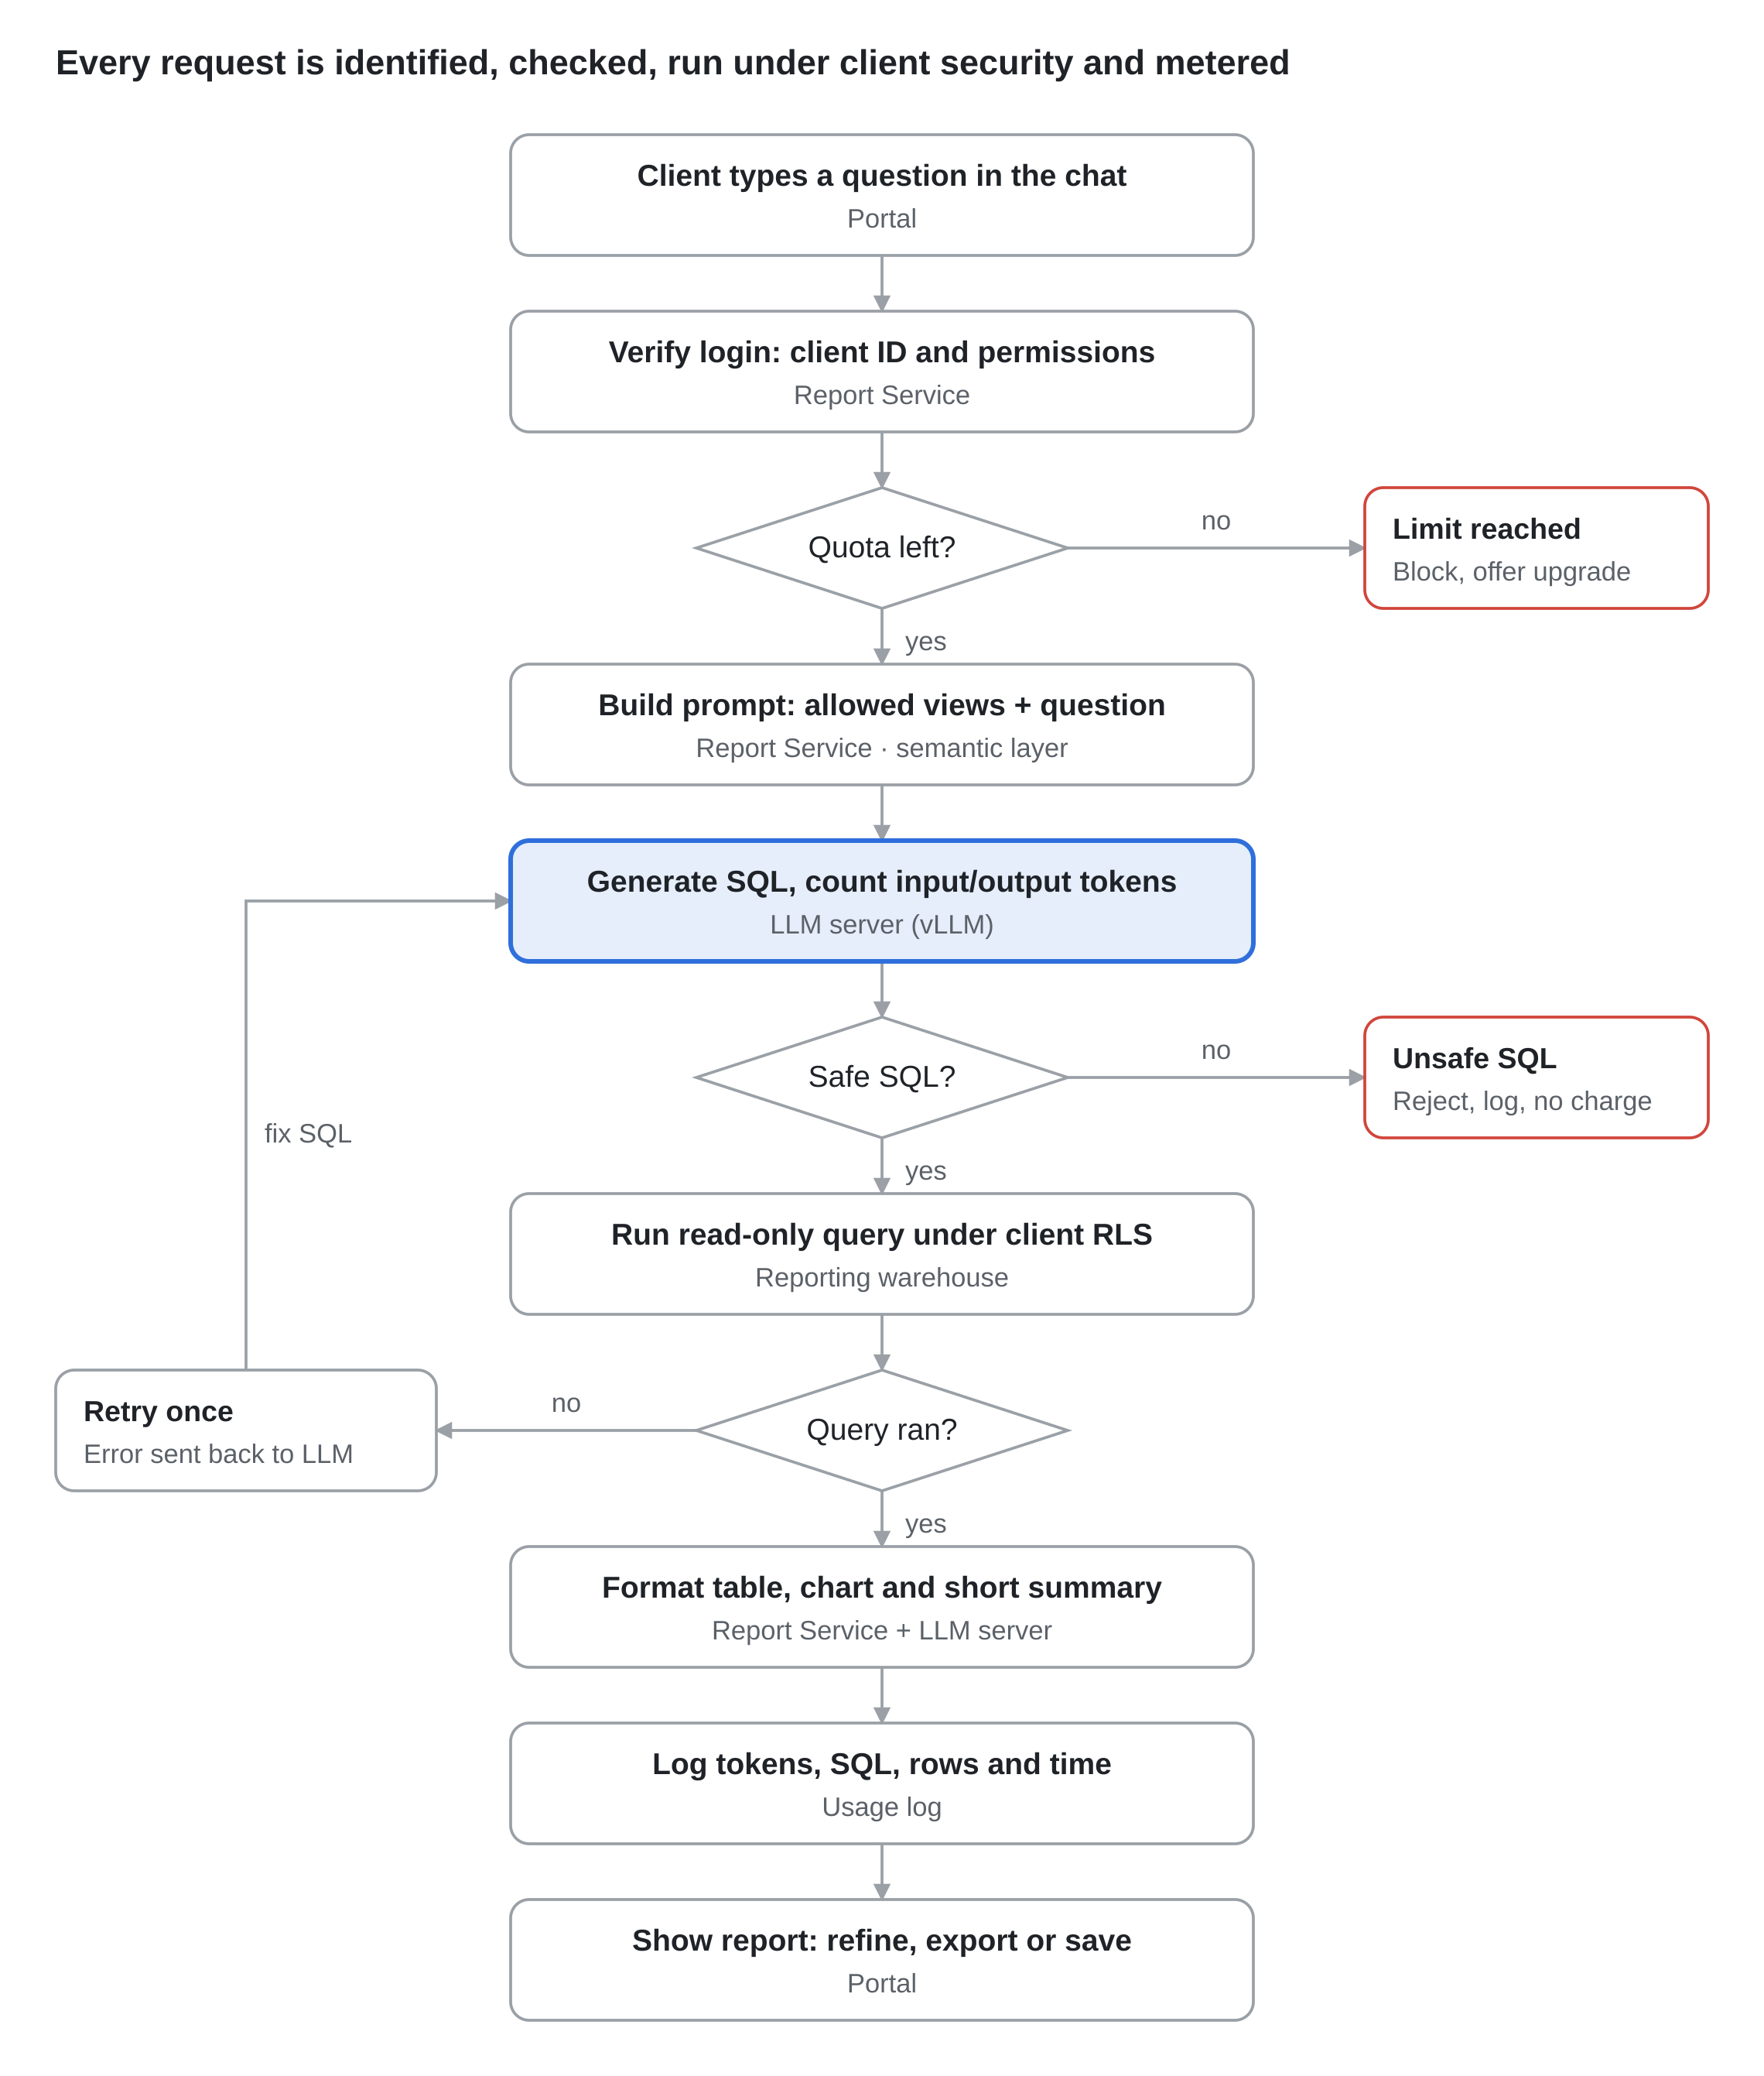
Figure 2. Request workflow
If the corrected query still fails, the client gets a clear message and a suggested rephrasing, and the attempt is logged but not charged. Tokens from every LLM call in the request, including the retry and the summary, are added to the same usage record.

Model Selection
We recommend testing two strong candidates in the proof of concept: a SQL-specialist model (Arctic-Text2SQL-R1-7B) and a general model (Qwen3.8-27B, with the older Qwen3.6-27B as a fallback). We choose the winner on our own benchmark of real client questions, not public scores alone.
The model must do two jobs: write correct SQL, and hold a natural conversation (clarify requests, summarise results). Recent research on on-premises Text-to-SQL found that a newer model generation matters more than raw size, and that a cheap self-correction step (retry when a query fails) gives a reliable accuracy gain (Beskorovainyi, 2026).
Model | Size | Strength for us | Published Text-to-SQL result | Licence
Arctic-Text2SQL-R1 (Snowflake) | 7B (public); 14B / 32B paper only | Built only for SQL; small and fast | BIRD-test 68.5% (7B). The paper also reports 70.0% (14B) and 71.8% (32B), but only the 7B weights are public | Apache 2.0 (7B card)
Qwen3.6-27B (Alibaba) | 27B dense | Strong coding and reasoning; good chat and summaries; multilingual, including Arabic; 262K context | Not published for BIRD; to be measured | Apache 2.0
Qwen3.8-27B (Alibaba) | 27B dense | Released August 2026; successor to Qwen3.6 with much higher published coding scores; 262K context | Not published for BIRD; to be measured | Apache 2.0
Qwen3-Coder-30B-A3B (Alibaba) | 30B MoE, 3B active | Coding-focused and very fast per request | Not published; to be measured | Apache 2.0
Llama-3.3-70B (Meta) | 70B | Strong general model, large community | BIRD-dev 49.2% from a different test setup, so not comparable with the scores above (source) | Llama community licence
The published scores come from different test sets and setups (BIRD-test vs BIRD-dev, different prompts and hardware), so they are not a like-for-like comparison. Only our own benchmark will compare the candidates fairly.

Recommendation:
- Primary SQL engine: Arctic-Text2SQL-R1-7B, the only Arctic size with public weights (the 14B and 32B results appear in the paper, but those models cannot be downloaded). It fits easily on a single 48 GB GPU. Arctic reasons ("thinks") before writing SQL, which adds time and tokens to every request.
- Conversation and summaries: Qwen3.8-27B (released August 2026), with Qwen3.6-27B as a fallback; or Qwen3.8-27B alone if it matches Arctic's accuracy on our benchmark (one model is simpler to run and to bill).
- Arabic: users will start in English; Arabic may be added later. When it is, Arabic questions are added to the benchmark. Arctic was trained on English Text-to-SQL data, so Arabic questions may need to go to the Qwen model, or be translated to English first.
- SQL Server: the client's databases run on Microsoft SQL Server, so the models must write T-SQL (for example TOP instead of LIMIT). Prompt examples and the benchmark use T-SQL, and the validator's parser is set to the T-SQL dialect.
- Documents: Qwen3.8-27B is a vision-language model, so the same model can read scanned POs, purchase requests and item-creation documents; no extra model is needed. It will be measured on the document test set.
- Fine-tuning: start with prompting plus examples from our own schema. Fine-tune with LoRA on our question–SQL pairs only if the benchmark shows a gap. This keeps the first phase cheap.

Public benchmarks are a guide, not a guarantee: the Arctic model card itself advises validating generated SQL before production use. Our validator and benchmark (below) cover this.

Hardware and Infrastructure Requirements
One server with a single 48 GB GPU is enough for the proof of concept. Production needs two GPU servers for capacity and failover.
GPU memory (VRAM) is the deciding factor. It must hold the model weights plus a working cache for each active request. The vLLM serving guidance puts 10B–30B models on 32–48 GB cards (A6000, L40S) and 30B–70B models on 80–180 GB of GPU memory (A100, H100) (Runpod vLLM guide). Quantising to 8-bit (FP8/INT8) roughly halves the memory a model needs.
Stage | GPU | CPU / RAM / storage | What it runs
Proof of concept | 1 × NVIDIA L40S 48 GB (or RTX 6000 Ada 48 GB) | 16+ cores, 128 GB RAM, 2 TB NVMe | Arctic-7B at 16-bit, or Qwen3.8-27B at 8-bit; 5–10 test users
Pilot | 2 × L40S 48 GB in one server | 32 cores, 256 GB RAM, 4 TB NVMe | Both models side by side; 2–3 pilot clients
Production | 2 servers, each 2 × H100 80 GB (or 4 × L40S) | 32+ cores, 256–512 GB RAM, RAID NVMe, 10 GbE | All portals; second server for failover and peak load

Software stack: Ubuntu Server, NVIDIA drivers and CUDA, Docker, vLLM as the inference server (batches many requests on one GPU and exposes an OpenAI-compatible API), and Prometheus/Grafana for GPU and latency monitoring.
Latency target: to be measured in the proof of concept. Arctic reasons before writing SQL, and that step alone can take around 10 seconds on an L40S. The client has confirmed it is acceptable to show the table and chart first, with the summary following around 10 seconds later. Real throughput (requests per minute per GPU) will also be measured before production hardware is ordered.
Hosting: confirmed by the client. Everything, including early testing, runs on local servers with a local LLM, so the client keeps complete control of its data.
Software licences: none required for the core stack. vLLM, the Hugging Face libraries and the recommended models are open source.

Data Pipeline and SAP / Database Integration
The LLM never connects to databases or SAP directly. A middle layer, the Report Service, owns every connection and runs every query.
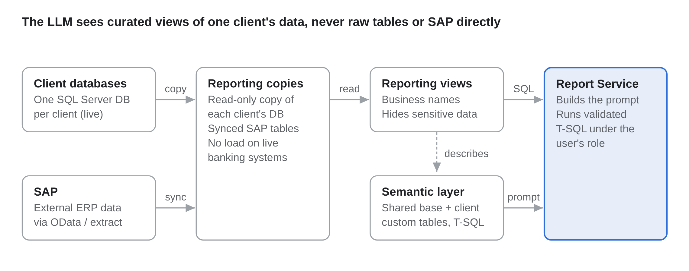
Figure 3. Data pipeline from source systems to the Report Service
Reporting data layer
- Each client has its own Microsoft SQL Server database. AI queries run on a read-only reporting copy of that database (for example an Always On readable secondary or a scheduled copy), so they never slow down live banking or inventory transactions.
- Sync SAP data into each client's reporting copy on a schedule (for example nightly or hourly) through SAP's standard interfaces (OData services or extraction tools already used by our integrations). Live SAP calls per question are avoided: they are slow and harder to secure.
- Build clean reporting views with business-friendly names (v_inventory_monthly, v_customer_balances). The LLM sees these views, not raw tables. This raises accuracy and hides sensitive columns.

Semantic layer (the model's "map")
- A short description of each view and column, with business terms ("stock on hand" = qty_available).
- 20–50 example questions with correct SQL per module, used as examples in the prompt.
- Stored as a versioned file so analysts can improve it without code changes.
- Customised tables: some clients have customised tables, so the semantic layer has a shared base for the standard product tables plus a client-specific part for each client's custom tables.

Report Service steps
- Receive the question and the client's verified session.
- Build the prompt: instructions, allowed views for this client, examples, question.
- Call the LLM through vLLM's API and receive SQL.
- Validate the SQL (read-only, allowed views, row limit, time limit).
- Run it with the client's database role; if it fails, send the error back to the LLM once for self-correction.
- Return results to the portal; log tokens, SQL, timing and outcome.

Portal integration: one shared chat widget and one REST API, so web portals, banking and inventory modules all use the same service rather than separate integrations.

Document Capture: Purchase Orders, Purchase Requests and Item Creation
The client also wants purchase orders (POs), purchase requests and item-creation documents to be read and saved into the system automatically. Today users create these documents in the portal. They go through an approval workflow, are held in a local SQL database during approval, and are then posted to SAP. The AI service fits into this existing flow: it reads the document and creates a draft in the approval workflow. It never posts to SAP itself. It uses the same on-premises model and GPU server as the reporting assistant, but runs as a separate service, because it writes data.
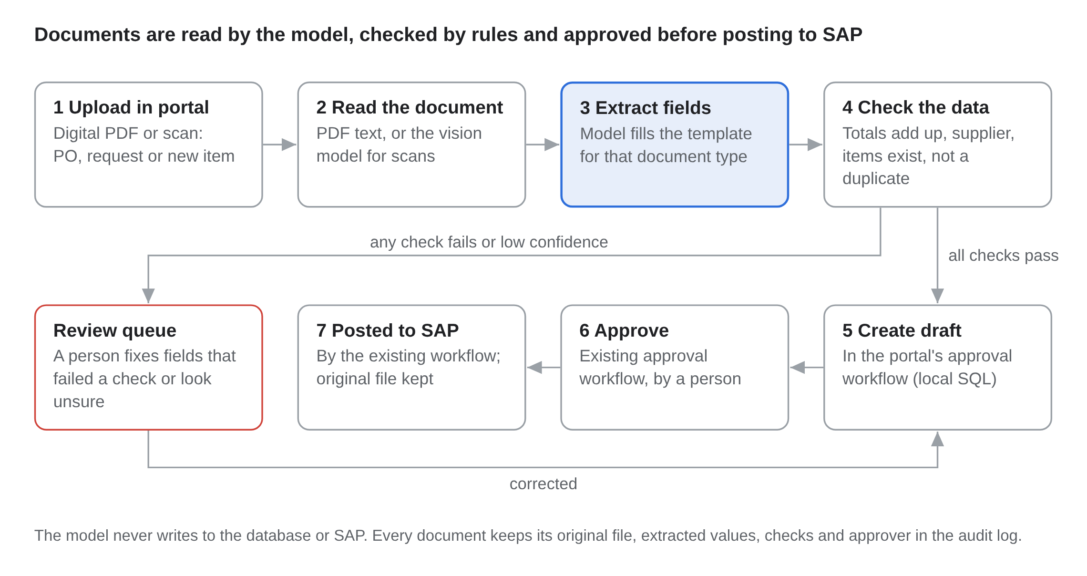
Figure 4. Document capture flow
What the service does
- Receive: documents are uploaded in the portal, which is how users already create them. Digital PDFs and digital scans are supported; handwritten documents are not in scope. Each file gets an ID, and the client comes from the user's login.
- Read: for digital PDFs, the text is taken straight from the file. For scans, Qwen3.8-27B reads the page image directly (it is a vision-language model), with a standard OCR engine as a fallback.
- Extract: each document type has its own fixed template, and vLLM's structured-output mode forces the model to return only valid JSON in that shape. POs: PO number, date, supplier, currency, line items (item code, description, quantity, unit, unit price, tax, line total), delivery date, payment terms and total. Purchase requests: requester, department, items, quantities, required-by date and justification. Item creation: item name, description, unit of measure, item group and the other fields the client's SAP setup requires.
- Check: rule-based checks in our own code, not the model: line totals and the order total add up; the supplier or customer and the item codes exist in master data; the PO number has not been saved before; required fields are present; dates and currency are valid. Prices are compared with the price list where one exists.
- Save: documents that pass every check are created as drafts in the portal's existing approval workflow (the local SQL database), through the portal's own API, never by writing to tables directly. After approval, the existing workflow posts them to SAP as it does today. The original file is stored and linked to the record.
- Review: documents that fail a check, or where the model is unsure, go to a review screen that shows the document next to the extracted fields. A person corrects them before they enter the approval workflow.
Approval
Every document goes through the client's existing approval workflow before it is posted to SAP, so a person always approves it. Later, the client may choose to fast-track simple, well-tested document types, but that is the client's decision, not the model's.
How document accuracy will be measured
- Test set: 100–200 real past documents of each type (digital PDFs and scans), with the correct values supplied by the client's purchasing team from what was actually posted to SAP.
- Measures: field accuracy (the share of fields extracted exactly right) and the share of documents with every field correct, which is the share that needs no correction.
- Target: every key field correct, in line with the client's 100% expectation. Because a person approves every document before it reaches SAP, an extraction error is caught at approval instead of being posted; the measured field accuracy shows how much correction work remains.
Security, billing and capacity
- Separate write account: document capture uses its own service account, which can only create drafts in the approval workflow through the portal API. The reporting service stays read-only.
- Document text is data: if a document contains instructions (for example "ignore the rules"), the model still only fills the template, and the checks still apply.
- Audit log: each document keeps its original file, extracted values, check results, and who approved it and when.
- Billing: document jobs are logged the same way, from vLLM's token counts. Pricing is agreed later (see Token Metering).
- Capacity: document jobs wait in a queue and can run during quiet periods, so they do not slow down reports. Pages per minute will be measured in the proof of concept.

Security, Data Isolation and Governance
Isolation is enforced by the database, not by trusting the LLM. Even a wrong or manipulated query cannot return another client's rows.
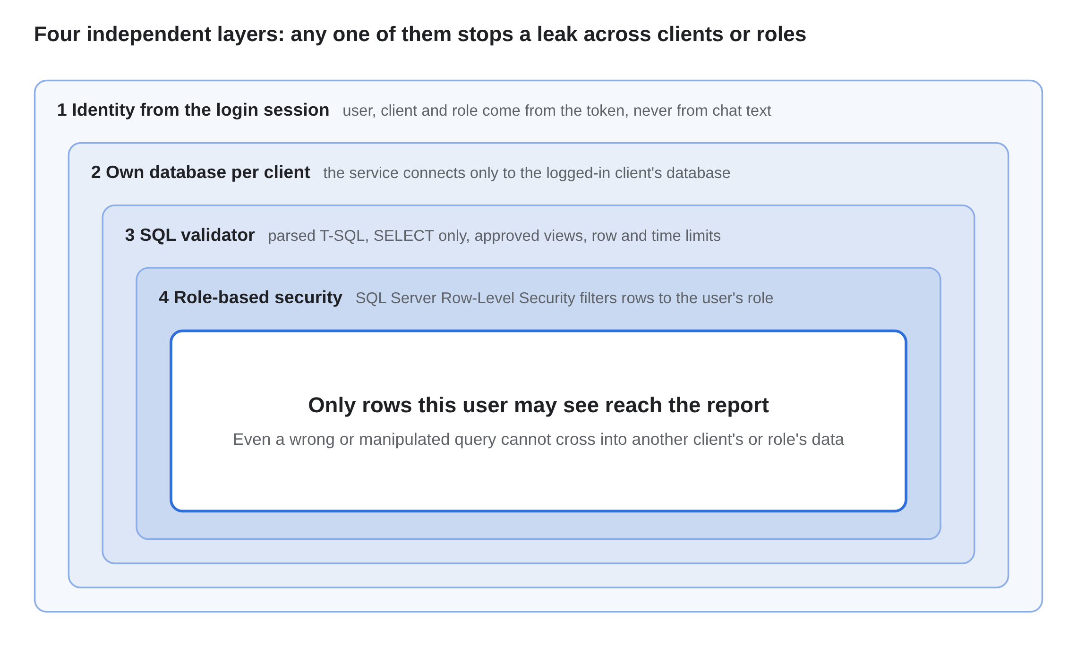
Figure 5. Four layers of data isolation
Four layers of protection
- Identity from the session, never from the chat. The client ID comes from the portal login token. Text like "show me client 55's data" is ignored.
- Separate database per client, with role-based security inside it. Each client already has its own SQL Server database, so the service connects only to the database of the logged-in client; the database comes from the session, never from the chat. Inside that database, the client's existing roles decide which data and functions each user can access. Queries run under the user's role, enforced with SQL Server Row-Level Security (security policies that filter rows using the user's role, set in SESSION_CONTEXT for each request). RLS can be bypassed in some setups: for example through views that run with the owner's rights instead of the caller's, or when a reused (pooled) database connection still carries the previous user's role. Whether the portals use connection pooling is still being confirmed; either way, the role is set on every request and cleared when the connection is reused, views are set to respect the caller's permissions, and both cases are tested in the red-team test.
- SQL validator before execution. The query is read with a proper SQL parser (for example sqlglot), not checked with keyword searches, so tricks such as comments, nested queries or several statements in one request are caught. Only a single SELECT is allowed; no INSERT, UPDATE, DELETE, DROP or system tables. Only approved views. Maximum rows (e.g. 50,000) and a query timeout (e.g. 30 seconds).
- Least-privilege database account. The Report Service's database user has read-only rights on the reporting views and nothing else.

Privacy and compliance
- The model, prompts and results stay on our servers; no data goes to external AI providers.
- The model sees query results only to write the summary, and receives only totals or a few sample rows, not the full report.
- Sensitive fields (national ID numbers, full account numbers) are masked in reporting views.
- Full audit log per request: user, question, generated SQL, rows returned, tokens, time.
- Banking data handling to be reviewed against the regulator requirements in the UAE and Pakistan (e.g. the Central Bank of the UAE and the State Bank of Pakistan) and client contracts before go-live. US rules will be reviewed later if US clients are added.

Prompt-injection protection: the model only produces SQL text; it has no tools to call and no network access. Results shown to the client come from the database, not from the model's memory.
Testing: before the pilot, a red-team test tries cross-client access, access beyond the user's role, destructive SQL and injection prompts. Go-live requires zero successful breaches.

Token Metering and Monetization
Every request's tokens are taken from vLLM's own usage count and logged against the client's account before the response is returned. This is the basis for billing and for enforcing monthly limits.
Agreed with the client: token usage is logged from the first test, but pricing, packages and billing rules (including whether thinking tokens and failed reports count) will be decided once the system runs in a test environment and its real-world performance and value can be measured. The packages below are only a starting point for that discussion.
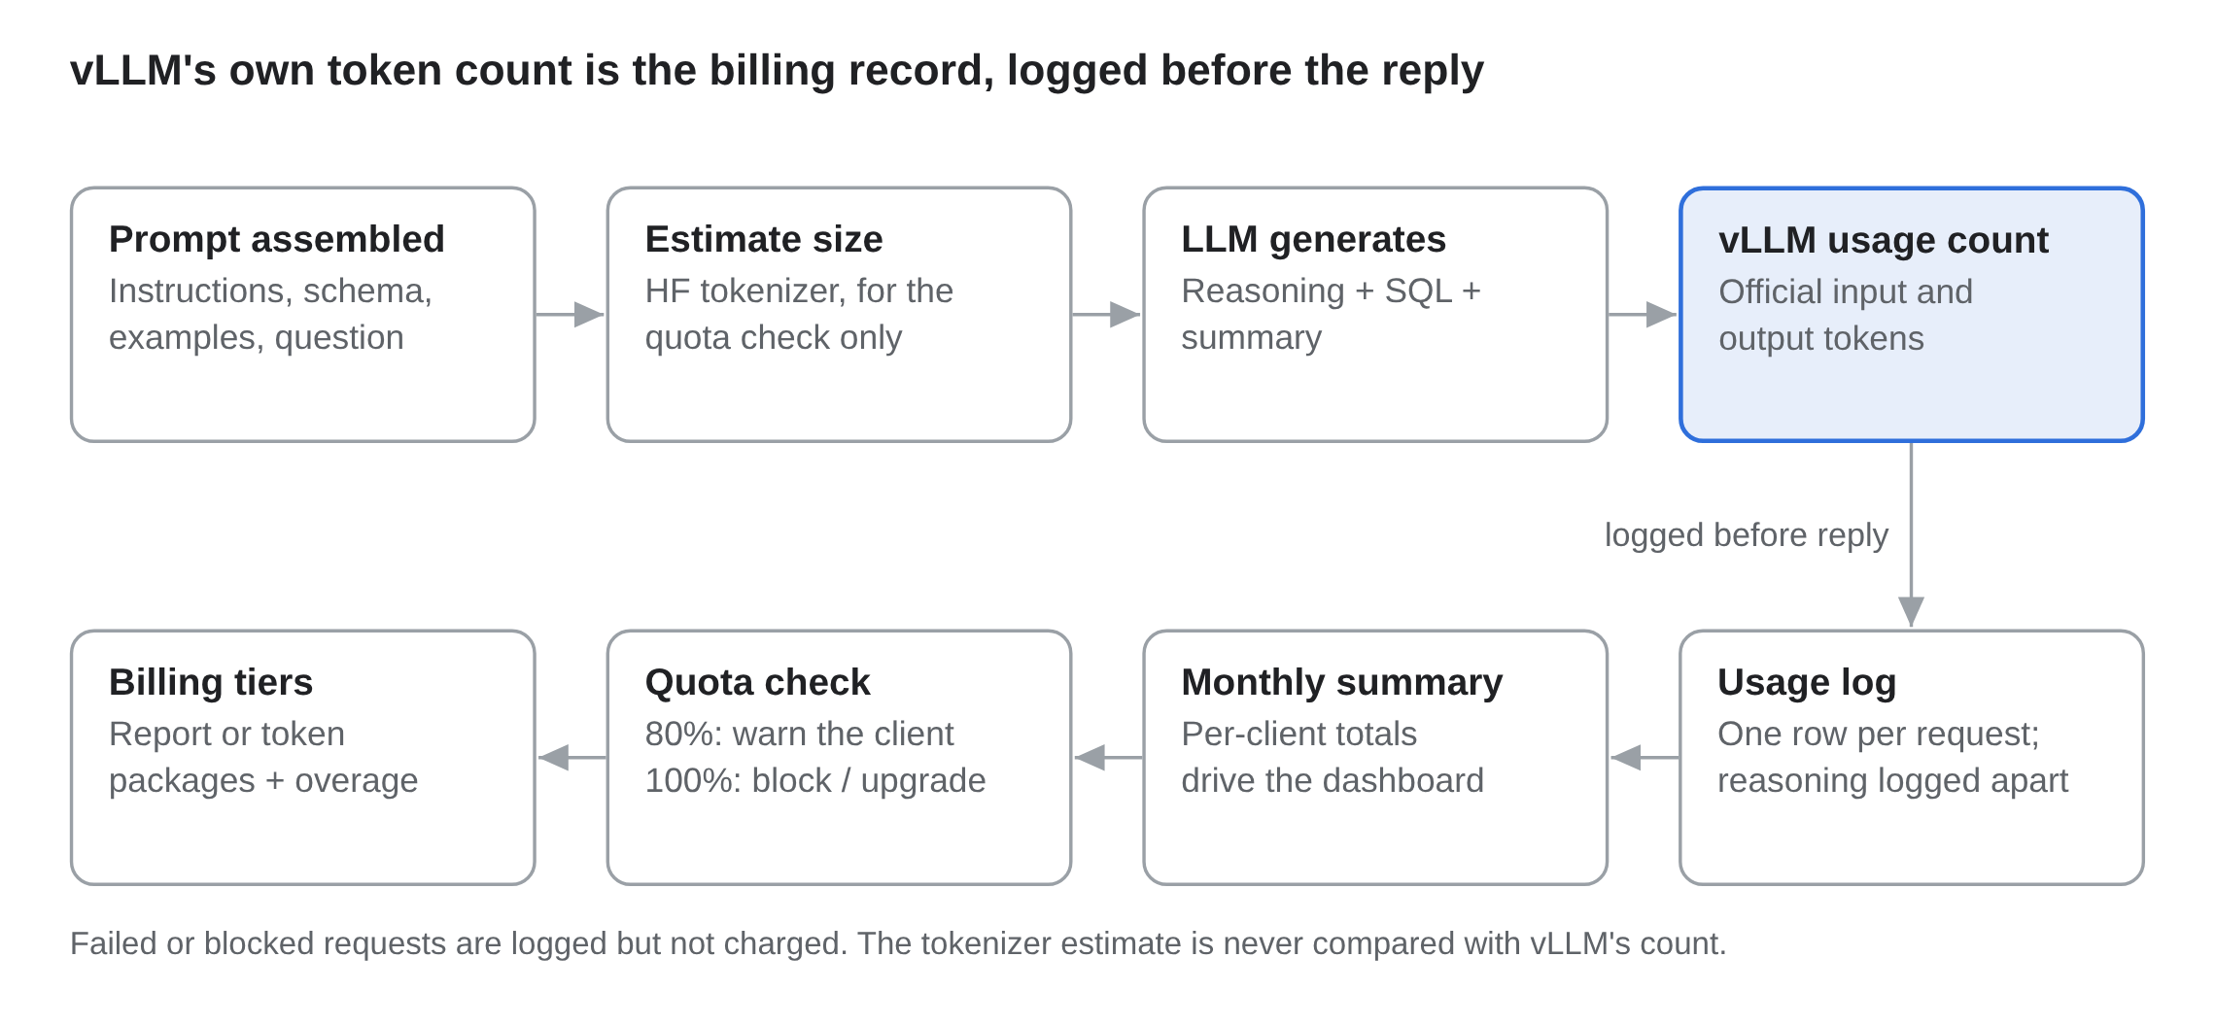
Figure 6. Token metering and billing flow
How counting works
- Input tokens = everything sent to the model: system instructions, schema description, examples, conversation history and the client's question. Note that the schema and examples are often larger than the question itself.
- Output tokens = everything the model generates: its reasoning (“thinking”), the SQL and the written summary.
- Tokenizer (estimates only): the Hugging Face transformers/tokenizers library, loading the exact tokenizer of the deployed model (AutoTokenizer.from_pretrained(<model>)). It is used before a request to estimate its size for the quota check, not for billing.
- Billing count: the prompt and completion token counts that vLLM returns with each response are the official billing figures. They will never match a separate tokenizer count exactly (the chat template and special tokens add extra tokens), so the two are not compared.
- If two models are used (SQL + summary), tokens from both calls are added to the same request record.
- Thinking tokens: Arctic and Qwen write reasoning text before the answer. These tokens use GPU time and are included in vLLM's output count. Whether they are charged will be decided with the client after the test environment, together with pricing. Either way they are logged separately as reasoning_tokens.

Usage log (one row per request)
Field | Example
request_id | 7f3c…
client_id | 42
user_id | u_1093
module | inventory
model | arctic-text2sql-r1-7b
input_tokens | 3,850
output_tokens | 1,620
reasoning_tokens | 1,200 (part of output_tokens)
status | success / failed / blocked
created_at | 2026-10-14 14:05

A monthly summary table per client powers the usage dashboard and limit checks. Before each request, the service checks the client's remaining quota; at 80% it warns, and at 100% it blocks or offers an upgrade.
Proposed packages (final numbers set by the product team after pilot data)
Package | Monthly allowance | Suited to
Basic | Up to X dynamic reports | Small clients with occasional needs
Standard | Up to Y total tokens | Regular users who refine and explore
Enterprise | Custom token pool + priority GPU capacity | Large banks and multi-branch clients
Overage | Price per extra 100,000 tokens | Any tier above its limit

Failed or blocked requests are logged but not charged, so clients pay only for reports they receive.

Implementation Plan
The project runs in four phases. Each phase ends in a go/no-go gate, and production hardware is bought only after the pilot proves the value.
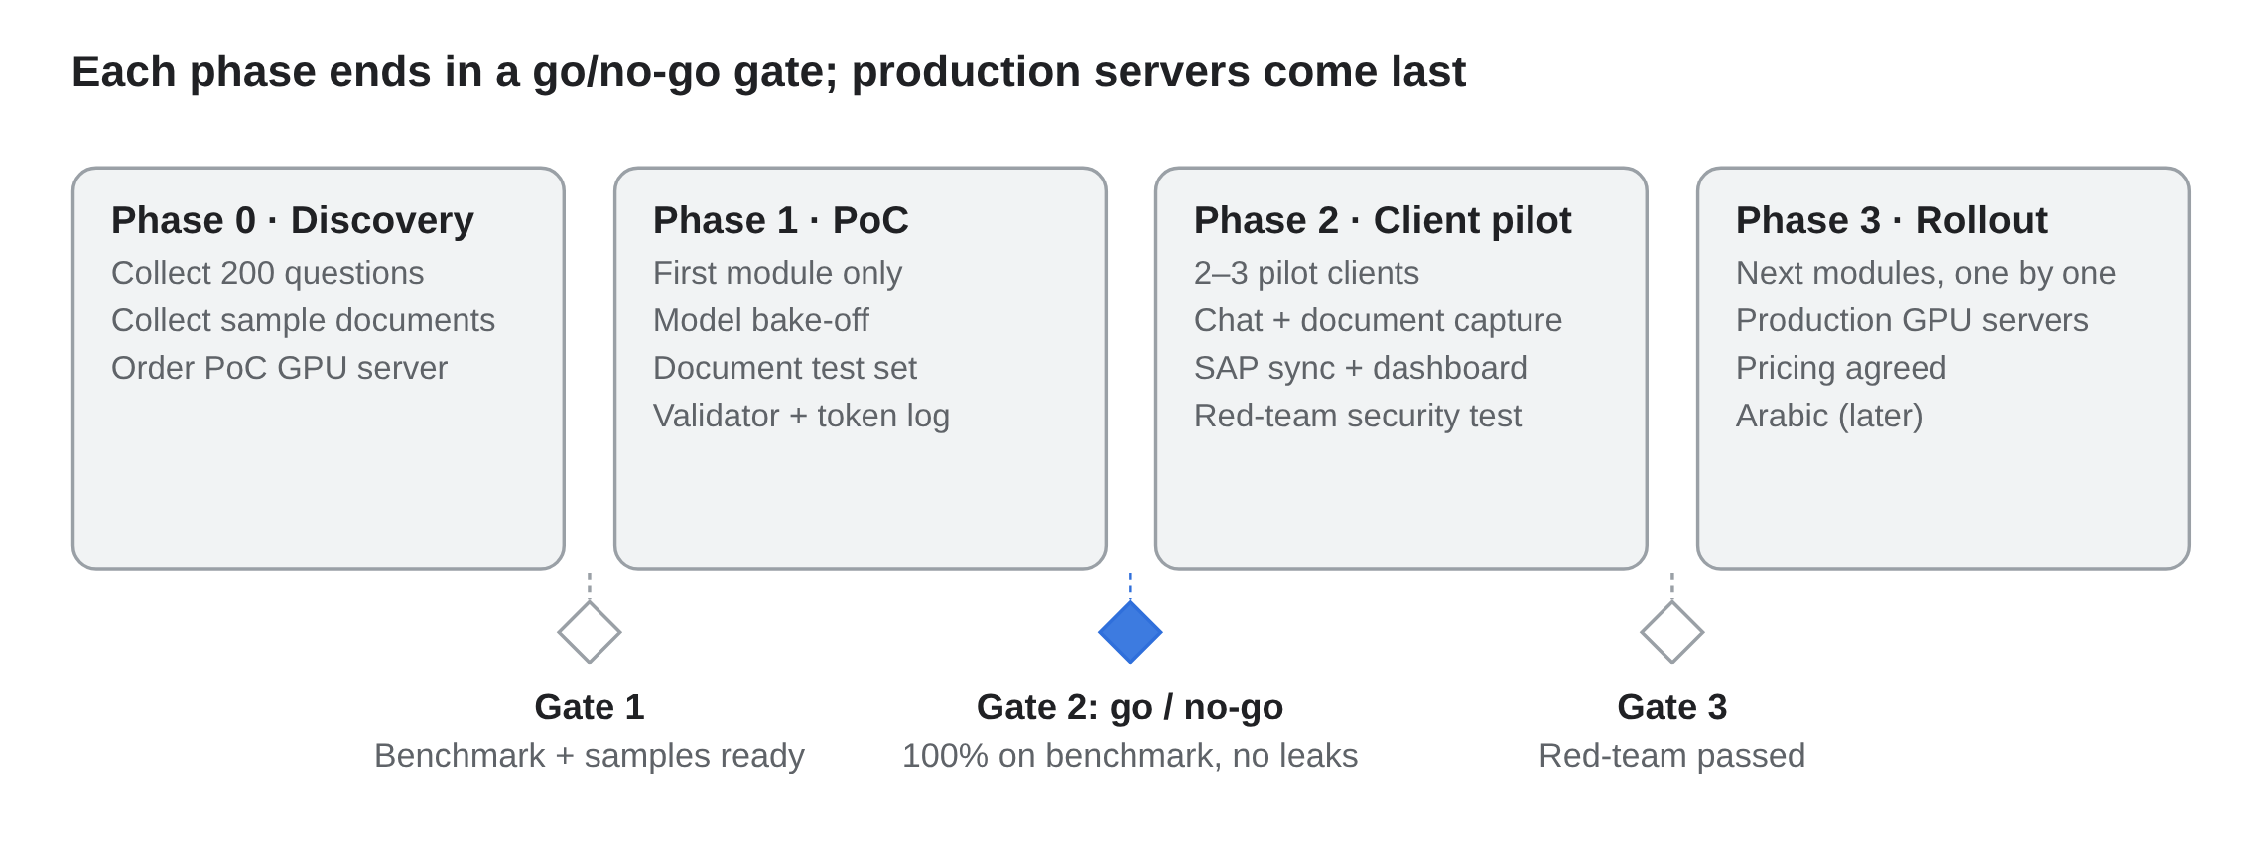
Figure 7. Implementation roadmap
Gate 2 is the main decision point: if the first module does not reach 100% on its benchmark with zero data leaks, we adjust the prompts, examples or model, or fine-tune, before involving any client.

Team
The project needs a core team of six to seven people, plus hardware bought in stages as each phase gate is passed.
Role | Allocation | Responsibility
Project lead / product owner | 50% | Scope, client pilot, pricing tiers
ML engineer | 100% | Model serving, prompts, benchmark, fine-tuning
Backend developers (2) | 100% | Report Service, validator, metering, portal API
Data engineer | 100% | Reporting views, SAP sync, semantic layer
Frontend developer | 50% | Chat widget, charts, export
QA / security tester | 50% | Benchmark testing, red-team, audit checks
Integration developer | 50% | Portal approval-workflow API for documents, review screen

Risks and Mitigations
The largest risk is a plausible but wrong report; the design answers it with validation, transparency and a measured benchmark before launch.
Risk | Impact | Mitigation
Wrong SQL gives a believable but incorrect report | High | Confirm-before-run in plain words; ask or decline instead of guessing; verified report library; benchmark of 200 real questions; "show query" option; users can flag wrong results
Cross-client data exposure | Critical | Separate database per client, role-based Row-Level Security, session-based identity, read-only account, red-team test before go-live
Slow responses at peak times | Medium | vLLM batching, quotas per tier, second production server, load testing in pilot
SAP data out of date | Medium | Show "data as of" time on every report; increase sync frequency for key tables
Token counts disputed by clients | Medium | Bill from vLLM's own count; per-request usage log and dashboard visible to clients
GPU hardware delays | Medium | Phase purchases by gate; start the proof of concept on one local GPU server
Complex or vague questions | Medium | Model asks a clarifying question; suggested question templates in the chat
Model becomes outdated | Low | Model-agnostic Report Service; re-run the benchmark when swapping models
Wrong document values (e.g. quantity or price) | High | Rule checks on totals and master data; existing approval workflow before posting to SAP; audit log of every document
Poor-quality or unusual scans | Medium | Review queue; vision model with OCR fallback; ask regular suppliers to send digital PDFs
Client expects 100% accuracy | High | Release one module at a time, only after 100% on its benchmark; confirm-before-run and ask-or-decline design; agree with the client how unanswered questions are handled

Answers to the Team's Action Items
Question | Proposed answer
Which open-source LLM suits Text-to-SQL? | Arctic-Text2SQL-R1-7B for SQL, tested against Qwen3.8-27B; final choice by our own benchmark
What server specifications are needed? | PoC: 1 × L40S 48 GB, 128 GB RAM. Production: 2 servers of 2 × H100 80 GB (or 4 × L40S), 256+ GB RAM
Which tokenizer library? | Hugging Face transformers/tokenizers, using the deployed model's own tokenizer for estimates; billing uses vLLM's reported counts
How will the LLM connect to databases and SAP? | Through a Report Service only: a read-only copy of each client's own SQL Server database, scheduled SAP sync, validated T-SQL under the user's role
How will purchase orders and other documents be read and saved? | The vision-capable model extracts fields into a fixed template per document type; rule checks; drafts created in the existing portal approval workflow, which posts to SAP after approval

Client Answers and Remaining Questions
The client answered the first round of questions. Their answers, and what each one changes in this proposal, are below.
Topic | Client answer | What it changes in this proposal
Database | Microsoft SQL Server. | Models write T-SQL; the validator parses the T-SQL dialect; SQL Server Row-Level Security is used.
Data isolation | Each client has a separate database; some have customised tables. | The service connects only to the logged-in client's database; each client gets its own additions to the semantic layer.
Security | Each client has roles that decide what functions and data each user can access. | Queries run under the user's role; the model only sees the tables that role may use.
Connection pooling | To be confirmed. | Listed below; the design works either way.
First module | Any module can go first, but it must be perfected before moving to the next. | One module at a time; the next starts only after 100% on the current module's benchmark.
Summaries | Short summaries alongside tables and charts are an added bonus. | Table and chart are the main output; the summary is kept short.
Accuracy | 100% expected: the data is sensitive banking and financial information, and no false results are acceptable. | Release gate raised to 100% on each module's benchmark; confirm-before-run and ask-or-decline design.
Response time | Showing tables and charts first, with the summary following after about 10 seconds, is acceptable. | Results shown in two steps.
Regions | UAE and Pakistan first; the US may be considered later. | Regulator review for the UAE and Pakistan before go-live; US later.
Language | English first; Arabic may be added later. | Benchmark in English; Arabic is a later phase.
Hosting | Local servers with a local LLM, for full control of local data. | All testing and production run on local servers; no cloud GPUs.
Documents | POs, purchase requests and item creation, created in the portal, approved in a workflow, held in a local SQL database, then posted to SAP. Digital PDFs, portal entries and digital scans; no handwriting. | The AI creates drafts in the existing approval workflow and never posts to SAP directly.
Tokens and billing | To be finalised once the system runs in a test environment. | Tokens are logged from the first test; pricing and billing rules are agreed later.
Still to confirm
- Connection pooling: do the portals reuse database connections? Your developers can check this in the portal's database connection settings.
- Past report requests: can you share some past custom-report requests, ideally with the final SQL or report? These start the benchmark.
- Correct answers: who on your side can help write and check the correct answers for the benchmark questions?
- First module: which module would you like to start with?
- How the assistant behaves when unsure: should it ask a clarifying question, or say it cannot answer and pass the request to the support team?
- Model restrictions: do any clients restrict which AI models can be used (for example by vendor or country of origin)?
- Document volume: roughly how many POs, purchase requests and item-creation documents are processed per day?
- Sample documents: can you share 100–200 past documents of each type, with the values that were posted to SAP?

Next Steps
- Approve the proof-of-concept phase and the first GPU server
- Choose the first module (any module; it must be perfected before the next) and 2–3 pilot clients
- Collect 200 real report requests from past tickets to build the benchmark
- Collect 100–200 past POs, purchase requests and item-creation documents, with the values posted to SAP
- Confirm whether the portals use connection pooling (database confirmed: Microsoft SQL Server)
- Agree pricing and billing rules once the test environment shows real usage

Sources
- Arctic-Text2SQL-R1 paper (Snowflake, arXiv 2505.20315)
- Arctic-Text2SQL-R1-7B model card, Hugging Face
- How Far Do On-Prem Open LLMs Get on Text-to-SQL? (arXiv 2606.29733)
- Qwen3.6 27B, OpenRouter model page
- Alibaba releases Qwen3.8-27B, DataNorth
- Qwen model family overview, Vantaige
- vLLM configuration and GPU selection, Runpod

