**Group Members:**

151805011 Dursun ERYILMAZ

151805024 Ülkü ÇOR

**Computer Info:**

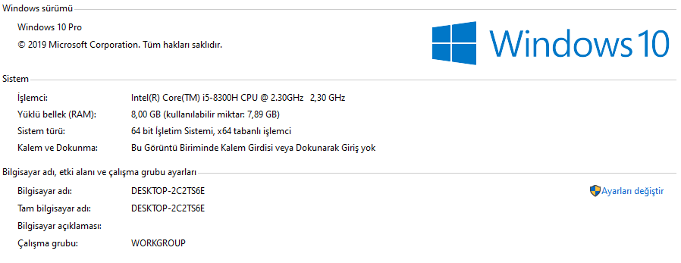

**About Dataset:**

user_id book_id rating

1 6264 7.000000

1 4350 7.000000

1 6252 5.000000

*Sample of book_ratings.dat file

Book_ID ISBN Book-Title Book-Author Year-Of-Publication Publisher Image-URL-S Image-URL-M Image-URL-L

1 0060973129 Decision in Normandy Carlo D'Este 1991 HarperPerennial http://images.amazon.com/images/P/0060973129.01.THUMBZZZ.jpg http://images.amazon.com/images/P/0060973129.01.MZZZZZZZ.jpg http://images.amazon.com/images/P/0060973129.01.LZZZZZZZ.jpg

2 0393045218 The Mummies of Urumchi E. J. W. Barber 1999 W. W. Norton &amp Company http://images.amazon.com/images/P/0393045218.01.THUMBZZZ.jpg http://images.amazon.com/images/P/0393045218.01.MZZZZZZZ.jpg http://images.amazon.com/images/P/0393045218.01.LZZZZZZZ.jpg

3 0425176428 What If?: The World's Foremost Military Historians Imagine What Might Have Been Robert Cowley 2000 Berkley Publishing Group http://images.amazon.com/images/P/0425176428.01.THUMBZZZ.jpg http://images.amazon.com/images/P/0425176428.01.MZZZZZZZ.jpg http://images.amazon.com/images/P/0425176428.01.LZZZZZZZ.jpg

*Sample of books_info.dat file

* Given rank and iteration parameters (10,50,200) has caused unfixable errors so we change them to (4,6,10)

* Dataset and more info about data set can be found link below.

<https://github.com/caserec/Datasets-for-Recommender-Systems/tree/master/Processed%20Datasets/BookCrossing>

MSE quite high and changes very large range, because distribution of data and ALS’s unappropriate parameters (given parameters occurrs errors).