Duru Demirbag

Practical Assessment for Solving Problems with Data and Text

1.Introduction
The Research Excellence Framework (REF) 2021 evaluates the quality of research across UK universities. One important part of this evaluation is the “research environment,” which looks at how well institutions support research activity. The School of Computing at the University of Kent is interested in improving its performance in this area for future REF results. This report compares data from universities that did slightly better and slightly worse than Kent in the environment category. By looking at both their numbers and their written environment statements, this report offers suggestions on how Kent can improve its results.
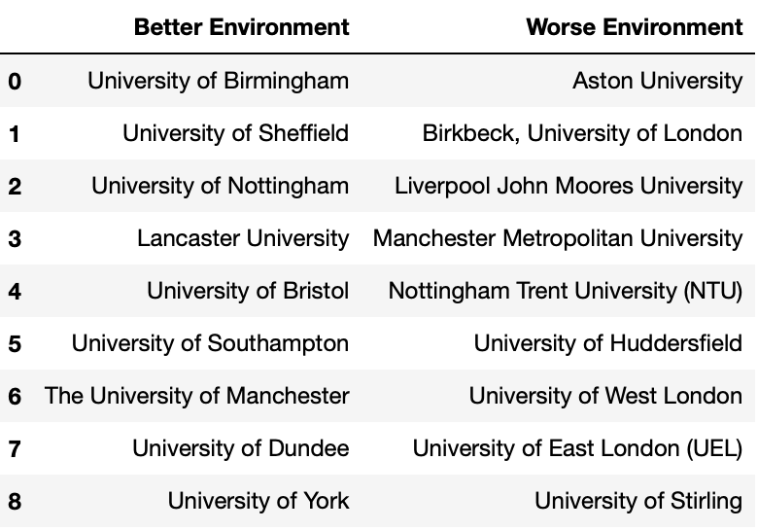
Table 1.1 Universities with Their Environments

The analysis uses three main data sources, which are REF2021Results-SelectedSamples.xlsx, inst.txt and unit.txt. First is a file with numbers related to research income, doctoral completions, and other environment-related indicators. The second and third are two text files: one includes statements written by Computing departments (unit-level), and the other includes general statements from the universities (institution-level). Nine universities that performed slightly better than Kent and nine that performed slightly worse were chosen as comparison groups (Table 1.1).

2. Findings from Analysis

2.1 Findings from Quantitative Analysis

The excel file consists of 4 sheets, which are summary, research income, research income in kind, doctoral and docs. We will examine them separately.

2.1.1 Summary

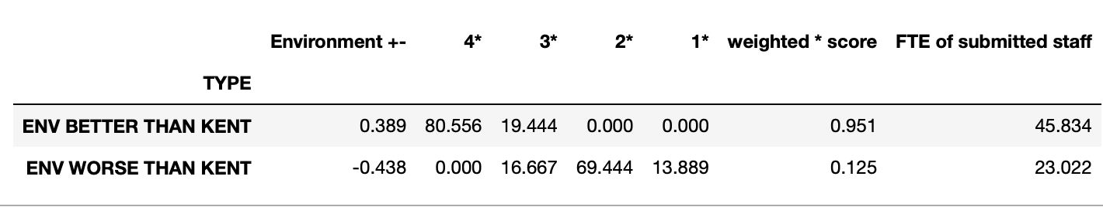
Table 2.1.1.1
Table 2.1.1.1 compares average REF2021 environment performance data for two groups of universities, those that performed better than the University of Kent and those that performed worse. The first column labelled “TYPE,” distinguishes these two categories. The “Environment +−” column indicates how much better or worse each group scored, on average, compared to Kent. Universities in the better performing group scored approximately 0.389 points higher than Kent, while those in the worse performing group scored 0.438 points lower.
The next four column 4*, 3*, 2*, and 1* represent the average percentages of each group’s submitted research environment that was rated at each of the REF star levels. A 4* rating means the environment was judged to be world-leading, while 3* is internationally excellent, 2* is internationally recognized, and 1* is nationally recognized [1]. In the better-performing group, over 80 percent of the environment submissions were rated as 4*, and the remaining 19.4 percent received a 3* rating. No parts of their submissions were rated at 2* or 1*, suggesting that the overall quality of their environments was considered very high. In contrast, the worse performing universities had no 4* ratings at all. Around 16.7 percent of their submissions were rated 3*, but the majority were only rated 2*, with almost 14 percent receiving the lowest rating of 1*. This clearly illustrates the gap in quality between the two groups.
The column labelled “weighted * score” shows the average environment Grade Point Average (GPA) for each group. This GPA is calculated by assigning weights to each rating: 4 for a 4* rating, 3 for a 3* rating, and so on, then averaging the result across the percentages. The better performing universities achieved a high GPA of 0.951, while the worse performing group averaged only 0.125. This metric summarizes the overall environment quality in a single score and aligns closely with the pattern seen in the detailed star ratings.
The final column, “FTE of submitted staff,” represents the average number of full-time equivalent (FTE) staff submitted by each group of universities for assessment. Better performing institutions submitted an average of 45.8 FTE staff, which is significantly higher than the 23 FTE submitted by the lower performing group. This suggests that larger research units may be better equipped to build and maintain high quality research environments, offering more structured support, resources, and research culture [2].

2.1.2 Research Income/ Research Income in Kind

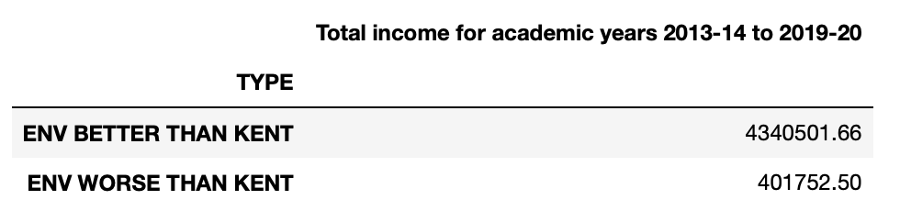
Table 2.1.2.1
Table 2.1.2.1 presents the total research income for two groups of universities, those that performed better than the University of Kent, and those that performed worse over a seven-year period, from academic year 2013–14 to 2019–20.
According to the data, universities in the better performing group received an average total income of approximately £4,340,501.66 during this time. In contrast, the worse performing group received significantly less only about £401,752.50 on average over the same period.
It is therefore reasonable to suggest that institutions with more financial resources might have more opportunities to invest in research infrastructure, provide better support for academic staff and research students, and engage in collaborative projects.

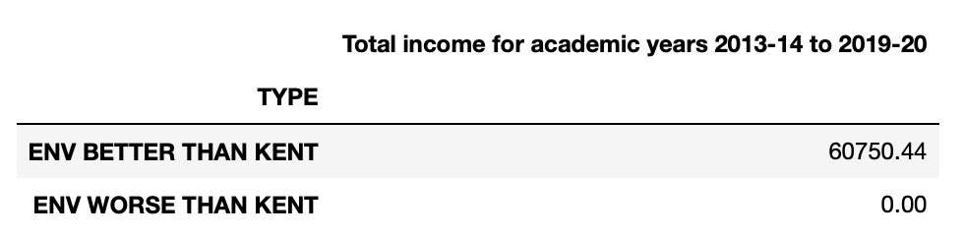
Table 2.1.2.2

Table 2.1.2.2 provides a summary of research income-in-kind received between the academic years 2013–14 to 2019–20 by the two groups.
The group of universities that performed better than Kent in the REF environment scores received approximately £60,750.44 in total research income in kind during that period. On the other hand, the worse performing group reported zero income in kind.
While the total value here is much lower than direct income, its presence in the better group and absence in the worse group may suggest that collaborative engagement and partnerships are more actively pursued or better captured by higher scoring institutions.

    - Doctoral
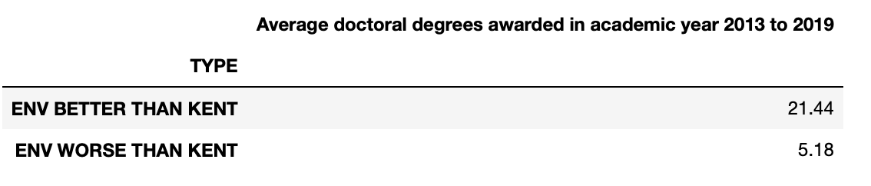
Table 2.1.3.1

Table 2.1.3.1 shows the average number of doctoral degrees awarded per university between 2013 and 2019, for two groups. Universities that performed better than Kent awarded, on average, 21.44 PhD degrees per year. Performed worse than Kent awarded only 5.18 PhD degrees per year.
In simple terms, it may mean that the stronger performing universities had more PhD students successfully graduating each year, which can be an important sign of an active and well supported research environment.

  - Findings from Textual Analysis

2.2.1 Unit-Level

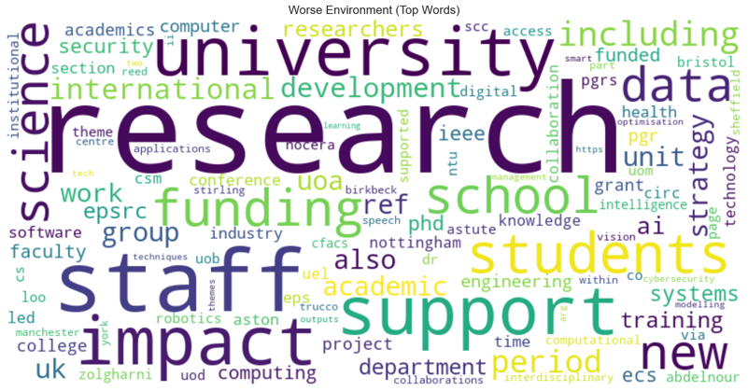
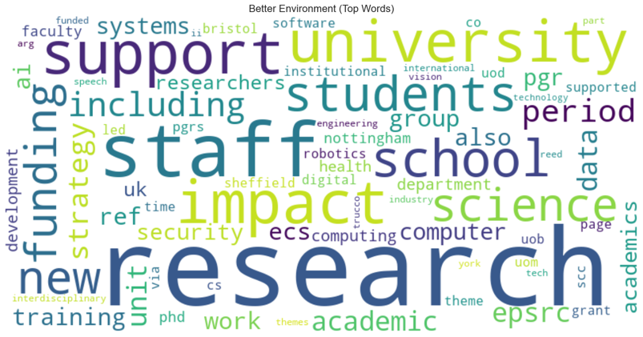
Top words for unit-level

Figure 2.2.1.1 Figure 2.2.1.2
After preprocessing and tokenization, the most frequently used terms in each institution’s unit-level submission were extracted and analysed. A comparison between the better and worse environment groups revealed notable differences in word usage.
The word clouds in Figure 2.2.1.1 and 2.2.1.2 show the most common words in the unit-level environment statements of universities that performed better and worse than Kent. Both groups use similar words like “research”, “staff”, and “students”, but there are some clear differences.
In the better-performing group, words like “impact”, “strategy”, “funding”, and “training” appear more often. This shows a stronger focus on planning, investment, and development.
In the worse performing group, although the same keywords are present, they are less central. The focus seems to be more on general descriptions rather than clear plans or outcomes. This may be one reason why those universities scored lower in the REF environment assessment.

2.2.2 Institution-Level
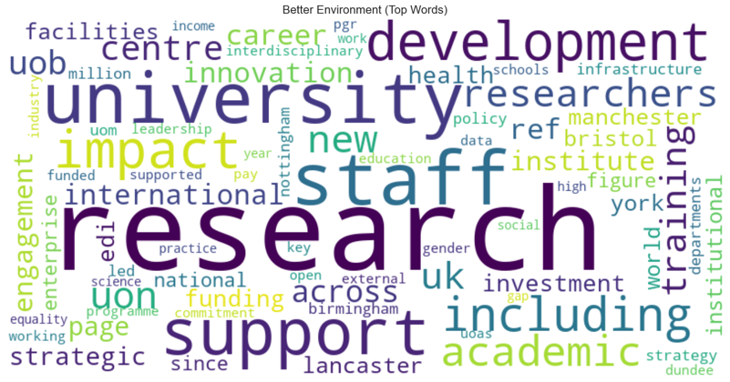
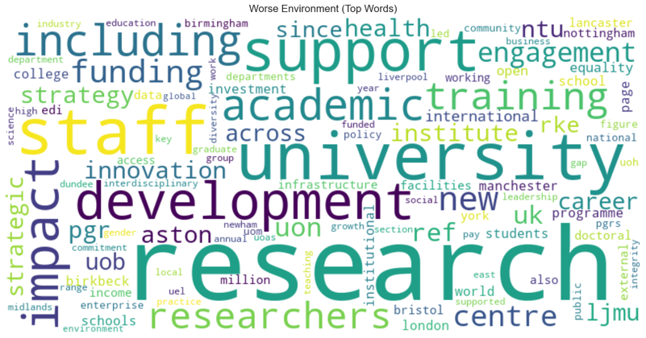
Top words for institution-level
Figure 2.2.2.1 Figure 2.2.2.2
As with the unit-level texts, institution-level statements were pre-processed and tokenized. The top 20 most frequent words were extracted for each university and grouped by better and worse environment classification.
The institution-level word clouds in Figure 2.2.2.1 and 2.2.2.2 highlight the most frequent words used by universities with better and worse REF environment scores. As expected, both groups share common terms such as “research”, “university”, “staff”, “training”, and “development”, which reflect general themes found in most submissions.
However, better performing universities more often use words like “impact”, “investment”, “innovation”, “facilities”, and “enterprise”. These terms suggest a stronger focus on infrastructure, forward planning, and support for research at a strategic level.
In contrast, while the worse performing group also uses key words like “support” and “training”, their statements appear to place less emphasis on strategic growth or measurable improvements. The presence of more generic terms may indicate that these institutions focus more on describing activities than showing the outcomes or long-term benefits.

3. Conclusion
The analysis of REF2021 data highlights key differences between universities that performed better and worse than the University of Kent in the environment category. Quantitative findings show that better performing institutions have higher research income, more research income-in-kind, and a greater number of doctoral completions. These indicators point to better funding, more external engagement, and stronger research training environments.
Textual analysis also revealed differences in how each group presents their research environment. Universities with higher environment scores tend to use more strategic and outcome focused language, often highlighting planning, investment, infrastructure, and impact. In contrast, lower scoring universities use similar vocabulary but with less emphasis on measurable results and long-term goals.
Together, these results suggest that both substance and presentation matter in REF submissions. For the University of Kent, improving future REF performance may depend on strengthening research capacity, increasing external partnerships, and clearly communicating strategy and impact in both unit and institution level statements.

References:
- https://2021.ref.ac.uk/guidance-on-results/guidance-on-ref-2021-results/index.html#qualityRatings
- https://2021.ref.ac.uk/guidance-and-criteria-on-submissions/news/substantial-increase-expected-in-number-of-staff-submitted-in-ref-2021/index.html#:~:text=The%20data%20show%20that%20HEIs,a%2043%20per%20cent%20increase.

