Q1. Print customer name with highest number of orders.
Query:
select customer_id,count(*) as total_orders
from dmart_orders
group by customer_id
order by total_orders desc limit 1;
Screenshot:
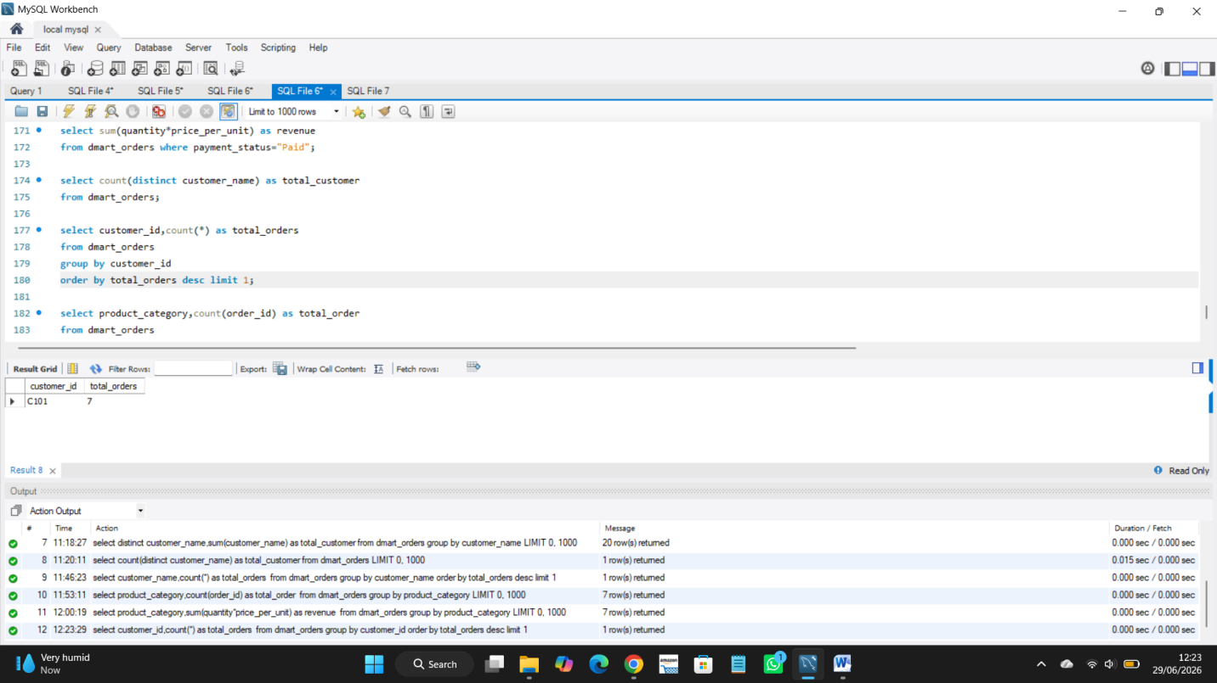

Insights:
1. Find the customer who has placed the highest number of order.

Q2. Find total number orders per category.
Query:
select product_category,count(order_id) as total_order
from dmart_orders
group by product_category;
Screenshot:
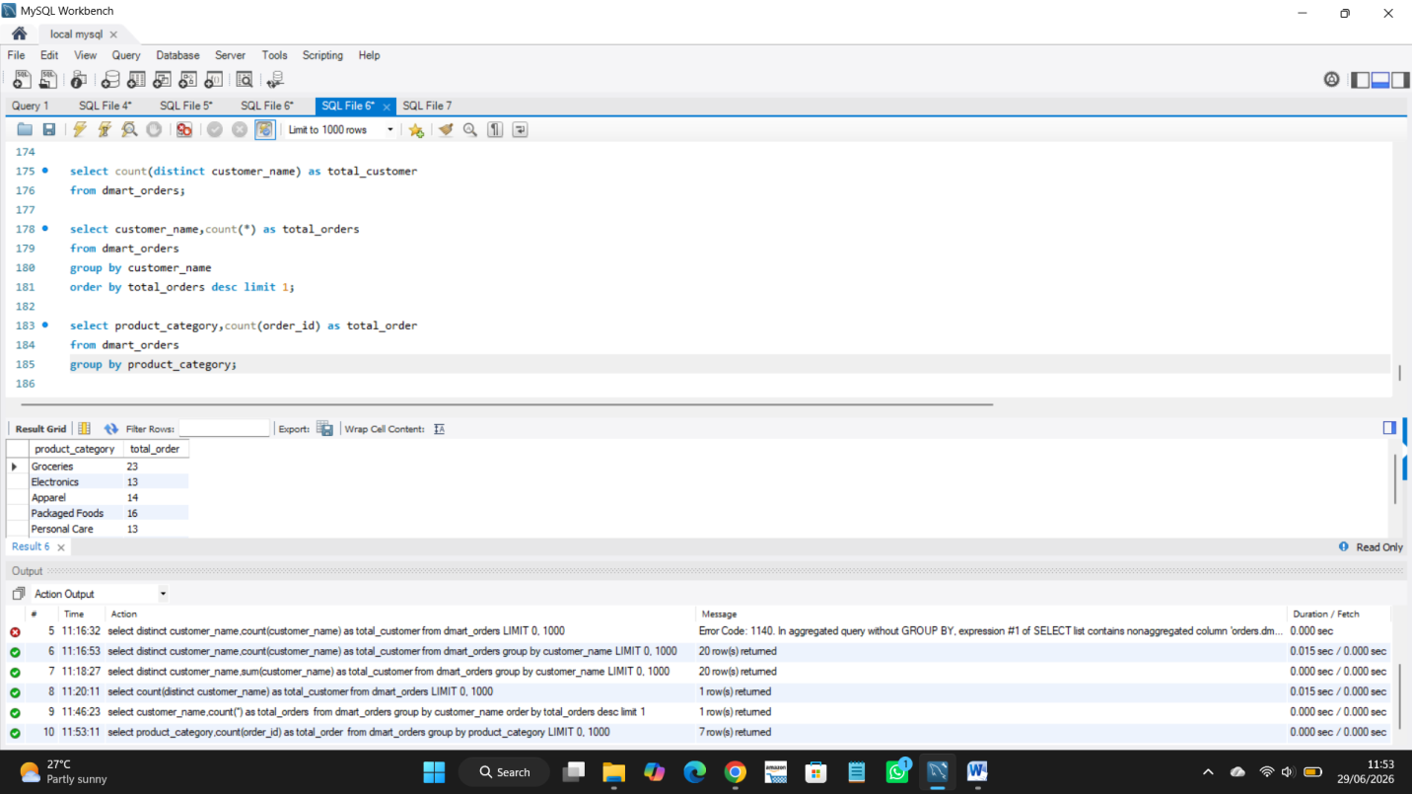

Insights:
1. This query counts how many orders are placed for each product category.

Q3. Print revenue per order category.
Query:
select product_category,sum(quantity*price_per_unit) as revenue
from dmart_orders
group by product_category;
Screenshot:
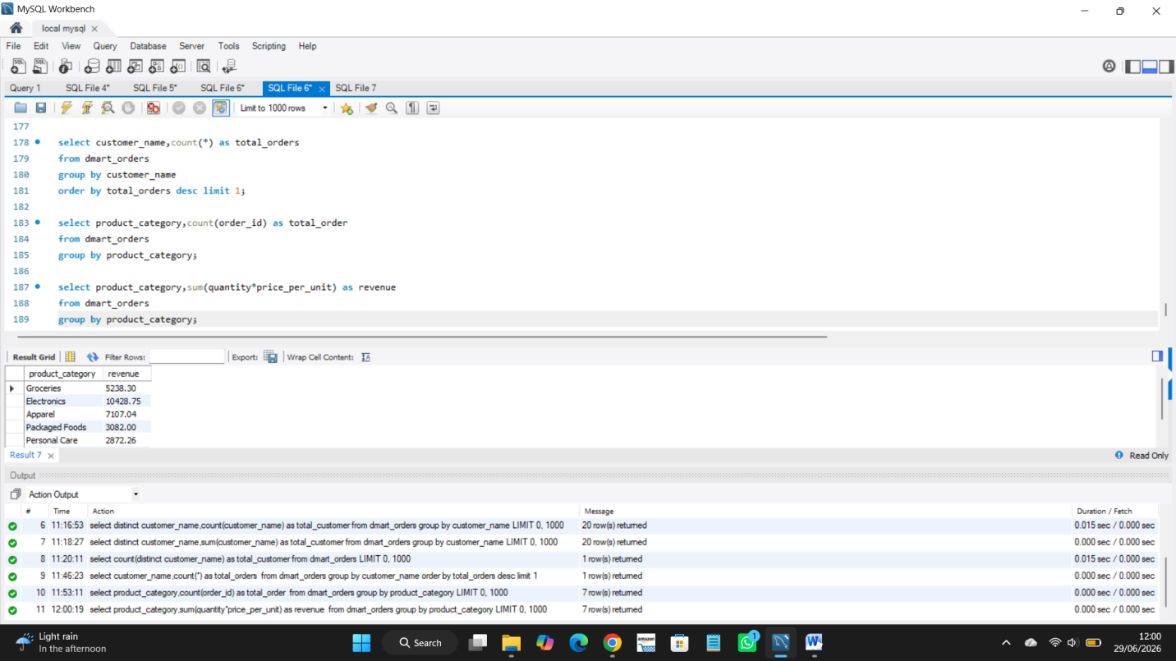

Insights:
1. This query shows the total revenue earned from each product category.

Q4. Find credit amount.
Query:
select sum(quantity*price_per_unit) as revenue
from dmart_orders where payment_status="Pending";
Screenshot:
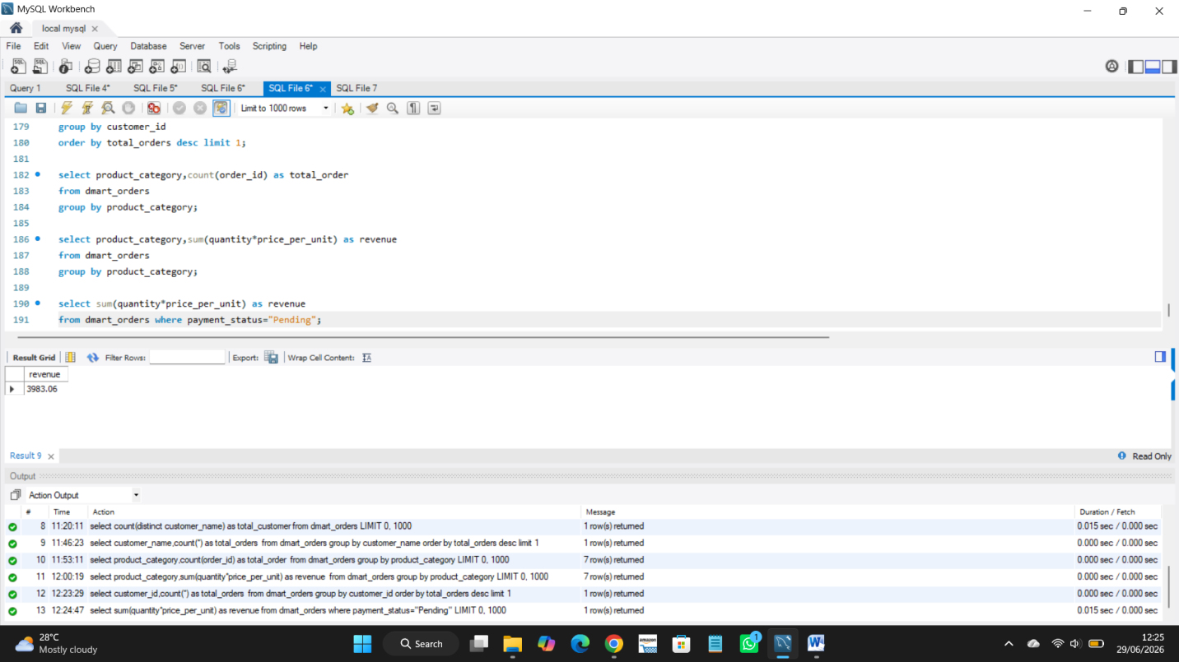

Insights:
This query calculate the total amount that customers had pending.

