Q1. Inner Join.
Query:
select T1.teacher_id,
T1.teacher_name,
D1.dept_name
from
department D1 inner join teacher T1
on D1.dept_id=T1.dept_id;
Screenshot:
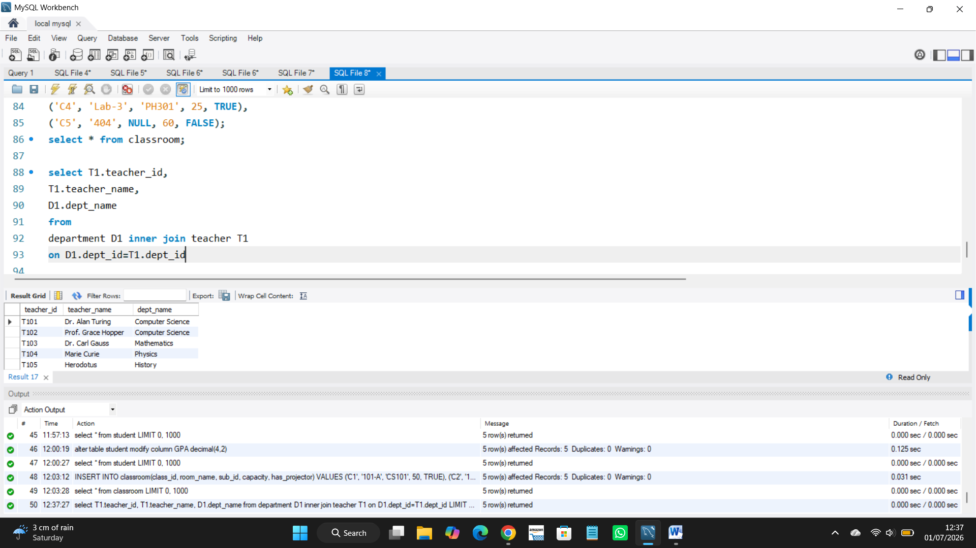
Insights:
This query shows each teacher name with their department name.
It combine teacher and department tables.

Q2. Left Join.
Query:
select C1.class_id,
C1.room_name,
S1.sub_name
from
classroom C1 left join subject1 S1
on C1.sub_id=S1.sub_id;
Screenshot:
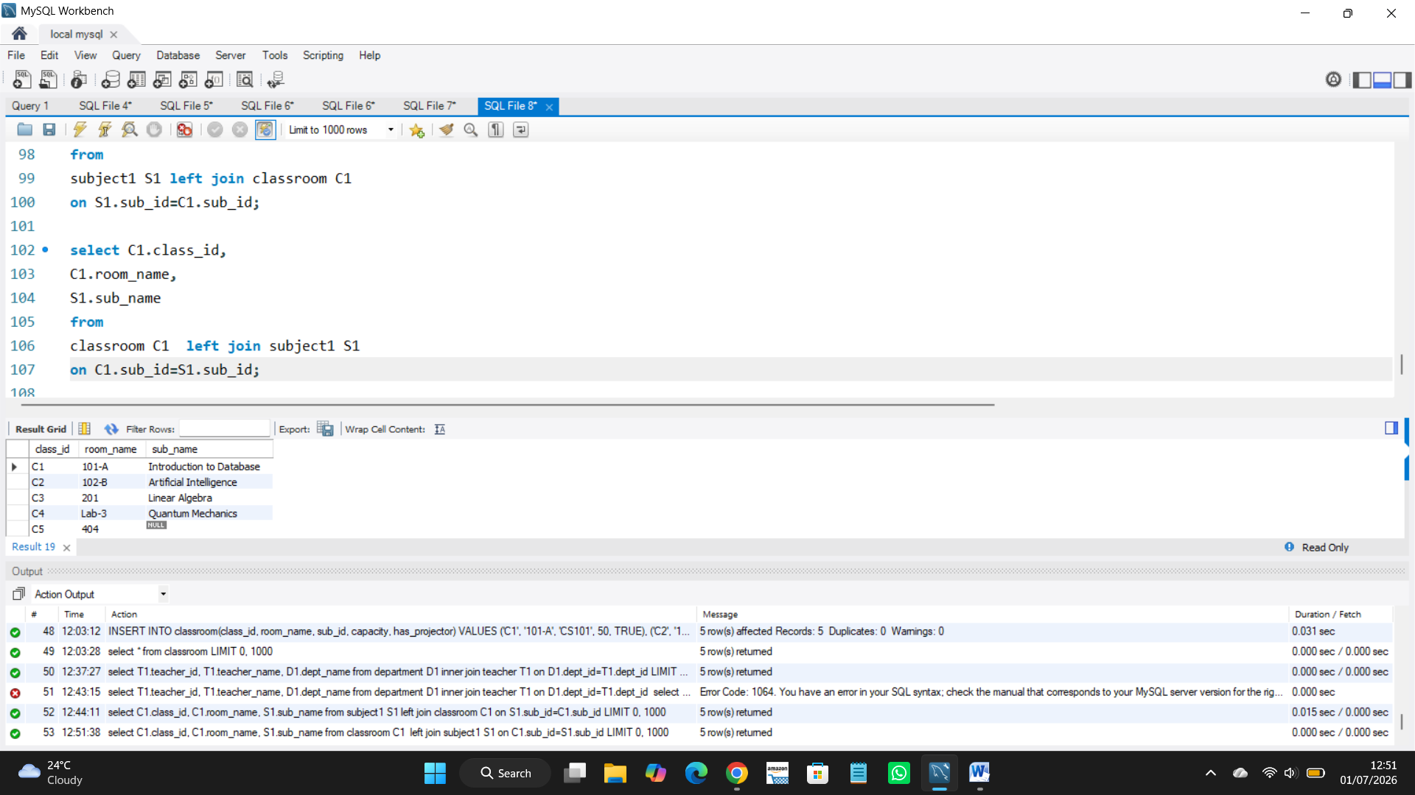
Insights:
This query shows all classroom with their subject name.
If classroom has not matching subject name then it shows null.

Q3. Right Join.
Query:
select C1.class_id,
C1.room_name,
S1.sub_name
from
classroom C1 right join subject1 S1
on C1.sub_id=S1.sub_id;
Screenshot:
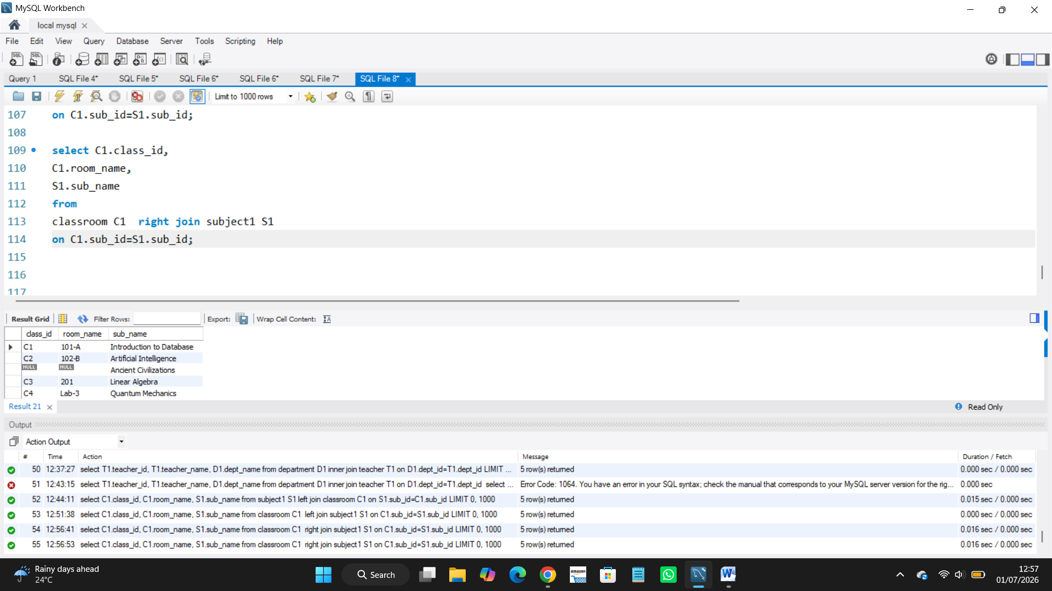
Insights:
It shows all classroom with their subject name.
If subject has not matching classroom then it shows null.

