SVKM's Narsee Monjee College of Commerce & Economics (Autonomous)
2026-27
TY BSc (Information Technology)
Semester V
Version Control with GitHub
&
Computational Indic Studies
Group Members' Details:
Roll No. | Name | SAP ID
A002 | Piyush Arun | 45618240030
A019 | Durvankur Kate | 45618240009

Question:
Develop a Decision Tree-based system for handwritten Gurmukhi character classification using a publicly available labeled Gurmukhi character dataset. Students should explore the dataset, preprocess the character images and convert them into appropriate feature vectors before training the Decision Tree classifier. The trained model should classify unseen character images and its performance should be evaluated using accuracy, precision, recall, F1-score and confusion matrix. Students should visualize the classification results and provide a brief interpretation of the model's performance. Students must create a public GitHub repository containing all Python files developed for the project and submit the repository link.
GitHub link: https://github.com/durvankurkate26-droid/gurmukhi-decision-tree.git

Code & Output:
1. Google Drive Mounting
Explanation: Mounts the user's Google Drive to the Google Colab environment using the drive.mount() function. This allows the notebook to access the dataset and other project files stored in Google Drive. Once the drive is successfully connected, a confirmation message “Mounted at /content/drive” is displayed.
2. Unzipping the Dataset
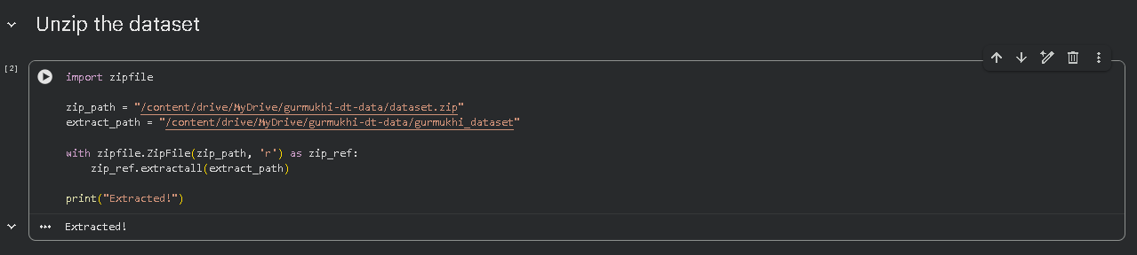
Explanation: Uses Python's built-in zipfile module to extract the Gurmukhi handwritten character dataset (uploaded to Drive as dataset.zip) into a folder named gurmukhi_dataset. This extraction only needs to be performed once; the cell is kept wrapped as an inert string in the notebook afterwards so it does not accidentally re-run and re-extract the dataset in later sessions. A confirmation message “Extracted!” is displayed once complete.
3. Verifying Extracted Folders
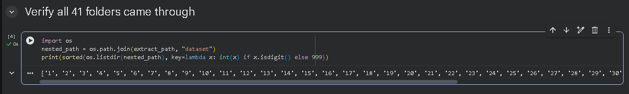
Explanation: Since the zip file contained an extra top-level folder named dataset wrapping the 41 individual class folders, this cell checks inside that nested folder using os.listdir() to confirm all 41 class folders (1 through 41) were extracted correctly before locking in the dataset path used for the rest of the project.
4. Dataset Path and Class Identification
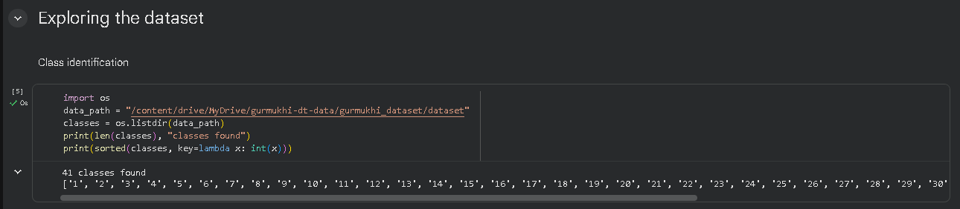
Explanation: Sets the final dataset path (pointing to the confirmed nested dataset folder) and uses os.listdir() to identify all class folders present. The code confirms that all 41 character classes were found and prints their names in sorted numerical order.
5. Exploring Images in a Dataset Class
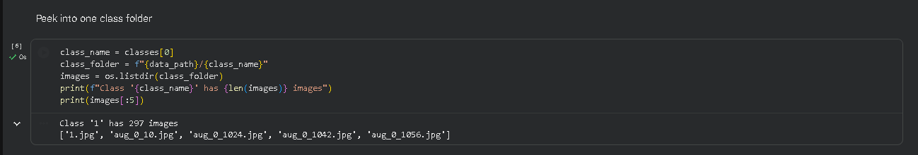
Explanation: Selects the first class folder and retrieves the image files stored inside it using os.listdir(). The code prints the total number of images in that folder and the first five filenames, confirming that each class contains one original scanned sample along with several augmented versions of it (filenames prefixed with aug_).
6. Counting Images in Each Class
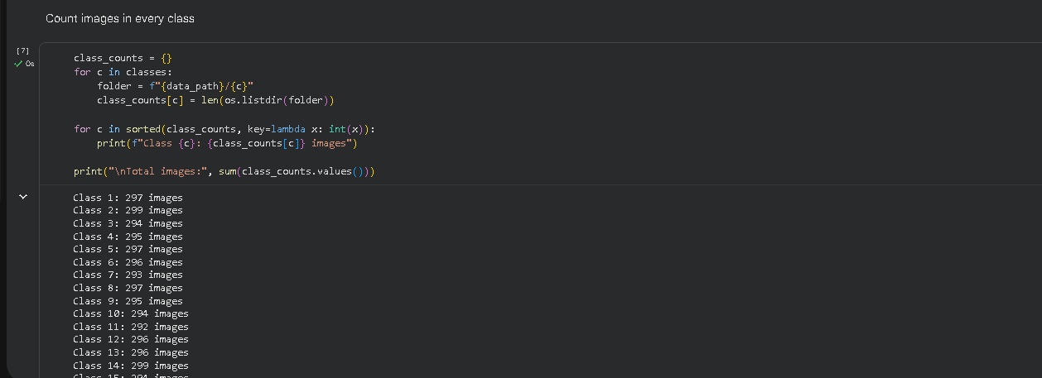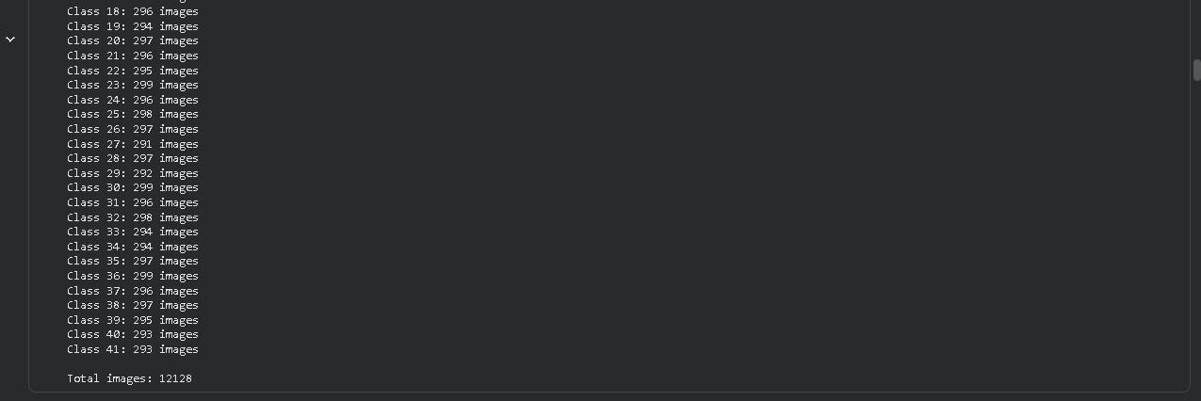
Explanation: Creates a dictionary to store the number of images available in each class of the Gurmukhi handwritten character dataset. The code loops through all class folders, counts the images present in each, and stores the corresponding count. It then prints the number of images for every class in sorted order and displays the total number of images available in the complete dataset (12,128 images across 41 classes).

7. Visualizing Images per Class
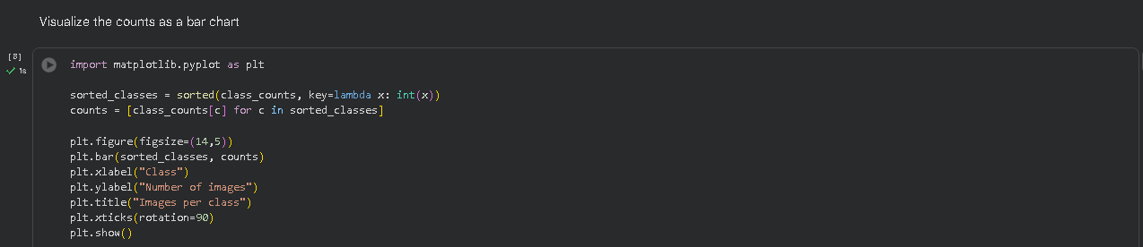
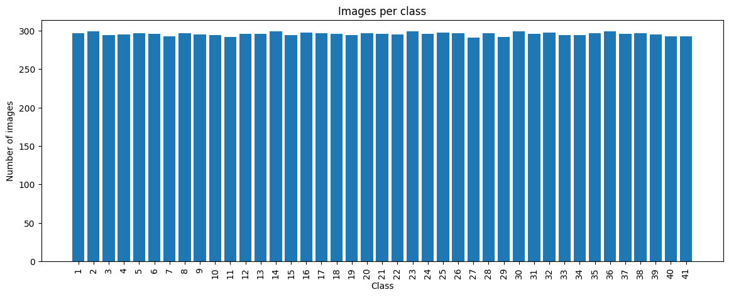
Explanation: Imports Matplotlib and prepares the class labels and corresponding image counts from the dataset. A bar chart is created to visually represent the number of images available in each class, confirming the dataset is close to perfectly balanced across all 41 classes.
8. Visualizing Sample Images from Different Classes
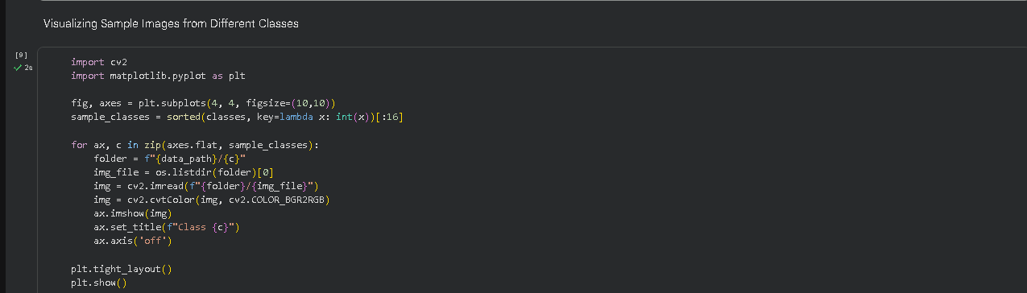
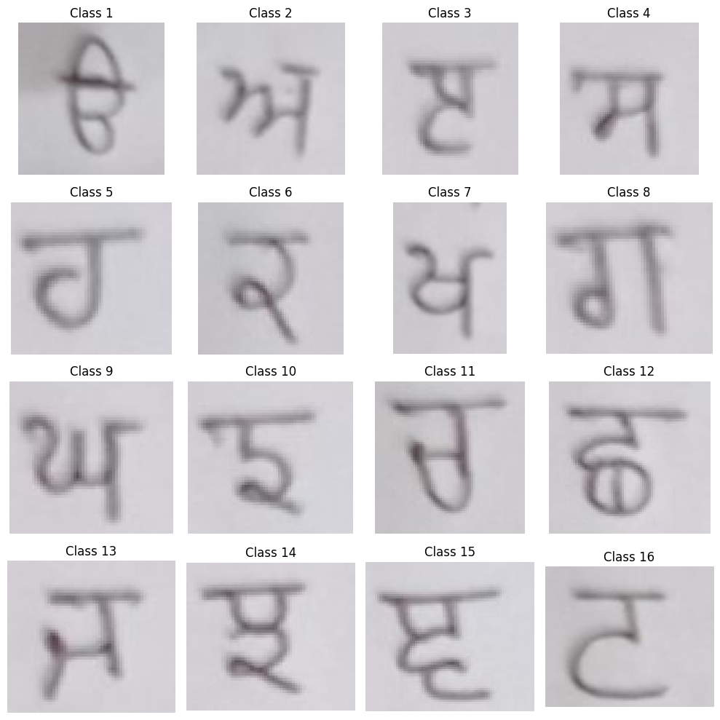
Explanation: Imports OpenCV and Matplotlib to load and display sample images from the dataset. The code selects the first 16 classes and retrieves one image from each, converts it from BGR to RGB format for correct display, and arranges the images in a 4×4 grid labeled by class. This provides a visual overview of the handwritten characters present in different classes.
9. Checking Sample Image Dimensions
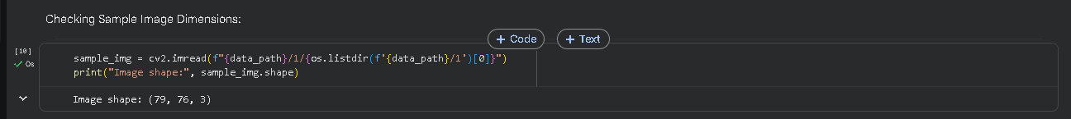
Explanation: Loads a sample image from Class 1 using OpenCV and checks its dimensions using the shape attribute. The output shows the images in this dataset are not uniformly sized (e.g. 79×76×3 for this sample), confirming that a consistent resizing step is required before the images can be used for feature extraction and model training.

10. Image Preprocessing and Visualization
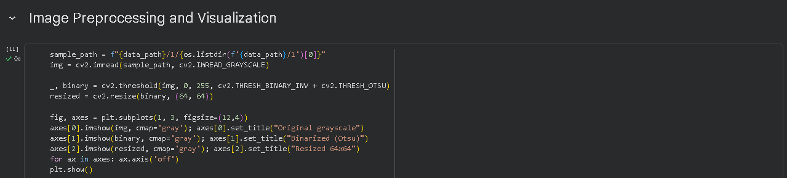
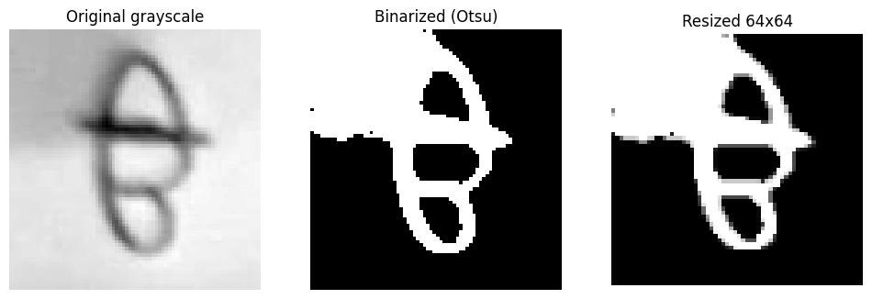
Explanation: Loads a sample image in grayscale format and applies the preprocessing pipeline to it. First, Otsu's thresholding method converts the grayscale image into a binary image, separating the handwritten character strokes from the background. The binary image is then resized to 64×64 pixels to provide a consistent input size. The original grayscale, binarized, and resized versions are displayed side by side to visualize each preprocessing stage.
11. Preprocessing and Loading the Complete Dataset
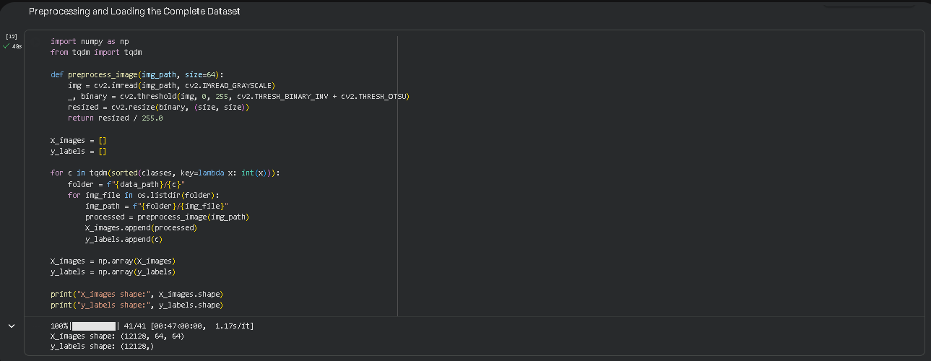
Explanation: Defines a preprocess_image() function that converts each image to grayscale, applies Otsu's thresholding, resizes it to 64×64 pixels, and normalizes the pixel values between 0 and 1. The code then loops through all 41 classes and every image within them, applying this preprocessing and storing the results in X_images with corresponding labels in y_labels. The final arrays are converted to NumPy arrays with shapes (12128, 64, 64) and (12128,) respectively, confirming all images were processed successfully.

12. Saving the Preprocessed Dataset
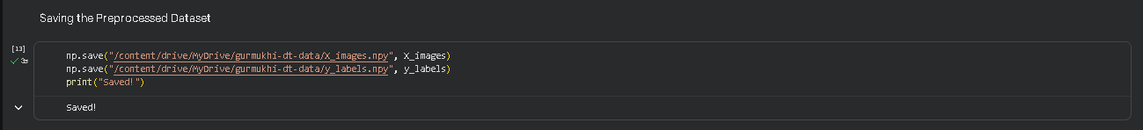
Explanation: Uses NumPy's save() function to store the preprocessed image array and corresponding labels as .npy files (X_images.npy and y_labels.npy) on Google Drive, so the preprocessing step does not need to be repeated in future sessions.
13. Loading the Preprocessed Dataset
Explanation: Loads the previously saved preprocessed image data and labels back from Google Drive using NumPy's load() function, allowing the project to continue from this point without re-running the preprocessing pipeline.
14. Extracting HOG Features from Images
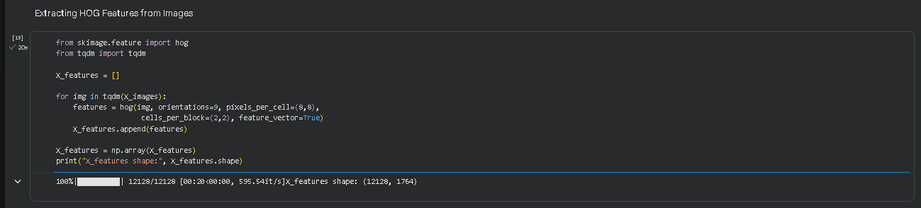
Explanation: Imports the Histogram of Oriented Gradients (HOG) feature extraction technique from scikit-image. The code loops through all preprocessed images and extracts HOG features based on the gradient direction and local shape information of each handwritten character, using 9 orientation bins, 8×8 pixel cells, and 2×2 cell blocks. The resulting feature array has shape (12128, 1764), giving every image a fixed-length numeric feature vector suitable for training a classifier.
15. Saving the Extracted HOG Features
Explanation: Uses NumPy's save() function to store the extracted HOG features in a .npy file (X_features.npy) on Google Drive, allowing them to be reused later for model training without repeating the feature extraction step.

16. Splitting the Dataset
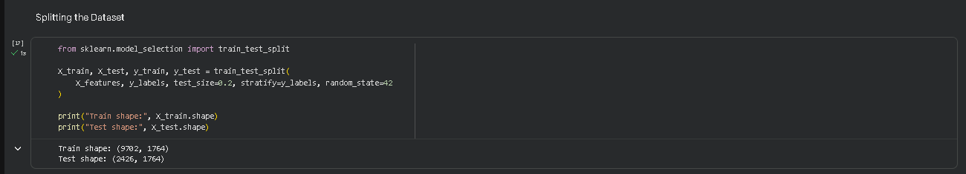
Explanation: Imports train_test_split from scikit-learn and divides the extracted HOG features and their labels into 80% training data and 20% testing data using stratified splitting, preserving the class distribution in both sets. Unlike the SVM approach, no feature scaling (StandardScaler) is applied here, since Decision Trees split on raw threshold values feature-by-feature and do not require normalized input.
17. Training the Decision Tree Classification Model
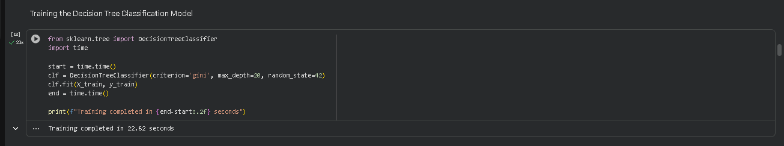
Explanation: Imports DecisionTreeClassifier from scikit-learn and the time module to measure training duration. A tree is initialized with the gini criterion and max_depth capped at 20 (as an initial, deliberately conservative starting point to limit overfitting) and trained on the training data. Training completed in just 22.62 seconds — considerably faster than an SVM's iterative margin optimization on the same data, since a Decision Tree builds its structure through a single greedy pass of feature splits.
18. Evaluating the Decision Tree Model
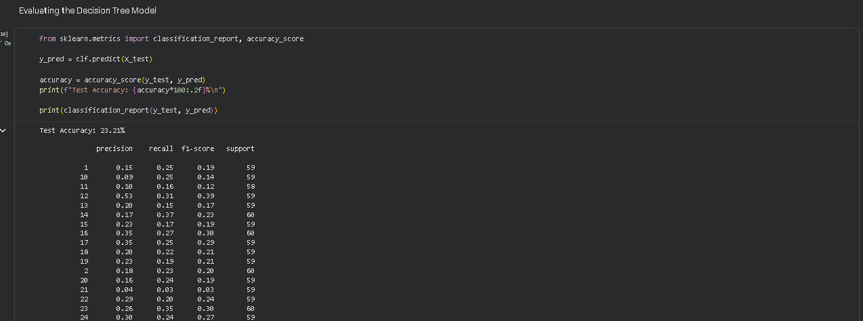

Explanation: Imports evaluation metrics from scikit-learn to assess the trained model on the held-out test set. The model predicts labels for the test data, and classification_report() reports precision, recall, and F1-score for every class. This initial (untuned) model achieved a Test Accuracy of only 23.21%, prompting further diagnosis in the following steps.
19. Generating the Confusion Matrix
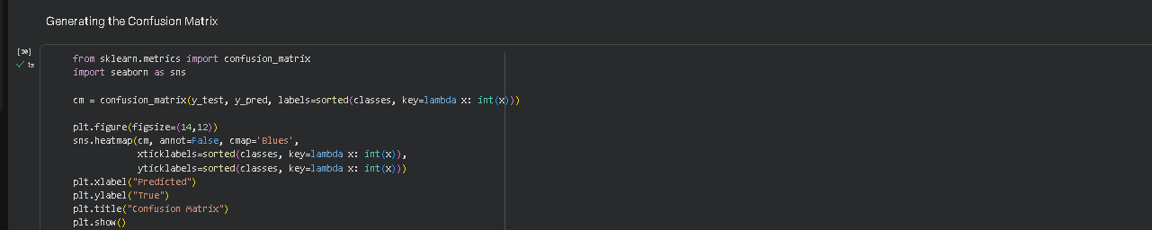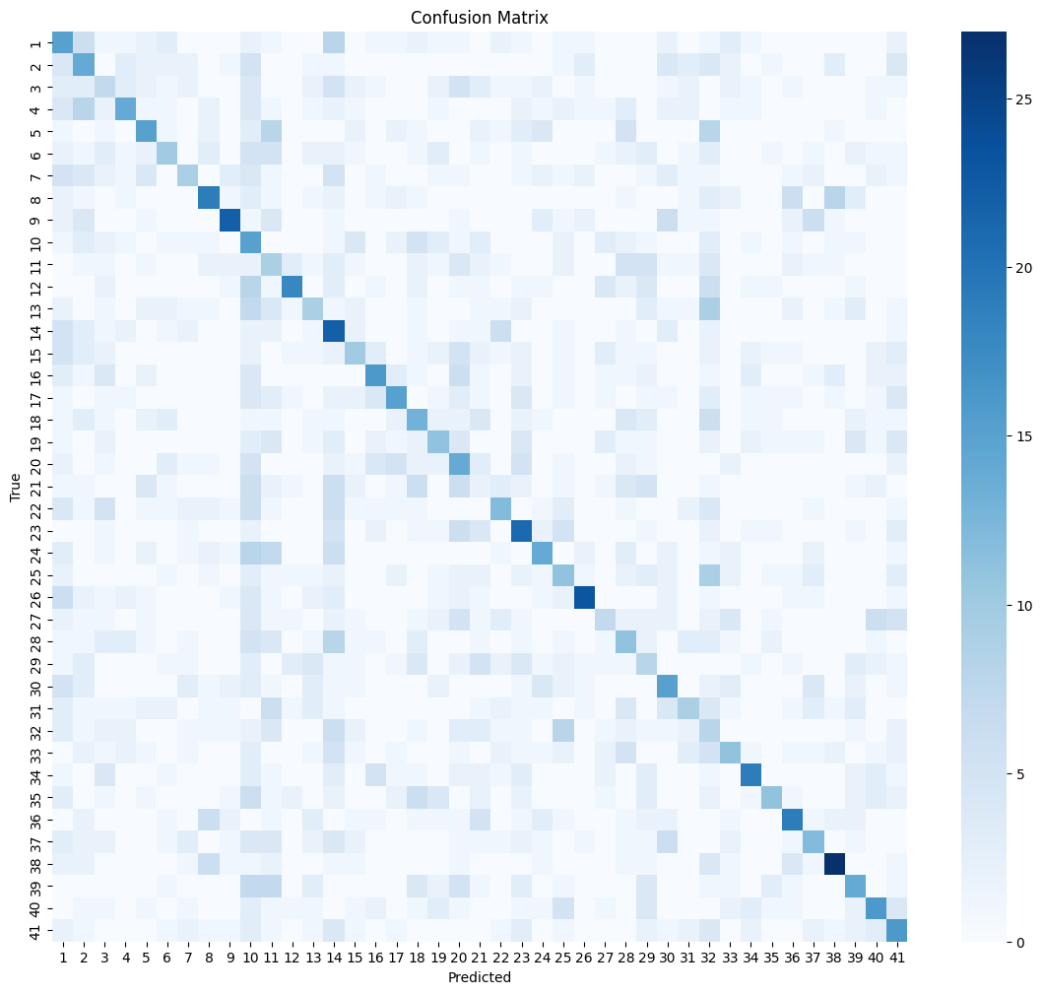
Explanation: Imports confusion_matrix from scikit-learn and Seaborn to visualize classification results as a heatmap, with predicted classes on the x-axis and true classes on the y-axis. Unlike a cleanly diagonal matrix, this heatmap shows confusion scattered fairly broadly across many class pairs rather than concentrated in a few visually similar characters, suggesting the untuned tree is struggling generally rather than confusing a small number of specific look-alike characters.

20. Checking for Overfitting/Underfitting
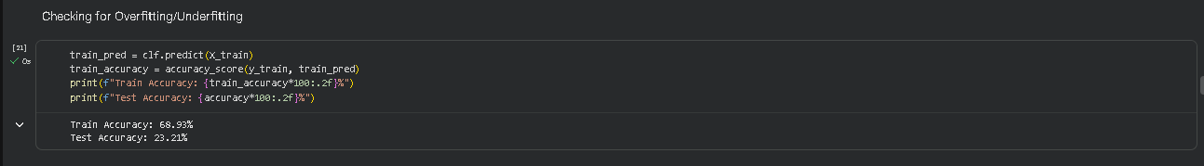
Explanation: Compares the model's accuracy on the training set against its accuracy on the test set. The result — Train Accuracy: 68.93% vs Test Accuracy: 23.21% — reveals a substantial gap even at a modest depth of 20, indicating the tree is already overfitting to the training data rather than learning patterns that generalize to unseen samples.
21. Retraining Without Depth Restriction
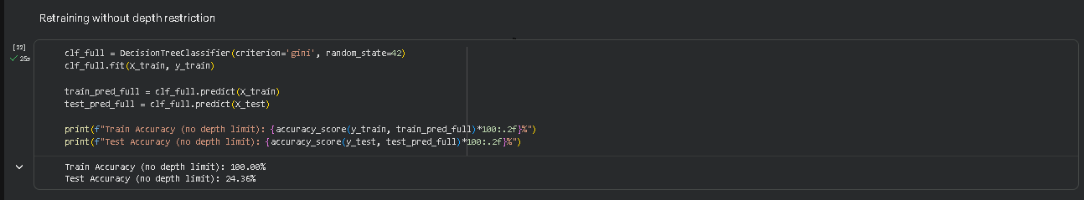
Explanation: Trains a second Decision Tree with no depth limit at all, to observe the model's natural ceiling. The result — Train Accuracy: 100.00% but Test Accuracy: 24.36% — confirms that removing the depth cap simply lets the tree memorize the entire training set, with almost no corresponding improvement on unseen data. This establishes that the overfitting is a structural property of a single Decision Tree on this high-dimensional feature space, not something an arbitrary depth setting alone can fix.
22. Hyperparameter Tuning via GridSearchCV
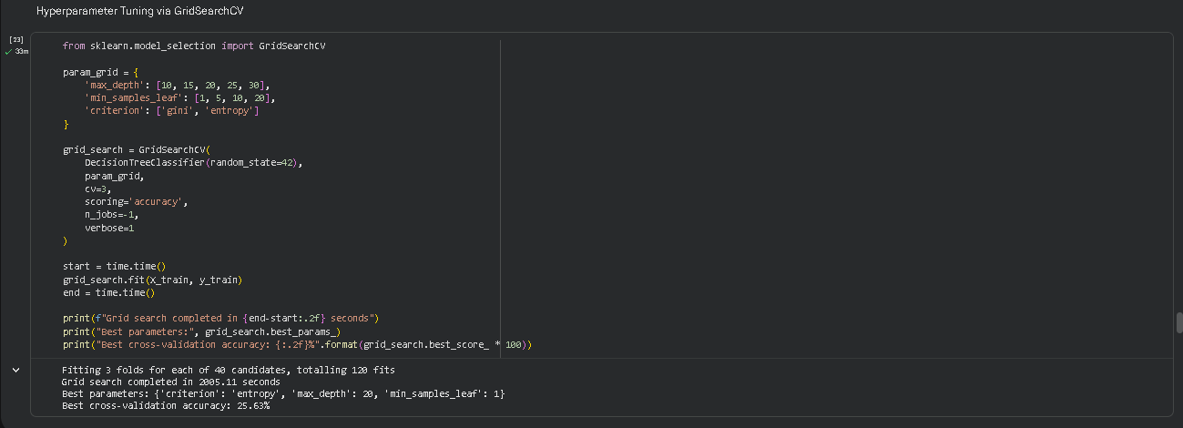
Explanation: Imports GridSearchCV from scikit-learn to systematically search across combinations of max_depth ([10, 15, 20, 25, 30]), min_samples_leaf ([1, 5, 10, 20]), and split criterion (gini, entropy) using 3-fold cross-validation — 40 combinations × 3 folds = 120 total model fits. The search identified criterion='entropy', max_depth=20, min_samples_leaf=1 as the best-performing combination, with a best cross-validation accuracy of 25.63%.

23. Training Final Model with Best Parameters
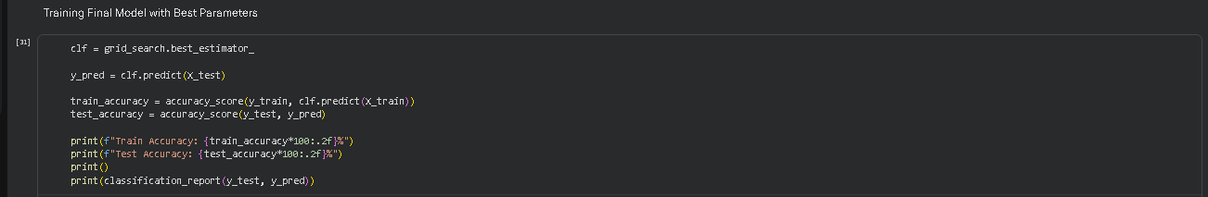
Explanation: Retrieves the best estimator found by GridSearchCV and evaluates it on the test set. The tuned model reached a Test Accuracy of 61.17% with a macro-averaged F1-score of 0.31 — an improvement over the original untuned tree, though the training accuracy of 100.00% shows the train/test gap persists even in the best combination the search could find, reinforcing that this is a genuine limitation of a single Decision Tree on this feature representation rather than a hyperparameter mismatch.
24. Confusion Matrix (Tuned Decision Tree)
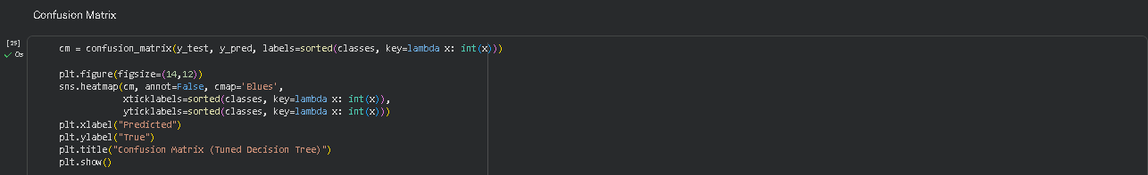
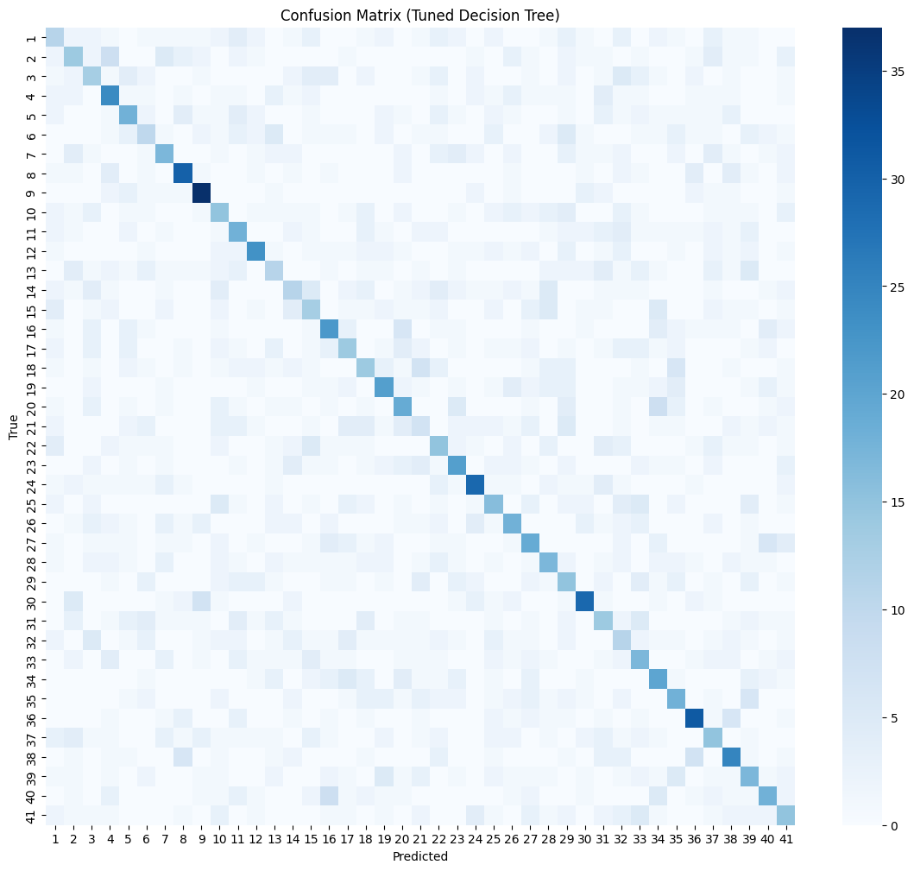
Explanation: Re-generates the confusion matrix heatmap using the tuned model's predictions. The diagonal is somewhat stronger than in the untuned version, but confusion remains diffuse across many class pairs rather than concentrated into a small number of visually similar characters — a pattern quite different from what a margin-based classifier like SVM typically produces on the same data.
25. Initializing the Git Repository

26. Staging the Project Files
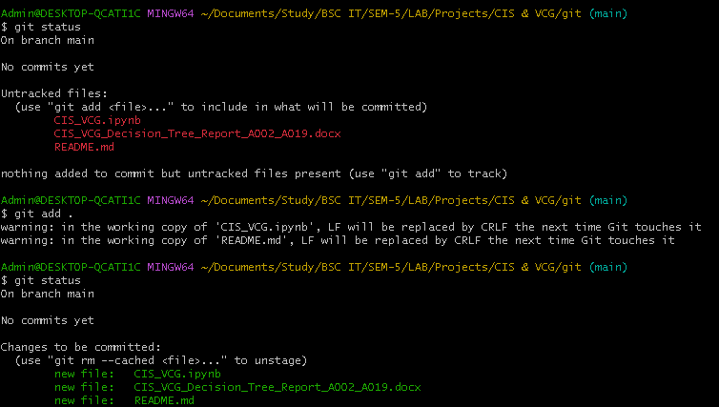
27. Committing the Initial Version
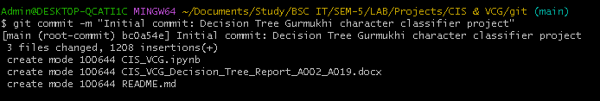
28. Creating a Public GitHub Repository
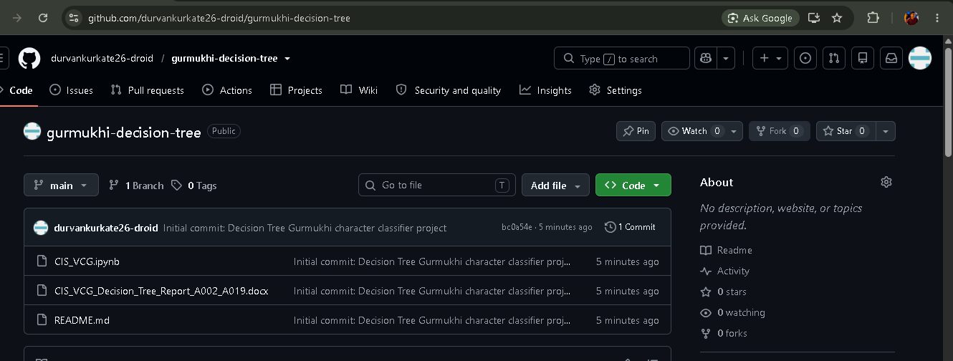

29. Linking the Local Repository to GitHub
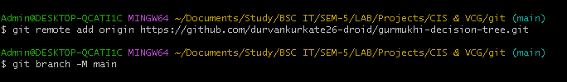
30. Pushing the Project to GitHub
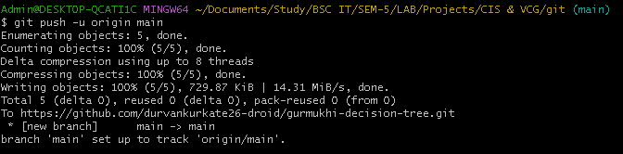

Performance:
1. Model Performance Overview
The tuned Decision Tree classifier (entropy criterion, max_depth=20, min_samples_leaf=1, selected via 3-fold GridSearchCV across 40 parameter combinations), trained on the same 1764-dimensional HOG feature space used throughout the project, achieves a test accuracy of 61.17% across all 41 Gurmukhi handwritten character classes, with a macro-averaged F1-score of 0.31. Despite reaching 100% accuracy on the training set, performance drops sharply on unseen data — a textbook overfitting signature for single decision trees operating on high-dimensional, continuous feature vectors. Unlike a margin-based classifier, a single tree makes axis-aligned splits one feature at a time, which struggles to carve stable, generalizable decision regions when features are numerous and correlated, as HOG features typically are.
2. Overfitting Behaviour and Diagnostic Findings
Before tuning, a tree capped at depth 20 already showed a wide gap between training accuracy (68.93%) and test accuracy (23.21%). Removing the depth restriction entirely pushed training accuracy to a perfect 100.00%, yet test accuracy barely moved (24.36%), confirming that additional depth was purely memorizing individual training samples rather than learning generalizable rules. Systematic hyperparameter tuning via GridSearchCV (varying max_depth, min_samples_leaf, and split criterion) selected max_depth=20, min_samples_leaf=1 with the entropy criterion as the best of 40 combinations tested — improving test accuracy to 61.17%, though the train/test gap (100% vs ≈31%) remained wide. This points to a structural limitation of a single decision tree on this feature representation, rather than a fixable hyperparameter mismatch.
3. Most and Least Reliably Classified Characters
Per-class F1-scores from the tuned model varied considerably. Class 9 was the strongest performer (F1 = 0.60), followed by Class 36 (0.52), Classes 24 and 30 (0.50 each), and Class 8 (0.50). At the other end, Class 21 was the weakest (F1 = 0.13), followed by Class 32 (0.17), and Classes 1 and 6 (0.19 each). Unlike a typical SVM confusion matrix, where misclassifications tend to concentrate into a handful of visually similar character pairs, the Decision Tree's confusion matrix shows a more diffuse pattern of scattered off-diagonal errors spread across many class pairs — suggesting the tree is not cleanly separating shape-based features the way a margin-based classifier can.
4. Dataset Size and Class Balance
The dataset is close to perfectly balanced, with roughly 291–299 images per class (12,128 images total across 41 classes). This balance ensures the Decision Tree's per-class metrics are directly comparable across classes and not skewed by any dominant class.
5. Comparison with Support Vector Machine (SVM)
Against an SVM (RBF kernel, C=10, gamma='scale') trained on the identical 1764-dimensional HOG feature space in a reference project on the same dataset, the Decision Tree performs substantially worse (61.17% vs the SVM's reported test accuracy in the high 80s). This gap illustrates a well-known trade-off: Decision Trees train far faster (22.62 seconds here) and require no feature scaling, but their axis-aligned, single-feature-at-a-time splitting struggles to model the smooth, high-dimensional decision boundaries needed to separate 41 visually similar handwritten character classes. An SVM's kernel trick allows it to combine information across all 1764 features simultaneously when drawing its decision boundary, which a single tree structurally cannot replicate — making SVM the clearly stronger choice for this specific classification task, while the Decision Tree remains valuable for its speed, interpretability, and lack of preprocessing requirements.

