31139 – Durvesh – CNLB2

**Writeup**

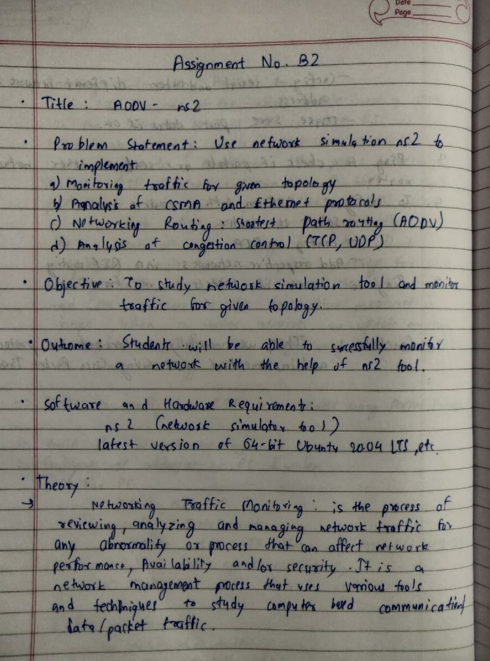

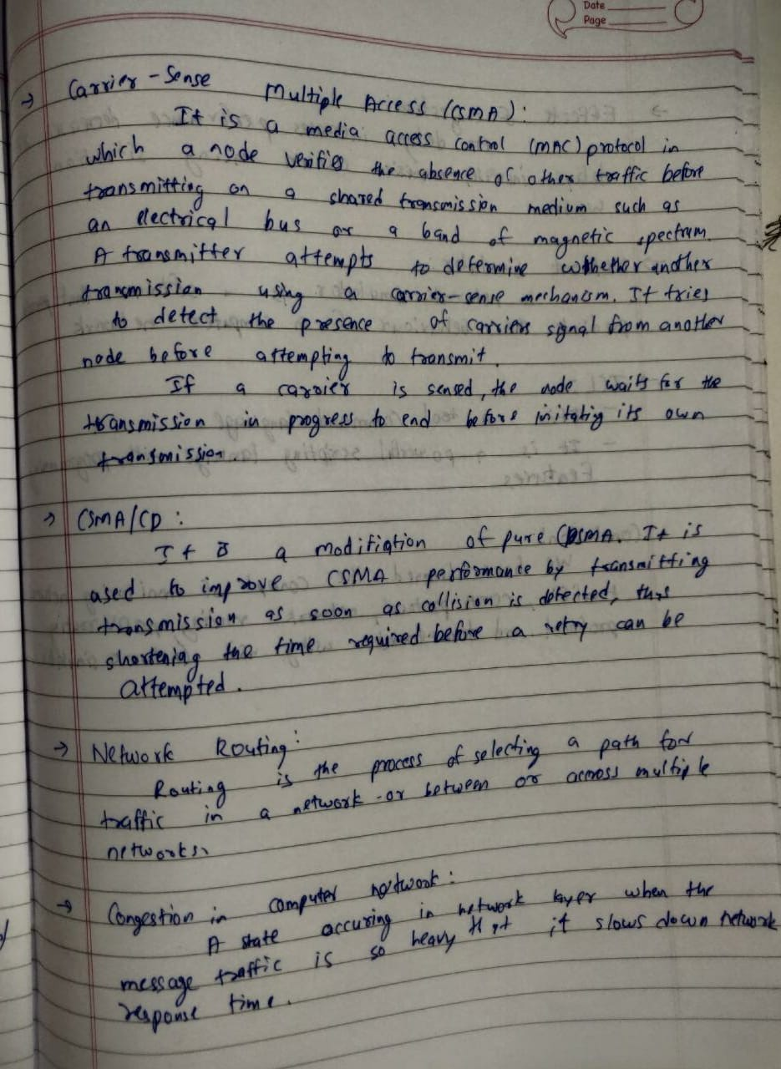

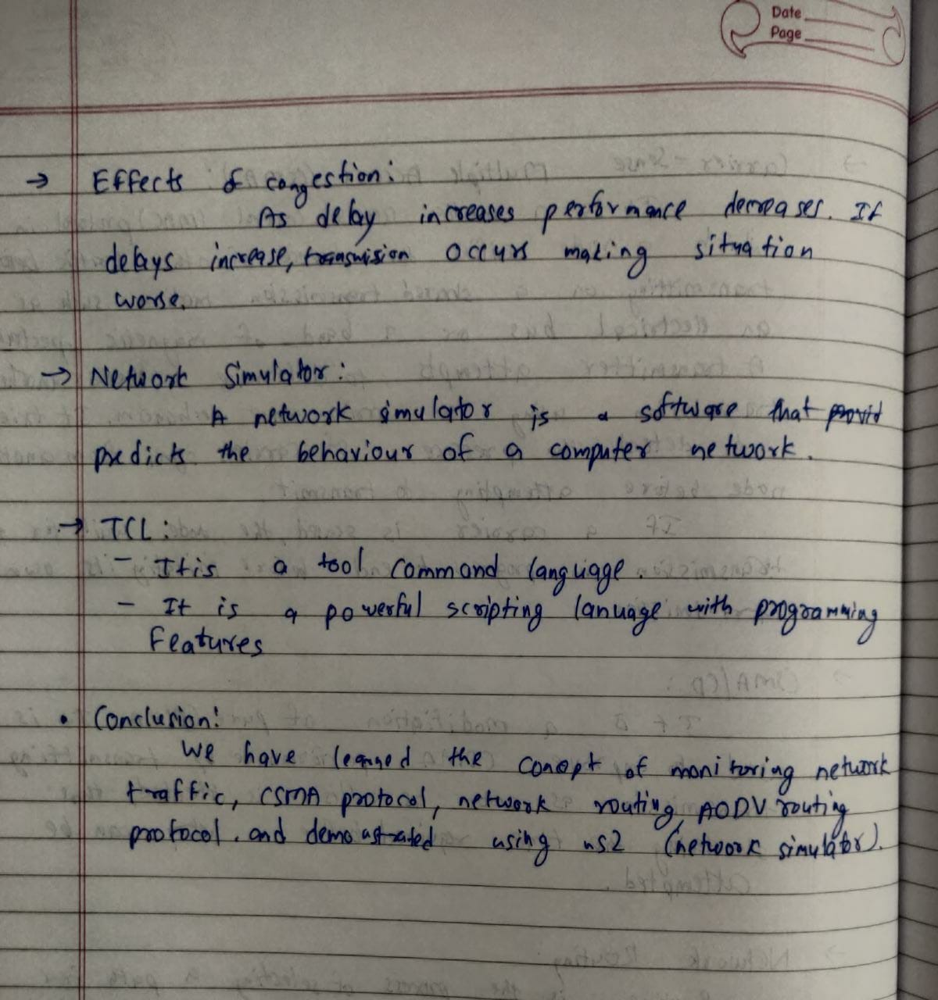

**Sample Code**

-------------b2.tcl--------------

set ns [new Simulator]

$ns color 1 Blue

$ns color 2 Red

set nf [open b2.nam w]

$ns namtrace-all $nf

set nt [open b2.tr w]

$ns trace-all $nt

$ns use-newtrace

proc finish {} {

global ns nf nt

$ns flush-trace

close $nf

close $nt

exec nam b2.nam &

exec awk -f cnlb2.awk b2.tr &

exit 0

}

set n0 [$ns node]

set n1 [$ns node]

set n2 [$ns node]

set n3 [$ns node]

set n4 [$ns node]

set n5 [$ns node]

$ns duplex-link $n0 $n2 10Mbps 10ms DropTail

$ns duplex-link $n1 $n2 10Mbps 10ms DropTail

$ns duplex-link $n2 $n3 10Mbps 10ms DropTail

$ns duplex-link $n3 $n4 10Mbps 10ms DropTail

$ns duplex-link $n3 $n5 10Mbps 10ms DropTail

$ns duplex-link-op $n0 $n2 orient down-right

$ns duplex-link-op $n1 $n2 orient up-right

$ns duplex-link-op $n2 $n3 orient right

$ns duplex-link-op $n3 $n4 orient right-up

$ns duplex-link-op $n3 $n5 orient right-down

set tcp [new Agent/TCP]

$tcp set class_ 2

$ns attach-agent $n0 $tcp

set sink [new Agent/TCPSink]

$ns attach-agent $n4 $sink

$ns connect $tcp $sink

$tcp set fid_ 1

set ftp [new Application/FTP]

$ftp attach-agent $tcp

$ftp set type_ FTP

$ftp set packet_size_ 1000

$ftp set rate_ 1mb

set udp [new Agent/UDP]

$ns attach-agent $n1 $udp

set null [new Agent/Null]

$ns attach-agent $n5 $null

$ns connect $udp $null

$udp set fid_ 2

set cbr [new Application/Traffic/CBR]

$cbr attach-agent $udp

$cbr set type_ CBR

$cbr set packet_size_ 1000

$cbr set rate_ 1mb

$ns at 1.0 "$ftp start"

$ns at 3.0 "$ftp stop"

$ns at 1.5 "$cbr start"

$ns at 3.5 "$cbr stop"

$ns at 5.0 "finish"

$ns run

--------------cnlb2.awk---------------

BEGIN{

sentPkts = 0

recvPkts = 0

forwardedPkts = 0

stime = 0

ftime = 0

flag = 0

fsize = 0

throughput = 0

latency = 0

sentPkts1 = 0

recvPkts1 = 0

forwardedPkts1 = 0

stime1 = 0

ftime1 = 0

flag1 = 0

fsize1 = 0

throughput1 = 0

latency1 = 0

}

{

if($1=="r" && $4==4)

{

fsize+=$6

if(flag==0)

{

stime = $2

flag = 1

}

ftime = $2

}

if($1=="r" && $4==5)

{

fsize1+=$6

if(flag1==0)

{

stime1 = $2

flag1 = 1

}

ftime1 = $2

}

if($1=="s")

{

sentPkts++;

}

if($1=="r")

{

recvPkts++;

}

if($1=="s")

{

forwardedPkts++;

printf("\nF P = %f", forwardedPkts);

}

}

END{

latency = ftime-stime

throughput = (fsize*8)/latency

latency1 = ftime1-stime1

throughput1 = (fsize1*8)/latency1

printf("\nSent Packets = %d", sentPkts)

printf("\nReceived Packets = %d", recvPkts)

printf("\nForwarded Packets = %d", forwardedPkts)

printf("\n\nLatency of TCP = %f", latency)

printf("\nThroughput of TCP = %f", throughput)

printf("\n\nLatency of UDP = %f", latency1)

printf("\nThroughput of UDP = %f", throughput1)

}

**Output**

