// Author: Durvesh Malpure 31139

// DBMSL Assignment 3

The tables:

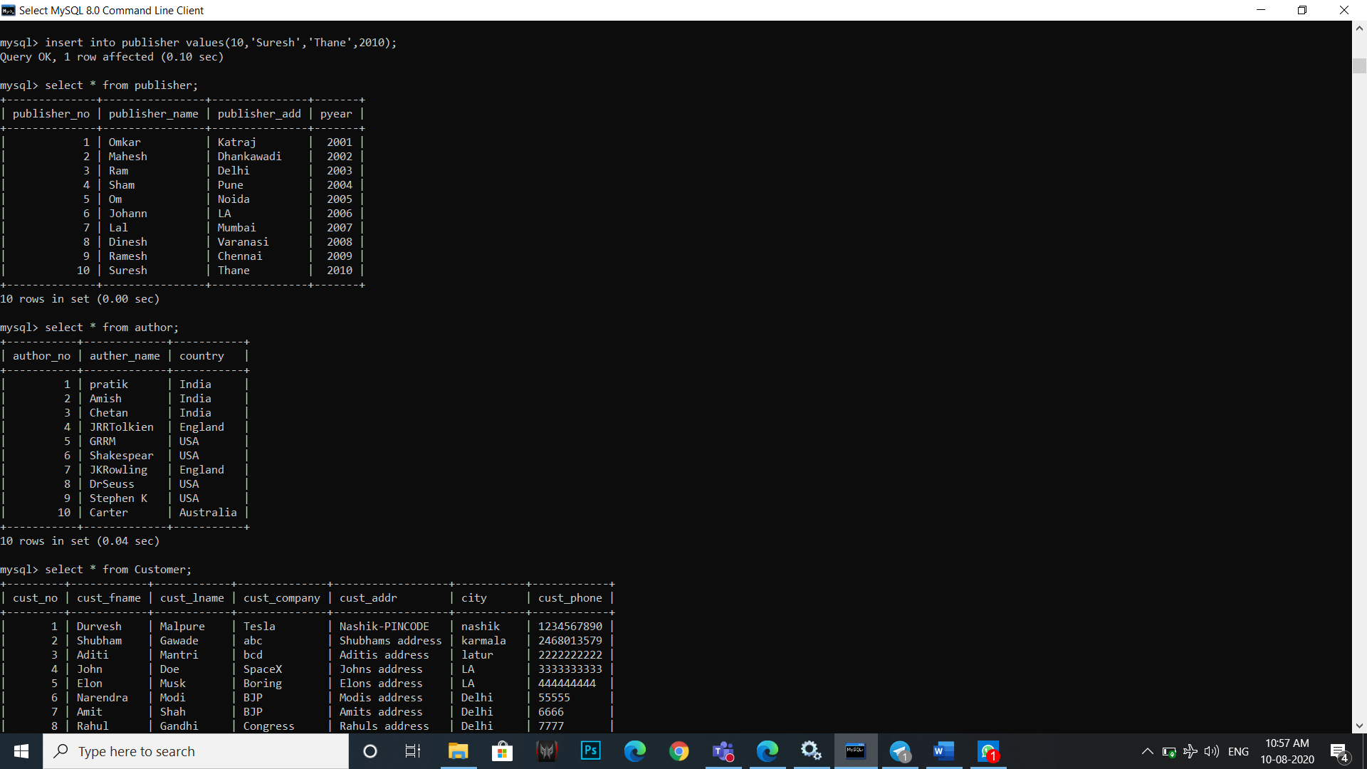

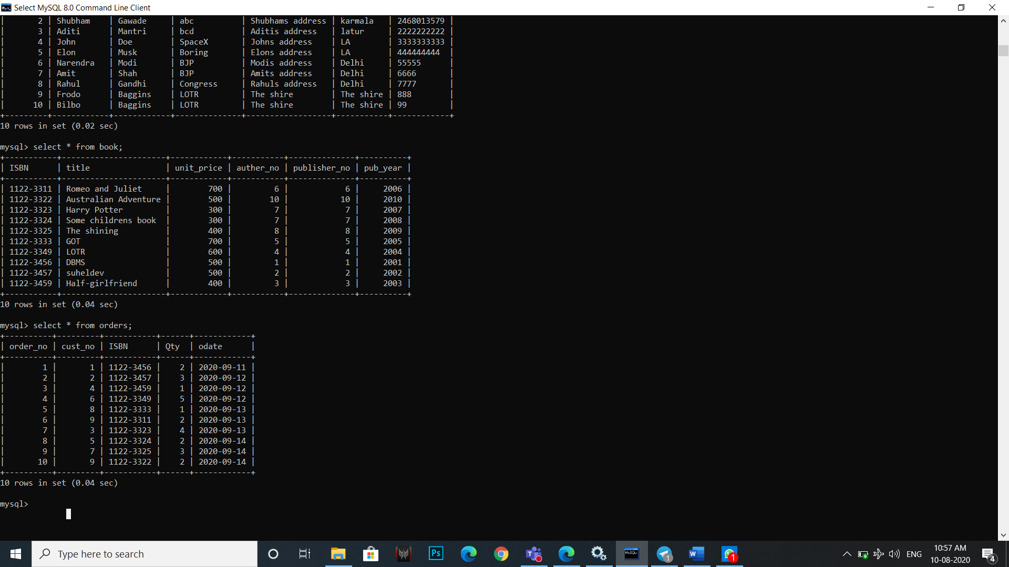

Queries:

mysql> select * from Customer where city='Pune' or city='Mumbai' or cust_fname like 'p%' or cust_fname like 'h%';

+---------+------------+------------+--------------+----------------+-----------+------------+

| cust_no | cust_fname | cust_lname | cust_company | cust_addr | city | cust_phone |

+---------+------------+------------+--------------+----------------+-----------+------------+

| 2 | Ram | Kumar | Sham | Pune | Pune | 8787 |

| 3 | Aditi | Mantri | bcd | Aditis address | Mumbai | 2222222222 |

| 4 | Sham | Kulkarni | Ram | Pune | Pune | 55551 |

| 5 | Phineas | Musk | Boring | Elons address | Mumbai | 444444444 |

| 9 | Henry | Baggins | LOTR | The shire | The shire | 888 |

| 10 | Hector | Baggins | LOTR | The shire | The shire | 99 |

+---------+------------+------------+--------------+----------------+-----------+------------+

6 rows in set (0.08 sec)

mysql> select distinct city from Customer;

+-----------+

| city |

+-----------+

| Nashik |

| Pune |

| Mumbai |

| Delhi |

| The shire |

+-----------+

5 rows in set (0.00 sec)

mysql> update book set unit_price=unit_price*1.05 where pub_year=2015;

Query OK, 2 rows affected (0.14 sec)

Rows matched: 2 Changed: 2 Warnings: 0

mysql> delete from customer where city='Pune';

Query OK, 2 rows affected (0.38 sec)

mysql> select author_name from author where country='India'

-> -> union

-> -> union^C

mysql> select author_name from author where country='India'

-> union

-> select author_name from author where country='Australia';

+-------------+

| author_name |

+-------------+

| pratik |

| Amish |

| Chetan |

| Carter |

+-------------+

4 rows in set (0.06 sec)

mysql> select * from publisher where pyear in (2015,2016);

+--------------+----------------+---------------+-------+

| publisher_no | publisher_name | publisher_add | pyear |

+--------------+----------------+---------------+-------+

| 4 | Sham | Pune | 2015 |

| 5 | Om | Noida | 2016 |

+--------------+----------------+---------------+-------+

2 rows in set (0.03 sec)

mysql> select *,max(unit_price) from book;

+-----------+------------------+------------+-----------+--------------+----------+-----------------+

| ISBN | title | unit_price | author_no | publisher_no | pub_year | max(unit_price) |

+-----------+------------------+------------+-----------+--------------+----------+-----------------+

| 1122-3311 | Romeo and Juliet | 700 | 6 | 6 | 2006 | 700 |

+-----------+------------------+------------+-----------+--------------+----------+-----------------+

1 row in set (0.09 sec)

mysql> select * from book where unit_price between 300 and 400;

+-----------+---------------------+------------+-----------+--------------+----------+

| ISBN | title | unit_price | author_no | publisher_no | pub_year |

+-----------+---------------------+------------+-----------+--------------+----------+

| 1122-3323 | Harry Potter | 300 | 7 | 7 | 2007 |

| 1122-3324 | Some childrens book | 386 | 8 | 8 | 2015 |

| 1122-3325 | The shining | 400 | 9 | 9 | 2000 |

| 1122-3459 | Half-girlfriend | 375 | 3 | 3 | 2004 |

+-----------+---------------------+------------+-----------+--------------+----------+

4 rows in set (0.01 sec)

mysql> select title,unit_price,pub_year from book order by pub_year desc;

+----------------------+------------+----------+

| title | unit_price | pub_year |

+----------------------+------------+----------+

| DBMS | 500 | 2018 |

| LOTR | 600 | 2017 |

| GOT | 700 | 2016 |

| Australian Adventure | 551 | 2015 |

| Some childrens book | 386 | 2015 |

| Harry Potter | 300 | 2007 |

| Romeo and Juliet | 700 | 2006 |

| Half-girlfriend | 375 | 2004 |

| suheldev | 500 | 2002 |

| The shining | 400 | 2000 |

+----------------------+------------+----------+

10 rows in set (0.00 sec)

mysql> select title,author_no,publisher_no from book where pub_year in (2000,2004,2006);

+------------------+-----------+--------------+

| title | author_no | publisher_no |

+------------------+-----------+--------------+

| Romeo and Juliet | 6 | 6 |

| The shining | 9 | 9 |

| Half-girlfriend | 3 | 3 |

+------------------+-----------+--------------+

3 rows in set (0.00 sec)