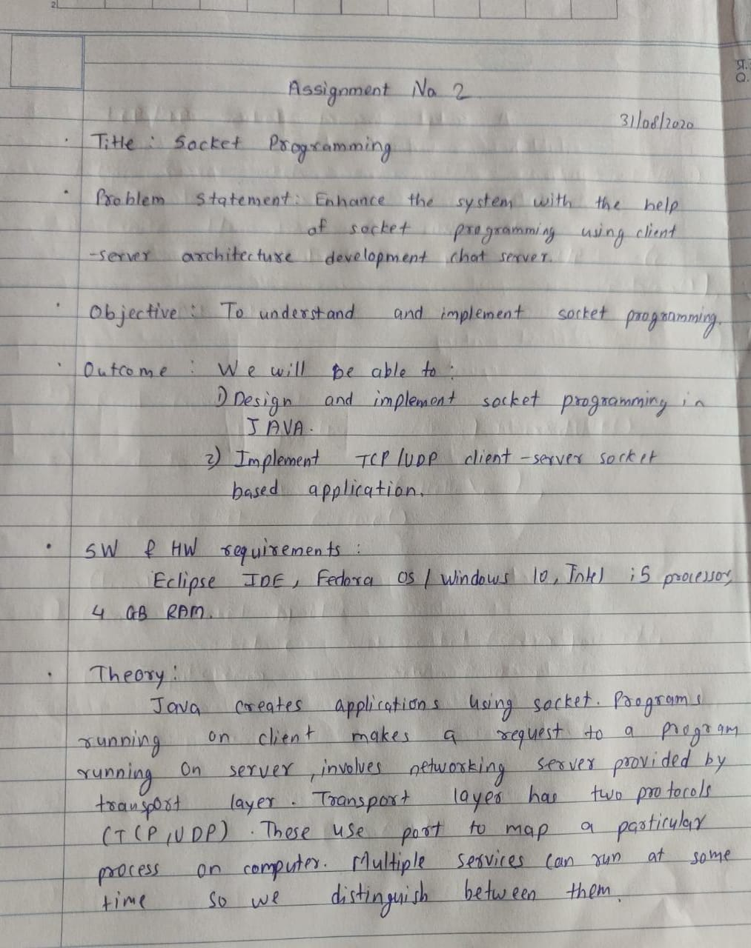

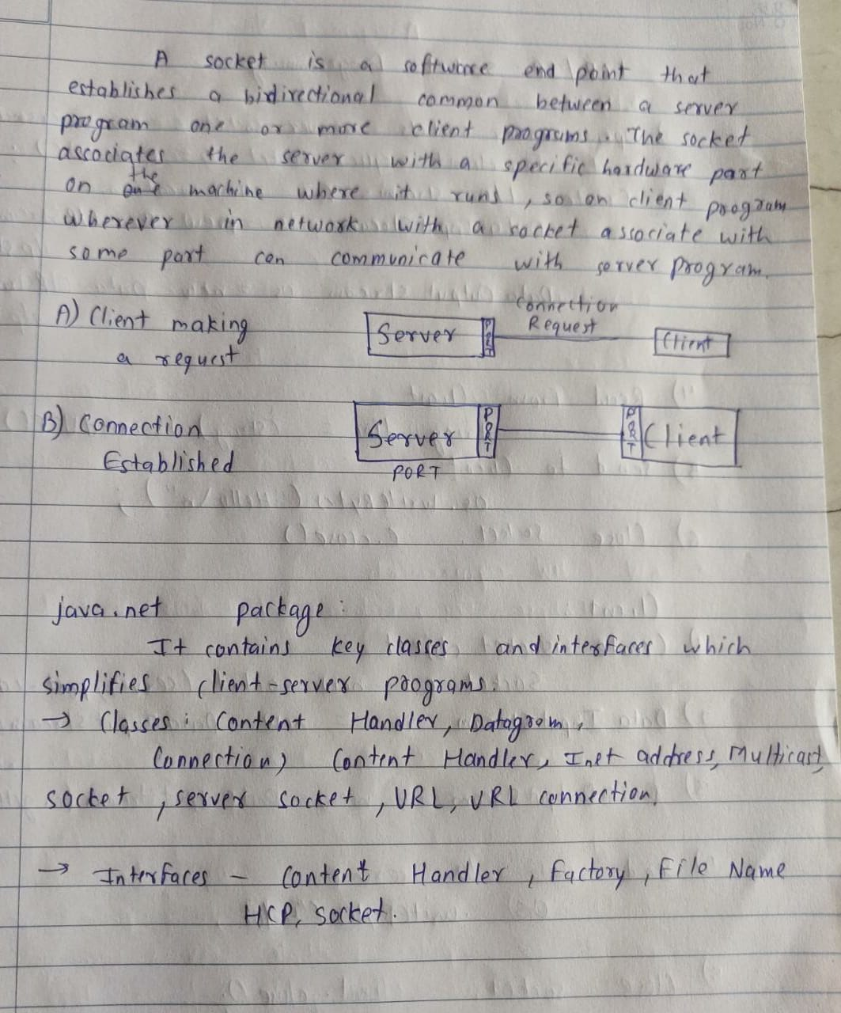

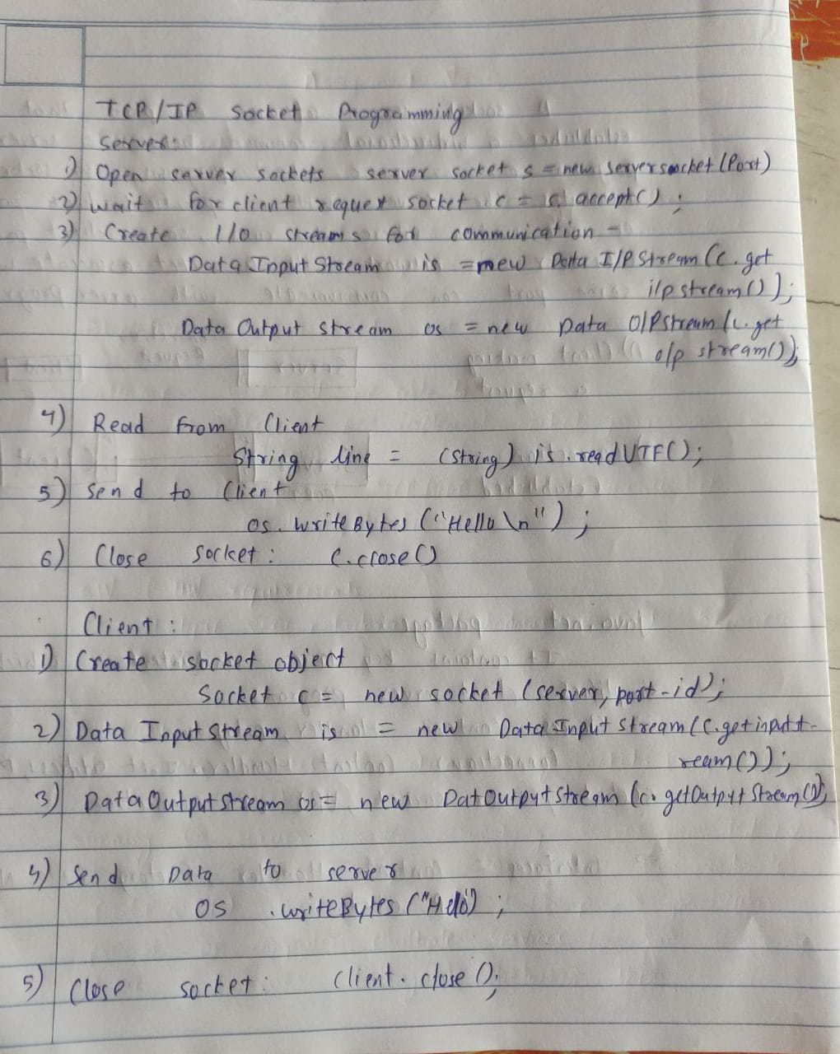

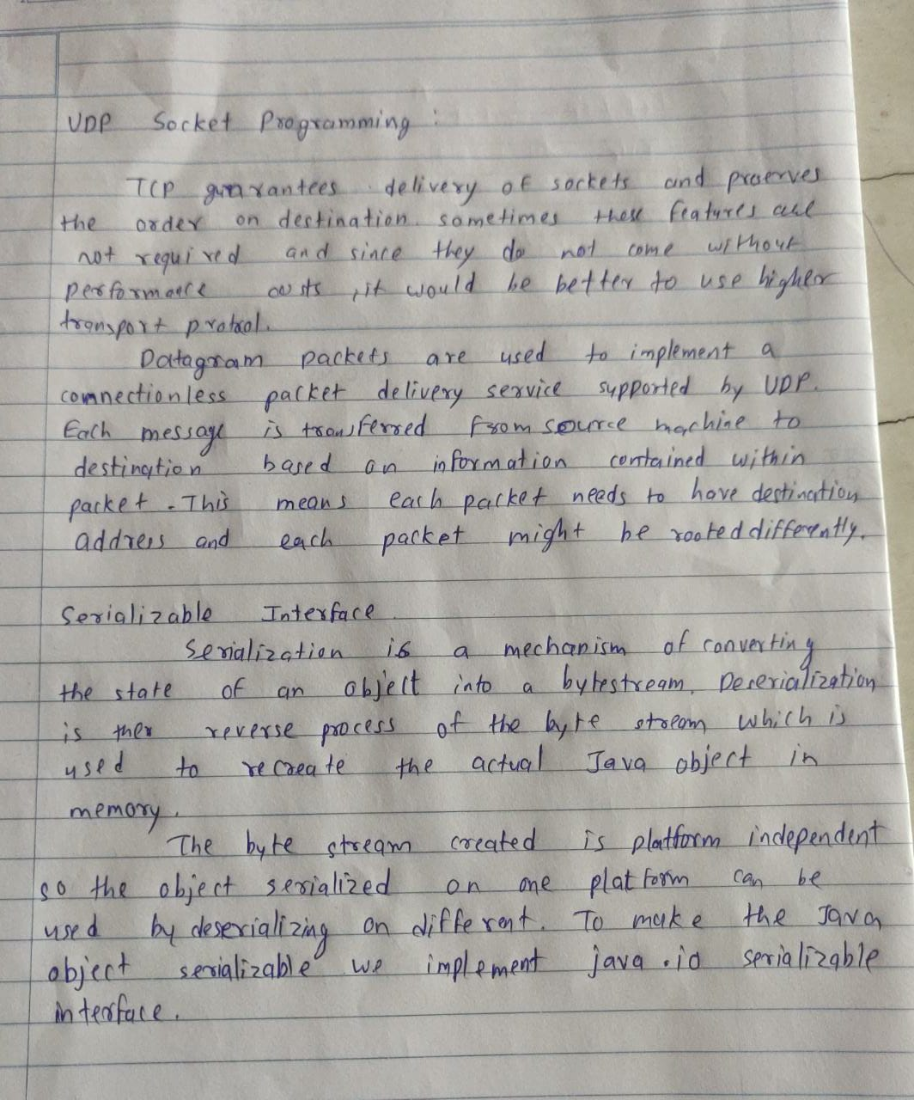

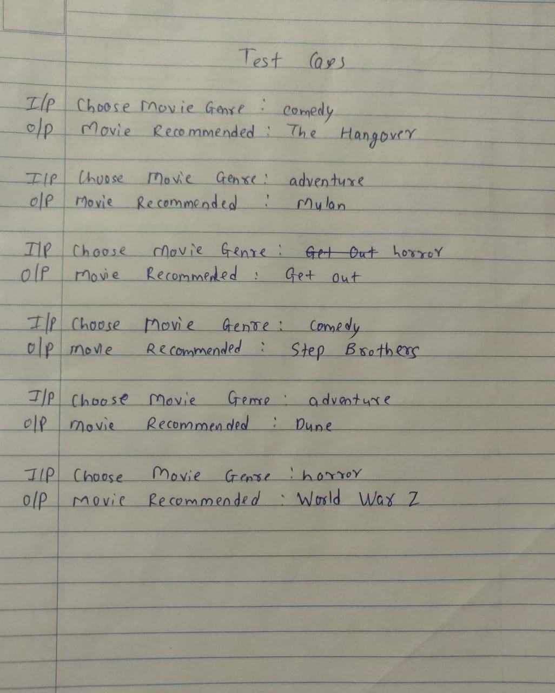

Server.java

import java.io.\*;

import java.net.\*;

import java.util.\*;

class Server {

// public static void CheckOutServer() throws Exception {

public static void main(String args[]) throws Exception {

Random rand = new Random();

ArrayList<String> comedy= new ArrayList<String>();

ArrayList<String> adventure= new ArrayList<String>();

ArrayList<String> horror= new ArrayList<String>();

horror.add("A quiet place");

horror.add("Get out");

horror.add("Alien");

horror.add("World War Z");

adventure.add("Mulan");

adventure.add("The Old Guard");

adventure.add("Dune");

adventure.add("Wonder Woman 1984");

comedy.add("Step Brothers");

comedy.add("White Chicks");

comedy.add("The Hot chick");

comedy.add("The Hangover");

System.out.println("S : Server started ");

// Create server Socket

ServerSocket ss = new ServerSocket(4449);

System.out.println("S : Server waiting.. ");

// connect it to client socket

Socket s = ss.accept();

System.out.println("S : Connection established ");

// to send data to the client

PrintStream ps = new PrintStream(s.getOutputStream());

// to read data coming from the client

BufferedReader br = new BufferedReader(new InputStreamReader(s.getInputStream()));

// to read data from the keyboard

BufferedReader kb = new BufferedReader(new InputStreamReader(System.in));

//DataInputStream din = new DataInputStream(s.getInputStream());

String str, str1 = "";

str = br.readLine();

//str = din.readUTF();

System.out.println("S : Client data: "+ str);

if(str.equals("comedy"))

{ str1 = comedy.get(rand.nextInt(comedy.size()));}

else if (str.equals("adventure"))

{ str1 = adventure.get(rand.nextInt(adventure.size()));}

else if (str.equals("horror"))

{ str1 = horror.get(rand.nextInt(horror.size()));}

else{

str1 = "Enter valid choice please\n";

}

ps.println(str1);

System.out.println("S : Data sent ");

// close connection

ps.close();

br.close();

kb.close();

ss.close();

s.close();

// terminate application

System.exit(0);

}

}

Client.java

import java.io.\*;

import java.net.\*;

class Client {

public static void main(String args[]) throws Exception {

System.out.println("C : In Client ");

// Create client socket

Socket s = new Socket("localhost", 4449);

// to send data to the server

DataOutputStream dos = new DataOutputStream(s.getOutputStream());

// to read data coming from the server

BufferedReader br = new BufferedReader(new InputStreamReader(s.getInputStream()));

// to read data from the keyboard

BufferedReader kb = new BufferedReader(new InputStreamReader(System.in));

String str, str1;

System.out.println("Choose Movie Genre(Enter lowercase name):\n1.Comedy\t2.Adventure\t3.Horror");

str = kb.readLine();

System.out.println("Genre Chosen");

dos.writeBytes(str + "\n");

// receive from the server

str1 = br.readLine();

System.out.println("C : Movie recommended: " + str1);

// close connection

dos.close();

br.close();

kb.close();

s.close();

}

}

