1. a script that creates a new directory, then creates three empty files inside it, and finally lists the contents of the directory.

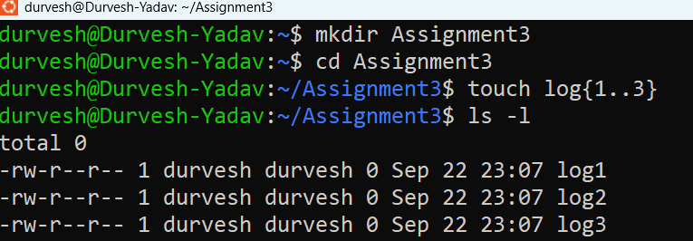

1. Create a script that prompts the user for a filename, then checks if the file exists and whether it is a regular file or a directory.

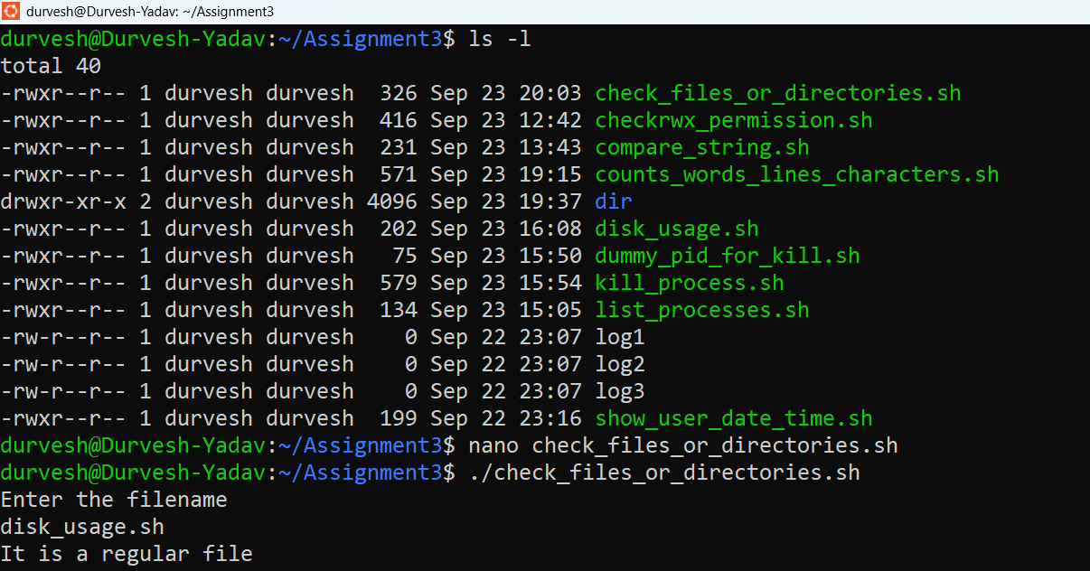

Nano Editor

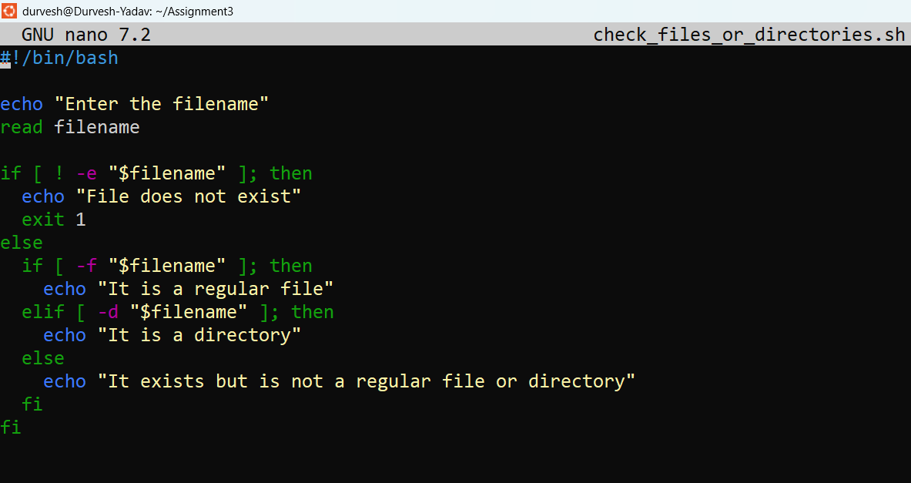

1. Write a script to copy a file from a source path to a destination path provided as arguments. Handle cases where source or destination are invalid.

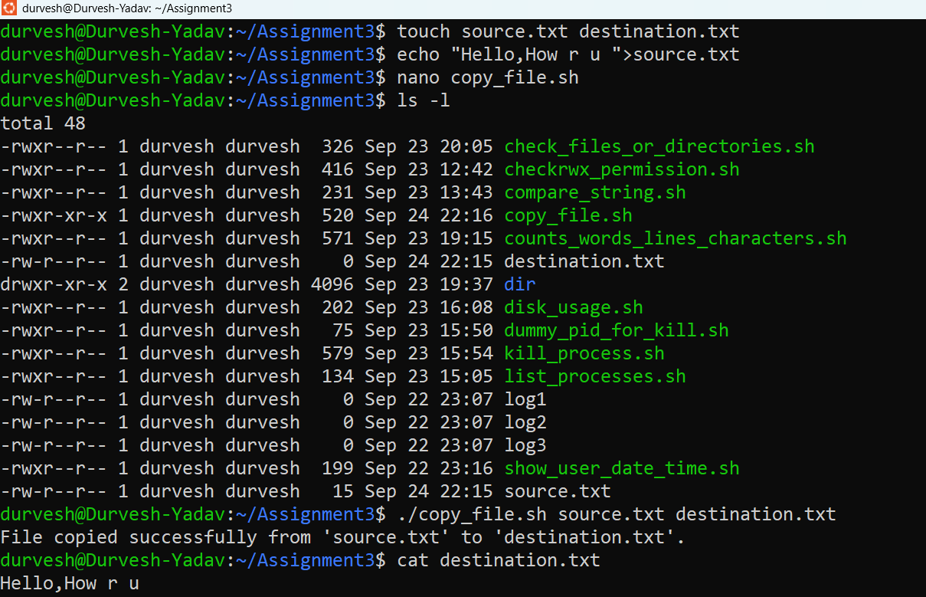

**Nano Editor:-**

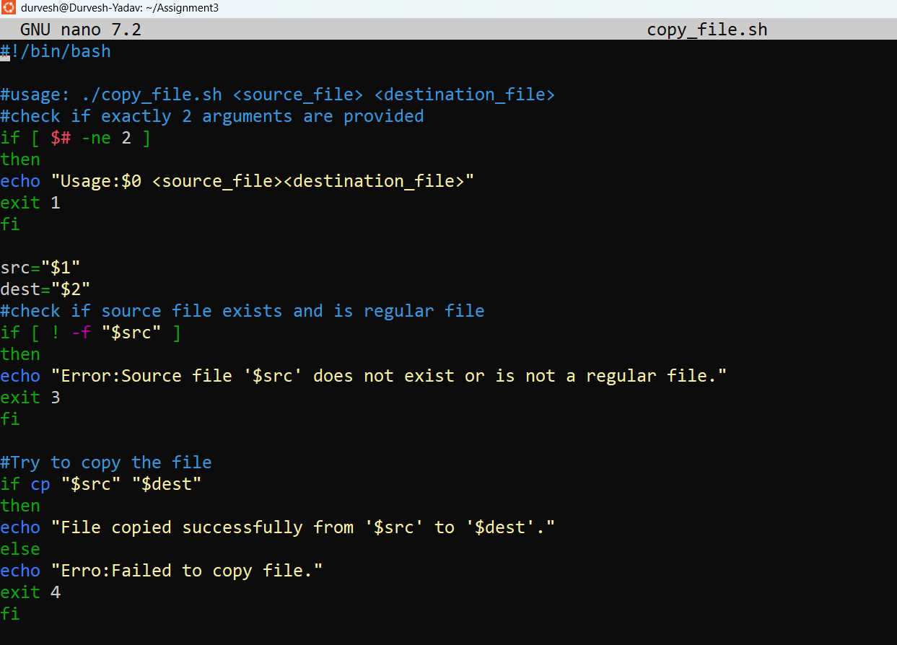

1. Develop a script that displays the current date, time, and your username.

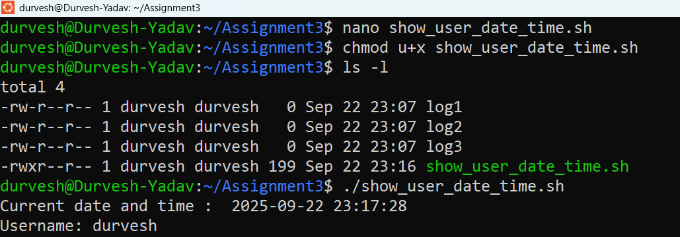

Nano Editor:-

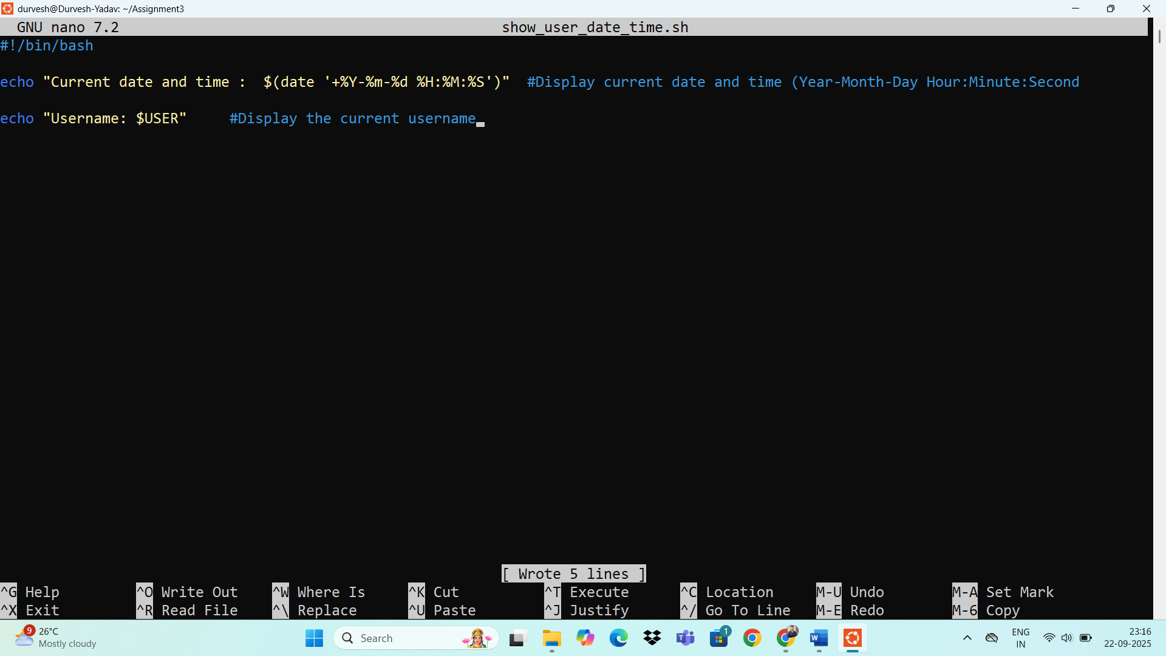

1. Create a script that checks if a given file has read, write, and execute permissions for the owner.

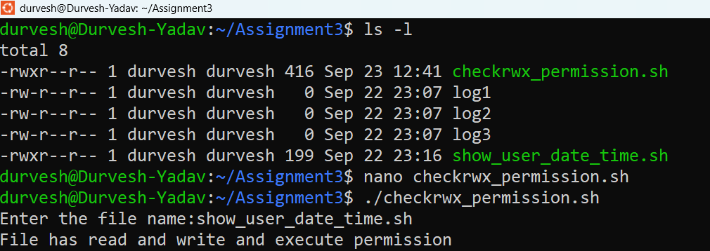

**Nano Editor:-**

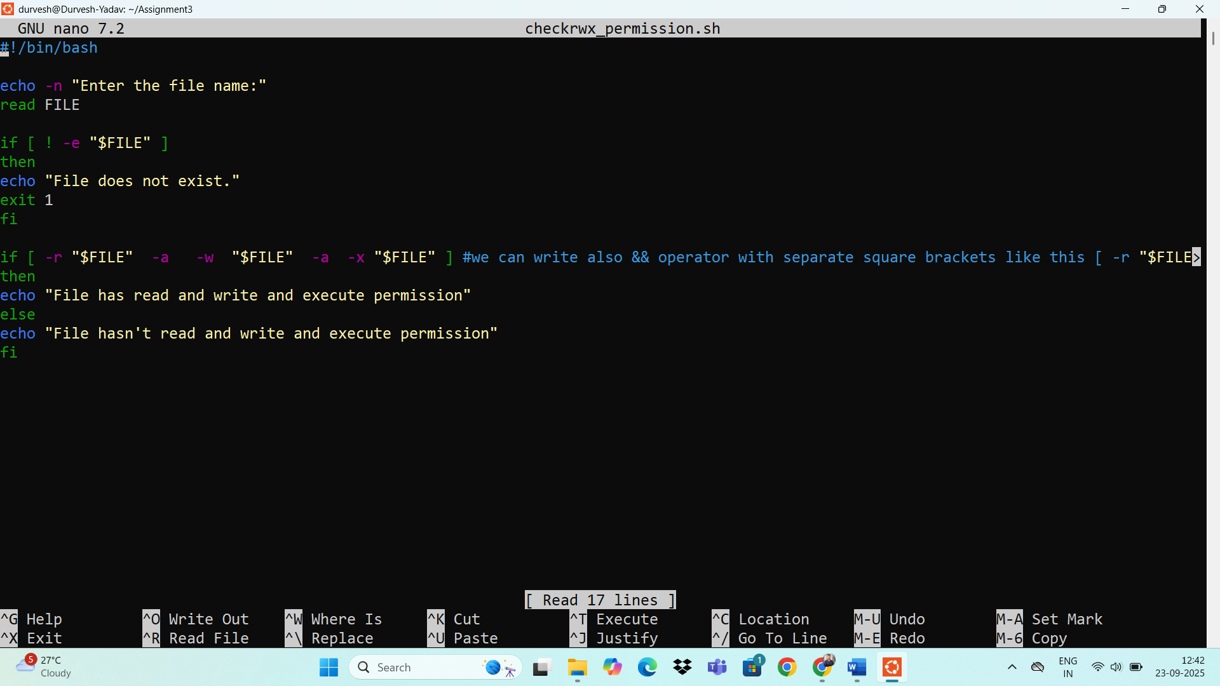

1. Develop a script that compares two strings provided as arguments and indicates if they are equal or different.

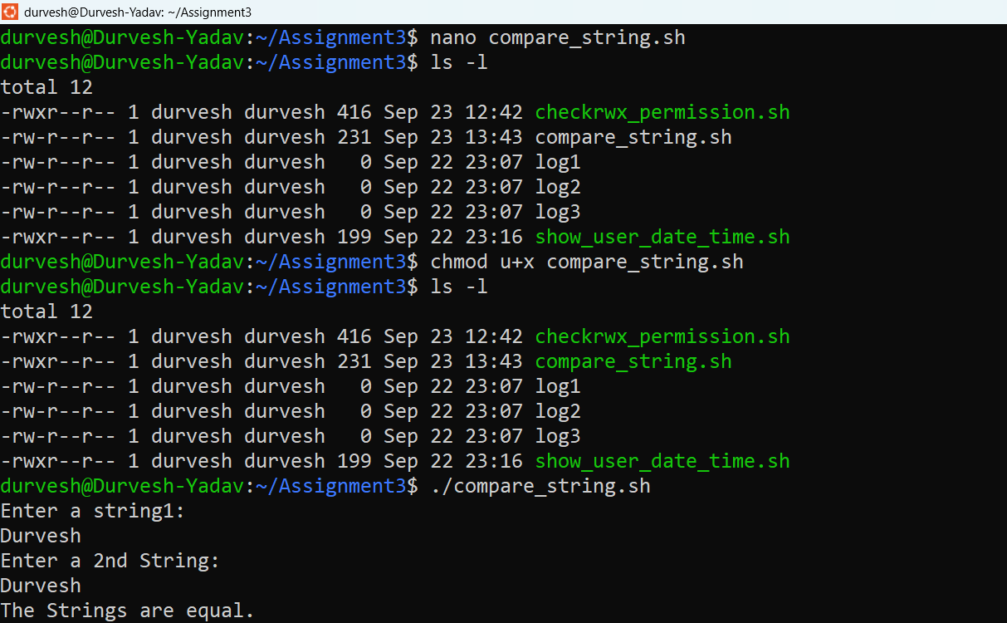

Nano Editor:-

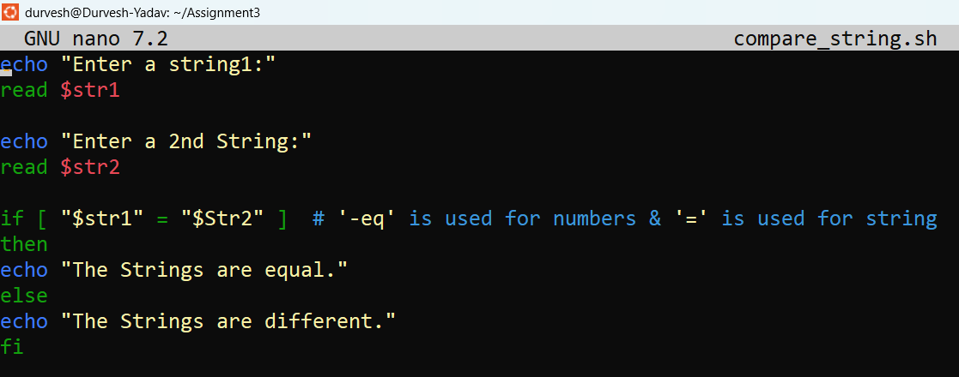

1. Write a script that lists all currently running processes and their PIDs.

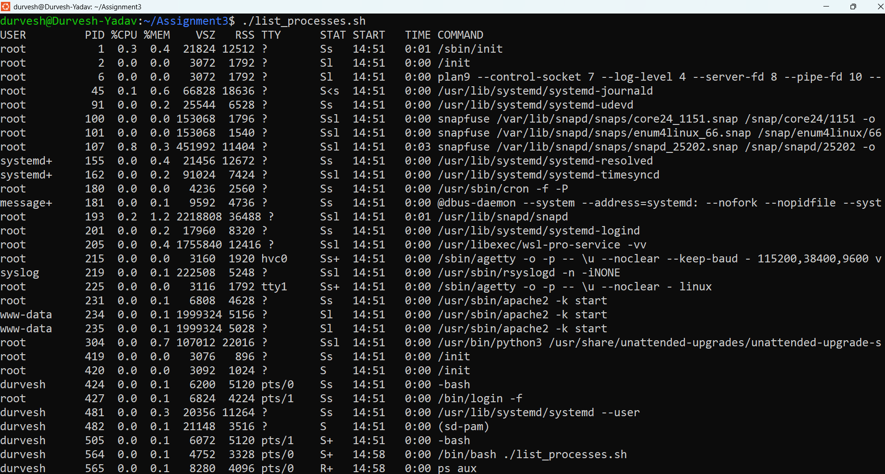

**Nano editor:-**

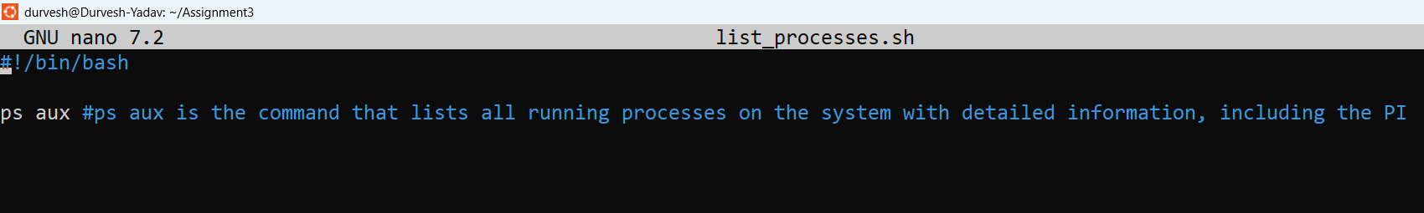

1. Create a script that takes a process ID as an argument and attempts to terminate that process.

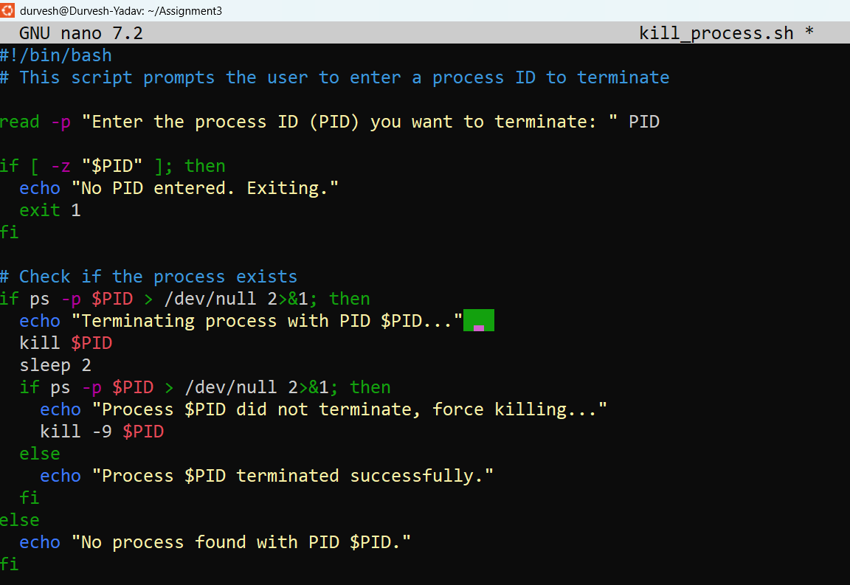

**Nano Editor:-**

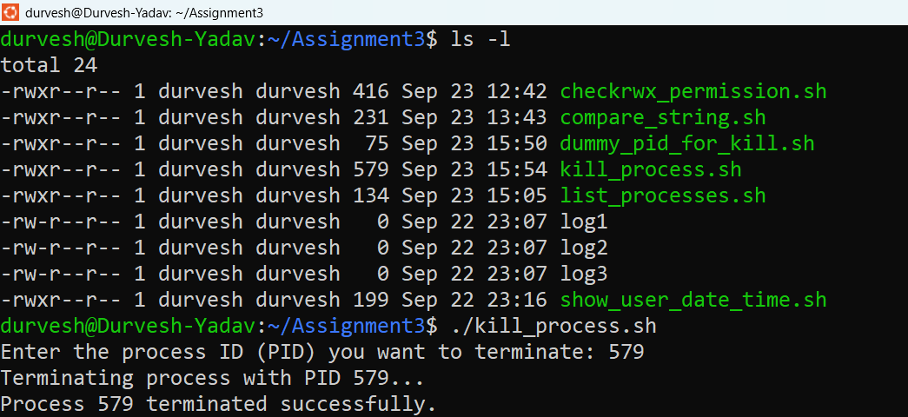

1. Develop a script that displays disk usage information for all mounted filesystems.

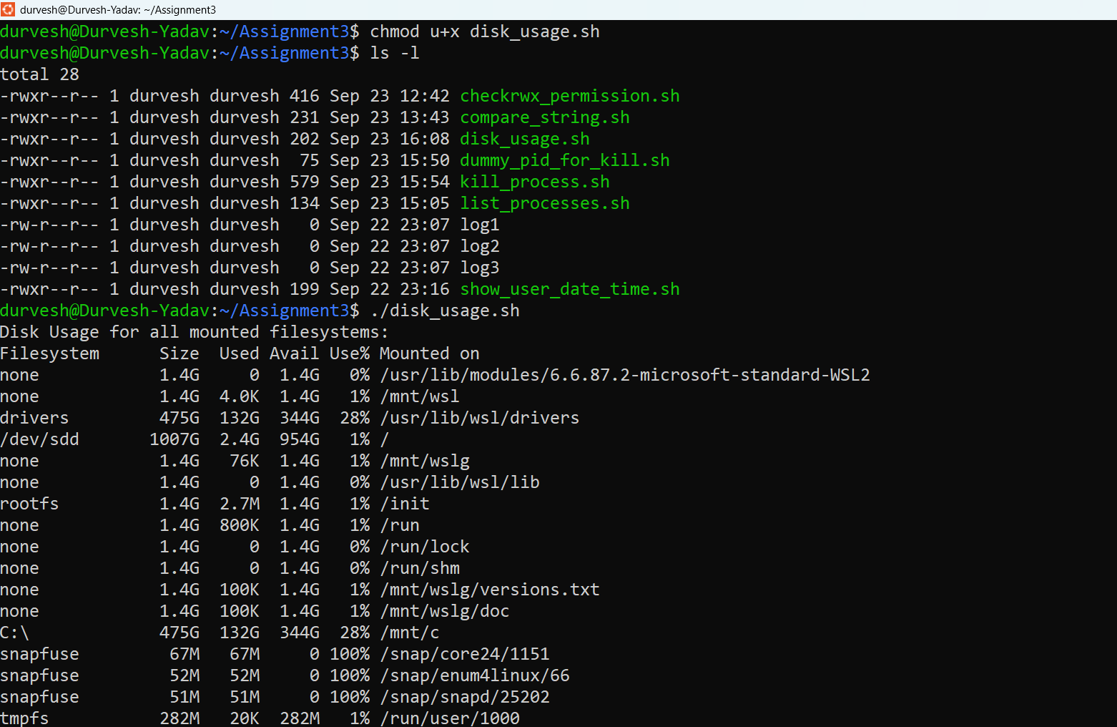

**Nano Editor:-**

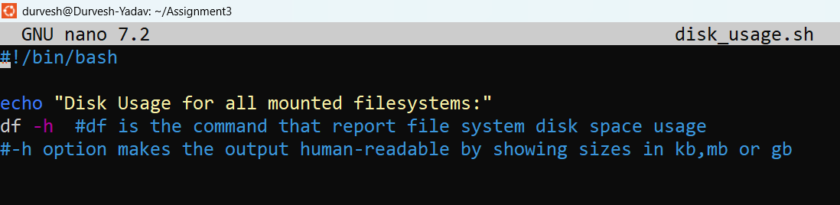

1. Write a script that counts the number of words, lines, and characters in a given text file.

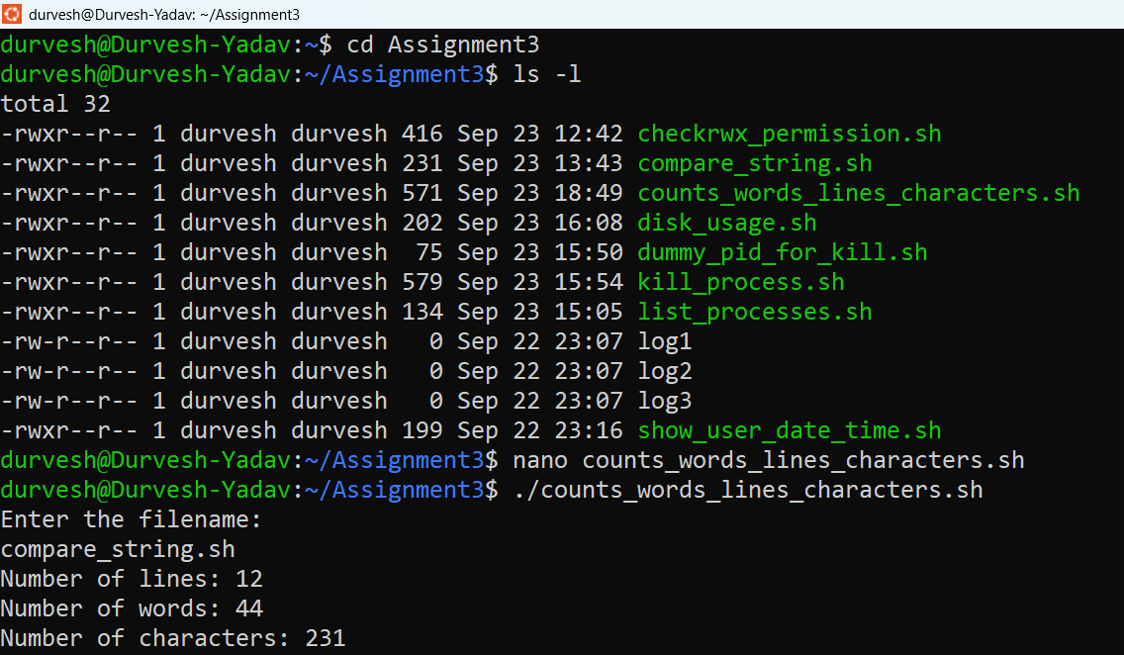

**Nano Editor:-**

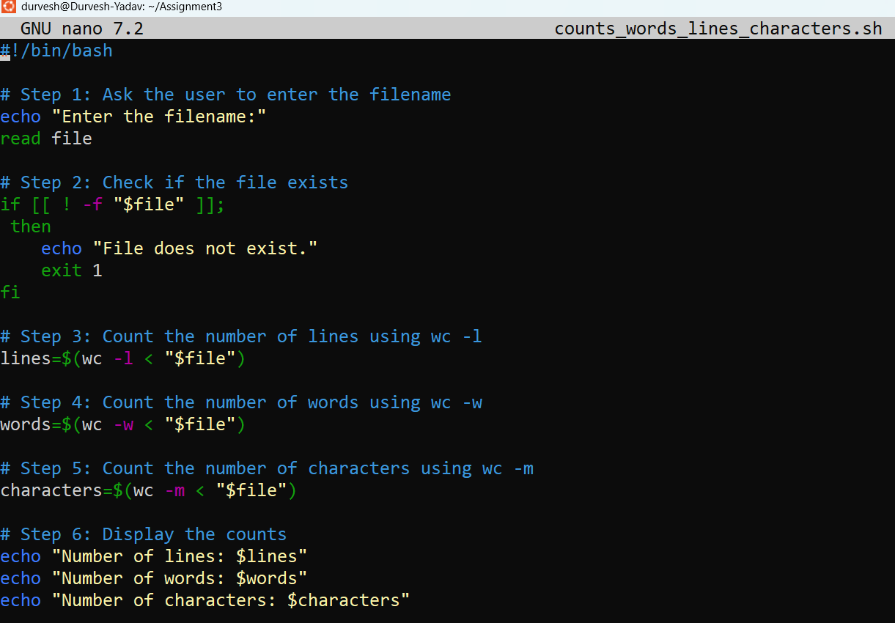

1. Create a script that searches for a specific string within a file or directory recursively.

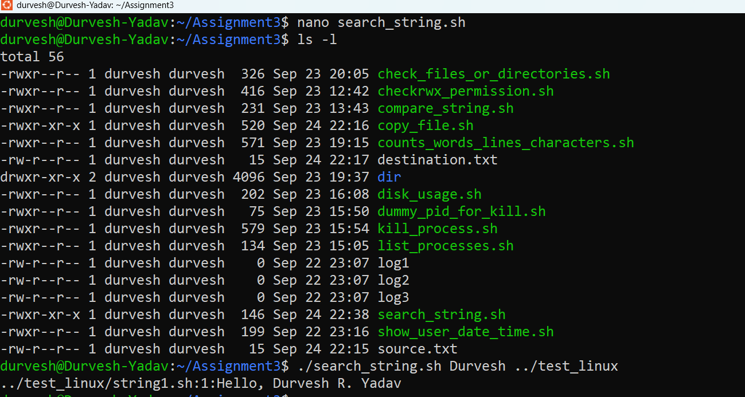

**Nano Editor:-**

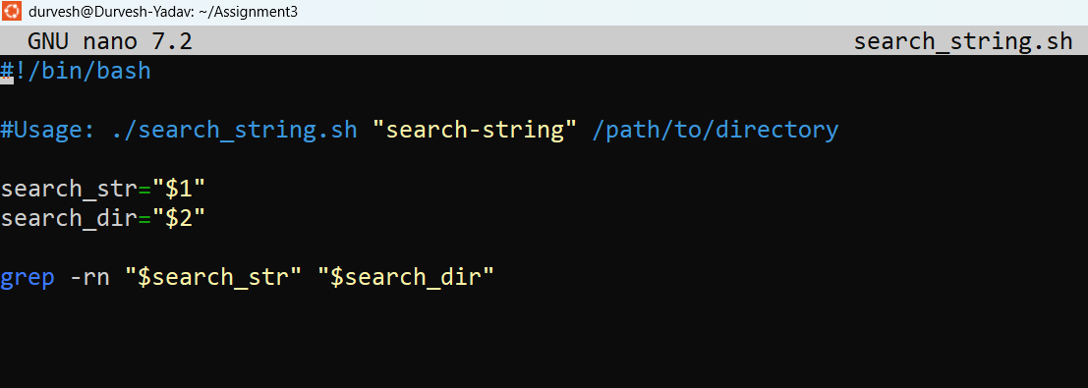

1. Develop a script that backs up a specific directory to a compressed archive, including a timestamp in the filename.

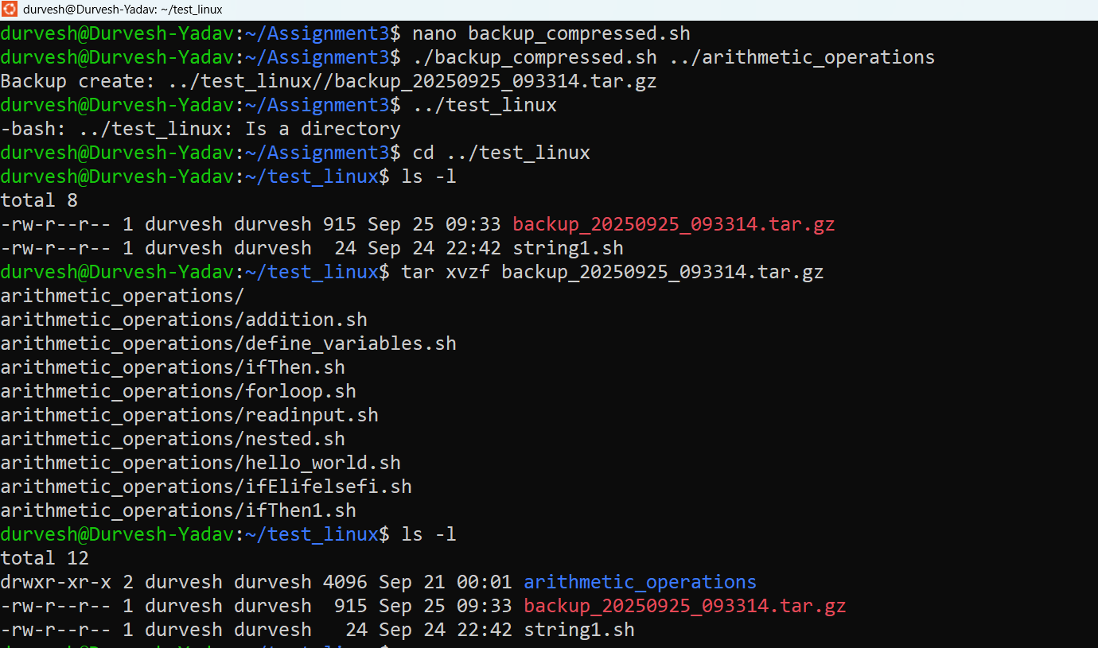

Nano Editor:-

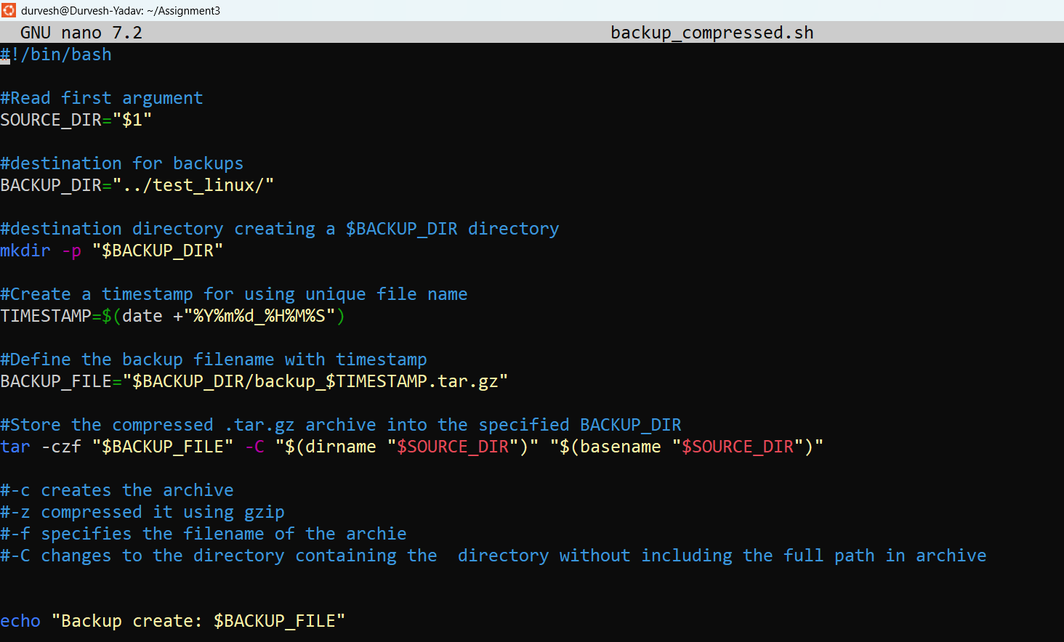

1. Write a script that schedules a task to run at a specific time using cron.
2. Write a script to replace all occurrences of one word with another throughout data.txt.
3. Print only the lines from data.txt where the second field is a number greater than 10. Use awk command.
4. Print lines from data.txt that contain a specific pattern, and then print a custom message for each matched line.