# TEST 1

.global A, C

.extern B

.section text:

jmp *A(%pc)

jmp *E(%pc)

jmp *B(%pc)

jmp *D(%pc)

D: .word D

mov %r1, B

mov C, %r1

mov %r1, E

.section data:

.skip 8

E: .equ X, A-E+D

.word C

.word B

A: .word B

.section bss:

C: .skip 8

.end

# TEST 1 OUTPUT

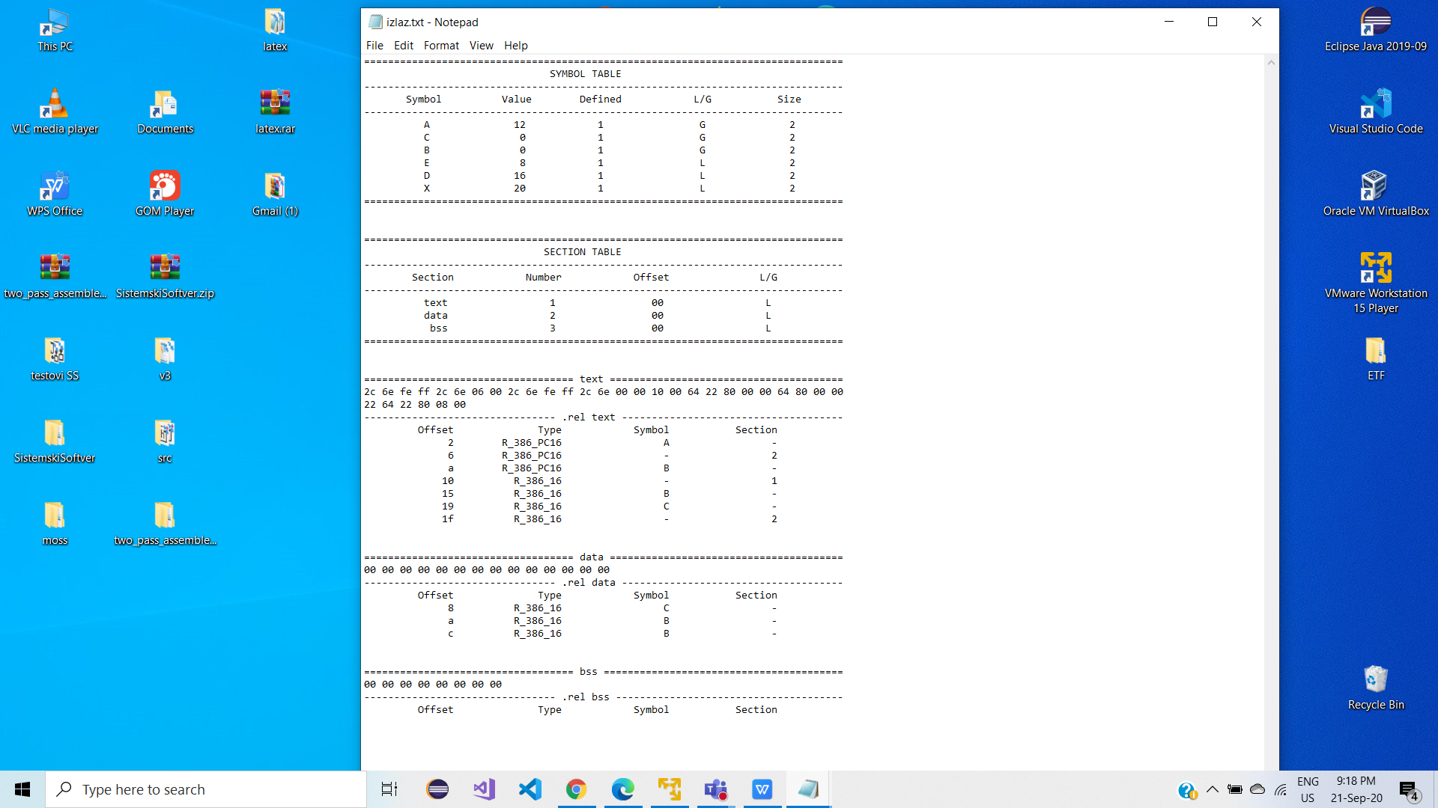

# TEST 2

.section text:

.global main

.extern readln, writeln

main:

halt

xchgb %r0h, %r0l

xchg %r0, %r1

xchgw %r1, 0(%r2)

xchgw %r2, 5(%r3)

xchg %r3, offset(%r4)

xchgw $782, %r4

xchg %r5, offset

xchg %r5, offset

xchg %r5, -597(%r6)

int 3

mov %r0, offset

addb %r0h, %r1l

sub %r2, offset

mul offset(%r5), %r3

div %r0, offset

cmp offset(%r7), %r0

not 0(%r5), %r1

andb %r0h, %r1l

orw %r0, offset(%pc)

xorb %r0h, %r0h

test:

test %r0, offset

shl $0x682, %r3

shr offset, %r2

push -892(%r3)

pop %r3

jmp *test

jeq *test(%r7)

jne *73

jgt offset(%r4)

call *func

iret

movw 0(%r2), 0x1234

jmp *offset

func:

push 5(%r3)

ret

.section data:

.word 2

offset: .word 576

.section rodata

hellostr: .byte 0x48, 0x65, 0x6c, 0x6c, 0x6f, 0x21, 0x0

.end

# TEST 2 OUTPUT

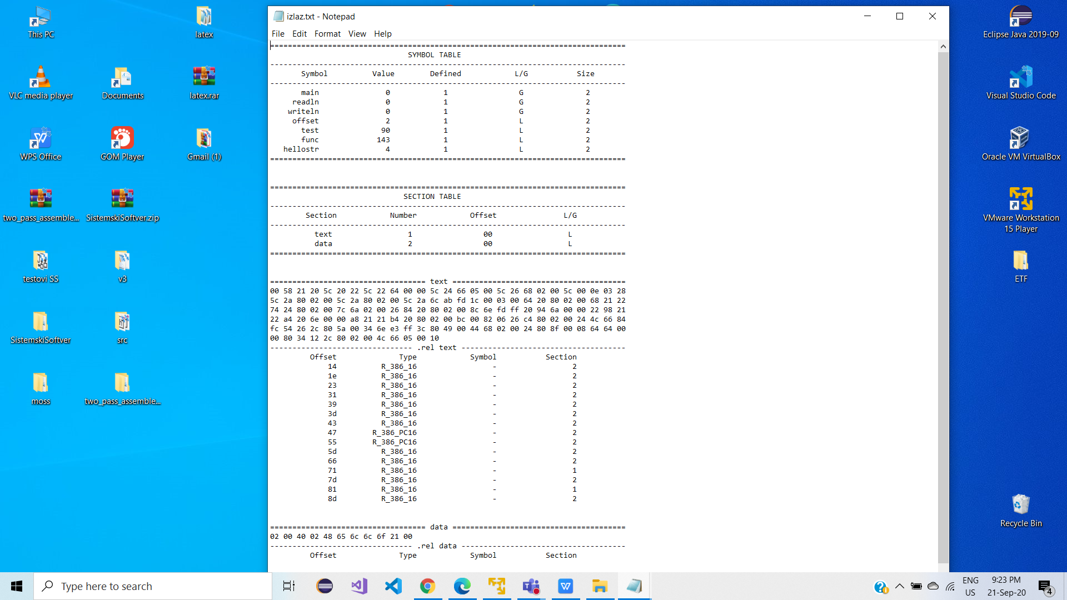

# TEST 3

.section text:

.global main

.extern readln, writeln

main:

halt

xchgb %r0h, %r0l

xchg %r0, %r1

xchgw %r1, 0(%r2)

xchgw %r2, 5(%r3)

xchg %r3, offset(%r4)

xchgw $782, %r4

xchg %r5, offset

xchg %r5, offset

xchg %r5, -597(%r6)

int 3

mov %r0, offset

addb %r0h, %r1l

sub %r2, offset

mul offset(%r5), %r3

div %r0, offset

cmp offset(%r7), %r0

not 0(%r5), %r1

andb %r0h, %r1l

orw %r0, offset(%pc)

xorb %r0h, %r0h

test:

test %r0, offset

shl $0x682, %r3

shr offset, %r2

push -892(%r3)

pop %r3

jmp *test

jeq *test(%r7)

jne *73

jgt offset(%r4)

call *func

iret

movw 0(%r2), 0x1234

jmp *offset

func:

push 5(%r3)

ret

.section data:

.word 2

offset: .word 576

.section rodata

hellostr: .byte 0x48, 0x65, 0x6c, 0x6c, 0x6f, 0x21, 0x0

.end

# TEST 3 OUTPUT

