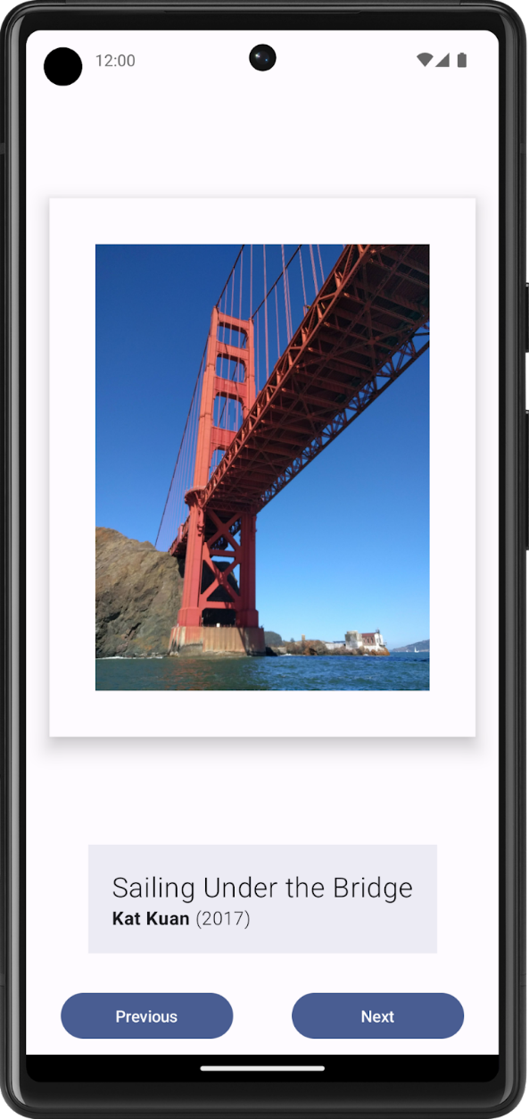 | An Android app that can display artwork or family photos.  - Artwork image.  - Information about the artwork, such as its title, artist, and year of publication.  - Any other elements, such as buttons that make the app interactive and dynamic  - Prepare three functions.

https://developer.android.com/courses

