Klic vremenskega API-ja v Android/Kotlin/Compose.
Cilj:
- pridobiti podatke iz spletnega APIja
- prikazati podatke v naši aplikaciji
- 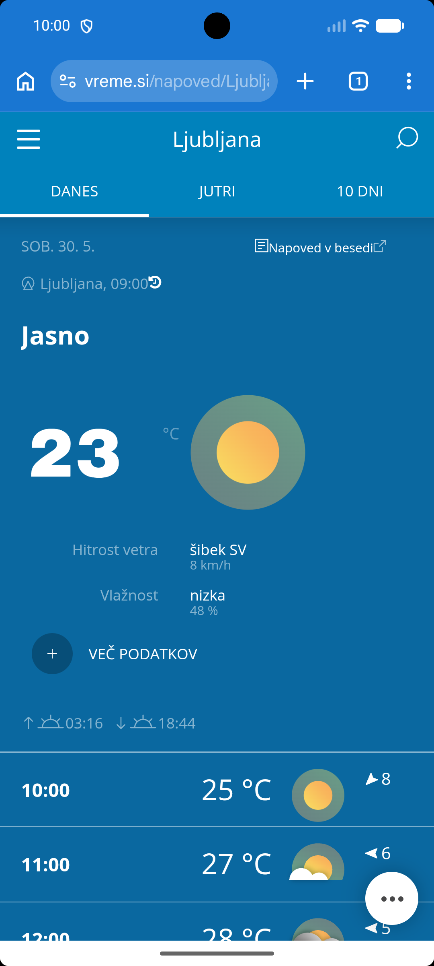

1. Kaj je API?
API je vmesnik, prek katerega naš program prosi drug program ali strežnik za podatke.
Primer:
Tvoja aplikacija vpraša OpenWeather:
Daj mi vreme za Maribor.
Strežnik odgovori s podatki, običajno v obliki JSON.
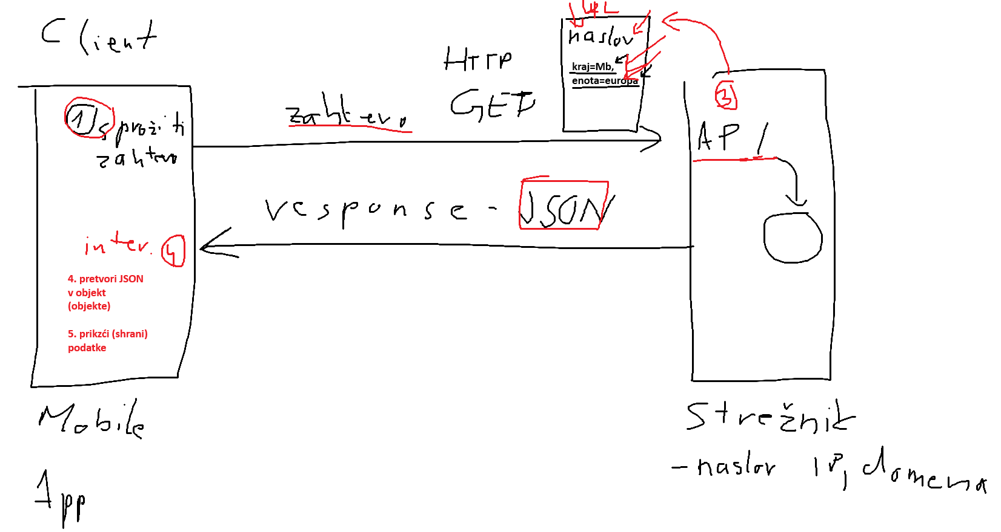

2. Kaj je JSON?
JSON je oblika zapisa podatkov.
Primer odgovora:
{
"main": {
"temp": 21.5,
"humidity": 65
},
"weather": [
{
"description": "clear sky"
}
]
}
To je navadno besedilo, podobno objektom v programiranju.
{ } pomeni OBJEKT
Objekt vsebuje pare:
"ime" : vrednost
Primer:
{
"ime": "Janez",
"starost": 20,
"spol": "m"
}
To je en objekt.
Lahko si ga predstavljaš kot Kotlin objekt:
Oseba(
ime = "Janez",
starost = 20,
spol = "m"
)

[ ] pomeni SEZNAM (ARRAY)
Primer:
[
"jabolko",
"hruška",
"banana"
]
To ustreza Kotlinu:
listOf(
"jabolko",
"hruška",
"banana"
)

Seznam objektov
To je zelo pogosto:
[
{
"ime": "Janez",
"starost": 20
},
{
"ime": "Miha",
"starost": 25
}
]
Pomen:
listOf(
Oseba("Janez",20),
Oseba("Miha",25)
)

Primer vremena
JSON:
{
"main": {
"temp": 18.4,
"humidity": 72
},
"weather": [
{
"description": "light rain"
}
]
}
Poglej strukturo:
Zunanji objekt
{
...
}
ima dva podatka:
"main"
"weather"

main je objekt
"main": {
"temp": 18.4,
"humidity": 72
}
zato:
data class Main(
val temp: Double,
val humidity: Int
)

weather je seznam
"weather": [
{
"description": "light rain"
}
]
zato:
val weather: List<Weather>
ker so oklepaji:
[ ]

Kako hitro prepoznaš?

Če vidiš
{
...
}
narediš:
data class Nekaj(...)

Če vidiš
[
...
]
narediš:
List<Nekaj>

Primer z osebami
JSON:
[
{
"ime":"Janez",
"starost":20
},
{
"ime":"Miha",
"starost":25
}
]
Kotlin:
data class Oseba(
val ime:String,
val starost:Int
)
in nato:
List<Oseba>

Zapomni si:
{ } = en objekt
[ ] = seznam objektov ali vrednosti
To je verjetno najpomembnejše pravilo pri branju JSON-a.

OpenWeather
- prijava v OpenWeather
- potrebujemo API key - klici se plačajo - ustvari ključ
- potrebujemo URL z vključenim API ključem - ustvari URL (treba poznati specifikacije za API - mi bomo utsvarili z AI pomočnikom)
- opravimo klic
- dobimo json

API Za trenutno vreme
https://api.openweathermap.org/data/2.5/weather

Temu pripnemo še parametre!
Parameter | Pomen | Primer
q | Ime mesta | q=Maribor
appid | API ključ | appid=abc123
units | Enote | units=metric
lang | Jezik opisa | lang=sl
lat | Geografska širina | lat=46.55
lon | Geografska dolžina | lon=15.65
zip | Poštna številka | zip=2000,SI
id | ID mesta v OpenWeather bazi | id=3195506
mode | Oblika odgovora | mode=json

Primer klica (namesto besede KLJUC vnesemo naš API KEY):
https://api.openweathermap.org/data/2.5/weather?q=Maribor&appid=KLJUC&units=metric&lang=sl

API Za vremensko napoved
Parameteri so enaki kot pri trenutni vremsenski napovedi.
https://api.openweathermap.org/data/2.5/forecast
Primer klica (namesto besede KLJUC vnesemo naš API KEY):
https://api.openweathermap.org/data/2.5/forecast?q=Maribor&appid=KLJUC&units=metric&lang=sl

3. Data class
Ker JSON ni neposredno Kotlin objekt, naredimo razrede, ki ustrezajo JSON strukturi. Poglejmo vrnjeno JSON datoteko pri trenutnem vremenu v Mariboru in sestavimo (data) razrede.
data class WeatherResponse(
val main: Main,
val weather: List<Weather>
)

data class Main(
val temp: Double,
val humidity: Int
)

data class Weather(
val description: String
)

To pomeni:
- WeatherResponse predstavlja celoten odgovor,
- main vsebuje temperaturo in vlažnost,
- weather je seznam opisov vremena.
{  "coord": {  "lon": 15.6467,  "lat": 46.5547  }  ,  "weather": [  {  "id": 804,  "main": "Clouds",  "description": "oblačno",  "icon": "04d"  }  ]  ,  "base": "stations"  ,  "main": {  "temp": 16.23,  "feels_like": 16.23,  "temp_min": 16.1,  "temp_max": 16.77,  "pressure": 1011,  "humidity": 89,  "sea_level": 1011,  "grnd_level": 960  }  ,  "visibility": 10000,  "wind": {  "speed": 0.45,  "deg": 315,  "gust": 1.79  }  ,  "clouds": {  "all": 100  }  ,  "dt": 1780497626,  "sys": {  "type": 2,  "id": 18640,  "country": "SI",  "sunrise": 1780456035,  "sunset": 1780512249  }  ,  "timezone": 7200,  "id": 3195506,  "name": "Maribor",  "cod": 200  } | data class WeatherResponse(  val main: Main,  val weather: List<Weather>  )  data class Main(  val temp: Double,  val humidity: Int  )  data class Weather(  val main: String  )

4. Retrofit
Retrofit je knjižnica, ki zna poslati HTTP zahtevo na API.
V build.gradle.kts dodamo:
implementation("com.squareup.retrofit2:retrofit:2.11.0")
implementation("com.squareup.retrofit2:converter-gson:2.11.0")

converter-gson poskrbi, da se JSON sam pretvori v tvoje data class objekte.

5. Internet dovoljenje
V AndroidManifest.xml moraš dodati:
<uses-permission android:name="android.permission.INTERNET" />

Brez tega aplikacija ne sme na internet.

6. Interface
Interface pove Retrofit-u, kateri naslov naj pokliče in katere parametre naj pošlje, ter kakšen objekt vrne.
interface WeatherApi {
@GET("weather")
suspend fun getWeather(
@Query("q") city: String,
@Query("appid") apiKey: String,
@Query("units") units: String = "metric",
@Query("lang") lang: String = "sl"
): WeatherResponse
}

Kodo dodajmo v novo mapo (package) network (kreiraj enako kot model) z imenom WeatherApi.kt
Pomen:
@GET("weather")
pomeni, da kličemo naslov:
https://api.openweathermap.org/data/2.5/weather

Parametri:
@Query("q") city
postane:
?q=Maribor

Skupaj nastane približno:
https://api.openweathermap.org/data/2.5/weather?q=Maribor&appid=KLJUC&units=metric&lang=sl

7. RetrofitInstance
To je objekt, ki pripravi povezavo do API-ja.
object RetrofitInstance {
val api: WeatherApi by lazy {
Retrofit.Builder()
.baseUrl("https://api.openweathermap.org/data/2.5/")
.addConverterFactory(GsonConverterFactory.create())
.build()
.create(WeatherApi::class.java)
}
}

Pomembno:
baseUrl("https://api.openweathermap.org/data/2.5/")

mora imeti / na koncu.

8. Klic API-ja
V Compose uporabimo LaunchedEffect, ker klic API-ja ne sme teči neposredno med risanjem zaslona.
LaunchedEffect(Unit) {
val result = RetrofitInstance.api.getWeather(
city = "Maribor",
apiKey = "TVOJ_API_KLJUC"
)

temperature = "${result.main.temp} °C"
description = result.weather.firstOrNull()?.description
humidity = "Vlažnost: ${result.main.humidity} %"
}

Kaj se zgodi?
- aplikacija pošlje zahtevo na internet,
- API vrne JSON,
- Gson pretvori JSON v WeatherResponse,
- iz objekta preberemo podatke,
- podatke prikažemo v Text.

9. Celoten tok
Aplikacija
↓
Retrofit pošlje zahtevo
↓
OpenWeather API
↓
JSON odgovor
↓
Gson pretvori JSON v data class
↓
Kotlin objekt WeatherResponse
↓
Compose prikaže podatke

Minimalna struktura projekta
com.example.am_weatherapi
│
├── MainActivity.kt
│
├── model
│ └── WeatherResponse.kt
│
└── network
└── WeatherApi.kt

Najbolj pomembno:
- API = strežnik, ki vrača podatke.
- JSON = oblika podatkov, ki jo strežnik pošlje.
- data class = Kotlin oblika teh podatkov.
- interface = opis, kateri API kličemo.
- Retrofit = orodje, ki izvede klic.
- Gson = orodje, ki JSON pretvori v Kotlin objekt.
- LaunchedEffect = mesto, kjer v Compose varno izvedemo klic.

https://api.openweathermap.org/data/2.5/weather?q=Maribor&units=metric&lang=sl&appid=API_KLJUC
{  "coord": {  "lon": 15.6467,  "lat": 46.5547  },  "weather": [  {  "id": 500,  "main": "Rain",  "description": "rahel dež",  "icon": "10d"  }  ],  "base": "stations",  "main": {  "temp": 14.68,  "feels_like": 14.63,  "temp_min": 14.43,  "temp_max": 16.16,  "pressure": 1011,  "humidity": 93,  "sea_level": 1011,  "grnd_level": 960  },  "visibility": 10000,  "wind": {  "speed": 1.76,  "deg": 347,  "gust": 8.07  },  "rain": {  "1h": 0.19  },  "clouds": {  "all": 100  },  "dt": 1780491842,  "sys": {  "type": 2,  "id": 18640,  "country": "SI",  "sunrise": 1780456035,  "sunset": 1780512249  },  "timezone": 7200,  "id": 3195506,  "name": "Maribor",  "cod": 200  } | Najprej si postavimo vprašanje:  Katere podatke želim prikazati?  Recimo:  - ime mesta  - temperaturo  - vlažnost  - opis vremena  Potem JSON beremo od zgoraj navzdol.  1. Celoten JSON  Celoten odgovor je:  {  ...  }  To pomeni:  Celoten odgovor = en objekt  Zato naredimo glavni razred:  data class WeatherResponse(  )  2. Katere podatke potrebujem?  Vidim:  {  "weather": [...],  "main": {...},  "name": "Maribor"  }  Zato bo glavni razred:  data class WeatherResponse(  val weather: List<Weather>,  val main: Main,  val name: String  )  3. Kako vem da je weather seznam?  Poglej:  "weather": [  {  "id": 500,  "main": "Rain",  "description": "rahel dež",  "icon": "10d"  }  ]  Vidimo:  [ ]  To pomeni:  seznam  Torej:  val weather: List<Weather>  in potrebujemo nov razred:  data class Weather(  )  4. Kaj vsebuje Weather?  Notri vidim:  {  "id": 500,  "main": "Rain",  "description": "rahel dež",  "icon": "10d"  }  Lahko vzamemo vse:  data class Weather(  val id: Int,  val main: String,  val description: String,  val icon: String  )  ali samo opis:  data class Weather(  val description: String  )  5. Kako vem da je main objekt?  Vidim:  "main": {  "temp": 14.68,  "humidity": 93  }  Ker so:  { }  je to objekt.  Zato:  val main: Main  in nov razred:  data class Main(  )  6. Kaj vsebuje Main?  Lahko vzamemo vse:  data class Main(  val temp: Double,  val feels_like: Double,  val temp_min: Double,  val temp_max: Double,  val pressure: Int,  val humidity: Int  )  ali samo kar potrebuješ:  data class Main(  val temp: Double,  val humidity: Int  )  7. Končni minimalni model  Če želiš:  - mesto  - temperaturo  - vlažnost  - opis  potem zadošča:  data class WeatherResponse(  val main: Main,  val weather: List<Weather>,  val name: String  )  data class Main(  val temp: Double,  val humidity: Int  )  data class Weather(  val description: String  )  8. Kaj naredi Gson?  JSON:  {  "name": "Maribor",  "main": {  "temp": 14.68,  "humidity": 93  },  "weather": [  {  "description": "rahel dež"  }  ]  }  pretvori v:  WeatherResponse(  name = "Maribor",  main = Main(  temp = 14.68,  humidity = 93  ),  weather = listOf(  Weather(  description = "rahel dež"  )  )  )  9. Kako dostopam do podatkov?  Ime mesta:  result.name  Rezultat:  Maribor  Temperatura:  result.main.temp  Rezultat:  14.68  Vlažnost:  result.main.humidity  Rezultat:  93  Opis:  result.weather[0].description  Rezultat:  rahel dež  Vizualni zemljevid  WeatherResponse  │  ├── name  │  ├── main  │ ├── temp  │ └── humidity  │  └── weather  │  └── [0]  │  └── description  Točno iz tega zemljevida nastanejo tvoji data class razredi. Ko vidiš:  - {} → nov data class  - [] → List<...>  - "besedilo" → String  - 14.68 → Double  - 93 → Int  Tako lahko skoraj vsak JSON ročno pretvoriš v Kotlin data class.

Program
datoteka: build.gradle.kts
plugins {
alias(libs.plugins.android.application)
alias(libs.plugins.kotlin.compose)
}
android {
namespace = "com.example.am_weatherapidemo"
compileSdk {
version = release(36) {
minorApiLevel = 1
}
}
defaultConfig {
applicationId = "com.example.am_weatherapidemo"
minSdk = 24
targetSdk = 36
versionCode = 1
versionName = "1.0"
testInstrumentationRunner = "androidx.test.runner.AndroidJUnitRunner"
}
buildTypes {
release {
isMinifyEnabled = false
proguardFiles(
getDefaultProguardFile("proguard-android-optimize.txt"),
"proguard-rules.pro"
)
}
}
compileOptions {
sourceCompatibility = JavaVersion.VERSION_11
targetCompatibility = JavaVersion.VERSION_11
}
buildFeatures {
compose = true
}
}
dependencies {
implementation(platform(libs.androidx.compose.bom))
implementation(libs.androidx.activity.compose)
implementation(libs.androidx.compose.material3)
implementation(libs.androidx.compose.ui)
implementation(libs.androidx.compose.ui.graphics)
implementation(libs.androidx.compose.ui.tooling.preview)
implementation(libs.androidx.core.ktx)
implementation(libs.androidx.lifecycle.runtime.ktx)
implementation("com.squareup.retrofit2:retrofit:2.11.0")
implementation("com.squareup.retrofit2:converter-gson:2.11.0")
testImplementation(libs.junit)
androidTestImplementation(platform(libs.androidx.compose.bom))
androidTestImplementation(libs.androidx.compose.ui.test.junit4)
androidTestImplementation(libs.androidx.espresso.core)
androidTestImplementation(libs.androidx.junit)
debugImplementation(libs.androidx.compose.ui.test.manifest)
debugImplementation(libs.androidx.compose.ui.tooling)
}
datoteka:AndroidManifest.xml
<?xml version="1.0" encoding="utf-8"?>
<manifest xmlns:android="http://schemas.android.com/apk/res/android"
xmlns:tools="http://schemas.android.com/tools">
<uses-permission android:name="android.permission.INTERNET" />
<application
android:allowBackup="true"
android:dataExtractionRules="@xml/data_extraction_rules"
android:fullBackupContent="@xml/backup_rules"
android:icon="@mipmap/ic_launcher"
android:label="@string/app_name"
android:roundIcon="@mipmap/ic_launcher_round"
android:supportsRtl="true"
android:theme="@style/Theme.AMWeatherAPIDemo">
<activity
android:name=".MainActivity"
android:exported="true"
android:label="@string/app_name"
android:theme="@style/Theme.AMWeatherAPIDemo">
<intent-filter>
<action android:name="android.intent.action.MAIN" />
<category android:name="android.intent.category.LAUNCHER" />
</intent-filter>
</activity>
</application>
</manifest>

datoteka:WeatherResponse.kt
package com.example.am_weatherapidemo.model
data class WeatherResponse(
val main: Main,
val weather: List<Weather>
)
data class Main(
val temp: Double,
val humidity: Int
)
data class Weather(
val description: String
)

datoteka:WeatherApi.kt
package com.example.am_weatherapidemo.network
import com.example.am_weatherapidemo.model.WeatherResponse
import retrofit2.http.GET
import retrofit2.http.Query
interface WeatherApi {
@GET("weather")
suspend fun getWeather(
@Query("q") city: String,
@Query("appid") apiKey: String,
@Query("units") units: String = "metric",
@Query("lang") lang: String = "sl"
): WeatherResponse
}
datoteka:MainActivity.kt
package com.example.am_weatherapidemo
import android.os.Bundle
import androidx.activity.ComponentActivity
import androidx.activity.compose.setContent
import androidx.activity.enableEdgeToEdge
import androidx.compose.foundation.layout.Column
import androidx.compose.foundation.layout.fillMaxSize
import androidx.compose.foundation.layout.padding
import androidx.compose.foundation.layout.size
import androidx.compose.foundation.layout.statusBarsPadding
import androidx.compose.material3.Scaffold
import androidx.compose.material3.Text
import androidx.compose.runtime.Composable
import androidx.compose.runtime.LaunchedEffect
import androidx.compose.runtime.getValue
import androidx.compose.runtime.mutableStateOf
import androidx.compose.runtime.remember
import androidx.compose.runtime.setValue
import androidx.compose.ui.Modifier
import androidx.compose.ui.tooling.preview.Preview
import com.example.am_weatherapidemo.network.WeatherApi
import com.example.am_weatherapidemo.ui.theme.AMWeatherAPIDemoTheme
import retrofit2.Retrofit
import retrofit2.converter.gson.GsonConverterFactory
class MainActivity : ComponentActivity() {
override fun onCreate(savedInstanceState: Bundle?) {
super.onCreate(savedInstanceState)
enableEdgeToEdge()
setContent {
Column(modifier = Modifier.statusBarsPadding()
) {
var temperature by remember { mutableStateOf("Nalagam...") }
var description by remember { mutableStateOf("") }
var humidity by remember { mutableStateOf("") }
LaunchedEffect(Unit) {
val result = RetrofitInstance.api.getWeather(
city = "Maribor",
apiKey = "da3bda918c21c70251dc701ab0e1cd7a"
)
temperature = "${result.main.temp} °C"
description = result.weather.firstOrNull()?.description ?: "Ni podatka"
humidity = "Vlažnost: ${result.main.humidity} %"
}
Text("Temperatura je ${temperature}.\n Vreme je ${description}.\n Vlažnosst je $humidity")
}
}
}
}
object RetrofitInstance {
val api: WeatherApi by lazy {
Retrofit.Builder()
.baseUrl("https://api.openweathermap.org/data/2.5/")
.addConverterFactory(GsonConverterFactory.create())
.build()
.create(WeatherApi::class.java)
}
}

Naloga: Pripravi razrede za hranjenje podatkov o vremenski napovedi za (temperaturo, pritisk, vreme (oblačno, sončno, ..),hitrost vetra, smer vetra)
{
"cod": "200",
"message": 0,
"cnt": 40,
"list": [
{
"dt": 1780585200,
"main": {
"temp": 26.62,
"feels_like": 26.62,
"temp_min": 26.62,
"temp_max": 28.35,
"pressure": 1008,
"sea_level": 1008,
"grnd_level": 958,
"humidity": 45,
"temp_kf": -1.73
},
"weather": [
{
"id": 803,
"main": "Clouds",
"description": "pretežno oblačno",
"icon": "04d"
}
],
"clouds": {
"all": 66
},
"wind": {
"speed": 3.89,
"deg": 188,
"gust": 6.09
},
"visibility": 10000,
"pop": 0,
"sys": {
"pod": "d"
},
"dt_txt": "2026-06-04 15:00:00"
},
{
"dt": 1780596000,
"main": {
"temp": 25.1,
"feels_like": 25.02,
"temp_min": 22.07,
"temp_max": 25.1,
"pressure": 1008,
"sea_level": 1008,
"grnd_level": 958,
"humidity": 52,
"temp_kf": 3.03
},
"weather": [
{
"id": 803,
"main": "Clouds",
"description": "pretežno oblačno",
"icon": "04d"
}
],
"clouds": {
"all": 69
},
"wind": {
"speed": 2.87,
"deg": 191,
"gust": 7.91
},
"visibility": 10000,
"pop": 0,
"sys": {
"pod": "d"
},
"dt_txt": "2026-06-04 18:00:00"
},
{
"dt": 1780606800,
"main": {
"temp": 20.87,
"feels_like": 20.76,
"temp_min": 18,
"temp_max": 20.87,
"pressure": 1008,
"sea_level": 1008,
"grnd_level": 958,
"humidity": 67,
"temp_kf": 2.87
},
"weather": [
{
"id": 804,
"main": "Clouds",
"description": "oblačno",
"icon": "04n"
}
],
"clouds": {
"all": 89
},
"wind": {
"speed": 2.65,
"deg": 219,
"gust": 6.22
},
"visibility": 10000,
"pop": 0,
"sys": {
"pod": "n"
},
"dt_txt": "2026-06-04 21:00:00"
},
...
]
}

Rešite
data class ForecastResponse(  val list:List<ForecastData>  )  data class ForecastData (  val main:MainData,  val weather:List<WeatherData>,  val wind:WindData,  val dt_txt:String  )  data class MainData (  val temp:Double,  val pressure:Int,  val humidity:Int  )  data class WindData (  val speed:Double,  val deg:Int  )  data class WeatherData (  val main:String,  val description:String  ) | data class ForecastResponse(  val list: List<ForecastData>  )  data class ForecastData(  val main: MainData,  val weather: List<Weather>,  val wind: WindData,  val dt_txt: String  )  data class MainData(  val temp: Double,  val pressure: Int,  val humidity: Int  )  data class WindData(  val speed: Double,  val deg: Int  )  data class Weather(  val main: String,  val description: String  )

