Sebastjan Poredoš napredni tip kalkulator
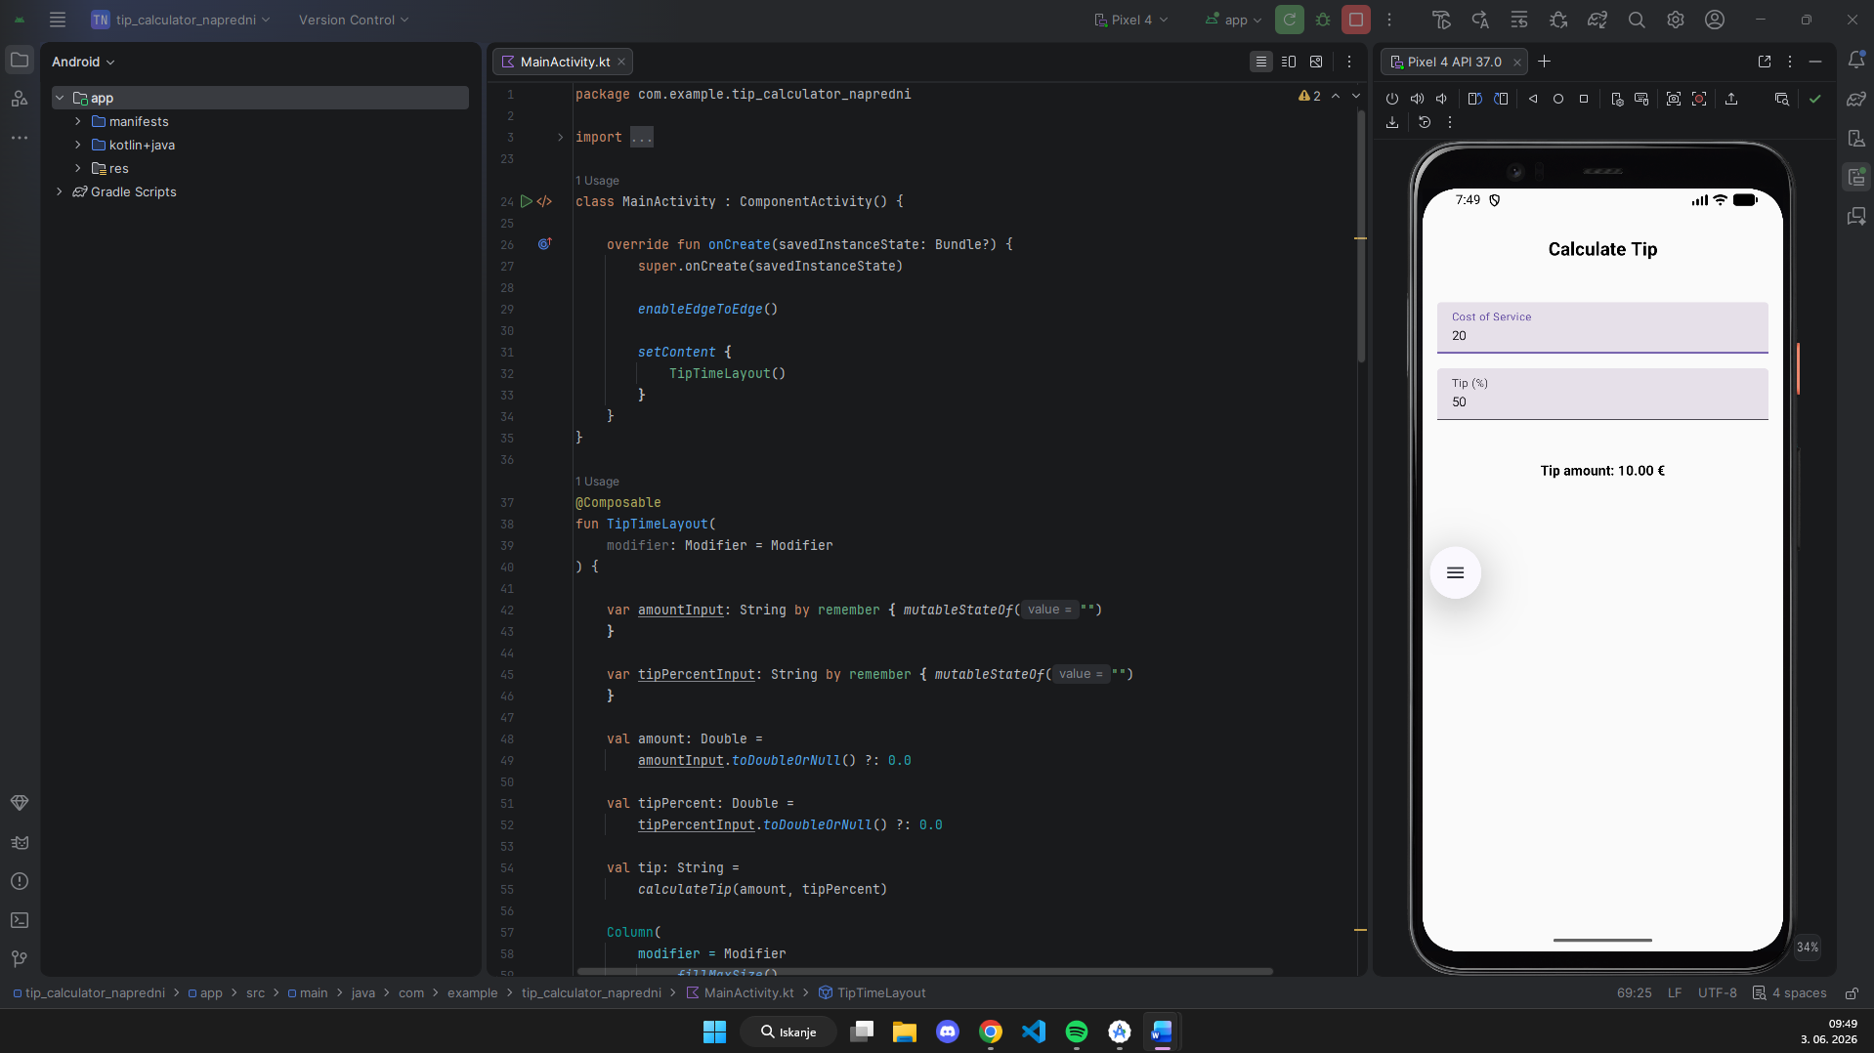

Uporabljena koda
package com.example.tip_calculator_napredni
import android.os.Bundle
import androidx.activity.ComponentActivity
import androidx.activity.compose.setContent
import androidx.activity.enableEdgeToEdge
import androidx.compose.foundation.layout.Arrangement
import androidx.compose.foundation.layout.Column
import androidx.compose.foundation.layout.fillMaxSize
import androidx.compose.foundation.layout.fillMaxWidth
import androidx.compose.foundation.layout.padding
import androidx.compose.foundation.layout.statusBarsPadding
import androidx.compose.foundation.text.KeyboardOptions
import androidx.compose.material3.Text
import androidx.compose.material3.TextField
import androidx.compose.runtime.*
import androidx.compose.ui.Alignment
import androidx.compose.ui.Modifier
import androidx.compose.ui.text.font.FontWeight
import androidx.compose.ui.text.input.KeyboardType
import androidx.compose.ui.unit.dp
import androidx.compose.ui.unit.sp
class MainActivity : ComponentActivity() {
override fun onCreate(savedInstanceState: Bundle?) {
super.onCreate(savedInstanceState)
enableEdgeToEdge()
setContent {
TipTimeLayout()
}
}
}
@Composable
fun TipTimeLayout(
modifier: Modifier = Modifier
) {
var amountInput: String by remember { mutableStateOf("")
}
var tipPercentInput: String by remember { mutableStateOf("")
}
val amount: Double =
amountInput.toDoubleOrNull() ?: 0.0
val tipPercent: Double =
tipPercentInput.toDoubleOrNull() ?: 0.0
val tip: String =
calculateTip(amount, tipPercent)
Column(
modifier = Modifier
.fillMaxSize()
.statusBarsPadding(),
horizontalAlignment = Alignment.CenterHorizontally,
verticalArrangement = Arrangement.Top
) {
Heading(
modifier = Modifier.padding(30.dp)
)
EditNumberField(
value = amountInput,
onValueC = {
amountInput = it
},
label = "Cost of Service",
modifier = Modifier
.fillMaxWidth()
.padding(16.dp)
)
EditNumberField(
value = tipPercentInput,
onValueC = {
tipPercentInput = it
},
label = "Tip (%)",
modifier = Modifier
.fillMaxWidth()
.padding(horizontal = 16.dp)
)
TipOutput(
tip = tip,
modifier = Modifier.padding(16.dp)
)
}
}
@Composable
fun Heading(
modifier: Modifier = Modifier
) {
Text(
text = "Calculate Tip",
fontWeight = FontWeight.Bold,
fontSize = 20.sp,
modifier = modifier
)
}
@Composable
fun EditNumberField(value: String, onValueC: (String) -> Unit, label: String, modifier: Modifier = Modifier
) {
TextField(
value = value,
onValueChange = onValueC,
modifier = modifier,
label = {
Text(label)
},
singleLine = true,
keyboardOptions = KeyboardOptions(
keyboardType = KeyboardType.Number
)
)
}
@Composable
fun TipOutput(tip: String, modifier: Modifier = Modifier
) {
Text(
text = "Tip amount: $tip €",
fontWeight = FontWeight.Bold,
fontSize = 15.sp,
modifier = modifier
.padding(top = 30.dp)
)
}
private fun calculateTip(amount: Double, tipPercent: Double): String
{
val tip: Double =
amount * (tipPercent / 100)
return String.format("%.2f", tip)
}

