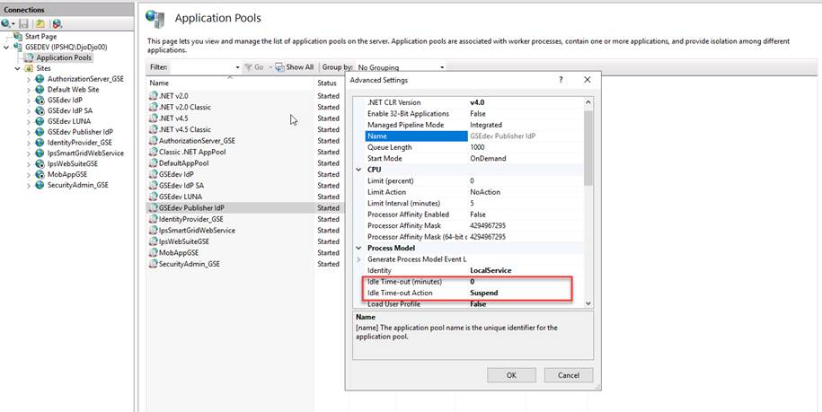

Da bi radilo kesiranje mora da se podesi u application poolu kao na slici

There are 3 config files which should be configured properly
- web.config
- IpsEnergy.PublisherCore.dll.config
- appsettings.json

IDP client stays same except for next urls which should be adjusted
CALLBACK URLs: PublisherUrl /signin-oidc
LOGOUT REDIRECT URLs : PublisherUrl /signout-callback-oidc

Also FastReports are generated through old Publisher application: azure/IPS®Publisher/Reports/latest version
We need another DNS entry for this – lets call this FastReportsUrl
IdP client can be as for Publisher .Core version or we can create new one exact same as before
Urls should look like
CALLBACK URLs: FastReportsUrl
LOGOUT REDIRECT URLs : FastReportsUrl

Connection between this two applications is done through Publisher .Core application
Under PublisherUrl/Administration/Setting/ there should be key FastReportsUrl with value entered

