explain: that's distribution volume, not accumulation
A volume spike by itself is directionless — the z-score only says "far more trading than usual for this coin at this hour." It can't tell you who started it. The same $5M of unusual volume prints whether a whale is quietly buying or a whale is dumping on panicked holders. Every trade has a buyer and a seller, so "lots of volume" alone means nothing about intent.
The tell is what price did while the volume happened. If volume explodes and price falls hard — RE did −14.6% on its spike, LIT −11.7% — then the aggressive side was sellers: someone needed out badly enough to smash through the bids, and the buyers were just passively catching the falling knife at ever-lower prices. That's distribution — inventory moving from big, informed hands into small ones, usually near the end of that inventory's good days. If instead volume explodes and price stays flat — nobody's smashing anything, yet unusual size is changing hands — someone is buying carefully, sized to not move the market. That's accumulation, and it's the whole reason your E signal demands silent=True: the silence filter throws away exactly these distribution spikes, which look identical on a volume chart.
Your W strategy is the refined version of the same logic: it uses taker data to see the direction of aggression explicitly, and buys when there's heavy selling aggression that mysteriously fails to push price down — meaning someone very large is absorbing the distribution on the bid. Absorption is literally "watching distribution meet a bigger buyer."
So yesterday's board: z2 spikes with double-digit red candles in a market 10% below trend = crowds selling, whales not catching. The volume is loud, but it's the sound of exits. The spikes worth watching are the quiet ones — which is, in one sentence, what this entire project figured out.

so some of my 3 strategies are checking the volume but doesn’t check if this volume came from buy or sell?
Sharp question — and the answer is different for each strategy, deliberately:
E-combo: volume magnitude only, no direction — but with an indirect direction filter. The z-score counts total volume. However, the silent requirement (price flat during the spike) does the directional work implicitly: heavily sell-driven volume crashes the price and heavily buy-driven volume pumps it, so both get excluded — what survives is volume with balanced or carefully-managed flow, which is the accumulation fingerprint. And here's the empirical kicker: we did test adding explicit direction (the buy_ratio taker data) to E in the indicator study — correlation with outcomes was 0.03, p=0.78, nothing. Once you require silence, knowing the taker split adds no information. That's why E stays simple.
W: fully directional — that's its entire identity. It splits every hour's volume into aggressive buys vs aggressive sells via Binance's taker data, and specifically hunts for heavy sell aggression that fails to move price down. It's the only strategy of the three that knows who was pushing.
B: doesn't look at volume at all. Pure price — did it break the 30-day high or not. The vol_z_now column in its screener is decoration for your eyes, not part of the rule. (And when we tested whether volume conditions improved breakouts, in effect, the playbook study showed breakout strength stands on its own.)
So the portfolio covers the spectrum: B ignores volume, E uses its size with price as the direction proxy, W decomposes it fully. The fact that E's explicit-direction upgrade was tested and rejected is worth remembering — it's a case where the "obviously better" feature measurably wasn't, which is exactly the kind of thing the null results in this project keep protecting you from.

so what is the logic behind buying when someone is aggresively selling? isnt that risky?
The key subtlety: W doesn't buy because someone is aggressively selling — it buys because aggressive selling is failing to move the price. Those are radically different situations, and the failure is the information.
Think about what heavy sell aggression should do: market sells smash through bid after bid, price drops. That's the normal physics — you saw it in RE and LIT losing 12–15% on their spikes. For price to stay flat under that pressure, something abnormal must be true: a buyer (or buyers) sitting on the bid with enough size and patience to eat everything thrown at them, at a level they've chosen to defend. The panicking side is paying the spread for immediacy — urgency is usually uninformed (stop-losses, capitulation, forced exits). The absorbing side is calm, price-insensitive, and conspicuously well-funded. When you see a wall of urgency losing to a wall of patience, betting with the patient money is the logic. And mechanically: once the impatient sellers are exhausted, the supply that was pressing on the price is simply gone — even modest demand afterward moves price up through the vacuum. That's the ~0.45%/day drift your data measured for two weeks after these events.
The filter that separates this from knife-catching is built into the signal: heavy selling plus price down = ordinary distribution, excluded (the score requires the 72h return to hold above −3%). W only fires when the fight is being won by the bid.
But your instinct is right, and the data agrees — it is risky, in two measured ways. The absorber can simply be wrong: 52% of W trades lose, and occasionally the defended level breaks spectacularly (worst trade −38%, hence the −25% disaster stop). And in a genuinely falling market, even huge buyers get overrun — that's precisely the 2025-H1 result, where W underperformed random entries, and why the screener screams caution whenever BTC is below its 100-day MA... like right now. The strategy's entire risk story is "patient whale beats urgent crowd, except when the whole ocean is draining."
So: risky, yes — quantified, bounded, regime-flagged, and paid ~+2.9% per trade over random for taking it. That's the only kind of risky worth having in the book.

So explain to me giving me some real life examples, what are the types of trades that whales/quant traders are doing to steal money from retail traders and what is the logic and execution text book.

This is worth understanding deeply, because your system's rules — no leverage, no tight stops, never chase, maker orders only — are essentially a list of antibodies against exactly these plays. Here's the field guide, with the mechanics and real cases.
1. Stop hunts / liquidity sweeps. Retail places stops in predictable spots: just below round numbers, just below "support," just below the recent low. Those stops are resting sell orders — a pool of guaranteed liquidity. A large player pushes price into the cluster with a modest sell, the triggered stops do the rest of the selling for them, and they buy the cascade at the bottom. The signature is the long wick: a violent spike down that reverses within minutes, usually in thin hours (Sunday nights, 03:00 UTC). Your own backtest quantified the victim side of this: adding a −5% stop to strategy W destroyed 88% of its edge — those stops were being collected by exactly this mechanic. It's why your stops are either wide disaster insurance or absent.
2. Liquidation cascades. The leveraged version, and crypto's biggest wealth transfer. Perp exchanges publish enough data (open interest, funding) for quants to estimate where the liquidation clusters sit. Push price a few percent into the cluster and the exchange's liquidation engine force-sells billions with zero price sensitivity — the pusher buys it all at a discount. Real cases: the repeated "$1B liquidated in an hour" wicks — May 2021, and the historic October 2025 cascade. Retail's contribution: using 10–20x leverage, which turns them from market participant into scheduled prey. This is precisely why I pushed back on levering your strategies.
3. Momentum ignition, then fade. A quant buys aggressively for a few minutes to punch price through a visible level, igniting breakout bots and FOMO chasers — then unloads into their buying. Your factor study measured the aftermath from the victims' side: coins that just pumped 24h underperform with t=−14. The chasers are the exit liquidity, statistically. Textbook defense is your rule: never buy strength that's already run — and note the subtlety that your B strategy buys breakouts at the first hourly close, not after the chase develops; the 30-day-high filter also means someone igniting it had to push through a month of real resistance, which is expensive to fake.
4. Pump-and-dump rings. Organizers accumulate a thin small-cap quietly (your W signature, used malignantly), announce the "signal" to thousands of Telegram followers, and sell into the retail spike. Academic work (Xu & Livshits, and others studying thousands of these events) found the average pump peaks within minutes and insiders capture nearly all the profit. Your event study is literally the morgue of these operations: median pump gives back 85% within 72h, 42% retrace fully. Anyone who bought the green candle held the bag.
5. Spoofing and fake walls. Placing huge visible orders with no intention of execution — a massive bid wall to fake "support" (retail buys in front of it), which vanishes the moment price approaches. Navinder Sarao did the index-futures version contributing to the 2010 Flash Crash; crypto's unregulated years were saturated with it. Defense: your system never reads the order book's displayed intentions — W reads executed taker flow, which can't be faked without spending real money.
6. Wash trading / fake volume. Exchanges and token teams trading with themselves to fabricate activity — the Bitwise report to the SEC famously estimated ~95% of reported BTC volume on unregulated venues was fake. Retail screens "top volume gainers" and walks straight into it. Your project dodged this by design twice: signals come only from Binance (real, deep flow), and your OKX experiment empirically showed secondary-venue volume carries no signal.
7. MEV / sandwich attacks (DeFi). On-chain, bots see your pending DEX swap in the mempool, buy in front of it, let your order push the price, and sell right behind you — a few tenths of a percent skimmed from nearly every naive swap, hundreds of millions a year in aggregate. Different venue than yours, same lesson: broadcasting your intention to trade is the cost.
8. Informed front-running. Buying before known-to-insiders catalysts — the Coinbase listing-effect trades led to crypto's first insider-trading conviction (the Wahi case, 2022). Retail sees the pump after the announcement; the trade happened weeks prior... looking, incidentally, exactly like quiet accumulation on your W scanner.
The meta-pattern across all eight: retail loses through urgency, leverage, predictable orders, and chasing — each one converts your information or your forced actions into someone else's fill. The extractors profit through patience, size discipline, and making others trade urgently. Which is why the boring system you've built — small equal stakes, spot only, maker orders, silence filters, calendar exits, and a log instead of adrenaline — isn't just statistically validated; it's structurally on the right side of every trade type above. The honest footnote: you now also know these games exist because your W signal detects footprints that are usually patient capital but occasionally a pump ring loading the gun. The regime banner, the 48% win rate, and the −25% stop are the acknowledgment that from the outside, you can't always tell which.
How whales & quants extract money from retail
Eight schematic anatomies. Synthetic charts, real mechanics - each annotated with where the money changes hands, and the corresponding defense built into the trend_analyzer system.
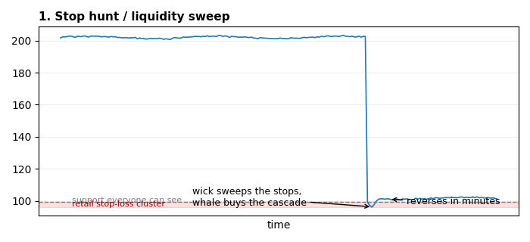
Stop hunt / liquidity sweep
Retail stops below obvious support are resting sell orders - guaranteed liquidity. A push into the cluster makes the stops do the selling; the attacker buys the cascade and price snaps back.
Defense: no tight stops (your W/B use wide -25% disaster stops only); your backtest showed a -5% stop destroyed 88% of W's edge - that loss was this chart.
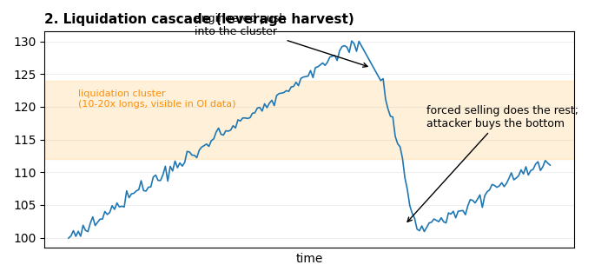
Liquidation cascade
Open interest and funding reveal where leveraged longs get force-closed. Push price into the zone and the exchange's liquidation engine sells billions with zero price sensitivity.
Defense: spot only, no leverage. A liquidation price is a stop-loss you don't control.
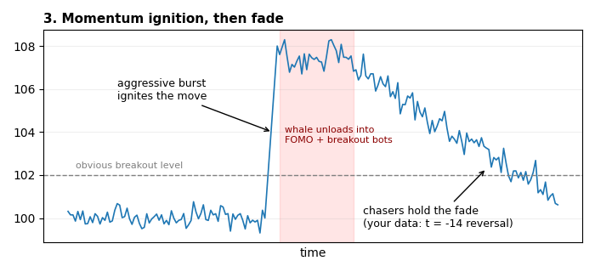
Momentum ignition, then fade
A short aggressive burst punches an obvious level, waking breakout bots and FOMO. The igniter unloads into the chase. Your factor study measured the victims: 24h winners underperform with t=-14.
Defense: never chase strength that already ran. Strategy B buys the first hourly close of a 30-DAY high - a level too expensive to fake with a burst.
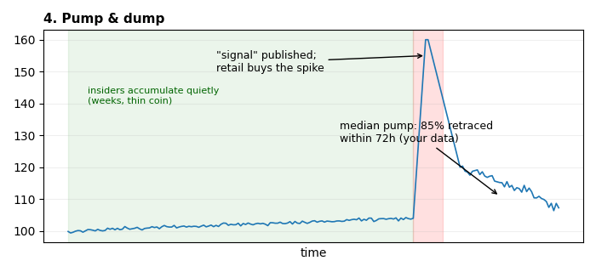
Pump & dump
Organizers accumulate a thin coin for weeks, then publish the 'signal'. The average pump peaks in minutes; your own event study found the median pump retraces 85% within 72h.
Defense: E-combo's silent filter buys BEFORE ignition or not at all; anything already +10% is exit liquidity.
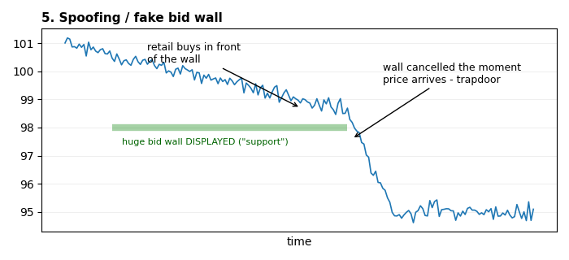
Spoofing / fake walls
Displayed size is free to fake; executed volume is not. The wall exists to trap front-runners, then vanishes.
Defense: your system never reads displayed order books - W reads executed taker flow, which costs real money to fake.
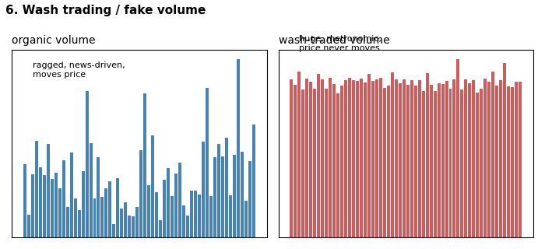
Wash trading / fake volume
Exchanges and tokens trade with themselves to look alive (Bitwise 2019: ~95% of reported BTC volume on unregulated venues was fake). Volume screens lure retail into ghost markets.
Defense: signals only from Binance's real flow; your OKX test empirically showed secondary-venue volume carries no signal.
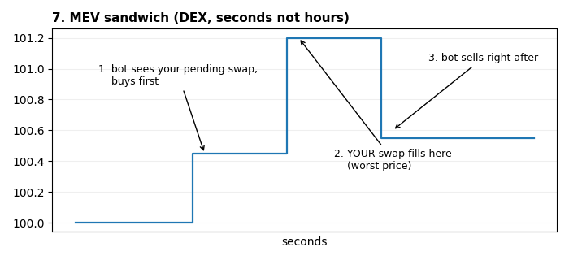
MEV sandwich
On DEXs your pending swap is public. Bots buy ahead of it, let your order move the price, sell behind it - a skim on nearly every naive on-chain swap.
Defense: CEX maker orders don't broadcast intent the same way; on-chain, use private RPCs / tight slippage limits.
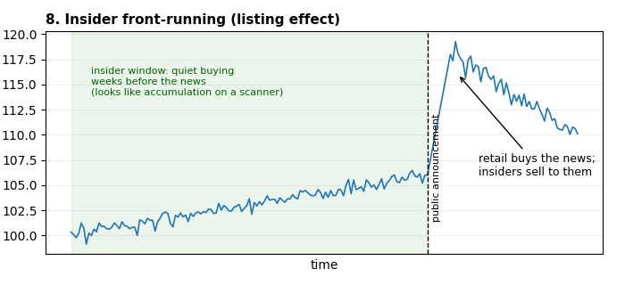
Insider front-running
Quiet buying weeks before non-public catalysts (listings). Crypto's first insider-trading conviction (Wahi, 2022) was exactly this trade.
Defense: none directly - but know that some 'whale accumulation' your W scanner sees is this. The 48% win rate and disaster stop price in that uncertainty.

