Project1: Weather trends analysis

# Overview:

In this project, I have analyzed average temperature of few cities and compared them with the average global temperature. It requires extraction, manipulation and visualization of the data as in the following goals.

# Goals:

Your goal will be to create a visualization and prepare a write up describing the similarities and differences between global temperature trends and temperature trends in cities of your choice.

Create a line chart that compares your city’s temperatures with the global temperatures. Make sure to plot the moving average rather than the yearly averages in order to smooth out the lines, making trends more observable.

Make observations about the similarities and differences between the world averages and your city’s averages, as well as overall trends. Here are some questions to get you started.

# Tools Used:

SQL, Python Jupyter Notebook(matplotlib)

# Step1: Data Extraction:

Used SQL queries as below:

SELECT * FROM city_data;

SELECT * FROM city_data where city = ‘Chicago’;

SELECT * FROM global_data;

# Step2: Moving Average Calculation:

Used Python code as below taking a window_size = 10:

Global moving average-

global_data['avg_temp'].**rolling**(window=window_size).mean()

Phoenix city moving average-

phoenix_data['avg_temp'].**rolling**(window=window_size).mean()

# Step3: Visualizations:

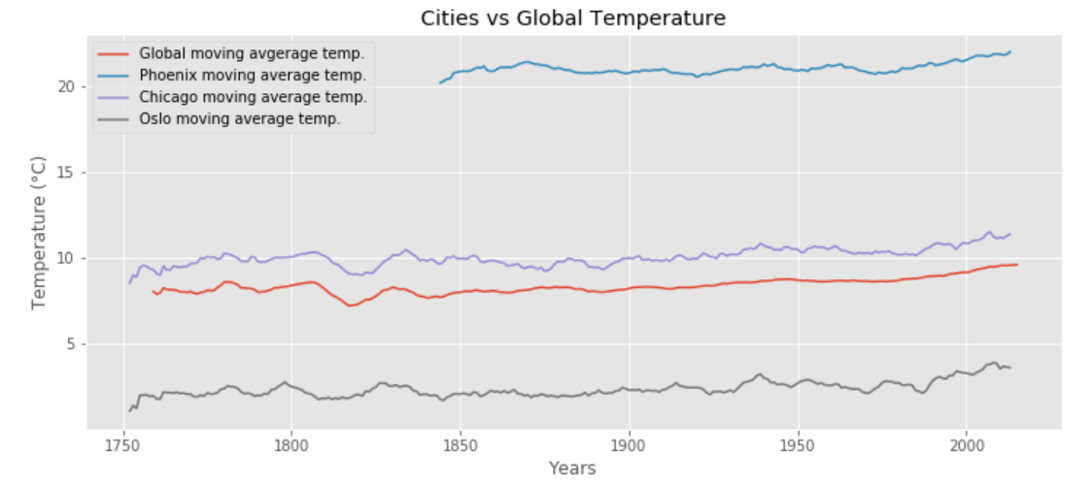

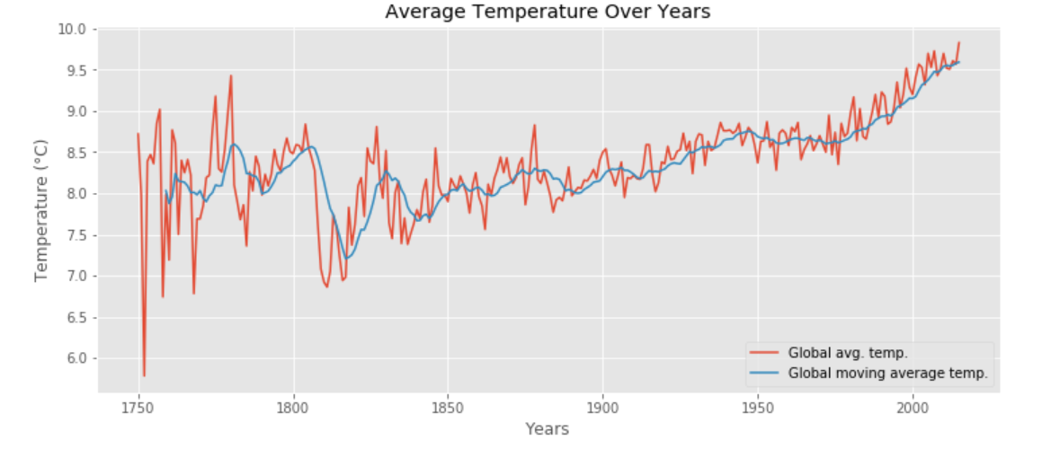

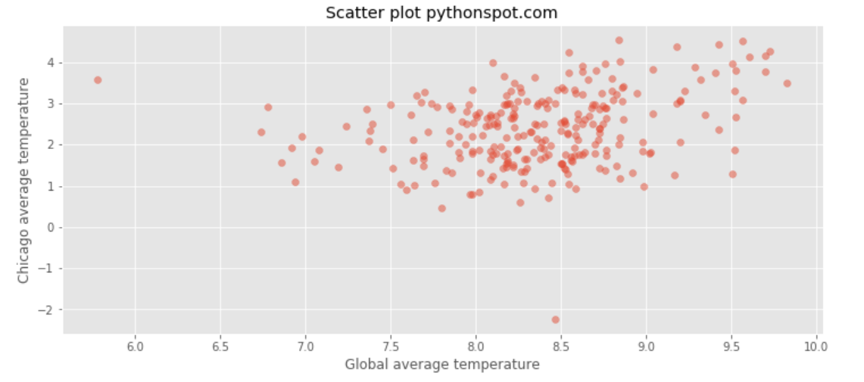

# Step4: Observations:

* Phoenix’s and Chicago’s temperature is higher than global temperature, and Phoenix is a much hotter city as temperature difference is very high
* Oslo’s temperature is even lower than Global temperature, hence a very cold city.
* Difference between Global and Chicago’s temperature is approximately consistent over the years. Also, the sudden drop in temperature around the year 1820 is consistent in both global and Chicago.
* Overall trend of the global temperature is increasing (especially in the last 40 years)
* Except for the few outliers, there is a high correlation between Global and Chicago’s temperature