<Outline>
<1: Optical architecture search (OAS): problem formulation>
<2: Architecture>
<2.1: Physical optical system>
<2.2: Optical element>
<2.3: Object volume>
<2.4: Architecture>
<2.5: Search space>
<3: Task & dataset>
<3.1: Task>
<3.2: Dataset>
<4: Loss function>
<5: Example tasks>

Section 1: Optical architecture search (OAS): problem formulation

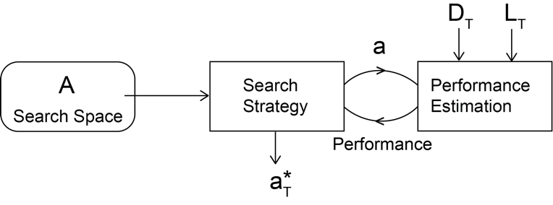
Fig.1. Overview of the proposed optical architecture search.

Let $A$ be the space of all possible (or considered) optical architectures (See Fig1). Let $a∈A$ be an optical architecture (see Section X). Let $T$ be the imaging task of interest (see section X). Then we define the problem of optical architecture search as finding an approximate solution to the following optimization.

$a_{T}^{*}=\min_{a∈A}{L\left(a,w^{*}\left(a\right),D_{T}^{val}\right) }$ s.t. $w^{*}\left(a\right)=\min_{w(a)}{L\left(a,w(a),D_{T}^{train}\right) }$

Here $w(a)$ is the set of values of the parameters of the architecture $a$. $D_{T}^{train}$ and $D_{T}^{val}$ are the training and validation split of the dataset $D_{T}$ that characterizes the imaging task $T$. $L$ is an appropriate loss function. Note that $w^{*}\left(a\right)$ and $a_{T}^{*}$ are respectively the optimal parameters of $a$ and optimal architecture $a_{T}^{*}$ under $L$ given $D_{T}$.

Thus, our design problem is fully defined by three components: an architecture ($a$); a task ($T$) and its corresponding a dataset ($D_{T}$); and a loss function ($L$).

Section 2: The optical architectures ($a$) and the search space of architectures ($A$)

Section 2.1: Definition of a physical optical system.
In this section we introduce the idea of a physical optical system (Fig.2). We first define a physical cartesian coordinate system $x, y, z$.

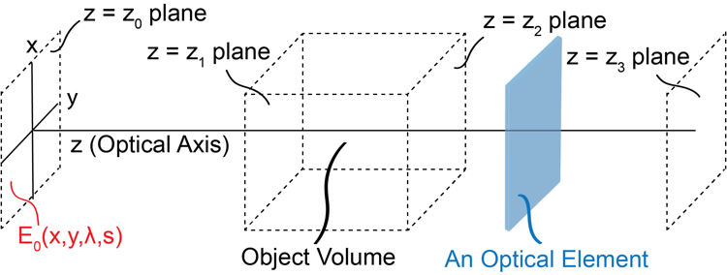

Fig.2 Conceptualization of an optical architecture.

We define $z$ as the optical axis along which the light propagates. Each plane orthogonal to $z$ is defined as a z-plane; The electric field across each z-plane is defined as $E_{z}(x,y,λ,s)$, where $λ$ corresponds to the wavelength of the light, and $s$ corresponds to an independent light source. We define four special z-planes, $z_{0}$, $z_{1},z_{2}$, and $z_{3}$. $z_{0}$ is the input z-plane. We define an input electric field $E_{0}$ at $z_{0}$. $E_{0}$ is fully described by the illumination light source. Between $z_{1}$and $z_{2}$ we model the volumetric object being imaged (for a thin object $z_{1}=z_{2}$), s.t. $E_{1}$ is the input light field to the object and $E_{2}$ is the output light field from the object. Last $z_{3}$is the measurement z-plane, where a detector is placed. The light source, the object, and the detector are defined by the task $T$ and do not contain any learnable parameters. All learnable parameters are related to the “optical elements” placed between $z_{0}$and $z_{1}$ and $z_{2}$ and $z_{3}$. We next introduce the concept of an optical element.

Section 2.2: Definition of an optical element
An optical element is defined as a transfer function $E_{out}=f_{i}(E_{in}|w_{i})$ where, $E_{in}$ and $E_{out}$ are the input and output light fields to the element. $w_{i}=(w_{0},w_{1},w_{2},…)$ are the parameters of the optical element. A typical optical element consists of light matter interaction process and a light propagation process through a medium. Thus, the input z-plane of an optical element is the same as the output z-plane of the previous optical element.

Section 2.3: Definition of the object volume
The object volume, $h$, is defined as a special optical element with two inputs, the input electric field and a 3D object $x_{j}$, and no learnable parameters.
$$E_{out}=h(E_{in},x_{j})$$

Section 2.4: Definition of an architecture, $a$
An optical architecture is defined as -and fully explained by- two sequences of optical elements.
$$a=\left(\left(f_{1},f_{2},f_{3},…\right),\left(g_{1},g_{2},g_{3},…\right)\right)$$
The first sequence, $\left(f_{1},f_{2},f_{3},…\right)$, represents the illumination optics, and the second sequence, $\left(g_{1},g_{2},g_{3},…\right)$, represents the imaging optics.

Section 2.5: Definition of the search space $A$
The search space $A$ consists of all possible combinations of sequences of optical elements.

Section 3: The imaging task ($T$) and its corresponding dataset ($D_{T}$)

Section 3.1: Definition of a task
We define an imaging task as a function or a procedure $T$ from a simulated 3D object $x_{j}∈X$ to its corresponding 2D target output light intensity field $y_{j}$ on an optical sensor, $S,$ s.t.
$$y_{j}=T\left(x_{j} | E_{0},S\right)$$
As explained in section 2.1, $E_{0}$ is the input electric field at the source z-plane $z_{0}$. $S$ represents the sensor; $S$ is defined as a function that transforms the electric field $E_{3}$ (at the measurement plane $z_{3}$), to a digital image $y_{j}$.
$$y_{j}=S\left(E_{3}\right)$$
$X$ is the distribution of expected 3D objects.

Section 3.2: The dataset $D_{T}$
We use $T$ to simulate $y_{i}$ given $x_{i}$ (see section xx for examples) so that we can generate a dataset of paired inputs and outputs to solve the optimization problem in Section 1. Given $P_{T}$ to generate $D_{T}=\{\left(x_{1},y_{1}\right),\left(x_{2},y_{2}\right),…,\left(x_{N},y_{N}\right)\}$ we follow the steps below.

Step 1: Simulate a randomly drawn instance $x_{j}∈X$ such that each voxel contains all optical properties relevant to the task $T$.
Step 2: Use $T$ to simulate the corresponding $y_{j}$.
Step 3: Repeat steps1 and 2 for each data point.

Section 4: The loss function, ($L$)
We define the loss function over the dataset $D_{T}^{'}$ as,

$$L\left(a,w\left(a\right),D_{T}^{'}\right)=\frac{1}{{\left\|D_{T}^{'}\right\|}_{0}}\sum_{\left(x_{j},y_{j}\right)∈D_{T}^{'}}{loss}\left(S\left(G\left(h\left(F(E_{0}),x_{j}\right)\right)\right),y_{j}\right)$$

Here, $F\left(.\right)=f_{N}\left(f_{N-1}\left(…\left(f_{1}\left(.\right)\right)…\right)\right)$ and $G\left(.\right)=g_{N}\left(g_{N-1}\left(…\left(g_{1}\left(.\right)\right)…\right)\right)$ are respectively the transfer functions of the illumination and imaging optics. They contain the learnable parameters. $loss(.)$ is a distance function (like MSE or L1) between the response of the learnable optical system and the target. ${\left\|D_{T}^{'}\right\|}_{0}$ is the cardinality of $D_{T}^{'}$.

Section 5: Example tasks

In this section we define a set of tasks to demonstrate our OAS approach.

3.1. Coherent imaging of a thin amplitude object: We first consider the simplest imaging task that relays one image plane to another with a desired magnification $m$. Traditionally this is performed using two lenses with different focal lengths placed at what is known as a $4f$ configuration.

We first define a thin object $x_{i}$ as a random amplitude mask, s.t. each spatial location $x_{i}(x,y)∈R$, and $x,y ∈[-r,r]$. Note that the mask is defined over a $2r×2r$ region centered at the optical axis. The corresponding intensity field at the output, $y_{i}$ is then given by,
$$y_{i}\left(x,y\right)=T\left(x_{j}\left(\frac{x}{m},\frac{y}{m}\right) | E_{0}=U,S=S_{IdealCam}\right)$$
Here the electric field from the source is a uniform field, $U$, and the sensor is an ideal camera,
$S_{IdealCam}\left(E_{3}\right)\sim Poisson\left({\left|E_{3}\right|}^{2}\right)$.

