<Outline>
<1: Optical architecture search (OAS): problem formulation>
<2: Architecture>
<2.1: Physical optical system>
<2.2: Optical element>
<2.3: Object volume>
<2.4: Architecture>
<2.5: Search space>
<3: Task & dataset>
<3.1: Task>
<3.2: Dataset>
<4: Loss function>
<5: Example tasks>

Section 1: Optical architecture search (OAS): problem formulation

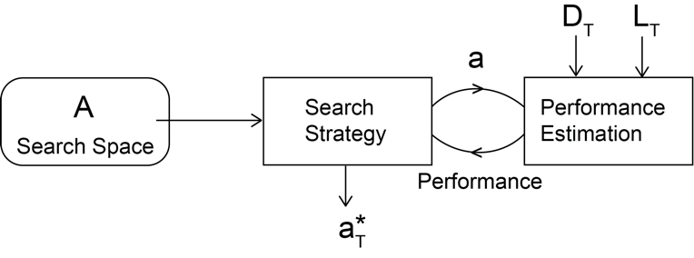
Fig.1. Overview of the proposed optical architecture search.

Let $A$ be the space of all possible (or considered) optical architectures (See Fig1). Let $a∈A$ be an optical architecture (see Section X). Let $T$ be the imaging task of interest (see section X). Then we define the problem of optical architecture search as finding an approximate solution to the following optimization.

$a_{T}^{*}=\min_{a∈A}{L\left(a,w^{*}\left(a\right),D_{T}^{val}\right) }$ s.t. $w^{*}\left(a\right)=\min_{w(a)}{L\left(a,w(a),D_{T}^{train}\right) }$

Here $w(a)$ is the set of values of the parameters of the architecture $a$. $D_{T}^{train}$ and $D_{T}^{val}$ are the training and validation split of the dataset $D_{T}$ that characterizes the imaging task $T$. $L$ is an appropriate loss function. Note that $w^{*}\left(a\right)$ and $a_{T}^{*}$ are respectively the optimal parameters of $a$ and optimal architecture $a_{T}^{*}$ under $L$ given $D_{T}$.

Thus, our design problem is fully defined by three components: an architecture ($a$); a task ($T$) and its corresponding a dataset ($D_{T}$); and a loss function ($L$).

Section 2: The optical architectures ($a$) and the search space of architectures ($A$)

Section 2.1: Definition of a physical optical system.
In this section we introduce the idea of a physical optical system (Fig.2). We first define a physical cartesian coordinate system $x, y, z$.

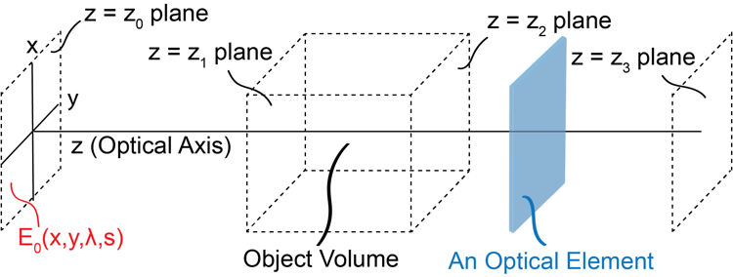

Fig.2 Conceptualization of an optical architecture.

We define $z$ as the optical axis along which the light propagates. Each plane orthogonal to $z$ is defined as a z-plane; The electric field across each z-plane is defined as $E_{z}(x,y,λ,s)$, where $λ$ corresponds to the wavelength of the light, and $s$ corresponds to an independent light source. We define four special z-planes, $z_{0}$, $z_{1},z_{2}$, and $z_{3}$. $z_{0}$ is the input z-plane. We define an input electric field $E_{0}$ at $z_{0}$. $E_{0}$ is fully described by the illumination light source. Between $z_{1}$and $z_{2}$ we model the volumetric object being imaged (for a thin object $z_{1}=z_{2}$), s.t. $E_{1}$ is the input light field to the object and $E_{2}$ is the output light field from the object. Last $z_{3}$is the measurement z-plane, where a detector is placed. The light source, the object, and the detector are defined by the task $T$ and do not contain any learnable parameters. All learnable parameters are related to the “optical elements” placed between $z_{0}$and $z_{1}$ and $z_{2}$ and $z_{3}$. We next introduce the concept of an optical element.

Section 2.2: Definition of an optical element
An optical element is defined as a transfer function $E_{out}=f_{i}(E_{in}|w_{i})$ where, $E_{in}$ and $E_{out}$ are the input and output light fields to the element. $w_{i}=(w_{0},w_{1},w_{2},…)$ are the parameters of the optical element. A typical optical element consists of light matter interaction process and a light propagation process through a medium. Thus, the input z-plane of an optical element is the same as the output z-plane of the previous optical element.

Section 2.4: Definition of an architecture, $a$
An optical architecture is defined as -and fully explained by- two sequences of optical elements.
$$a=\left(\left(f_{1},f_{2},f_{3},…\right),\left(g_{1},g_{2},g_{3},…\right)\right)$$
The first sequence, $\left(f_{1},f_{2},f_{3},…\right)$, represents the illumination optics, and the second sequence, $\left(g_{1},g_{2},g_{3},…\right)$, represents the imaging optics.

Section 2.5: Definition of the search space $A$
The search space $A$ consists of all possible combinations of sequences of optical elements.

Section 3: The imaging task ($T$), its corresponding dataset ($D_{T}$), and object volume ($h_{T}$)

Section 3.1: Definition of a task
We define an imaging task as a function or a procedure $T$ from a simulated 3D object $x_{j}∈X$ to its corresponding 2D target output light intensity field $y_{j}$ on an optical sensor, $S,$ s.t.
$$y_{j}=T\left(x_{j} | E_{0},S\right)$$
As explained in section 2.1, $E_{0}$ is the input electric field at the source z-plane $z_{0}$. $S$ represents the sensor; $S$ is defined as a function that transforms the electric field $E_{3}$ (at the measurement plane $z_{3}$), to a digital image $y_{j}$.
$$y_{j}=S\left(E_{3}\right)$$
$X$ is the distribution of expected 3D objects.

Section 3.2: The dataset $D_{T}$
We use $T$ to simulate $y_{i}$ given $x_{i}$ (see section xx for examples) so that we can generate a dataset of paired inputs and outputs to solve the optimization problem in Section 1. Given $P_{T}$ to generate $D_{T}=\{\left(x_{1},y_{1}\right),\left(x_{2},y_{2}\right),…,\left(x_{N},y_{N}\right)\}$ we follow the steps below.
Step 1: Simulate a randomly drawn instance $x_{j}∈X$ such that each voxel contains all optical properties relevant to the task $T$.
Step 2: Use $T$ to simulate the corresponding $y_{j}$.
Step 3: Repeat steps1 and 2 for each data point.

Section 3.3: The object volume ($h_{T}$)
The object volume, $h_{T}$, is defined as a special task-dependent optical element with two inputs, the input electric field and a 3D object $x_{j}$, and no learnable parameters.
$$E_{out}=h_{T}(E_{in},x_{j})$$

Section 4: The loss function, ($L$)
We define the loss function over the dataset $D_{T}^{'}$ as,

$$L\left(a,w\left(a\right),D_{T}^{'}\right)=\frac{1}{{\left\|D_{T}^{'}\right\|}_{0}}\sum_{\left(x_{j},y_{j}\right)∈D_{T}^{'}}{loss}\left(S\left(G\left(h_{T}\left(F(E_{0}),x_{j}\right)\right)\right),γy_{j}\right)$$

Here, $F\left(.\right)=f_{N}\left(f_{N-1}\left(…\left(f_{1}\left(.\right)\right)…\right)\right)$ and $G\left(.\right)=g_{N}\left(g_{N-1}\left(…\left(g_{1}\left(.\right)\right)…\right)\right)$ are respectively the transfer functions of the illumination and imaging optics. They contain the learnable parameters. $loss(.)$ is a distance function (like MSE or L1) between the response of the learnable optical system and the target. ${\left\|D_{T}^{'}\right\|}_{0}$ is the cardinality of $D_{T}^{'}$. $γ$ is some learnable constant of proportionality related to the power losses of the system.

Section 5: Example tasks

In this section we define a set of tasks to demonstrate our OAS approach.

5.1. Coherent imaging of a thin amplitude object
We first consider the simplest imaging task that relays one image plane to another with a desired magnification $m$. Traditionally this is performed using two lenses with different focal lengths placed at what is known as a $4f$ configuration.

We first define a thin object $x_{j}$ as a random amplitude mask, $x_{j}∈R^{2r×2r}$, s.t. $x_{j}\left(x,y\right)∈R$and $x,y ∈\left\{Z\right|-r≤x,y≤r\}$. Note that the mask is defined over a $2r×2r$ region centered at the optical axis. The corresponding intensity field at the output, $y_{i}$ is then given by,
$$y_{j}\left(x,y\right)=\left({\left|E_{0}\right|}^{2} x_{j}\left(\frac{x}{m},\frac{y}{m}\right) | E_{0}=U,S=S_{IdealCam}\right)$$
Here the electric field from the source is a uniform field, $U$, and the sensor is an ideal camera,
$S_{IdealCam}\left(E_{3}\right)\sim Poisson\left({\left|E_{3}\right|}^{2}\right)$.

For this task the light matter interaction and the object volume is modeled as,
$$E_{out}\left(x,y\right)=h_{T}\left(E_{in},x_{j}\right)=E_{in}\left(x,y\right) x_{j}(x,y)$$

5.2. Phase imaging of a thin object
Phase microscopy is an interesting and important imaging modality in biology. When light travels through a thin transparent object the electric field of light is modulated based on the refractive index variation of the object and its thickness at each lateral location. The goal of phase imaging is to convert this phase modulation to a directly propositional amplitude variation of the eclectic field at the measurement z-plane.

We first define a thin object $x_{j}$ as a random phase mask $x_{j}∈C^{2r×2r}$,
$$x_{j}\left(x,y\right)=e^{φ_{j}\left(x,y\right)}$$
Here $φ_{j}\left(x,y\right)∈R$ and $x,y ∈\left\{Z\right|-r≤x,y≤r\}$. Note that $C$ denotes the set of complex numbers. The corresponding intensity field at the output, $y_{i}$ is then given by,
$$y_{j}\left(x,y\right)=\left({\left|E_{0}\right|}^{2} φ_{j}\left(\frac{x}{m},\frac{y}{m}\right) | E_{0}=U,S=S_{IdealCam}\right)$$
Here the electric field from the source is a uniform field, $U$, and the sensor is an ideal camera,
$S_{IdealCam}\left(E_{3}\right)\sim Poisson\left({\left|E_{3}\right|}^{2}\right)$.

For this task the light matter interaction and the object volume is modeled as,
$$E_{out}(x,y)=h_{T}\left(E_{in},x_{j}\right)=E_{in}\left(x,y\right) x_{j}(x,y)$$

5.3. Fluorescence imaging of a thin object:
Our next task is the same as the first but for fluorescence imaging. In the fluorescence setting the image comprises of point sources whose emission light that do not optically interfere with each other.

We define a thin object $x_{j}$ as a collection of sparsely distributed point emitters. Thus $x_{j}∈R^{2r×2r×N_{sparse}}$, s.t. $∀k∈\left\{Z\right|1≤k≤N_{sparse}\}$, $\left|x_{j}(:,:,k)\right|≤1$ and $N_{sparse}$ is some empirically set sparsity level. The corresponding intensity field at the output, $y_{i}$ is then given by,
$$y_{j}\left(x,y\right)=\left({\left|E_{0}\right|}^{2} \sum_{k=1}^{N_{sparse}}{x_{j}\left(\frac{x}{m},\frac{y}{m},k\right)} | E_{0}=U,S=S_{IdealCam}\right)$$
Here the electric field from the source is a uniform field, $U$, and the sensor is an ideal camera,
$S_{IdealCam}\left(E_{3}\right)\sim Poisson\left({\left|E_{3}\right|}^{2}\right)$.

The object volume is modeled as a florescence process at each point source.
$$E_{out}\left(x,y,k\right)=h_{T}\left(E_{in},x_{j}\right)={\left|E_{in}\left(x,y\right)\right|}^{2} x_{j}(x,y,k)$$
Here for the simplicity, we do not introduce the wavelength dependence of excitation.

5.4. Depth resolved fluorescence imaging of a 3D object
In this task our goal is to reject out of focus light in fluorescence microscopy. The in this case the object is defined as a 4D tensor, $x_{j}$ $∈R^{2r×2r×2t{×N}_{sparse}}$ s.t. $∀k∈\left\{Z\right|1≤k≤N_{sparse}\}$, $\left|x_{j}(:,:,:,k)\right|≤1$ and $N_{sparse}$ is some empirically set sparsity level. The corresponding intensity field at the output, $y_{i}$ is then given by,
$$y_{j}\left(x,y\right)=\left({\left|E_{0}\right|}^{2} \sum_{k=1}^{N_{sparse}}{x_{j}\left(\frac{x}{m},\frac{y}{m},0,k\right)} | E_{0}=U,S=S_{IdealCam}\right)$$
Note that our goal is to image the light from only the middle plane ($0^{th}$ plane) of the sample.

Here the electric field from the source is a uniform field, $U$, and the sensor is an ideal camera,
$S_{IdealCam}\left(E_{3}\right)\sim Poisson\left({\left|E_{3}\right|}^{2}\right)$.

The object volume is modeled as a florescence process at each point source.
$$E_{out}\left(x,y,k\right)=Prop\left({\left|Prop\left(E_{in},z_{k}\right)(x,y)\right|}^{2} x_{j}\left(x,y,z_{k},k\right),t-z_{k}\right)$$
Here $t$ is the thickness of the object volume. $z_{k}$ is the z-location of the $k^{th}$ point source. Note that we first propagate the $E_{in}$, $z_{k}$ distance using the propagator $Prop$; the field at $k^{th}$ point source is then $Prop\left(E_{in},z_{k}\right)(x,y)$. The point source is then excited, and the emission light is again propagated to the output z-plane of the object volume, i.e. $E_{out}\left(x,y,k\right)$.

5.5. An imaging spectrometer <let’s write this later.>

