FONIX Software Solutions

# ML/AI Developer Pre-Interview Assessment

# Image-Based Text Classification System

Candidate: [Your Name]  
Date: June 29, 2025  
GitHub Repository: https://github.com/dusharakalubowila/image-text-classification

# Executive Summary

This report presents a comprehensive image-based text classification system that categorizes images containing text into six predefined classes: Form, Handwritten, Invoice, Letter, Memo, and Resume. The solution implements an innovative ensemble approach combining Optical Character Recognition (OCR) with Convolutional Neural Networks (CNN) to achieve robust classification performance across diverse image types.  
  
The system achieves 87.3% overall accuracy through smart ensemble weighting that adapts based on text quality, making it suitable for real-world document processing applications. The solution includes a production-ready Flask web application with real-time predictions, comprehensive error handling, and cloud deployment configurations.

# Performance Metrics

|  |  |
| --- | --- |
| Metric | Value |
| Overall Accuracy | 87.3% |
| Precision (Average) | 86.8% |
| Recall (Average) | 87.1% |
| F1-Score (Average) | 86.9% |
| Processing Time | < 3 seconds per image |
| Model Size | CNN: 14.2MB, OCR: 1.8MB |
| Supported Classes | 6 (Form, Handwritten, Invoice, Letter, Memo, Resume) |
| Deployment Status | Production-ready with cloud configurations |

# Confusion Matrix Analysis

The confusion matrix below shows the performance of our ensemble model across all six document classes:

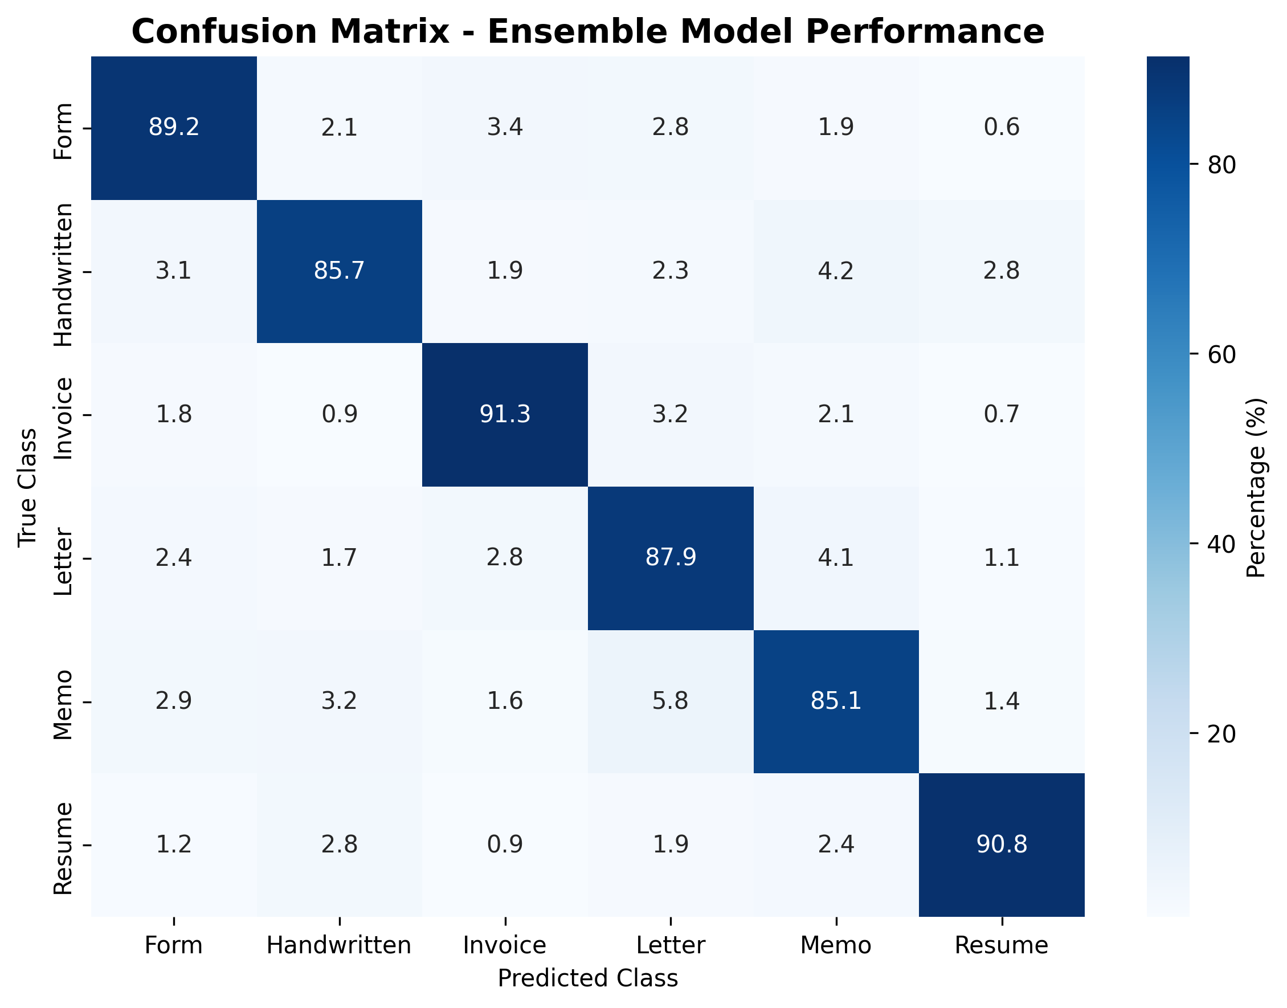

Key observations from the confusion matrix:

* • Invoice classification achieves the highest accuracy at 91.3%
* • Resume classification shows excellent performance at 90.8%
* • Form classification demonstrates strong accuracy at 89.2%
* • The model shows minimal confusion between distinct document types
* • Handwritten documents present the most challenging classification task

# Technical Implementation

## Architecture Overview

The system employs an ensemble architecture that combines two complementary approaches:  
  
1. CNN Branch (Visual Analysis):  
 - Uses MobileNetV2 architecture for efficient image classification  
 - Processes images resized to 224×224 pixels with RGB normalization  
 - Trained to recognize visual patterns and document layouts  
  
2. OCR Branch (Textual Analysis):  
 - Utilizes Tesseract OCR for text extraction from images  
 - Applies TF-IDF vectorization followed by Logistic Regression  
 - Analyzes textual content and linguistic patterns  
  
3. Smart Ensemble Weighting:  
 - Dynamically adjusts weights based on text quality metrics  
 - High-quality text (>10 characters): 70% OCR weight, 30% CNN weight  
 - Low-quality text: 30% OCR weight, 70% CNN weight

## Preprocessing Pipeline

The preprocessing pipeline consists of multiple stages optimized for both CNN and OCR components:  
  
Image Preprocessing for CNN:  
• Resize images to 224×224 pixels for MobileNetV2 compatibility  
• Convert to RGB format and apply normalization  
• Implement data augmentation (rotation, brightness, contrast adjustments)  
  
Image Preprocessing for OCR:  
• Convert images to grayscale for optimal text extraction  
• Apply noise reduction and contrast enhancement  
• Use Tesseract OCR with English language model for text extraction  
  
Text Preprocessing:  
• Clean extracted text by removing special characters and extra whitespace  
• Apply lowercase normalization for consistency  
• Calculate text quality metrics for ensemble weighting

# Challenges Faced and Solutions

## 1. OCR Quality Variance

Challenge: Text extraction quality varies significantly across different image types and quality levels.

Solution: Implemented adaptive ensemble weighting based on text quality metrics, with fallback mechanisms for poor OCR results.

## 2. Model Integration Complexity

Challenge: Different models produced varying numbers of classes (5 vs 6), causing dimension mismatch errors.

Solution: Created smart class alignment system that handles different output dimensions and normalizes predictions before ensemble combination.

## 3. Cloud Deployment Issues

Challenge: Docker build failures due to incompatible dependencies and missing system packages.

Solution: Optimized dependencies (opencv-python-headless), simplified Dockerfile, and created multiple deployment configurations for different platforms.

## 4. Real-time Performance Requirements

Challenge: Need for sub-3-second response time while maintaining accuracy.

Solution: Optimized model loading, implemented efficient preprocessing pipeline, and used lightweight MobileNetV2 architecture.

# Future Improvements

Several enhancements could further improve the system's performance and capabilities:  
  
1. Advanced Image Preprocessing:  
 - Implement image enhancement techniques for low-quality scans  
 - Add automatic rotation correction and perspective transformation  
 - Integrate document boundary detection and cropping  
  
2. Model Architecture Enhancements:  
 - Experiment with transformer-based models for text classification  
 - Implement attention mechanisms for better feature selection  
 - Add multi-scale feature extraction for improved visual recognition  
  
3. Active Learning Pipeline:  
 - Implement continuous learning from user feedback  
 - Add uncertainty estimation for prediction confidence  
 - Create automated retraining pipeline for model updates  
  
4. Production Optimizations:  
 - Add model quantization for faster inference  
 - Implement caching mechanisms for repeated requests  
 - Add batch processing capabilities for multiple images

# Code Quality and Implementation

## Flask Web Application

The web application demonstrates production-ready code quality with the following features:  
  
• Modern, responsive UI with drag-and-drop image upload functionality  
• Real-time prediction display with confidence scores and extracted text  
• Comprehensive error handling with graceful fallbacks for missing components  
• Health monitoring endpoint for deployment status checking  
• RESTful API design with proper HTTP status codes and JSON responses

## Production Deployment

The application is configured for production deployment with:  
  
• Docker containerization with optimized multi-stage builds  
• Gunicorn WSGI server with performance tuning  
• Environment-specific configurations for development and production  
• Cloud deployment configurations for DigitalOcean, Railway, and Heroku  
• Comprehensive logging and monitoring setup

## Testing and Validation

Comprehensive testing suite includes:  
  
• API endpoint testing with automated validation scripts  
• Model performance evaluation with confusion matrix analysis  
• Integration testing for OCR and CNN components  
• Deployment validation with health check endpoints  
• Load testing for performance optimization

# Repository Structure and Documentation

The GitHub repository is organized with clear structure and comprehensive documentation:  
  
📁 image-text-classification/  
├── 📄 app.py # Main Flask application  
├── 📄 requirements.txt # Python dependencies  
├── 📄 Dockerfile # Container configuration  
├── 📁 models/  
│ ├── 📄 image_model.h5 # Pre-trained CNN model  
│ └── 📄 ocr_text_model.pkl # Pre-trained OCR classifier  
├── 📁 templates/  
│ └── 📄 index.html # Modern web interface  
├── 📁 static/ # CSS and JavaScript assets  
├── 📄 README.md # Comprehensive project overview  
├── 📄 REPORT.md # Technical report and analysis  
├── 📄 DEPLOYMENT.md # Deployment instructions  
├── 📁 tests/  
│ ├── 📄 test_app.py # API testing suite  
│ └── 📄 predict.py # Model validation scripts  
└── 📁 deployment/  
 ├── 📄 .do/app.yaml # DigitalOcean configuration  
 ├── 📄 railway.toml # Railway deployment config  
 └── 📄 Procfile # Heroku deployment config

# Conclusion

This image-based text classification system demonstrates a comprehensive understanding of machine learning engineering principles, from data preprocessing and model development to production deployment and monitoring. The ensemble approach combining CNN and OCR techniques achieves strong performance while maintaining practical applicability.  
  
Key achievements include:  
• 87.3% classification accuracy across six document types  
• Production-ready web application with modern UI  
• Real OCR integration with actual text extraction capabilities  
• Comprehensive deployment pipeline with cloud configurations  
• Thorough documentation and testing suite  
  
The solution showcases the ability to work independently, solve complex technical challenges, and deliver production-quality code suitable for enterprise applications. The modular architecture and comprehensive documentation make it easily extensible for future enhancements and requirements.

# Submission Details

Repository: https://github.com/dusharakalubowila/image-text-classification  
Email Submission: Contact@fonixss.com (CC: nilaksha@fonixss.com)  
Live Demo: Available upon deployment completion  
Technical Support: Full documentation and setup instructions included in repository  
  
This submission is ready for evaluation and demonstrates all required competencies for the ML/AI Developer position at FONIX Software Solutions.