**PROJECT CYRUS**

***FUNCTIONAL SPECIFICATION***

Can you count, suckers? I say, the future is ours, if **you** can count.

***Project Name: Cyrus (code name)***

***Company: Dushkin Digital Media, LLC***

***Focus Area: Location-Based Social Gaming***

***Prepared By: Peter Dushkin***

**Document Revision History:**

|  |  |  |  |
| --- | --- | --- | --- |
| Version | Date | Author | Change Description |
| 0.0.0 | 7.20. 16 | Peter Dushkin | Document creation, Introduction |
| 0.0.0 | 7.21.16 | Peter Dushkin | Formatting |
| 0.1.0 | 7.25.16 | Peter Dushkin | Business Rules (Accounts, Profiles, Tribes) |
| 0.1.0 | 7.26.16 | Peter Dushkin | Business Rules (Health, Weapons, Battles) |
| 0.1.0 | 7.26.16 | Peter Dushkin | Use Cases (Accounts, Profiles) |
| 0.1.0 | 7.30.16 | Peter Dushkin | Account Types |
| 0.1.0 | 8.01.16 | Peter Dushkin | Added Navigation, Search, Ammunition, and Tutorials |
| 0.1.0 | 8.01.16 | Peter Dushkin | Reworking Rules -> User Requirements |
| 0.2.0 | 8.03.16 | Peter Dushkin | Completed User Requirements Revisions |
| 0.2.0 | 8.08.16 | Peter Dushkin | Screen Catalog: Battles, Navigation |
|  |  |  |  |
|  |  |  |  |
|  |  |  |  |
|  |  |  |  |
|  |  |  |  |

Table of Contents

1 Introduction 3

1.1 Purpose 3

1.2 Scope 3

1.3 Background 3

1.4 References 3

1.5 Assumptions & Constraints 4

1.6 Document Overview 4

2 Methodology 5

3 Context 5

4 User Requirements 5

4.1.1 Tutorial 5

4.1.2 Accounts 5

4.1.3 Navigation 8

4.1.4 Profiles 8

4.1.5 Location Services 10

4.1.6 Tribes 11

4.1.7 Health 11

4.1.8 Weapons 13

4.1.9 Ammunition 14

4.2.0 Battles 14

5 Navigation & Screen Flow 16

5.1.1 First Use 16

5.1.2 Tribe Requests 16

5.1.3 Locating Players 17

6 Screen Catalog 20

6.1.1 First Use 20

6.1.2 Accounts 20

6.1.3 Profiles 22

6.1.4 Navigation 28

6.1.5 Battles 31

# 1 Introduction

Project Cyrus is a highly interactive, social, mobile application that simulates a real-world game of “tag”. Separating itself from passive mobile games, the location-aware mobile application forces its participants to interact with each-other in the real-world, using their devices as a common stage.

[TODO: A Brief Description of the Game]

## Concept

## 1.2 Scope

## 1.3 Background

The center-piece of Project Cyrus is the map. It is the application’s stage. Like a chessboard, players track pieces here – deciding when to move aggressively and when to defend. Players will also rely on their maps in order to build their territorial positions through alliances. In terms of application design, *the map is everything*.

Group management will also play a key role in the design of Project Cyrus. Players increase their chances of survival when they form alliances. Alliances are made by befriending other players and being accepted into a “Tribe” or group of similarly entitled participants.

Finally, the technical IQ behind player-to-player engagements requires further clarification. In order to get players to play in an active way – by moving through the physical world – tagging must be allowed in only a set, limited, proximity from each other. Proximity is an important restriction of the game, and it must be sniper-fire accurate. Without establishing 100% technical credibility in terms of in-game accuracy, the game will fail. All the time and effort in the world must be expended to get things right on day-one.

Finally, other usability, albeit technical, considerations will be important during design-time. Questions such as the game’s demand on phone power consumption, and checks and balances to ensure fair play, will factor into the applications overall design.

## Reference Games

## Terminology

The document contains the following definitions:

1. **Stage**: When we are talking about the Stage, we are talking about everything that can happen within the game.
2. **Nearby Stage**: The viewable game environment – what the player can see happening around him on his mobile phone.
3. **Distant Stage**: The non-viewable game environment – what is happening in the game that the user cannot see on his iphone’s map.
4. **Avatar**: The in-game identity of a player.
5. **Arsenal**: The total amount of weapons and ammunition that a player’s avatar has available.

# 2 Methodology

The driving approach behind this project is to pinpoint the hard problems first and ***try to fail.*** In other words, if we fail fast, we have learned quickly and limited our expenses. We have also identified key issues that may or may not be addressable.

|  |  |  |  |
| --- | --- | --- | --- |
| # | Requirement | Proof of Failure | Proof of Success |
| 1 | Proximity | App cannot accurately determine player location. | App can pinpoint proximity within 500 feet. |
| 2 |  | App cannot sufficiently track players when they move. | App can keep other players updated of other player locations. |
| 3 |  |  |  |

# 3 Target Audience

# 4 User Requirements

The below ‘requirements’ determine the guiding structure behind the Project Cyrus application.

Requirements follow the below format.

FORMAT:

**<Subject doing action> <auxiliary verb> <capability or functionality to be provided><criterion that limits or further explains requirement** (optional component)**>**

EXAMPLE:

**<The Company> <shall> <develop an SMS notification system>** enabling patients to **<receive alerts when their prescriptions are ready>.**

## 4.1.1 Tutorial

A tutorial will be necessary to get first-time users started in the game. .

|  |  |  |  |
| --- | --- | --- | --- |
| **#** | **Requirement** | **Sign-Off** | **Phase** |
| 1 | A new User will see a tutorial avatar when he first logs into the system, allowing him to better understand how to use it. | No | Phase III |

## 4.1.2 Accounts

Accounts hold basic information about users. Information that is necessary to identify who they are and what they can do within the system.

*Registration*

We must know who somebody is in order for them to play the game. A user can make him or herself known by signing up using a social network such as Google Plus or Facebook. Alternatively, a user can register within the Cyrus database.

|  |  |  |  |
| --- | --- | --- | --- |
| **#** | **Requirement** | **Sign-Off** | **Phase** |
| 2 | A new User can register using Google Sign-In, allowing him to simplify the signup process. See; https://developers.google.com/identity/sign-in/ios/ | YES | Phase I |

|  |  |  |  |
| --- | --- | --- | --- |
| **#** | **Requirement** | **Sign-Off** | **Phase** |
| 3 | A new User can register using Facebook, allowing him to simplify the signup process. | PENDING | TBD |

|  |  |  |  |
| --- | --- | --- | --- |
| **#** | **Requirement** | **Sign-Off** | **Phase** |
| 4 | A new User can choose to register using the Cyrus database, if he doesn’t have a Google or Facebook account (or doesn’t want to use them). | OK | Phase I |

|  |  |  |  |
| --- | --- | --- | --- |
| **#** | **Requirement** | **Sign-Off** | **Phase** |
| 4 | Certain Users can be Administrators, allowing them to perform privileged tasks in the system. | OK | Phase I |

|  |  |  |  |
| --- | --- | --- | --- |
| **#** | **Requirement** | **Sign-Off** | **Phase** |
| **4** | Anonymous users should be prevented from viewing secured data / secured views in the application. | OK | Phase I |

|  |  |  |  |
| --- | --- | --- | --- |
| **#** | **Requirement** | **Sign-Off** | **Phase** |
| **4** | Once the user is logged in successfully, the system should not ask for credentials or re-authenticate the user for the next 30 minutes. | OK | Phase I |

*Login*

|  |  |  |  |
| --- | --- | --- | --- |
| **#** | **Requirement** | **Sign-Off** | **Phase** |
| 5 | The User will be able to log into the system using either his Cyrus credentials (if registered) or Google Sign-On. | OK | Phase I |

|  |  |  |  |
| --- | --- | --- | --- |
| **#** | **Requirement** | **Sign-Off** | **Phase** |
| 6 | The User will not need to log into the system each time, if he has elected to be remembered by the application. | OK | Phase I |

## 4.1.3 Movement

Movement is a visual representation of player activity as represented by their avatars.

|  |  |  |  |
| --- | --- | --- | --- |
| **#** | **Requirement** | **Sign-Off** | **Phase** |
| 7 | The User will see his avatar simulating his own movement, allowing him to interact with the digital world by moving in the physical world. | OK | P I |

|  |  |  |  |
| --- | --- | --- | --- |
| **#** | **Requirement** | **Sign-Off** | **Phase** |
| 7 | The User will see the activities of others in the Stage as represented by their avatars. | OK | P I |

## 4.1.4 Profiles

A profile is the game-play identity of the registered user.

|  |  |  |  |
| --- | --- | --- | --- |
| **#** | **Requirement** | **Sign-Off** | **Phase** |
| 8 | A User will be able to create a new profile in the system, allowing them to assume a game identity and interact with others in the system. | Yes | Phase I |

|  |  |  |  |
| --- | --- | --- | --- |
| **#** | **Requirement** | **Sign-Off** | **Phase** |
| **8** | A User’s avatar will represent his level in the game. Accordingly, a new player will have only basic avatars available for selection. As the user makes his way and acquires increased health, he will have new avatars offered to him, allowing his profile to reflect his abilities. | Yes | Phase II |

|  |  |  |  |
| --- | --- | --- | --- |
| **#** | **Requirement** | **Sign-Off** | **Phase** |
| 9 | A User will need to start over by creating a new profile, should his avatar get killed during the course of normal game play. This will allow him to continue to play the game. | Yes | Phase I |

|  |  |  |  |
| --- | --- | --- | --- |
| **#** | **Requirement** | **Sign-Off** | **Phase** |
| 10 | A User will see different profile details depending on which profile he is looking it – e.g. his own profile, another person’s profile, another person in the same tribe, etc. | Yes | Phase I |

## 4.1.5 Location Services

Search will be a core feature in the application as it allows players to find each other.

|  |  |  |  |
| --- | --- | --- | --- |
| **#** | **Requirement** | **Sign-Off** | **Phase** |
| 11 | The User will always see nearby players ordered by proximity, allowing him to know who is close and who is far. | OK | P I |

|  |  |  |  |
| --- | --- | --- | --- |
| **#** | **Requirement** | **Sign-Off** | **Phase** |
| 12 | The User will always see nearby weapons, ordered by proximity, allowing him pick them up, adding to his arsenal. | OK | P I |

|  |  |  |  |
| --- | --- | --- | --- |
| **#** | **Requirement** | **Sign-Off** | **Phase** |
| 13 | The User will always see nearby ammunition, ordered by proximity, allowing him to pick more up, adding to his arsenal. | OK | P I |

|  |  |  |  |
| --- | --- | --- | --- |
| **#** | **Requirement** | **Sign-Off** | **Phase** |
| 14 | A user will be able to filter nearby weapons by weapons type. | OK | P I |

|  |  |  |  |
| --- | --- | --- | --- |
| **#** | **Requirement** | **Sign-Off** | **Phase** |
| 15 | A user will be able to filter nearby ammunition by ammunition type. | OK | P I |

|  |  |  |  |
| --- | --- | --- | --- |
| **#** | **Requirement** | **Sign-Off** | **Phase** |
| 16 | A user will be able to filter nearby players by tribe name. | OK | P I |

|  |  |  |  |
| --- | --- | --- | --- |
| **#** | **Requirement** | **Sign-Off** | **Phase** |
| 17 | A user will be able to filter nearby players by “favorites”. | OK | P I |

## 4.1.6 Tribes

A group that is fighting in coordination with each other is known as a “Tribe”. Tribe members support each other - improving a player’s chances in the game.

|  |  |  |  |
| --- | --- | --- | --- |
| **#** | **Requirement** | **Sign-Off** | **Phase** |
| 18 | A User can create a group – called a Tribe – once he has reached a certain level in the game. | OK | P I |

|  |  |  |  |
| --- | --- | --- | --- |
| **#** | **Requirement** | **Sign-Off** | **Phase** |
| 19 | Users on a shared tribe will be able to view all information about each other (except health level), allowing tribe members to know what others are carrying. | OK | P I |

|  |  |  |  |
| --- | --- | --- | --- |
| **#** | **Requirement** | **Sign-Off** | **Phase** |
| 20 | If unaffiliated, a User can request tribe membership from an affiliated player; this must be done in close proximity to the tribe member. | OK | P I |

|  |  |  |  |
| --- | --- | --- | --- |
| **#** | **Requirement** | **Sign-Off** | **Phase** |
| 21 | An unaffiliated user can request as many tribes as he wants until a tribe accepts his request, allowing him to increase his chances of joining. Once on a tribe, he cannot join or create others. | OK | P I |

## 4.1.7 Health

Health is a count of user longevity in the system. Like gasoline in a car, health determines how far a player will go. To stay in the game, players must acquire health from other players while defending their own.

|  |  |  |  |
| --- | --- | --- | --- |
| **#** | **Requirement** | **Sign-Off** | **Phase** |
| 22 | A new User profile will start out with 4 health units by default, allowing him to get started in the game. | PENDING | P I |

|  |  |  |  |
| --- | --- | --- | --- |
| **#** | **Requirement** | **Sign-Off** | **Phase** |
| 23 | A User will gain 4 health units when joining a Tribe. | PENDING | TBD |

|  |  |  |  |
| --- | --- | --- | --- |
| **#** | **Requirement** | **Sign-Off** | **Phase** |
| 24 | A User will lose 4 health units when leaving a Tribe. | PENDING | TBD |

|  |  |  |  |
| --- | --- | --- | --- |
| **#** | **Requirement** | **Sign-Off** | **Phase** |
| 25 | A User can acquire health by beating another player using Weapons and Ammunition. Health is only conceded / acquired at the time of victory. | Yes | PI |

|  |  |  |  |
| --- | --- | --- | --- |
| **#** | **Requirement** | **Sign-Off** | **Phase** |
| 26 | Users can acquire health from others in accordance with the weapons used, allowing them to gain more health with more powerful weapons. | PENDING | P I |

|  |  |  |  |
| --- | --- | --- | --- |
| **#** | **Requirement** | **Sign-Off** | **Phase** |
| 27 | If a player escapes during a battle (by exceeding Proximity), players from past battles are not credited should his avatar die in a future engagement. Health can only be taken during an active fight.. | Yes | P I |

|  |  |  |  |
| --- | --- | --- | --- |
| **#** | **Requirement** | **Sign-Off** | **Phase** |
| 28 | If a User is killed during a tribe attack, health is distributed among attacking members in accordance with damage done by the weapons of each member. | PENDING | P II |

## 4.1.8 Weapons

Weapons are varying objects players use to engage (attack & defend) in battles. Impact on the target player’s health depends on the type of weapon used.

|  |  |  |  |
| --- | --- | --- | --- |
| **#** | **Requirement** | **Sign-Off** | **Phase** |
| 29 | A new User profile will have a default weapon (or weapons) so that he can defend himself as he starts game play. | Yes | Phase I |

|  |  |  |  |
| --- | --- | --- | --- |
| **#** | **Requirement** | **Sign-Off** | **Phase** |
| 30 | A User will be able to find weapons on the map during the regular course of game-play, allowing him to increase his defenses. | Yes | Phase I |

|  |  |  |  |
| --- | --- | --- | --- |
| **#** | **Requirement** | **Sign-Off** | **Phase** |
| 31 | A User can acquire weapons from defeated players, enabling him to increase his defenses. | Yes | Phase I |

|  |  |  |  |
| --- | --- | --- | --- |
| **#** | **Requirement** | **Sign-Off** | **Phase** |
| 32 | A User can trade weapons within his tribe, enabling him to increase his defenses. | PENDING | TBD |

|  |  |  |  |
| --- | --- | --- | --- |
| **#** | **Requirement** | **Sign-Off** | **Phase** |
| 33 | A User can gift weapons within his tribe, enabling him to increase the personal defenses of other, more vulnerable, members. | PENDING | TBD |

|  |  |  |  |
| --- | --- | --- | --- |
| **#** | **Requirement** | **Sign-Off** | **Phase** |
| 344 | A User can see what weapons other members have in his Tribe (only), providing important information when calling upon others for battle assistance.. | TBD | TBD |

## 4.1.9 Ammunition

Per the comment below, I have not yet decided on how the game will deal with this.

|  |  |  |  |
| --- | --- | --- | --- |
| **#** | **Requirement** | **Sign-Off** | **Phase** |
| 35 | A User will need to collect ammunition, either by finding it or by taking it from a fallen player, in order to be sufficiently ready for battles. | Yes | Phase I |

## 4.2.0 Battles

Battles are interactions between players with the intent of acquiring health units and possessions. They can happen one-to-one, one-to-many, many-to-one, or many-to-many.

|  |  |  |  |
| --- | --- | --- | --- |
| **#** | **Requirement** | **Sign-Off** | **Phase** |
| 36 | A User can initiate a battle if he is in nearby proximity with another user and does not share a common tribe membership. | Yes | P I |
|  |  |  |  |

|  |  |  |  |
| --- | --- | --- | --- |
| **#** | **Requirement** | **Sign-Off** | **Phase** |
| 37 |  | PENDING |  |

|  |  |  |  |
| --- | --- | --- | --- |
| **#** | **Requirement** | **Sign-Off** | **Phase** |
| 38 | A User can escape a battle by exceeding the range of attacking players, allowing him to live another day. In this case, lost health is not transferred. | PENDING |  |

|  |  |  |  |
| --- | --- | --- | --- |
| **#** | **Requirement** | **Sign-Off** | **Phase** |
| 39 | A User cannot battle another User on his Tribe (see: Tribes). | PENDING |  |

|  |  |  |  |
| --- | --- | --- | --- |
| **#** | **Requirement** | **Sign-Off** | **Phase** |
| 40 | A User can join forces with other members on his tribe to overcome other players, allowing him to increase his chances during battles. | PENDING |  |

|  |  |  |  |
| --- | --- | --- | --- |
| **#** | **Requirement** | **Sign-Off** | **Phase** |
| 41 | A User will have (automatic) visual access to his weapons in proximity to other players (not in his tribe, if he has one) so he can engage in battle, if he needs to. | Yes | Phase I |

## 4.2.1 Alerts

Alerts are in-game messages meant to inform players of some significant event that has happened. They will be persisted in a core ALERTS table, triggered by an in-game event, and bubble up to the UI using Apples Push Notifications API.

|  |  |  |  |
| --- | --- | --- | --- |
| **#** | **Requirement** | **Sign-Off** | **Phase** |
| 42 | A user can request to be notified if certain players on his or her Favorites list are in or approaching Proximity. | OK | Phase II |

|  |  |  |  |
| --- | --- | --- | --- |
| **#** | **Requirement** | **Sign-Off** | **Phase** |
| 43 | A user can request to be notified if he or she is in Proximity of desired ammunition. | OK | Phase II |

|  |  |  |  |
| --- | --- | --- | --- |
| **#** | **Requirement** | **Sign-Off** | **Phase** |
| 44 | A user can request to be notified if he or she is in Proximity of desired weapons. | OK | Phase II |

|  |  |  |  |
| --- | --- | --- | --- |
| **#** | **Requirement** | **Sign-Off** | **Phase** |
| 45 | A user can request to be notified if players from a specific Tribe are in or approaching Proximity | PENDING | Phase III |

# 5 Navigation & Screen Flow

Each of the following sections defines a user task along with the corresponding

screen flow. The intent is to give an overall view of how the application works from

the user's perspective. Later, we’ll describe each screen in detail.

## 5.1.1 First Use

After downloading the application, users must register their account to start playing the game. This can be done through the application or by using a social media account such as Google or Facebook. Once complete, the user creates a profile and then enters game play. Profile creation involves selecting an avatar and making an avatar name. The whole sequence should not last longer than a number of minutes. The intent is to engage users immediately, rather than provide hurdles.

***Overview***

A high-level summary looks like this:

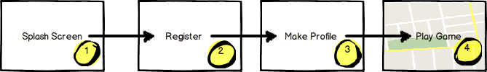

***Actions***

|  |  |  |
| --- | --- | --- |
| # | User Action | Resulting Behavior |
| 1 | View Splash Screen | Completes Load - > Loads Register View |
| 2 | Registers Account | Completes Register -> Goes to Make Profile |
| 3 | Makes Profile | Completes Profile Creation -> Goes to Game Play |
| 4 | Enters Game Play |  |

## 5.1.2 Tribe Interactions

## 5.1.2.1 Tribe Requests

John Holms has just joined the Project Cyrus game. However, as a new player, he is vulnerable. He has a limited amount of health – given by default at the time he joined – and has no support from other players. He is a newborn calf making its way through lion territory at night. To improve his chances, John Holms needs to join a Tribe.

***Overview***

A high-level summary looks like this:

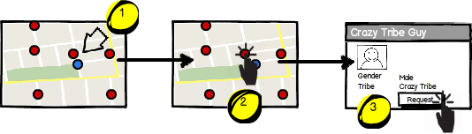

***Actions***

|  |  |  |
| --- | --- | --- |
| # | User Action | Resulting Behavior |
| 1 | Physical Movement | Establish nearby proximity to tribe member |
| 2 | Tap tribe member avatar | Opens player profile |
| 3 | Tap request button | Sends tribe request to member |

## 5.1.3 Locating Players

Finding players is an integral part of game-play. Accordingly, there will be different ways of locating players. Some will be nearby; others will be off-screen (or, out of proximity). In other cases, a User may want to locate another player in his tribe or favorites list.

**5.1.3.1 Nearby**

In this scenario, the target player is viewable on the map and in the Nearby Dashboard.

***Overview***

At a high-level, the screen flow would look like this:*

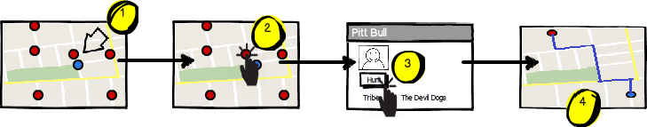

*\* Weapon and Nearby dashboards have been omitted*

***Actions***

|  |  |  |
| --- | --- | --- |
| # | User Actions | Resulting Behaviors |
| 1 | Movement to nearby proximity | Target player appears on active map and nearby dashboard. |
| 2 | Tap on avatar icon in map or nearby dashboard | Brings up avatar profile view. |
| 3 | Tap on “Hunt” button. | Brings up map with “directions” to locate the user.  **IMPORTANT**: The “directions” must update as the target player moves. |

**5.1.3.1 Out of Range**

In this scenario, a User wants to hunt a player that is not viewable on his map. This is done by using the “Nearby” dashboard that is ever-present to the user as he moves.

***Overview***

At a high-level, finding a player that is outside of proximity looks like this:

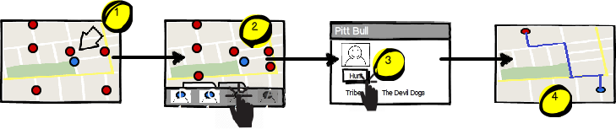

***Actions***

|  |  |  |
| --- | --- | --- |
| # | User Actions | Resulting Behaviors |
| 1 | movement | Sees players in Nearby dashboard – close and far |
| 2 | Taps remote player in dashboard | Brings up far away player profile |
| 3 | Taps HUNT button | A route to the player is established |

**4.3.1 Filter by Tribe**

***Overview***

At a high-level, filtering by a tribe looks like the following:

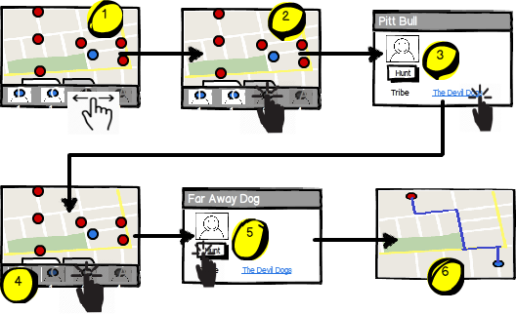

***Actions***

|  |  |  |
| --- | --- | --- |
| # | User Actions | Resulting Behaviors |
| 1 | Swipe through players in Nearby dashboard | Filters players in Nearby dashboard. View by proximity – close to far. |
| 2 | Tap player in dashboard | Brings up player profile |
| 3 | Select player’s tribe. | Resets players in Nearby dashboard, filtered by tribe and proximity. |
| 4 | Tap to select a player. | Brings up player’s profile. |
| 5 | Tap to select Hunt. | Maps best route to the target tribe member. |
| 6 | Movement | Google maps routes player within the Cyrus stage. |

**4.3.1 Filter by Favorites**

***Overview***

At a high-level, locating a tribe member looks like this:

***Actions***

|  |  |  |
| --- | --- | --- |
| # | User Actions | Resulting Behaviors |
| 1 | Locate player, either by dashboard or map view. | Target player in focus |
| 2 | Tap player (using map view or dashboard) | Brings up target player profile. |
| 3 | Tap tribe link | Goes back to map view, with ordered list of tribe members by proximity in the dashboard view. |
| 4 | Tap on tribe member | Brings up tribe member profile. |
| 5 | Tap on hunt button | Sends user back to map view with “directions” for hunting. |

# 6 Screen Catalog

## 6.1.1 First Use

**SPLASH VIEW**

***Appearance***

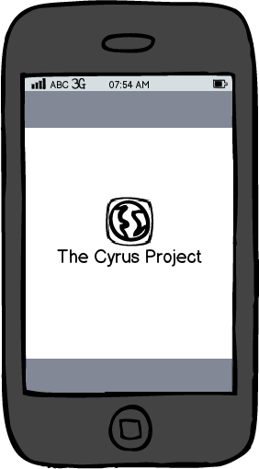

***Actions***

Game is loading in the background. No buttons and no user actions on this screen.

## 6.1.2 Accounts

**ACCOUNT TYPE**

***Appearance***

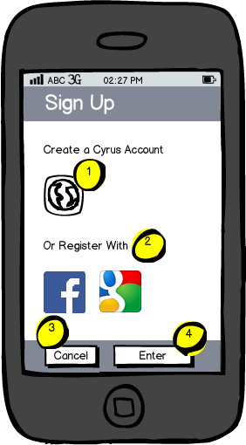

***Actions***

|  |  |  |  |
| --- | --- | --- | --- |
| # | User Action | Behavior | Returns |
| 1 | Tap Image | Redirect to Cyrus Project Sign Up |  |
| 2 | Tap Image | Redirect to Social Network Auth |  |
| 3 | Tap Cancel |  |  |
| 5 | Tap Enter | Submit Form (Validation)-> Profile |  |

**REGISTRATION**

***Appearance***

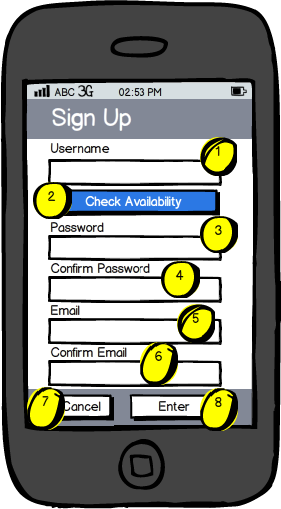

***Actions***

|  |  |  |  |
| --- | --- | --- | --- |
| Item | User Action | Behavior | Returns |
| 1 | Tap Input Field | Brings Up Keyboard |  |
| 2 | Tap Button | Checks Username | Availability (Yes or No) |
| 3 | Tap Input Field | Brings Up Keyboard |  |
| 4 | Tap Input Field | Brings Up Keyboard | Match (Yes or No) |
| 5 | Tap Input Field | Brings Up Keyboard |  |
| 6 | Tap Input Field | Validate match | Match (Yes or No) |
| 7 | Tap Cancel Button | Opens Dialog – Are You Sure? | Cancel or Redirect to… |
| 8 | Tap Enter Button | Opens “working” icon | TBD |

## 6.1.3 Profiles

**CREATE – PROFILE GENDER**

***Appearance***

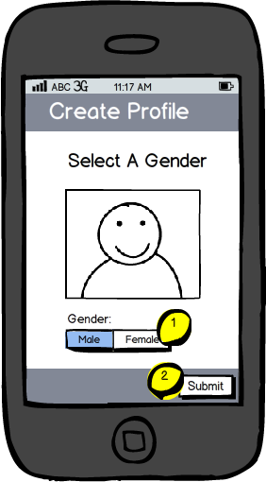

***Actions***

|  |  |  |  |
| --- | --- | --- | --- |
| Item | User Action | Resulting Behavior | Returns |
| 1 | Tap Gender Button (Male/Female) | Changes Gender Image | Male or Female |
| 2 | Submit | Submit & Go To Screen 5.2 |  |

**CREATE – PROFILE AVATAR**

***Appearance***

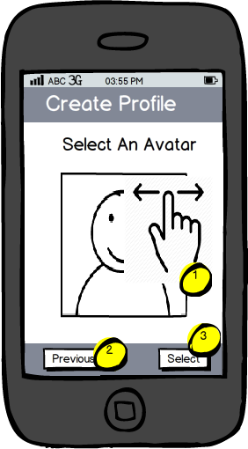

***Actions***

|  |  |  |
| --- | --- | --- |
| Item | User Action | Resulting Behavior |
| 1 | Finger Swipe: Horizontal | Displays different NEWBIE avatars to choose from. |
| 2 | Tap Pervious | Go to gender screen; discard any choices on current screen. |
| 3 | Tap Select | Submit choice, go to next screen. |

**VIEW –MY PROFILE**

***Appearance***

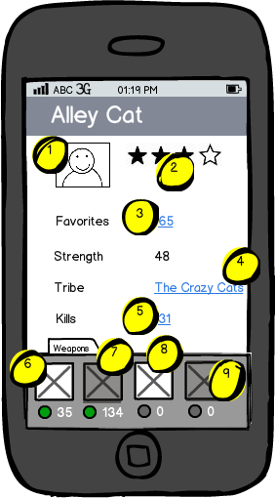

***Actions***

|  |  |  |
| --- | --- | --- |
| Item | User Action | Resulting Behavior |
| 1 | Tap Avatar | Go to Avatar Editor. |
| 2 | Tap Crowd Feedback | Go Comments / Ratings. |
| 3 | Tap Favorites | Go to map view with “nearby” favorites ordered list in view. |
| 4 | Tap My Tribe | Go to map view with my “nearby” tribe view as an ordered list. |
| 5 | Tap My Kills | TBD |
| 6 | Tap Weapon (shows available weapons & available ammunition) | Goes to weapon detail. |
| 7 | Tap Weapon (shows weapon not owned, but available ammo for that weapon) | Goes to weapon detail. |
| 8 | Tap Weapon (shows weapon owned, but no ammo left.) | Goes to weapon detail. |
| 9 | Tap Weapon (shows no weapon owned, and no ammo left.) | Goes to weapon detail. |

**VIEW – OTHER PROFILES**

***Appearance***

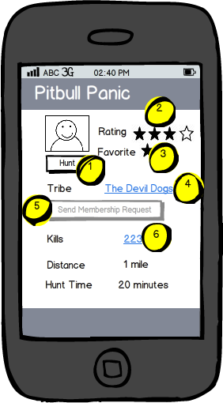

***Actions***

|  |  |  |
| --- | --- | --- |
| Item | User Action | Resulting Behavior |
| 1 | Text Input | Create Unique Game Profile ID. Allows dynamic verification of availability. |
| 2 | Horizontal Scroll | Allows Select of Game Avatar |
| 3 | Submit | Submit. |

**VIEW – OTHER PROFILES (MY TRIBE)**

***Appearance***

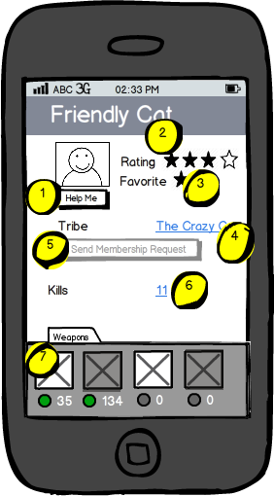

***Actions***

|  |  |  |
| --- | --- | --- |
| Item | User Action | Resulting Behavior |
| 1 | Tap Crowd Feedback | Go Comments / Ratings. |
| 2 | Tap Help Button | The HUNT button is replaced by the HELP button from players in the same tribe. Action results in a notification sent to intended user. |
| 3 | Tap Crazy Cat Tribe Link | Go to detail about Crazy Cat Tribe + list of tribe members |
| 4 | Tap Deactivated Send Membership Request | Notification – You are already in the Crazy Cat Tribe. |
| 5 | Tap Each Weapon image | Go to detail view about weapon. |
| 6 | Tap Each Ammo image | Go to detail view about ammo |
| 7 | Tap Kills Amount | Go to list of past players killed. |

## 6.1.4 Navigation

**NEARBY DASHBOARD**

The nearby dashboard is always present to the user as he navigates through the game environment. It will always tell him where people or things are relative to his position in the field.

***Appearance***

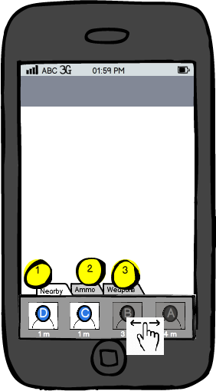

***Actions***

|  |  |  |
| --- | --- | --- |
| Item | User Action | Resulting Behavior |
| 1 | Tap ‘Nearby’ Selection | Shows list of all avatars ordered by proximity to User. |
| 2 | Tap ‘Ammo’ Selection | Switch to list of all available ammo on game board ordered by proximity. |
| 3 | Tap ‘Weapons’ Selection | Switch to list of all available weapons on game board ordered by proximity. |

**WEAPONS DASHBOARD**

The Weapons dashboard is always present to the user when he is near other players that are not on the same tribe. The weapons view gives the user access to his arsenal.

***Appearance***

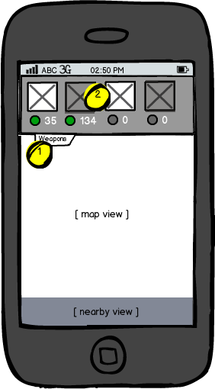

***Actions***

|  |  |  |
| --- | --- | --- |
| Item | User Action | Resulting Behavior |
| 1 | User movement. Other non tribe players on map. | Weapons dashboard appears. |
| 2 | Tap weapon | Highlight selected weapon and display ammo and ammo count in preparation for battle. |

**MOVEMENT**

When moving through the physical world, the game reflects the User’s actions.

***Appearance***

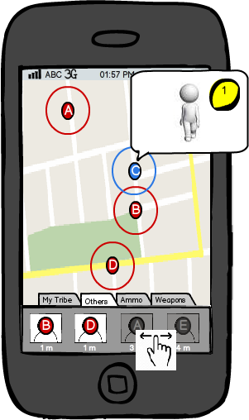

***Actions***

|  |  |  |  |
| --- | --- | --- | --- |
| Item | User Action | Resulting Behavior | Returns |
| 1 | User walking in physical world | Avatar appears to be walking on map with user movements |  |
| 2 | Other players walking in physical world. | Avatar of other players appears to be walking on map with user movements. |  |

## 6.1.5 Battles

**WEAPON ACCESS**

The weapons dashboard appears when a user is in proximity with another player that is not in the same tribe. In order to prepare for battle, players need to select a weapon in the dashboard, which will expose ammunition and ammo count.

***Appearance***

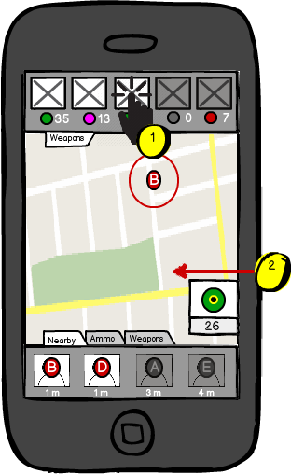

***Actions***

|  |  |  |
| --- | --- | --- |
| Item | User Action | Resulting Behavior |
| 1 | Tap on selected weapon | Ammunition and count for weapon appears in isolated view on map (#2) |

**ATTACKING / DEFENDING**

To attack another player, a user must direct ammo by swiping towards his position on the map. While doing this, the ammo count will decrease.

***Appearance***

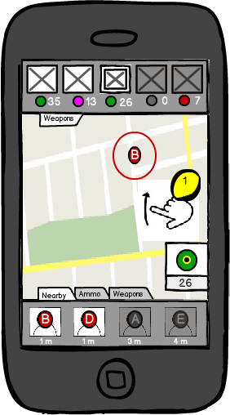

***Actions***

|  |  |  |
| --- | --- | --- |
| Item | User Action | Resulting Behavior |
| 1 | Finger Swipe: Horizontal Up | Animation of weapon ammo - appears to be thrown at target. Ammo count decreases with each throw. |