How Saturn V5.4 Works: A Technical & Biological Guide
Saturn V5.4 is an automated image-analysis pipeline designed to extract, reconstruct, and measure the 3D morphological properties of mature *Drosophila* sperm nuclei from confocal Z-stack images.
Analyzing densely packed, thread-like nuclei that push the physical resolution limits of optical microscopy is highly subjective when done manually. Saturn resolves this by implementing a rigorous mathematical framework, taking raw image volumes and producing standardized, bias-free datasets.
Here is a detailed breakdown of the algorithms driving each step of the pipeline.

1. 2D Segmentation: Finding Nuclei in Each Slice
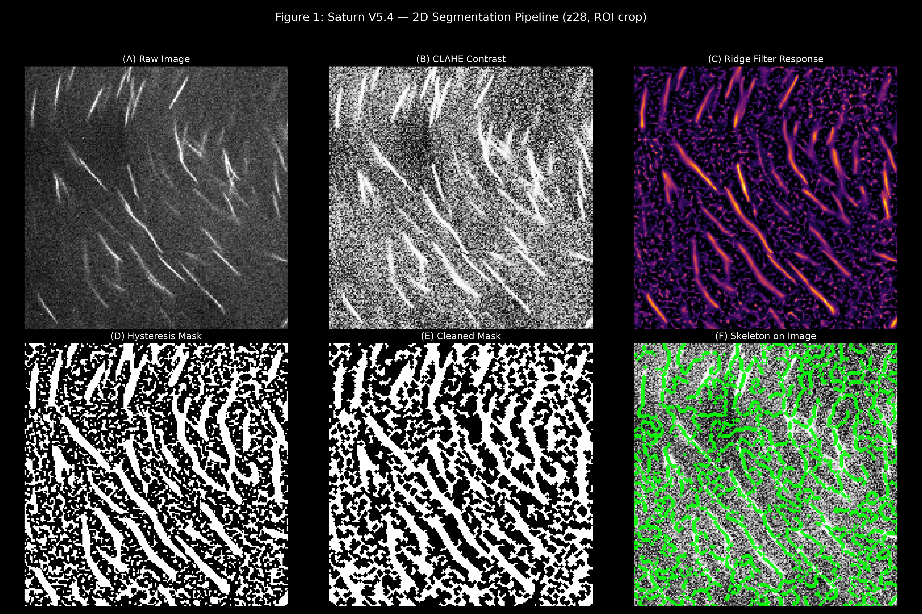
*Figure 1: Progression of 2D morphological segmentation. (A) Raw image crop. (B) CLAHE contrast enhancement. (C) Background-subtracted signal. (D) Meijering Ridge Filter response. (E) Extracted skeleton centerline overlaid on raw data.*
Before building a 3D model, the software isolates the sperm in each 2D image slice using a multi-stage morphological algorithm:
- Intensity Normalization & CLAHE: Raw microscope images often suffer from uneven illumination. The software applies Contrast Limited Adaptive Histogram Equalization (CLAHE) to locally normalize contrast, preventing dim nuclei from being washed out by bright local clusters.
- Background Subtraction: A Gaussian blur is applied to create a low-frequency background map, which is then subtracted from the CLAHE image to remove large artifacts and cellular debris.
- Topological Ridge Detection (Meijering Filter): Instead of simple intensity thresholding, Saturn uses the Meijering filter. This algorithm calculates the eigenvalues of the Hessian matrix for every pixel, specifically searching for "tubeness"—continuous, ridge-like structures. This perfectly isolates the string-like sperm nuclei while suppressing round or irregular shapes.
- Distance Transform & Skeletonization: The continuous ridges are binarized. The algorithm calculates the Euclidean Distance Transform (EDT) on these shapes to determine exact pixel widths. Finally, the shapes are "skeletonized" down to a strict 1-pixel-wide centerline.

2. 3D Tracking: Connecting the Pieces
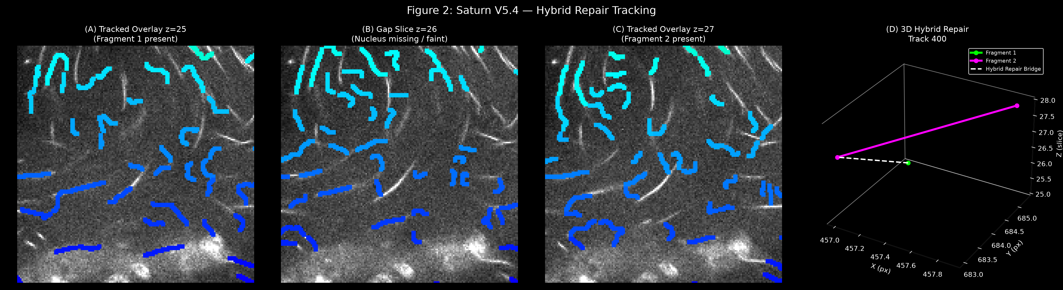
*Figure 2: Hybrid Repair mechanism. (A) Fragment 1 detected in slice Z. (B) The signal is lost or too weak in the gap slice Z+1. (C) Fragment 2 detected in slice Z+2. (D) 3D scatter plot demonstrating the Union-Find algorithm bridging the Z-gap.*
Once the 2D skeletons are extracted, Saturn stitches them together across the Z-stack using a sophisticated tracking algorithm.
- Conservative Overlap Tracking: The primary pass compares skeletons in adjacent slices (Z and Z+1). If pixels physically overlap beyond a defined threshold, they are assigned the same track ID.
- Hybrid Repair (Union-Find Algorithm): Due to uneven staining or focal drift, a single sperm may become fragmented across Z-slices. The hybrid repair algorithm uses a Union-Find graph data structure to look across small spatial gaps (e.g., 1-2 slices). If two fragments are highly aligned in the XY plane but separated by a Z gap, they are stitched together.
- Biological Constraints: The hybrid repair will only merge fragments if the resulting combined structure does not exceed realistic biological length or tortuosity (curvature) limits, preventing artificial "monster merges."

3. The Two-Tier Quality Audit
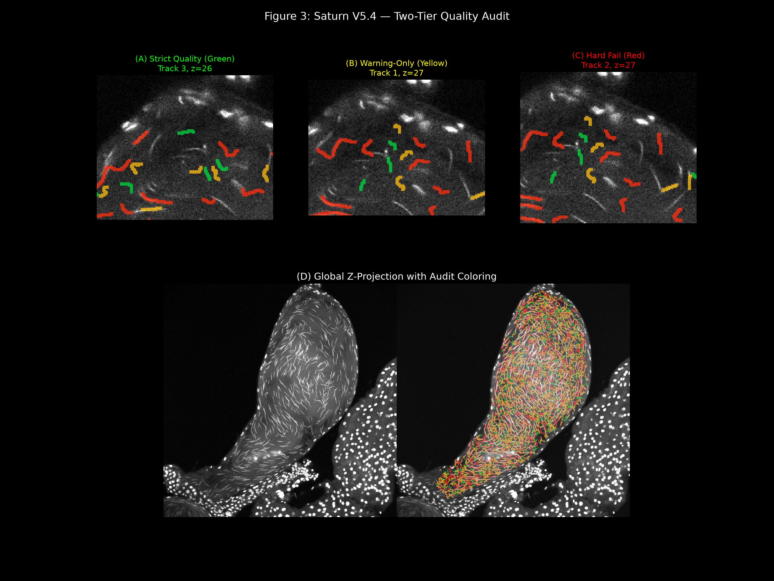
*Figure 3: Two-Tier Audit breakdown. (A) Green: Structurally flawless track. (B) Yellow: Valid track with minor PSF-induced blur/taper warnings. (C) Red: Hard fail track (impossibly long or tangled). (D) Global Z-projection overlay showing the population distribution.*
Because a mature sperm nucleus (~0.3 µm) is physically thinner than the typical axial resolution of a confocal microscope, optical blurring (the Point Spread Function, or PSF) artificially inflates the nucleus width and tapers the ends.
To filter out optical illusions and tracking errors (like two sperm tangled together) without discarding real biological variance, Saturn executes a mathematical Two-Tier Audit:

🟢 Tier 1: Biological Candidates (Green & Yellow)
This pool represents all mathematically valid sperm nuclei for downstream analysis.
- Green (Strict Quality): Tracks that pass all stringent geometrical thresholds (length, width, tortuosity).
- Yellow (Warning-Only): Tracks that are slightly thick or tapered due to the PSF. Because this variance is a known artifact of the optics rather than biology, the software flags them with a warning but retains them for statistical analysis.

🔴 Tier 2: Hard Fails (Red)
Tracks that violate the absolute biological ceilings. If a track is radically long (>25 µm), highly tortuous (knotted), or exhibits extreme thickness, it is rejected. These usually represent tangled webs of multiple sperm that could not be safely untangled.

4. Automated Tuning Parameters
Because optical setups and staining qualities vary, hardcoded parameters will eventually fail. Saturn relies on an Automated Tuner that systematically scores parameter combinations to find the mathematical optimum for your specific images.
The tuning and execution process requires loading two distinct JSON files, separating image segmentation from 3D tracking:
- The Segmentation Tuning JSON:
This file (`best_segmentation_params_...json`) contains optimized 2D image processing parameters (CLAHE clip limits, background sigma, Meijering sigmas, and bridge lengths). It is generated by running the Tuner over a small set of representative slices.
- The Tracking Preset JSON:
Once segmentation is optimized, you load a tracking preset (e.g., `saturnv5.4_hybrid_repair_prototype.json`). This configures the 3D logic: overlap thresholds, gap allowances for hybrid repair, and the strict geometric ceilings used by the Two-Tier Audit.
By loading both JSONs into the pipeline, you guarantee that the entire analysis is uniquely calibrated to your optical conditions while maintaining rigorous biological constraints.

5. Data Outputs and Measurements
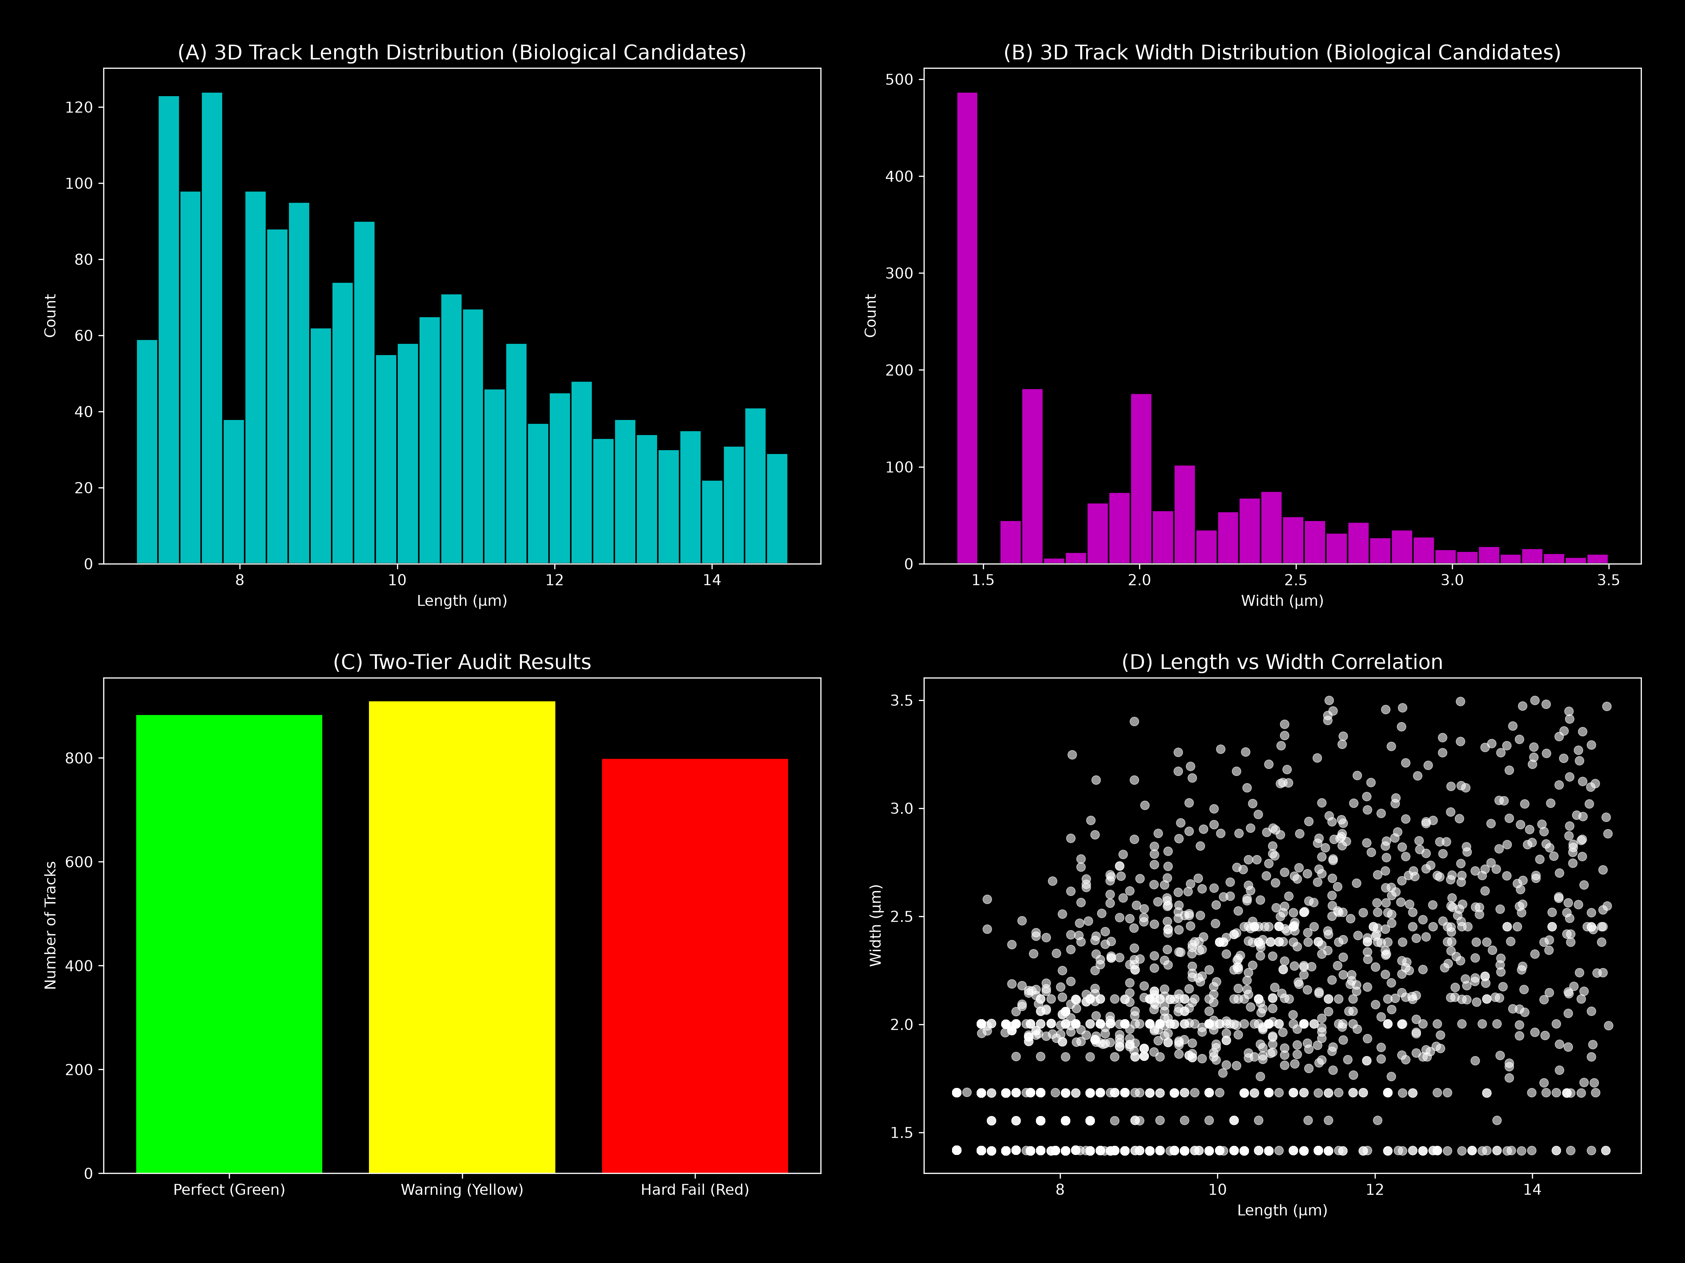
*Figure 4: Extracted quantitative metrics. (A) Histogram of track lengths. (B) Histogram of track widths. (C) Population counts across audit categories.*
After tracking and auditing, Saturn automatically computes highly accurate 3D geometries for every valid biological candidate:
- True 3D Length: Calculated by walking the extracted centerline skeleton through 3D space, taking the hypotenuse between adjacent pixels while properly weighting the physical XY resolution (µm/pixel) and the Z-step size.
- True 3D Width: Derived from the maximum value of the Euclidean Distance Transform (EDT) mapped across the skeleton, effectively measuring the thickest cross-section of the 3D volume.
- Global Output: The results are exported as a comprehensive `measurements_with_tracks.csv` database containing coordinates, shape metrics, and audit statuses for every nucleus, alongside high-resolution PDF and Excel summary reports.

