Saturn v5.7 Illustrated Technical Workflow
A technical demonstration from ROI-aware preprocessing and hybrid segmentation through 2D measurement, cross-slice reconstruction, quantitative reporting, and multi-sample studies
Demonstration item | Value
Pipeline | sperm_segmentation_saturnv5.7.py
Sample stack | C:\Users\dmishra\Desktop\sperm images
Stack dimensions | 88 slices; 1024 x 1024 pixels
Saved ROI | C:\Users\dmishra\Desktop\sperm images\roi_z28.1.npy
Illustrated slices | z34, z35, z36, z37
Analysis mode | Hybrid Saturn + 2.5D U-Net rescue
Physical calibration | 0.756836 um/pixel XY; 1.040460 um/slice Z

Scope note: z34-z37 are used to illustrate the workflow. Their 2D counts are not a complete-stack biological result and must not be summed as unique nuclei until cross-slice tracking has linked repeated appearances.

1. What Saturn v5.7 Does
Saturn v5.7 is a microscopy analysis workflow for elongated Drosophila sperm nuclei. It restricts preprocessing to a specimen ROI, combines a classical ridge/skeleton lane with optional 2.5D U-Net probability evidence, measures accepted 2D centerlines, links detections through Z, and exports both complete and quality-controlled populations.
- ROI-aware stack normalization prevents bright tissue outside the specimen ROI from setting thresholds.
- Classical Saturn detects elongated ridge structures and measures their skeleton geometry.
- The U-Net lane rescues probable nuclei missed by classical segmentation and splits connected probability regions before measurement.
- Tracking links 2D detections across adjacent Z planes without treating each plane as a unique biological object.
- Comparative audit retains morphology warnings while excluding technical failures from the primary comparison population.
- The study manager analyzes specimens independently, records acquisition exposure, and creates specimen- and group-level tables.

2. GUI, Stack, and ROI
The GUI loads the top-level Z stack, navigates individual planes, loads or draws a polygon ROI, applies tuned parameter JSON files, launches segmentation/tracking tuning, runs single-plane or full-stack analysis, and opens the multi-sample study manager.
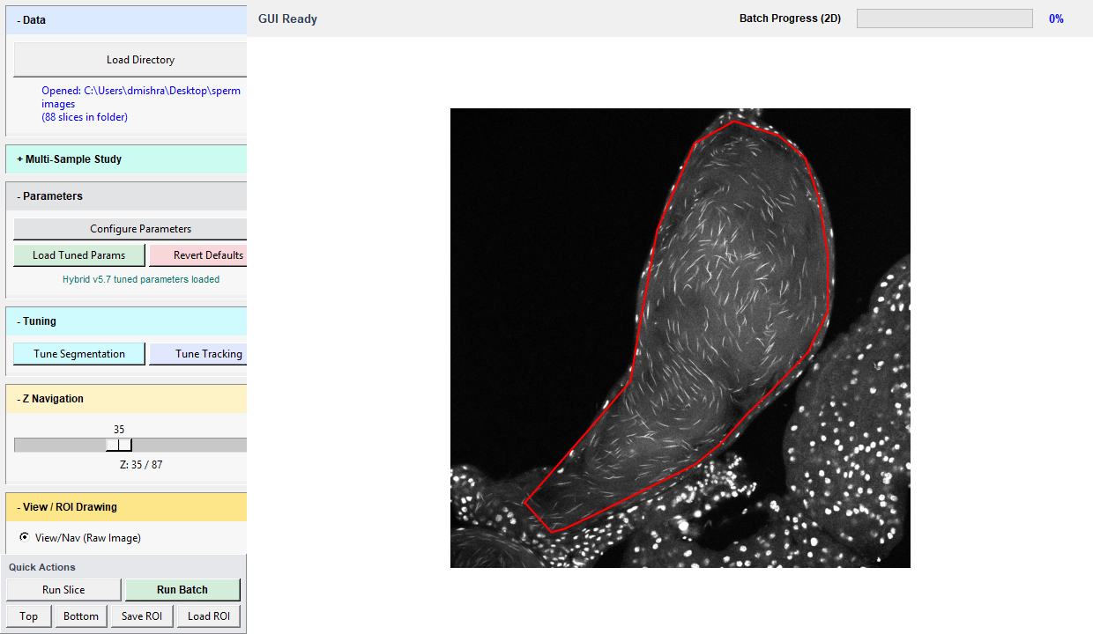
Figure 1. Saturn v5.7 GUI with the 88-slice demonstration stack, hybrid tuned parameters, and the saved ROI shown in red.
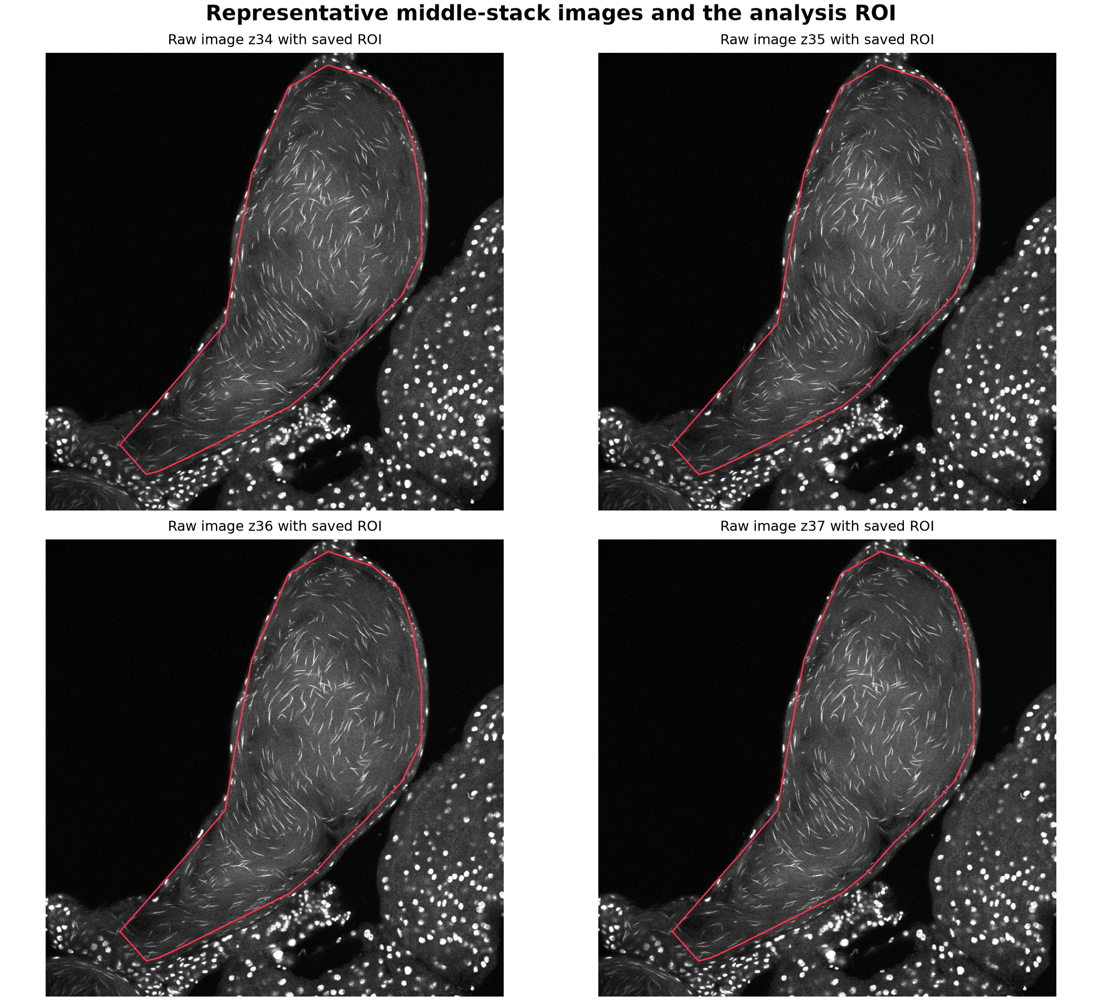
Figure 2. Four consecutive middle planes (z34-z37). The same saved ROI is applied to every plane; pixels outside it do not enter threshold estimation or segmentation.

3. ROI-Aware Preprocessing
Saturn samples intensity statistics across the stack inside the valid ROI. The stack-level range is blended with per-slice statistics so contrast can adapt to local signal without allowing off-ROI tissue to dominate. Denoising and background estimation operate on an ROI-aware crop, and all masks and skeletons are clipped back to the valid ROI.
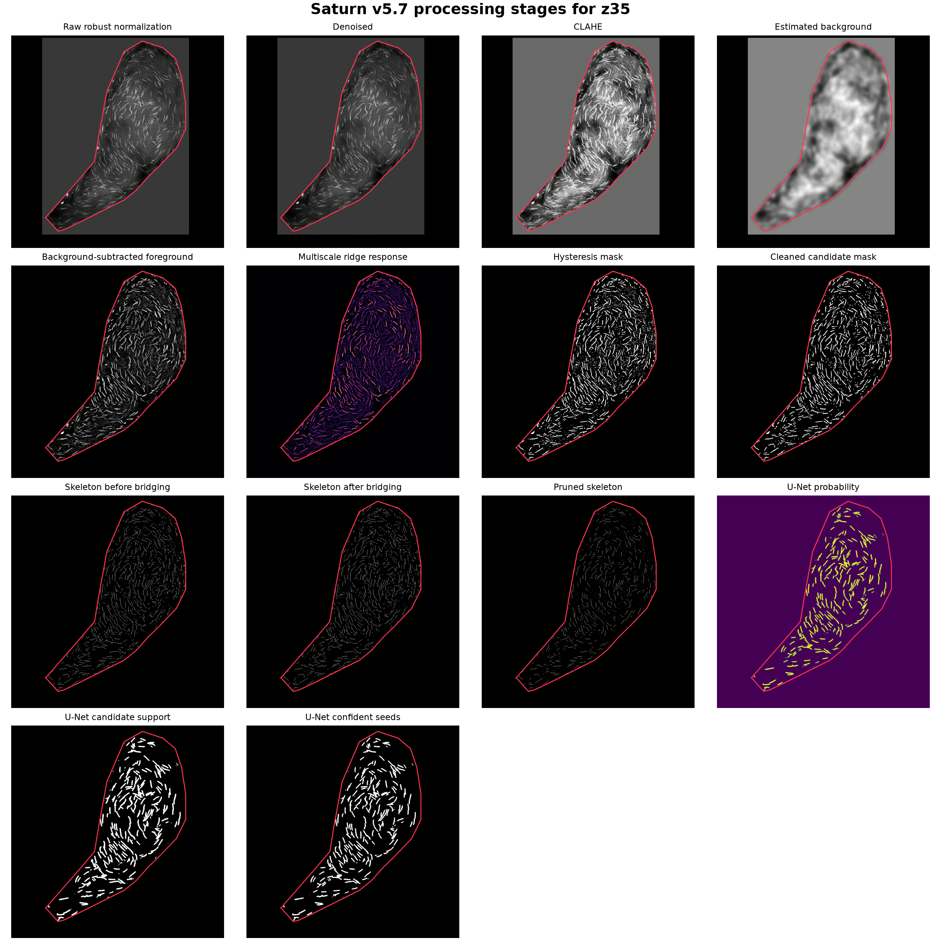
Figure 3. Real z35 processing stages: robust normalization, denoising, CLAHE, background subtraction, ridge response, masks, skeleton operations, and U-Net probability evidence.
- Robust normalization: stack and slice percentiles stabilize dynamic range.
- CLAHE: enhances local contrast within the ROI.
- Background subtraction: reduces broad tissue intensity while retaining narrow elongated structures.
- Multiscale ridge response: emphasizes line-like nuclei over broad edges and round puncta.
- Hysteresis and cleanup: connect confident ridge pixels and remove small unsupported foreground.
- Bridging and pruning: repair short centerline gaps conservatively and remove incompatible topology.

4. Hybrid U-Net Rescue
The 2.5D U-Net sees the previous, current, and next Z planes as channels and returns a probability map for the center plane. Saturn uses that map as evidence rather than as a COCO annotation. A low candidate threshold preserves faint possibilities, a higher seed threshold identifies confident cores, and watershed-style instance splitting separates connected probability regions before centerline measurement.
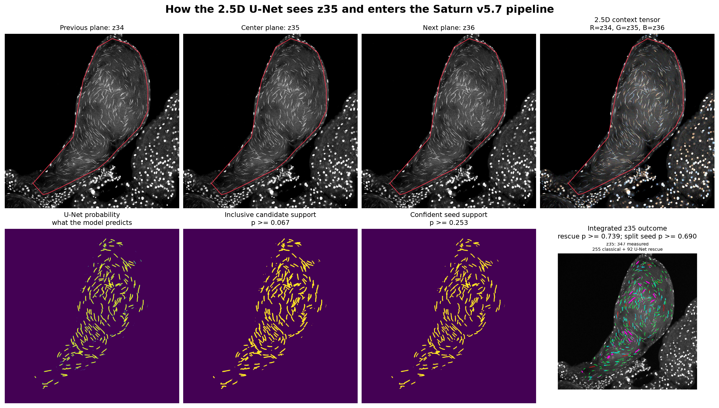
Figure 4. How the 2.5D U-Net sees z35. The model receives z34, z35, and z36 as separate grayscale channels, predicts center-plane probability, and passes candidate and seed evidence into Saturn instance splitting and measurement. The RGB panel is only a visualization of the three channels.
Integration stage | What happens | Effect on reported measurements
Three-plane context | The previous, center, and next planes form the 2.5D model input for the center plane. | Adds local Z evidence without counting adjacent planes as separate outputs.
Probability inference | The model predicts a continuous sperm-nucleus probability map; tiled crops are blended before thresholding. | No count or morphology is produced yet.
Candidate support | A low probability cutoff preserves inclusive faint evidence inside the ROI. | Defines possibilities, not accepted nuclei.
Confident seeds | Higher-probability cores provide seeds for connected-region separation. | Helps split touching probability regions before measurement.
Instance splitting | Probability topology and seed locations divide connected regions into candidate instances. | Prevents one connected probability mass from automatically becoming one giant nucleus.
Duplicate exclusion | Regions already occupied by accepted classical centerlines are excluded from the rescue lane. | Avoids counting the same nucleus twice.
Saturn measurement gate | Candidate centerlines are measured for length, width, ratio, topology, tortuosity, and probability support. | Only accepted undilated centerlines enter counts and tracking.
Provenance and tracking | Rows retain classical or U-Net-rescued source labels and optional U-Net confidence. | Enables source-specific audit and confidence-supported cross-slice linking.
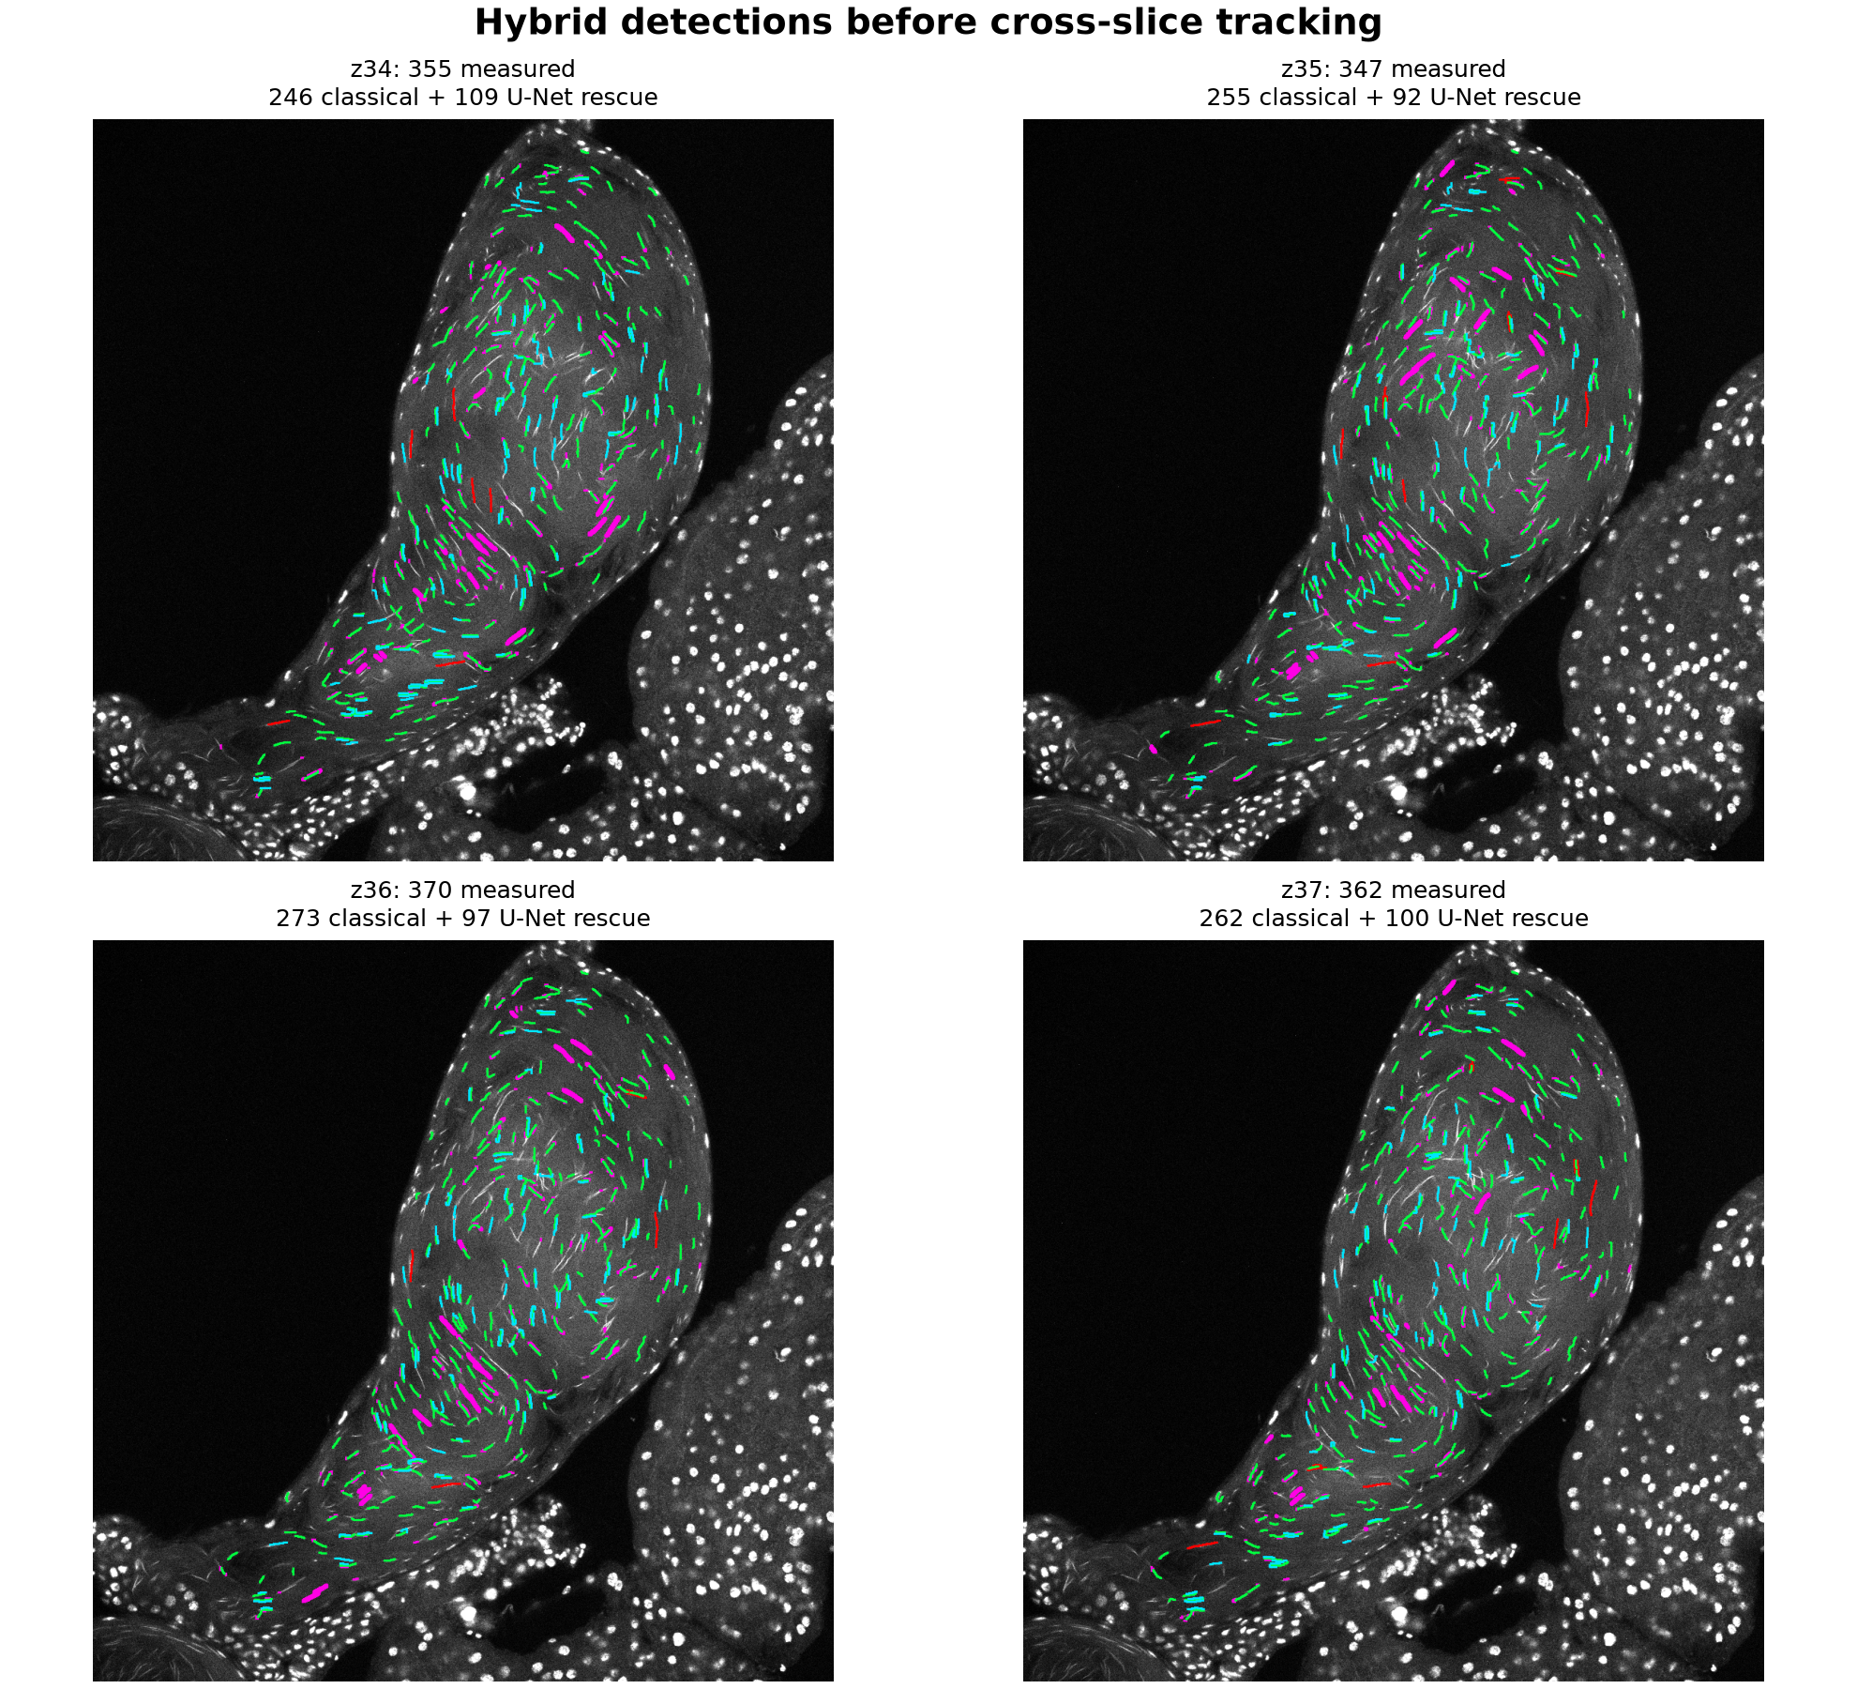
Figure 5. Hybrid detections on z34-z37. Green is accepted classical Saturn; cyan is accepted U-Net rescue; magenta, orange, and red show rejected U-Net candidates by audit class.
The colored overlays are review graphics. Their lines are dilated to a common visible thickness only during rendering. Counting, length, width, area, and tracking use the original one-pixel centerline and undilated masks.
Plane | Accepted 2D | Classical | U-Net rescue | Median length (um) | Median width (um)
z34 | 355 | 246 | 109 | 11.85 | 3.03
z35 | 347 | 255 | 92 | 12.29 | 3.03
z36 | 370 | 273 | 97 | 11.67 | 3.03
z37 | 362 | 262 | 100 | 11.54 | 3.03
Four-plane total | 1434 | 1036 | 398 | not pooled as unique nuclei | PSF-sensitive

5. Two-Dimensional Measurements
Each accepted object is represented by a labeled centerline and its supporting cleaned mask. Measurements are calculated before any display dilation.
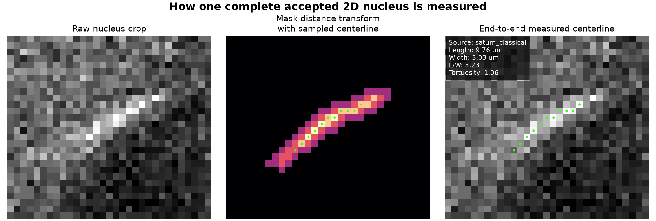
Figure 6. Technical measurement of one complete accepted 2D nucleus. The middle panel shows the supporting-mask distance transform sampled along the undilated centerline. The right panel overlays the end-to-end centerline on the raw crop and records source, geodesic length, apparent width, length-to-width ratio, and tortuosity in the upper-left measurement block. Display-line thickness is not used in any calculation.
2D geodesic length | L2D = sum(centerline edge lengths) x XY_um_per_pixel  Diagonal centerline steps contribute sqrt(2) pixels; orthogonal steps contribute 1 pixel.
Median width | W2D = median[2 x distance_transform(mask)] along centerline x XY_um_per_pixel  This is an image-derived apparent width and can be broadened by the microscope point-spread function.
Elongation | length-to-width ratio = L2D / W2D  Low values flag broad or round objects; they are not automatically evidence of a biological genotype effect.
2D tortuosity | T2D = geodesic centerline length / endpoint Euclidean distance  A straight centerline approaches 1.0. Branches, loops, and severe curvature are recorded separately.
Projected area estimate | Apx = centerline_length_px x median_width_px  This slender-object approximation supports downstream volume estimates; it is not a direct filled-mask area.

6. Cross-Slice Tracking and 3D Estimates
Accepted 2D detections are linked across nearby Z planes by spatial displacement and morphology compatibility. U-Net confidence can support ambiguous links in hybrid mode, but tracking remains auditable and each 2D member retains its source and slice label.
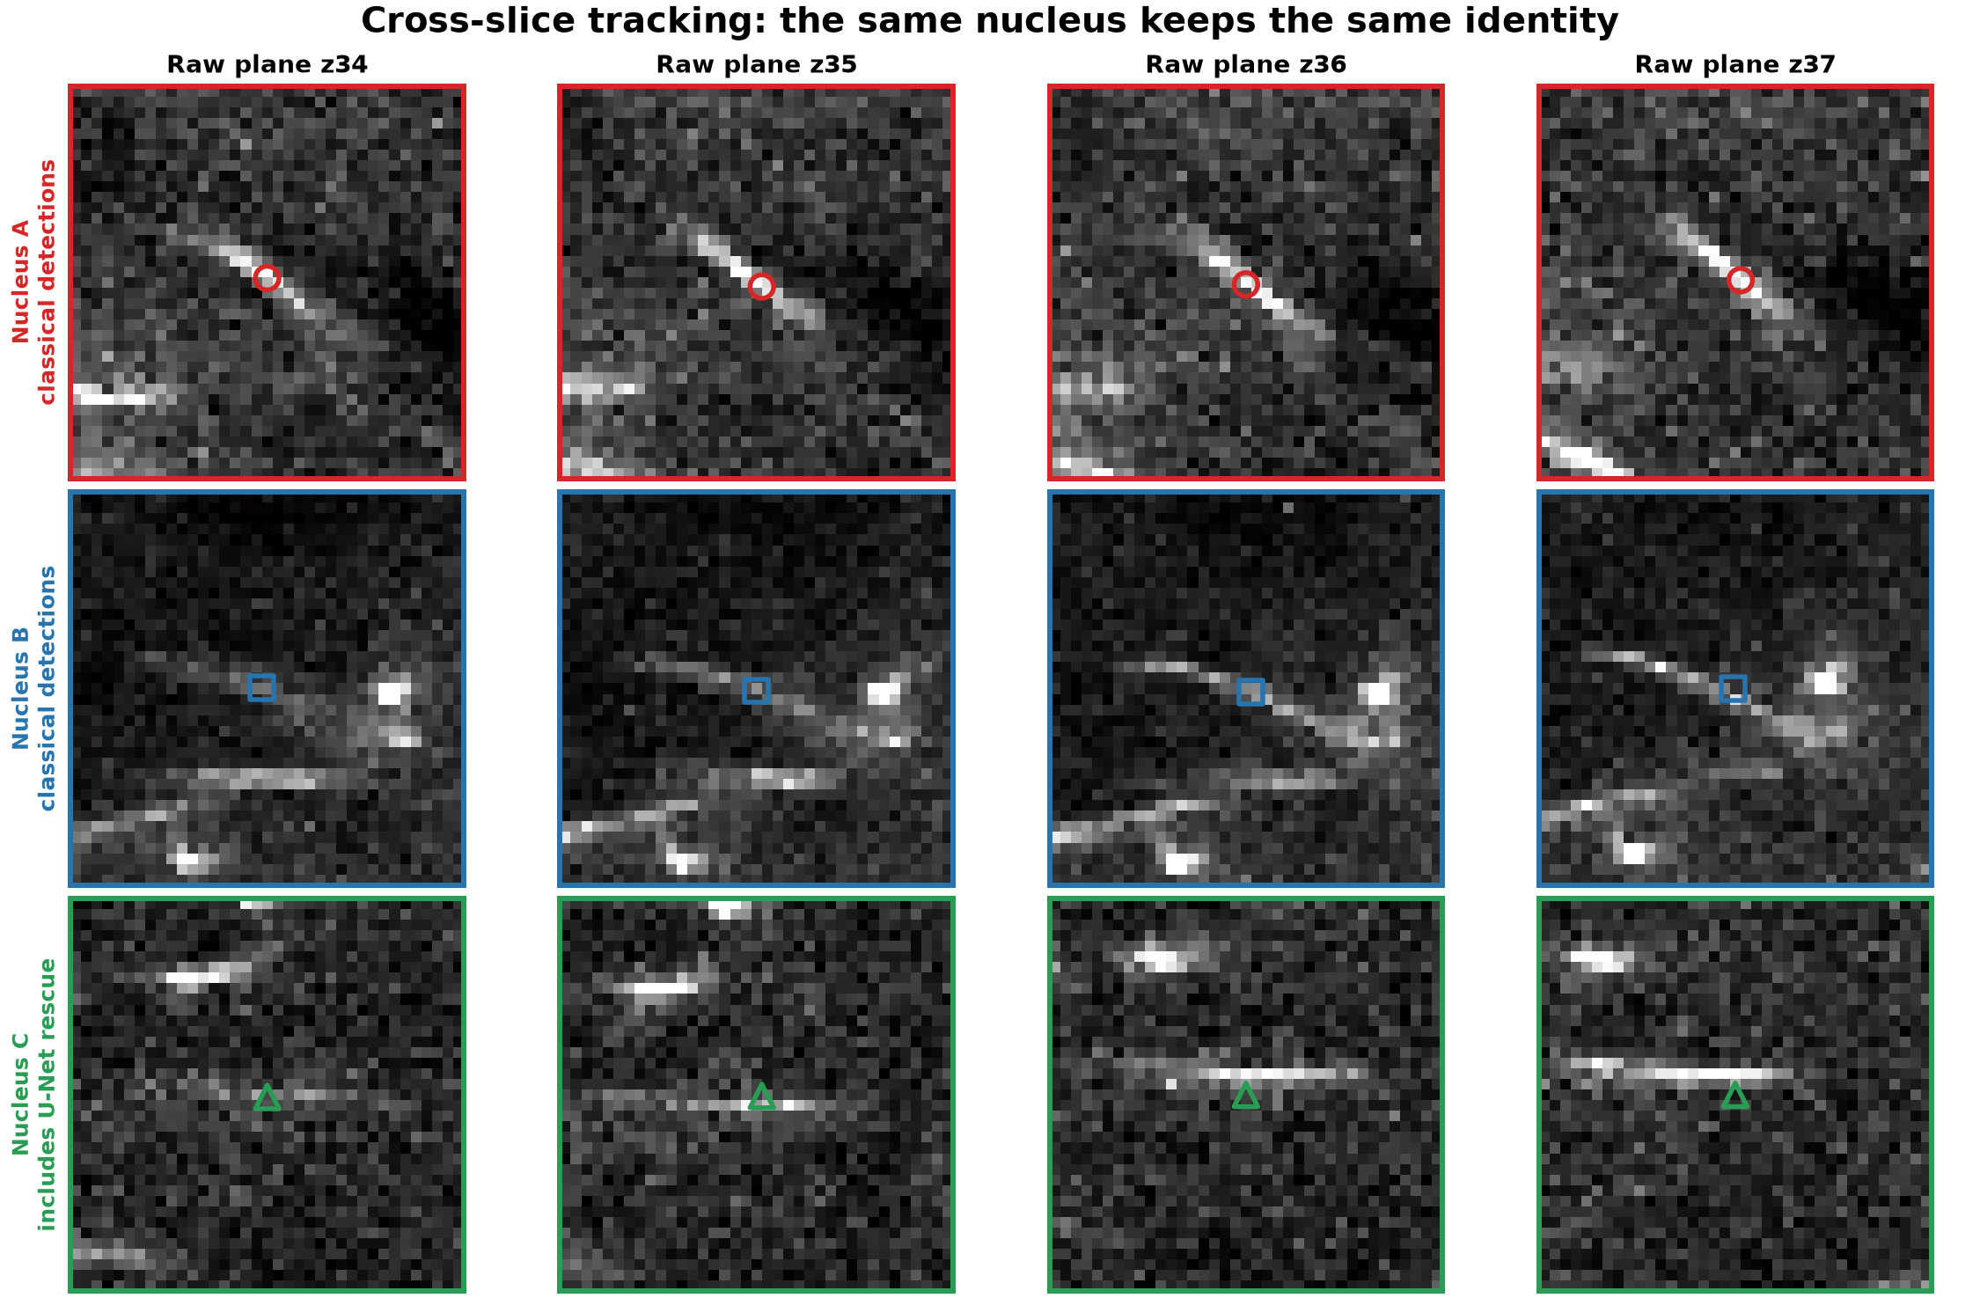
Figure 7. Three nuclei followed through four consecutive raw Z planes. Each nucleus keeps the same letter, color, and marker shape in every plane. Nucleus C contains a U-Net-rescued member; the other examples are classical detections.
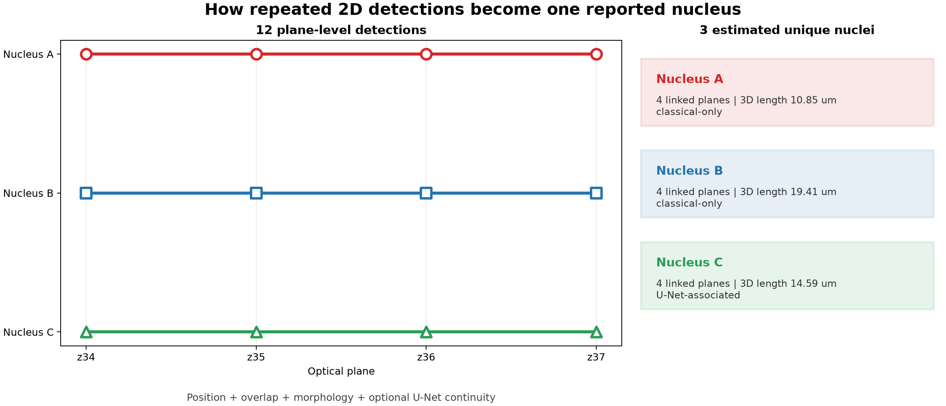
Figure 8. Cross-slice assignment converts 12 plane-level detections into three estimated unique nuclei. Links use position, overlap, morphology, and optional U-Net continuity. The output retains the contributing planes and detection provenance.
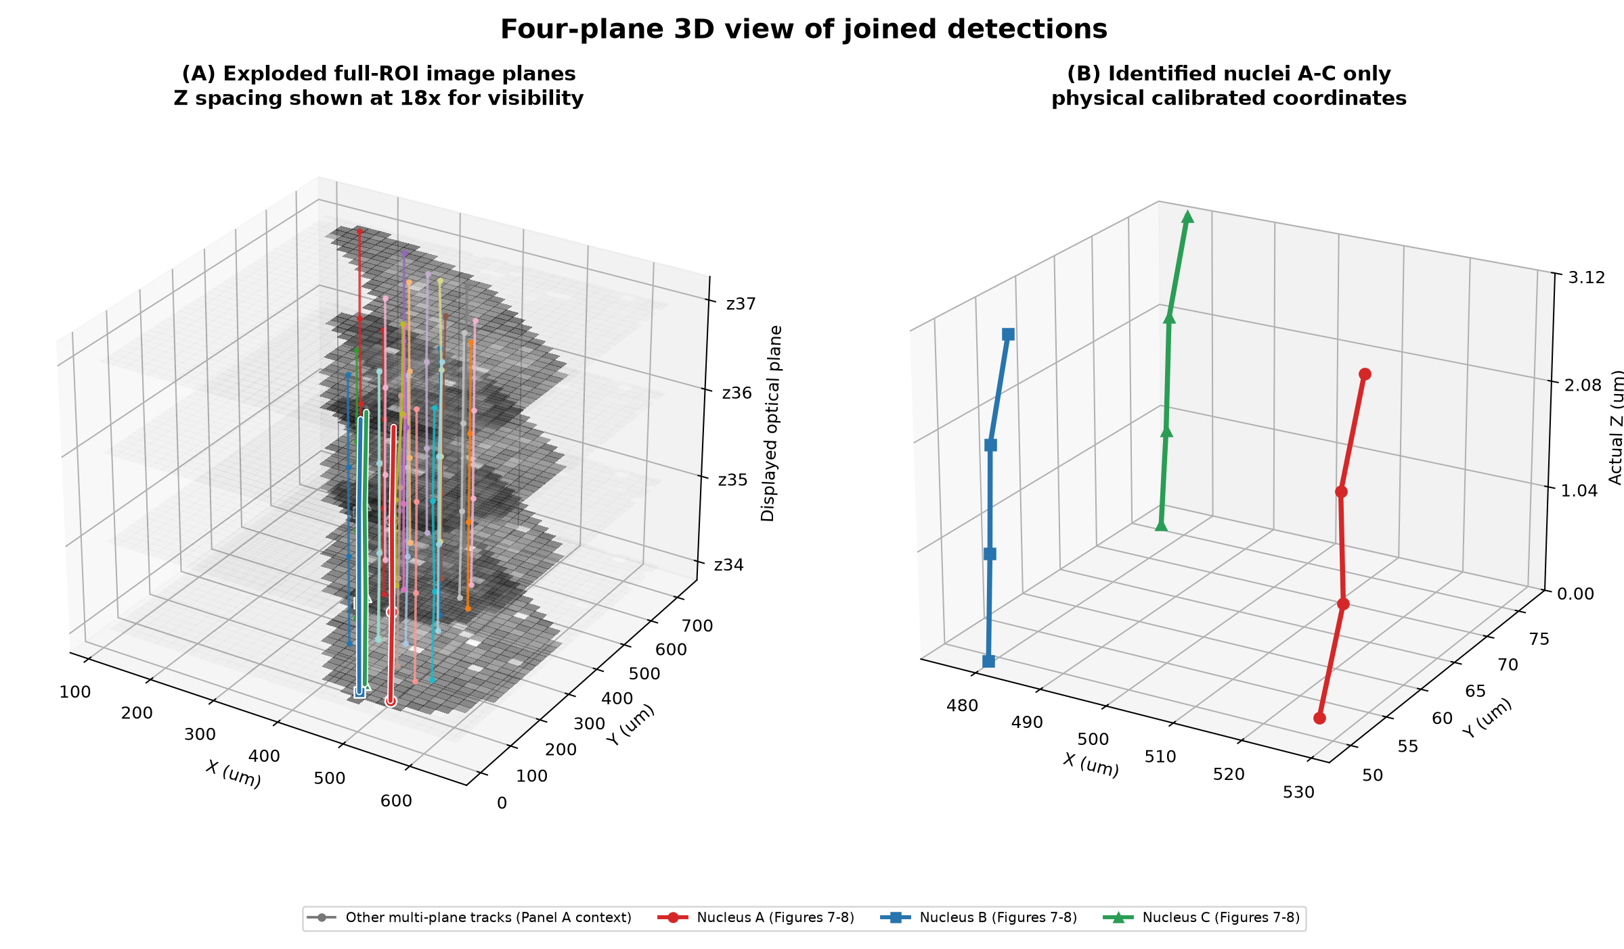
Figure 9. Full-ROI three-dimensional view of cross-slice reconstruction. The left panel displays four complete ROI image planes with an 18x display-only Z exaggeration; its thinner trajectories provide stack-wide reconstruction context. The right panel isolates only the three illustrated nuclei A-C in calibrated physical coordinates. The strongly highlighted red-circle, blue-square, and green-triangle trajectories are the same nuclei shown in Figures 7 and 8. The contextual tracks in the left panel are not additional illustrated examples. All measurements use the true XY and Z calibration rather than the display exaggeration.
Four-plane tracking output | Count or setting | Interpretation
Accepted 2D detections | 1434 | Plane-level centerlines before joining.
Joined tracks | 683 | Candidate unique nuclei within the four-plane window.
Classical-only tracks | 422 | Every member originated in the classical lane.
U-Net-associated tracks | 261 | At least one member was recovered by U-Net rescue.
Tracks on all four planes | 107 | Complete only with respect to this small demonstration window.
Tracks on at least three planes | 234 | Long-span examples favored in the tracking figures.
Tracking backend | hybrid_repair | Global assignment followed by conservative fragment repair.
Maximum centroid distance | 6.8711 um | Geometric gate before a candidate link can be accepted.
Maximum missing-plane gap | 1 | Allows one absent intermediate detection.

How U-Net enters tracking
U-Net evidence is optional link support, not a separate tracker. For a possible link, Saturn reads the mean U-Net probability of each detection when available. Weak average support adds a cost of support_weight x (1 - mean_probability), and an abrupt probability change adds continuity_weight x absolute_probability_change. Geometry, overlap, length, width, area, orientation, and maximum-cost gates still determine whether the link is accepted.
U-Net tracking term | Demonstration value | Role
U-Net tracking support | True | Enables probability-derived cost terms in hybrid mode.
Assignment support weight | 0.6 | Penalizes a proposed global-assignment link when U-Net support is weak.
Assignment continuity weight | 0.25 | Penalizes an abrupt probability change between adjacent members.
Hybrid-repair support weight | 0.4 | Applies a weaker support penalty when considering conservative fragment repair.
Missing U-Net probability | No probability penalty | Classical detections remain trackable; absence of U-Net evidence is not an automatic rejection.
Tiny-stack limitation: 661 of 683 tracks received at least one morphology warning because four planes truncate Z extent and provide incomplete area, taper, thickness, and trajectory context. The 138-track reference-shape subset is shown only to explain the audit machinery. Neither value should be used as a biological estimate from this specimen.
Z span | Zspan = (z_end - z_start) x Z_um_per_slice  Endpoint displacement. A one-slice track has zero Z span.
Z covered | Zcovered = (z_end - z_start + 1) x Z_um_per_slice  Sampled slab thickness, distinct from endpoint displacement.
Reported 3D length | L3D = sqrt(max(max_2D_geodesic, centroid_lateral_span)^2 + Zspan^2)  This is a lateral-corrected hypotenuse estimate. It is not a voxel-by-voxel 3D centerline arc length.
Volume estimate | V = sum(projected_area_px) x XY_um_per_pixel^2 x Z_um_per_slice  Sensitive to segmentation width, slice spacing, axial sampling, and the optical point-spread function.
Effective thickness | Deffective = 2 x sqrt[(V / L3D) / pi]  Equivalent circular diameter inferred from estimated volume and length; interpret as PSF-sensitive.
3D tortuosity | T3D = L3D / sqrt(max_2D_endpoint_distance^2 + Zspan^2)  Capped at 20 to prevent numerical blow-up for nearly coincident endpoints.

7. One Biological Population and Its QC Annotations
Saturn reports one primary biological population: estimated unique nuclei after cross-slice reconstruction and hard technical QC. Morphology warnings, reference-shape labels, boundary contact, detection source, and rejected-extension near-misses remain annotations on that population. They are review aids, not additional counts to add or subtract.
Population | Meaning | Recommended use
All tracks | Every completed cross-slice track, including technical failures. | Audit and troubleshooting only.
Technical-valid / biological candidates | Tracks without hard technical failures. | Primary WT-versus-mutant comparison population.
Morphology-warning | Technical-valid tracks with unusual length, thickness, taper, tortuosity, or related morphology. | Retain and report; visually review warning burden.
Reference-morphology pass | Technical-valid subset matching the configured reference morphology. | Diagnostic sensitivity subset, not biological ground truth.
Technical failures | Clear merge, unrecoverable tracking/label inconsistency, or other hard failure. | Exclude from primary morphology estimates but preserve in output.

8. Software Outputs and Quantitative Summaries
For biological analysis, use the estimated unique-nucleus count and the one-row-per-track morphology table. Per-plane counts describe segmentation through Z and are diagnostic only; they must not be added and interpreted as unique nuclei. QC annotations stay attached to each track so sensitivity analyses can be performed without creating competing result populations.
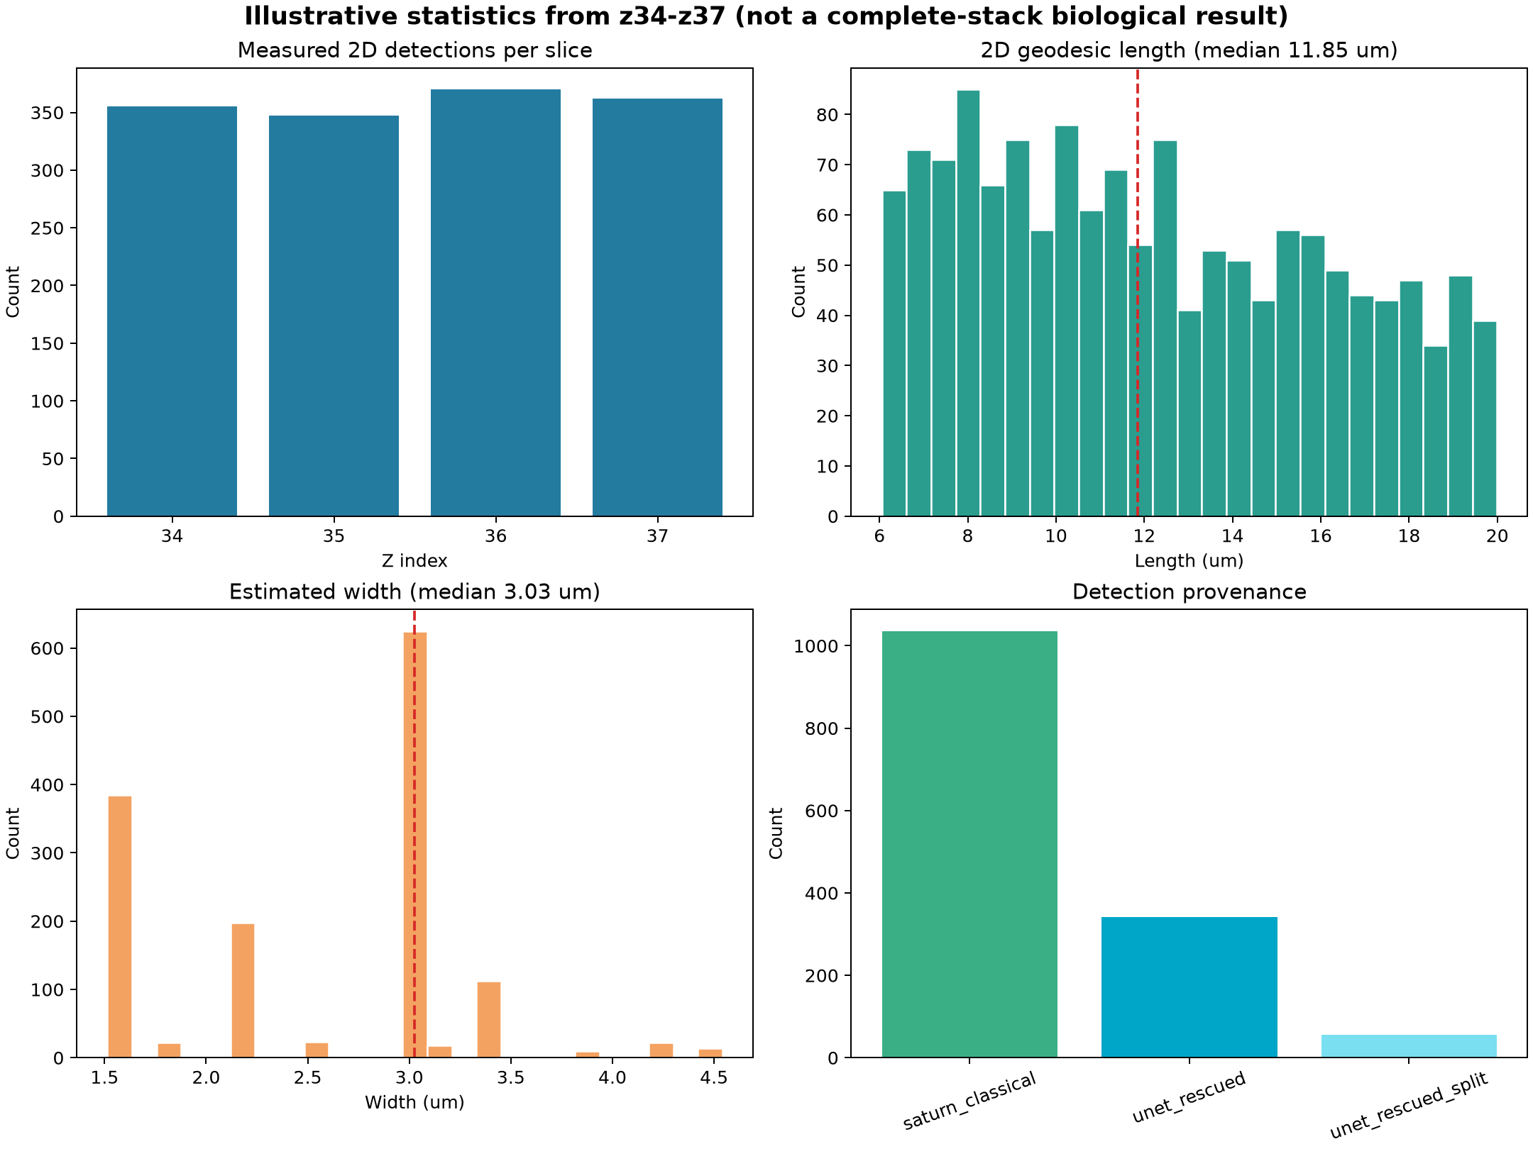
Figure 10. Example software-report output: plane-level detection counts, 2D length and width distributions, and classical/U-Net provenance. These plots demonstrate reporting and are not a substitute for the tracked unique-nucleus result.
- spermatid_measurements: technical plane-level detections used to inspect segmentation; not the unique-nucleus count.
- measurements_with_tracks: plane-level provenance showing which detections were joined.
- track_summary_all: reconstruction audit table, including hard technical failures.
- track_summary_technical_valid: primary one-row-per-estimated-nucleus table for biological analysis.
- Reference-morphology and morphology-warning fields: QC annotations for review and sensitivity analysis, not separate biological populations.
- PDF summary: the recommended first result for a biologist, including the estimated unique-nucleus count, morphology summaries, sampled exposure, and QC warnings.

9. Multi-Sample Studies and ROI Normalization
Each biological specimen is processed independently with its own image directory, ROI, Z range, XY calibration, and Z spacing. The manager writes one attempt directory per specimen and then aggregates specimen-level summaries. Individual tracks are not treated as biological replicates; the specimen is the replicate for group comparisons.
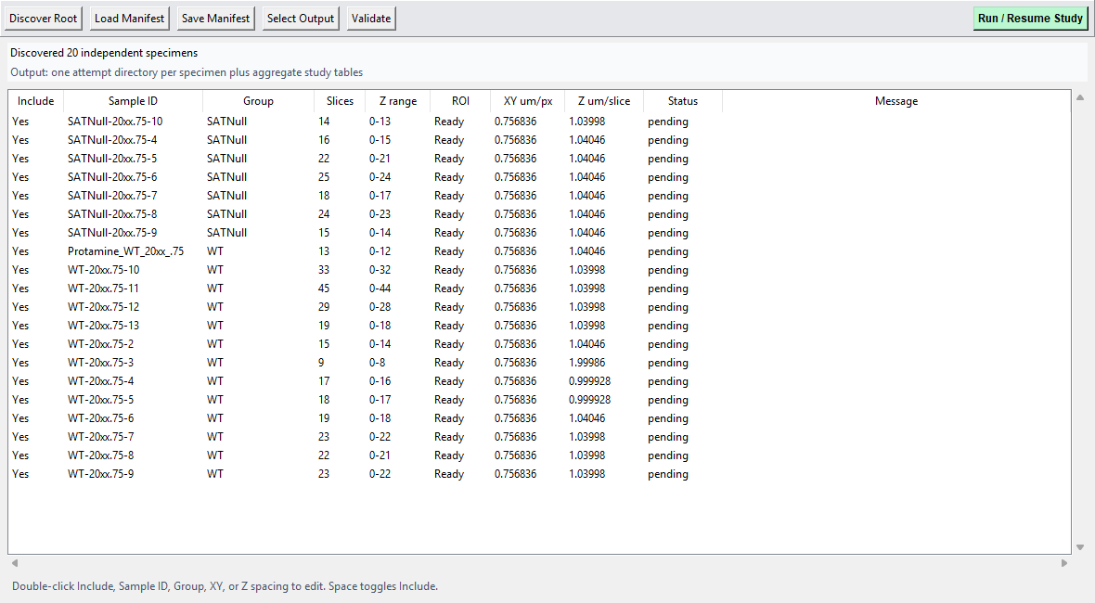
Figure 11. Multi-sample study manager with independently identified WT and SATNull specimens. Each row records its own image directory, ROI, analyzed Z range, calibration, status, and output location.
ROI area | ROI_area_um2 = ROI_pixel_count x XY_um_per_pixel^2  Records how much specimen area was sampled in each image plane.
Sampled depth | sampled_depth_um = included_slice_count x Z_um_per_slice  Uses sampled slab thickness. Stack endpoint span is reported separately as (slices - 1) x Z spacing.
Sampled ROI volume | sampled_volume_um3 = ROI_area_um2 x sampled_depth_um  Used for exposure-normalized count rates, with an explicit Z-boundary censoring warning.
Normalized counts | tracks_per_1000_um2 = tracks / ROI_area_um2 x 1000  tracks_per_100000_um3 = tracks / sampled_volume_um3 x 100000  These rates correct unequal sampled exposure; they do not correct biological differences in tissue packing, staining, or acquisition quality.
The study output includes specimen_summary.csv, group_summary.csv, study_track_records.csv, study_manifest.csv, study_run_state.json, and normalization_qc.json. The normalization QC warns when ROI area or sampled volume differs greatly across specimens, exposure is invalid, or many tracks touch a Z boundary.

10. Reproducibility and Interpretation
Record for every study | Why it matters
Raw image paths and specimen IDs | Separates biological replicates and prevents mixed output folders.
ROI file and ROI pixel count | Defines sampled tissue and normalization exposure.
XY pixel size and Z spacing | Scales every length, width, volume, angle, and normalized count.
Pipeline version and tuned parameter JSON | Makes segmentation and tracking behavior reproducible.
U-Net checkpoint and probability thresholds | Defines AI evidence, rescue sensitivity, and instance splitting.
Detection source and audit flags | Keeps classical/U-Net provenance and QC annotations auditable without creating competing biological populations.
Acquisition class and microscope settings | Prevents interpretation of optical differences as genotype effects.
Normalization and Z-boundary QC | Identifies unequal exposure and truncated stacks.

11. Important Limitations
- A 2.5D U-Net uses local Z context but does not itself create unique 3D nuclei; cross-slice tracking is still required.
- The U-Net was trained on a limited annotated dataset. New acquisition classes require representative visual validation and may require fine-tuning.
- Apparent width, projected area, volume, and effective thickness are sensitive to PSF, staining, saturation, and thresholding.
- The reported 3D length is a calibrated hypotenuse estimate, not a full 3D voxel centerline arc.
- Tracks touching the first or last acquired Z plane may be truncated; their counts and morphology need censoring review.
- ROI normalization corrects sampled exposure, not biological tissue density or staining efficiency.
- WT-versus-mutant inference should use specimens as replicates, report sample size and effect sizes, and avoid treating thousands of tracks as independent animals.
- Visual review panels remain essential when applying the pipeline to a new microscope, magnification, channel, genotype, or preparation.

12. Recommended New-Dataset Workflow
- Organize one top-level image directory per biological specimen and retain the microscope metadata.
- Create or load one ROI per specimen; confirm its contour on early, middle, and late planes.
- Enter the correct XY pixel size and Z spacing for each acquisition.
- Run a representative-slice smoke test before the complete stack.
- Inspect raw, preprocessing, probability, accepted, rejected, and tracking overlays.
- Tune segmentation and U-Net rescue only on representative development images; keep held-out specimens for validation.
- Run the multi-sample manager so every specimen receives an independent attempt directory.
- Review normalization_qc.json and Z-boundary warnings before comparing groups.
- Use the estimated unique-nucleus population for the primary comparison. Review morphology, boundary, and tracking annotations as sensitivity analyses rather than treating them as separate counts.
- Archive the manifest, parameter JSON, U-Net checkpoint identifier, reports, and code version with the study.

Appendix A. Demonstration Run Provenance
Item | Recorded value
Pipeline | C:\Users\dmishra\Desktop\sperm_project\sperm_segmentation_saturnv5.7.py
Dataset | C:\Users\dmishra\Desktop\sperm images
ROI | C:\Users\dmishra\Desktop\sperm images\roi_z28.1.npy
Tuned parameters | C:\Users\dmishra\Desktop\sperm_project\parameter_tuning_results_v5_7\unet_rescue_cached\best_unet_rescue_params_v5_7_001.json
U-Net checkpoint | C:\Users\dmishra\Downloads\unet25d_output_kaggle_resume\checkpoints_resatt_partial_annotated2_resume\best.pt
Selected slices | 34, 35, 36, 37
ROI pixels | 284,436
Illustrative accepted 2D detections | 1,434 (1,036 classical; 398 U-Net rescue)

Appendix B. Terminology
Term | Operational meaning in Saturn v5.7
Detection | One accepted 2D centerline on one Z plane.
Track | A set of linked plane-level detections interpreted as one estimated unique nucleus across Z.
Classical | Detection produced by ridge, mask, skeleton, and morphology processing.
U-Net rescue | Detection recovered from model probability evidence after instance splitting and biological measurement checks.
ROI normalization | Counts scaled by sampled ROI area or sampled ROI volume.
Technical-valid | A reconstructed nucleus without a hard technical failure. This is the single primary estimated-nucleus population.
Reference morphology | Optional review annotation for nuclei matching configured reference-shape limits; it is not a second population to add to the count.

