TCP Traffic Analysis Using Wireshark

Aim
To capture and examine TCP traffic in Wireshark, identify the communication between a client and a web server, and observe TCP acknowledgements, duplicate acknowledgements, sequence numbers, and HTTP requests.

Procedure
- Open Wireshark and select the network interface that is carrying the traffic.
- Start the packet capture and generate web traffic by accessing the relevant website or application.
- Stop the capture after sufficient packets have been collected.
- Apply the display filter `tcp` to view TCP packets. Use `http` if you want to focus on visible HTTP requests.
- Inspect the Source, Destination, Protocol, Length, and Info columns to identify the communicating hosts and TCP activity.
- Select individual packets and examine the packet-details pane for Ethernet, IP, and TCP header fields such as source port, destination port, sequence number, acknowledgement number, and TCP flags.
- Observe the highlighted TCP Dup ACK packets. These indicate that the receiver is repeatedly acknowledging the same sequence position, which can occur when segments are missing or arrive out of order.
- Record the observations and stop the capture.

Screenshot
The screenshot below shows TCP traffic in Wireshark, including ACK packets, TCP duplicate acknowledgements, TCP segments associated with a reassembled PDU, and an HTTP GET request.
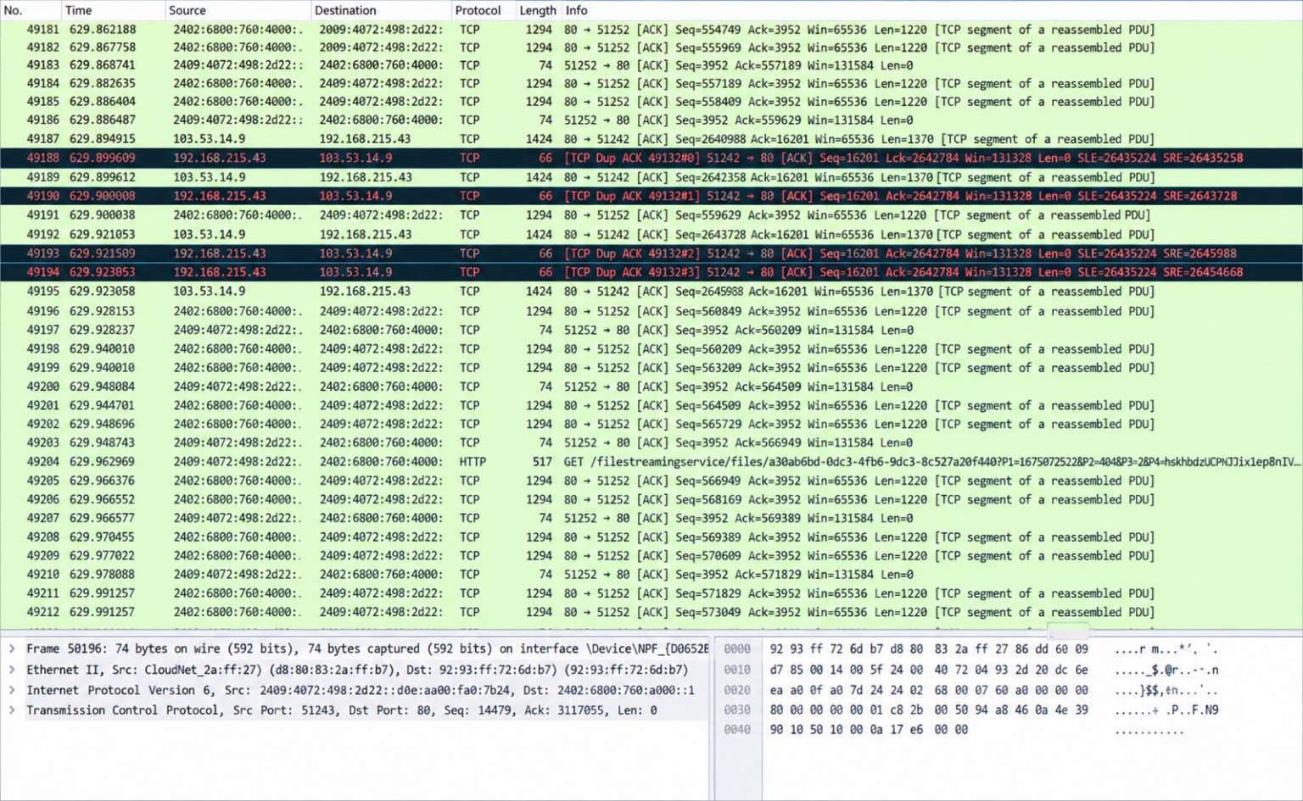

Result
TCP traffic was successfully examined in Wireshark. The packet list shows communication involving a web server on port 80, acknowledgement packets, repeated TCP duplicate ACKs, and an HTTP GET request. Duplicate ACKs may suggest packet loss or out-of-order delivery, but the screenshot alone is not sufficient to confirm the exact cause. The packet-details pane also displays TCP header information, including ports, sequence and acknowledgement numbers.

