DNS RECORDS AND NETWORK DIAGNOSTICS
Domain: saveetha.com

Aim
To examine the DNS records and domain registration information of saveetha.com, and to study the network connectivity and route to the domain using ping and traceroute.

Procedure
- Open a DNS/WHOIS lookup website and enter the domain name saveetha.com.
- View the DNS records, including SOA, NS, A, and MX records, and note their values.
- Review the registrar information, domain status, important dates, and name servers shown in the WHOIS results.
- Run the ping diagnostic for saveetha.com to check whether the host responds and to observe response time and packet loss.
- Run traceroute to saveetha.com to view the network hops taken by packets toward the destination.
- Capture screenshots of the DNS records, WHOIS information, ping output, and traceroute output, then include them in the report.

Observations
The supplied screenshots show DNS records for saveetha.com, registrar and name-server details, and network diagnostic results. The displayed DNS entries include A records pointing to 198.185.159.145 and 198.185.159.144, and MX records associated with Google mail servers.
In the supplied ping output, 5 packets were transmitted and 5 were received, with 0% packet loss. The reported round-trip times are approximately 8.389 ms minimum, 8.722 ms average, and 9.221 ms maximum.
The traceroute screenshot displays the initial network hops toward saveetha.com. Some hops may show intermediate routers rather than the destination.

Screenshots
Figure 1: DNS records for saveetha.com
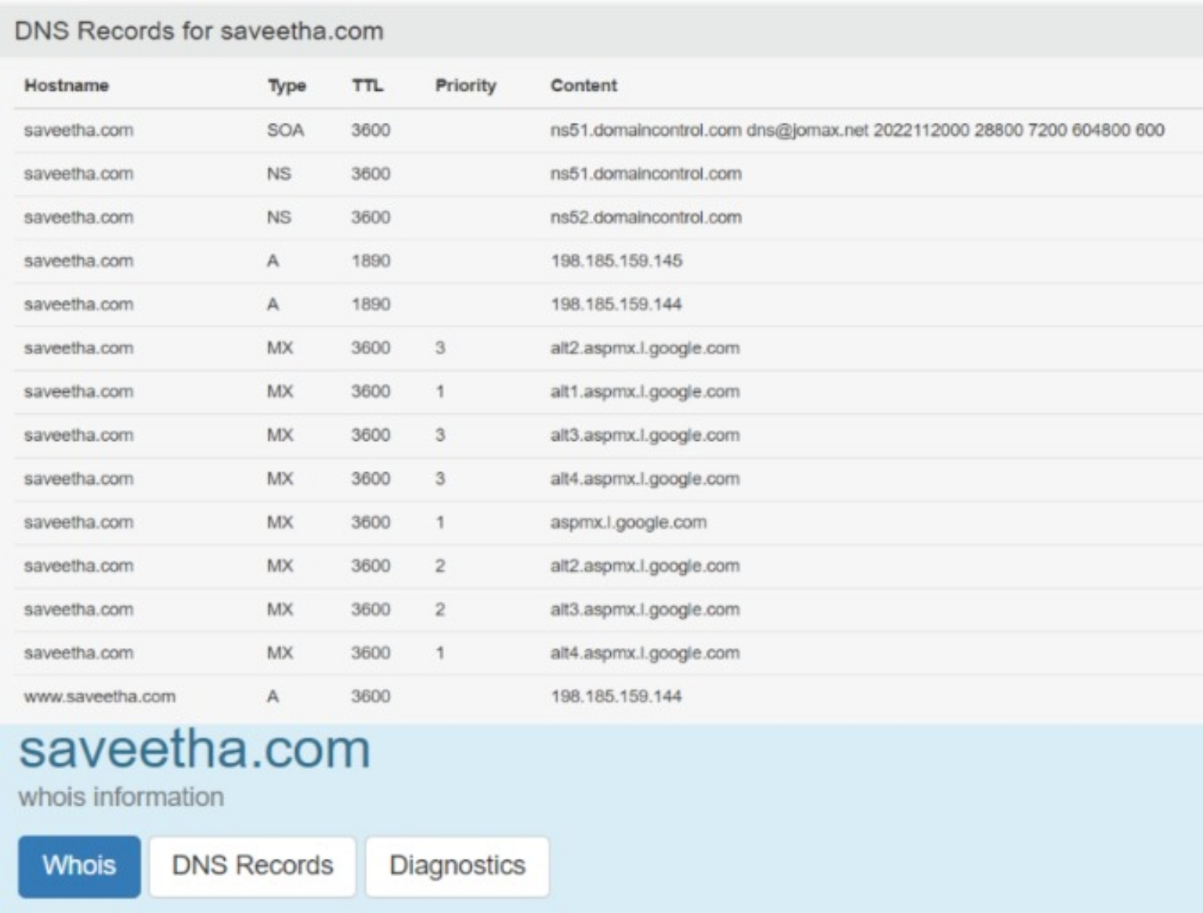
Figure 2: WHOIS registrar information, important dates, and name servers
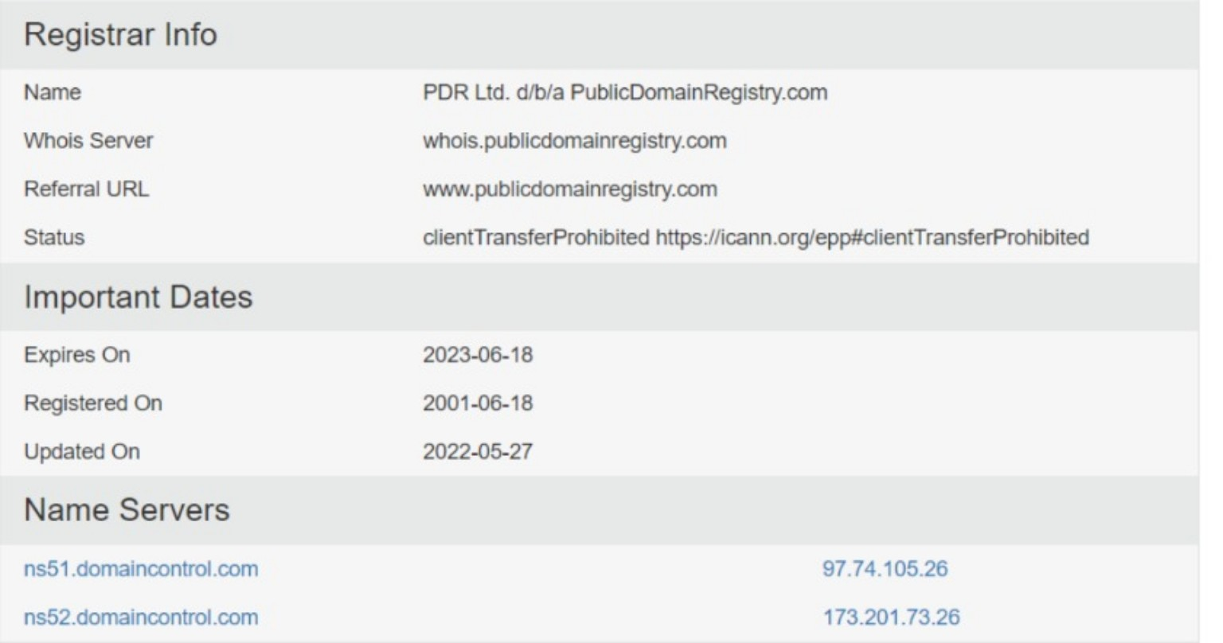
Figure 3: Ping and traceroute diagnostic output
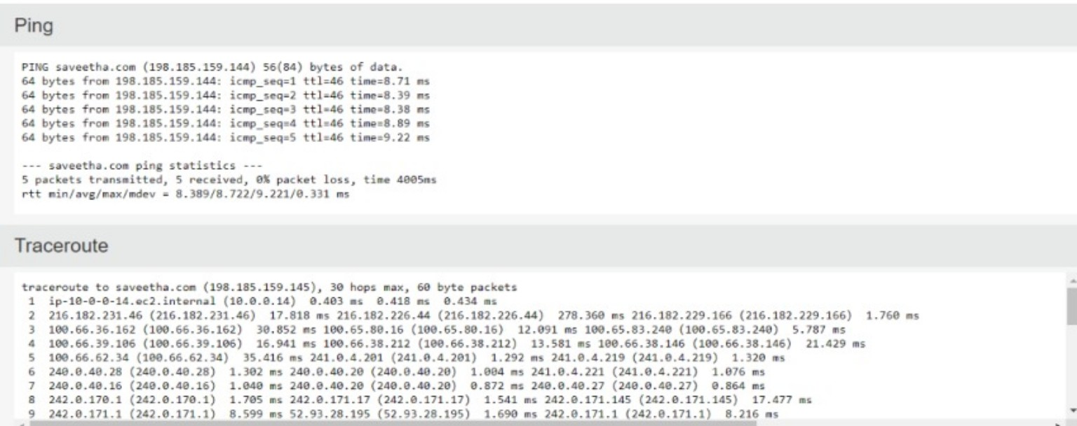

Result
The DNS and WHOIS information for saveetha.com was examined, and the supplied network diagnostics were interpreted. The ping test received all 5 replies with 0% packet loss and an average round-trip time of about 8.722 ms, indicating successful connectivity during the test. The traceroute output showed the initial route hops toward the domain.

