NETWORK DIAGNOSTIC COMMANDS IN WINDOWS
Ping • IP Configuration • Traceroute • Netstat

Aim
To use Windows Command Prompt network diagnostic commands to verify connectivity to www.saveetha.com, inspect network adapter configuration, trace the route to the destination, and examine active network connections and protocol statistics.

Procedure
- Open Command Prompt. Search for “cmd” in the Windows Start menu and launch Command Prompt.
- Test reachability. Run ping www.saveetha.com to send four test packets and review the replies, packet loss, and round-trip times.
- Inspect adapter settings. Run ipconfig to view the configuration of available network adapters, including IP address, subnet mask, default gateway, and DNS-related details when displayed.
- Trace the path. Run tracert www.saveetha.com to identify responding hops between the computer and the destination.
- Check active connections. Run netstat to list local and remote connections and their states. Use netstat -ano when process IDs are also required.
- Review protocol counters. Run netstat -s to display cumulative protocol statistics such as received packets, errors, and discards.

Result
The commands were used to examine network connectivity and the local TCP/IP configuration. The supplied outputs show the following observations:
Command / Test | Observation from output
ping www.saveetha.com | The hostname resolved to IPv6 address 64:ff9b::c6b9:9f90. Four packets were sent and received, with 0% packet loss. Round-trip time: minimum 332 ms, maximum 428 ms, average 382 ms.
ipconfig | Two “Local Area Connection*” wireless virtual adapters showed “Media disconnected.” A Wi-Fi adapter was listed, but its IP details are not visible in the supplied screenshot.
tracert www.saveetha.com | The trace reached the destination at hop 13. Hops 3–12 reported “Request timed out,” which can occur when intermediate devices do not return traceroute responses.
netstat | The active-connections output showed multiple TCP connections in ESTABLISHED and TIME_WAIT states, including HTTPS traffic and connections to a DNS service.
Protocol statistics | The statistics screen showed cumulative IPv4 counters, including received packets, header/address errors, and discarded packets. These totals alone do not identify the cause of an issue.
Conclusion: Connectivity to the destination was successful during the ping test, and the route completed. The diagnostic commands also displayed adapter, connection, and protocol information useful for basic network troubleshooting. The relatively high ping times and traceroute timeouts may warrant further checks if users are experiencing slow connectivity.

SCREENSHOTS / EXPERIMENT OUTPUTS

Screenshot 1: Ping Test
Command: ping www.saveetha.com
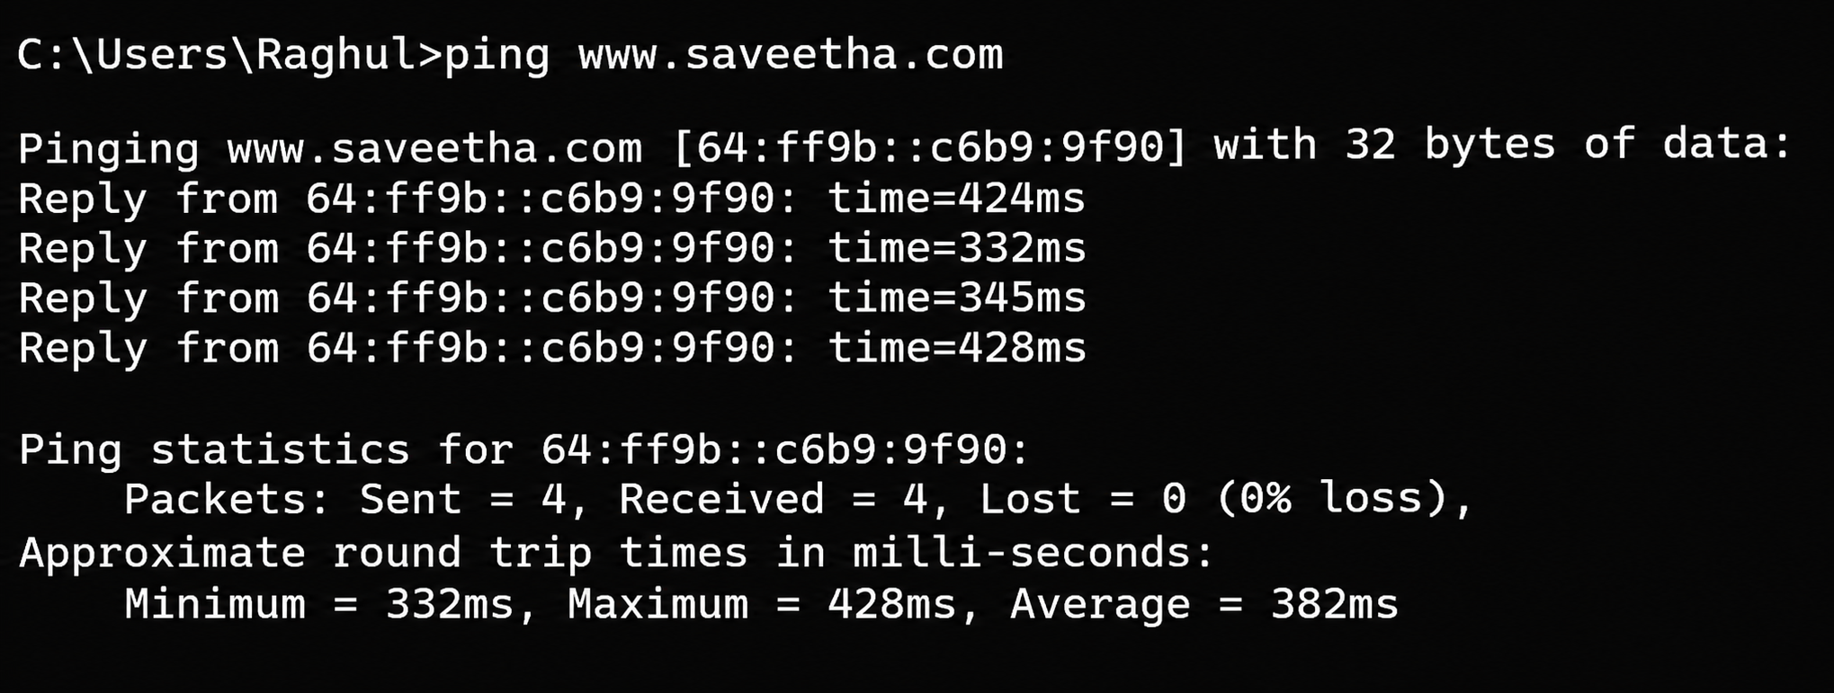

Screenshot 2: IP Configuration
Command: ipconfig
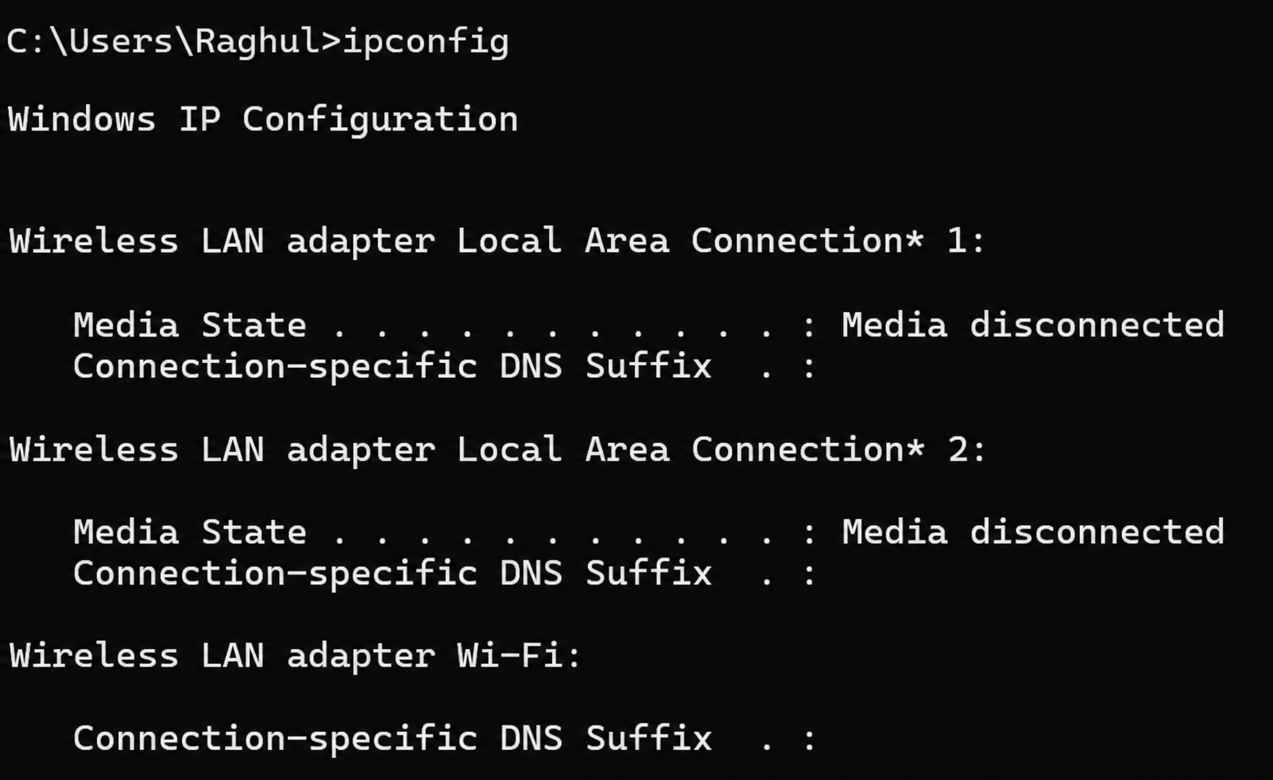

Screenshot 3: Traceroute
Command: tracert www.saveetha.com
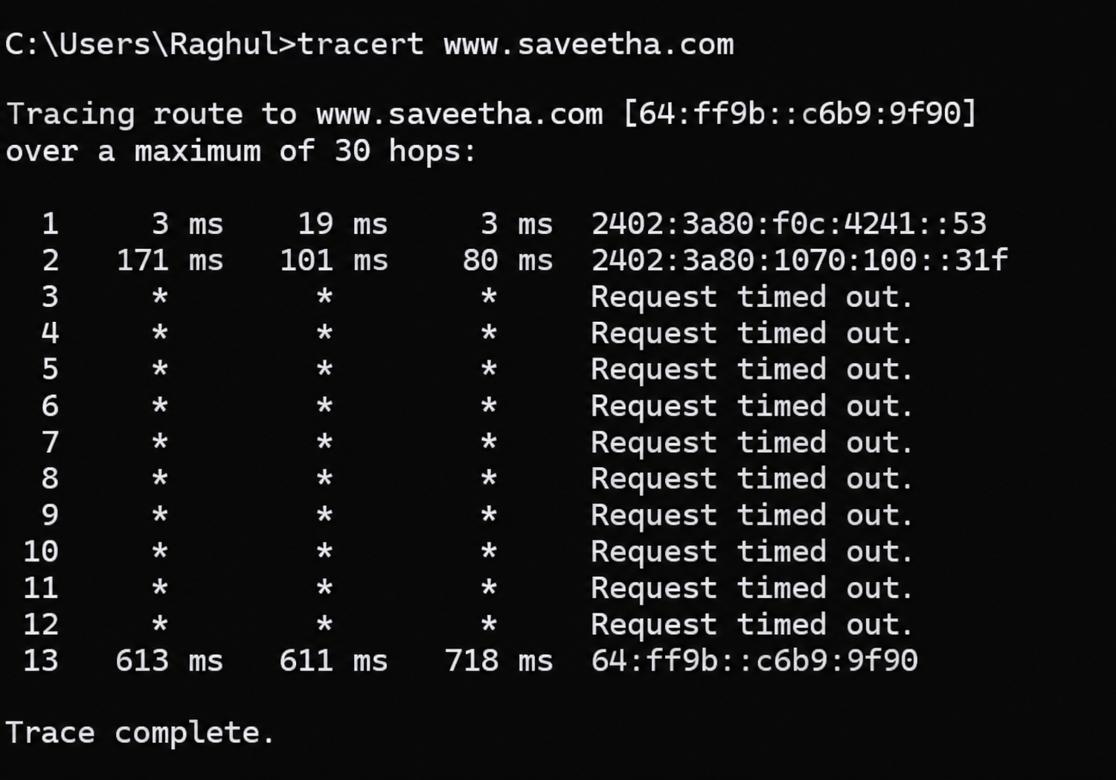

Screenshot 4: Network Interface and IPv4 Statistics
Network interface and IPv4 statistics output
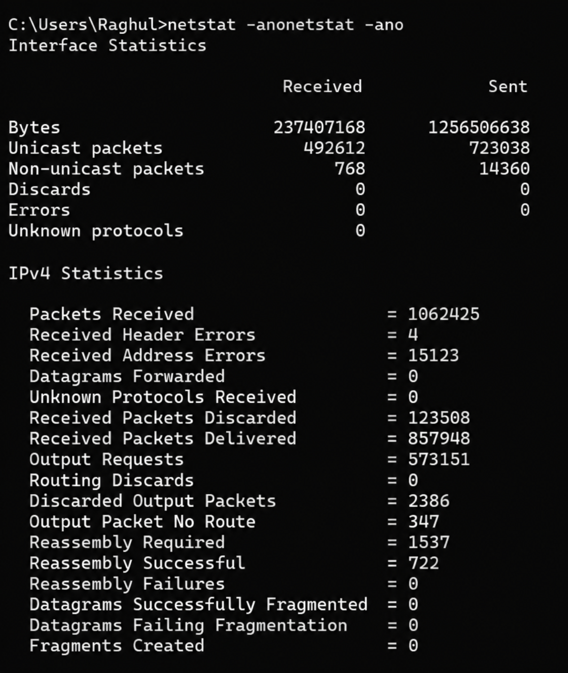

Screenshot 5: Active Network Connections
Command: netstat
