# 13016245 Embedded System Software – Project outline

## Beverage vending machine

Sitinut Waisara 59090030

## Introduction

In the present day, we are entering digital world. Everything is stored in digital world, including money. Cashless system become more convenient, secure and fast. It would be great if we can buy goods without human service and pay by cashless system.

## System overview

The system consists of two main parts. First, all electronics and mechanical parts that deliver the beverage to customers. Second is the user interface part which is powered by Android OS device, it also generates QR code for customer to pay and check the payment. Both parts will communicate to each other with Bluetooth.

## Components

* ESP32 Microcontroller
* Android Device
* Motor Driver
* Water pump
* Bulk converter

## TeacherWi-FiBluetoothBlock diagram

Pump

Motor controller

ESP32 Microcontroller

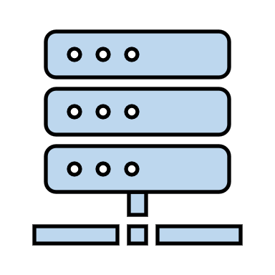

Server

User

Android Device

# 13016245 Embedded System Software – Project outline

## CAD Drawing

