#1136 : Professor Q's Software

时间限制:10000ms

单点时限:1000ms

内存限制:256MB

|  |
| --- |
|  |

描述

Professor Q develops a new software. The software consists of N modules which are numbered from 1 to N. The i-th module will be started up by signal Si. If signal Si is generated multiple times, the i-th module will also be started multiple times. Two different modules may be started up by the same signal. During its lifecircle, the i-th module will generate Ki signals: E1, E2, ..., EKi. These signals may start up other modules and so on. Fortunately the software is so carefully designed that **there is no loop in the starting chain of modules**, which means eventually all the modules will be stoped. Professor Q generates some initial signals and want to know how many times each module is started.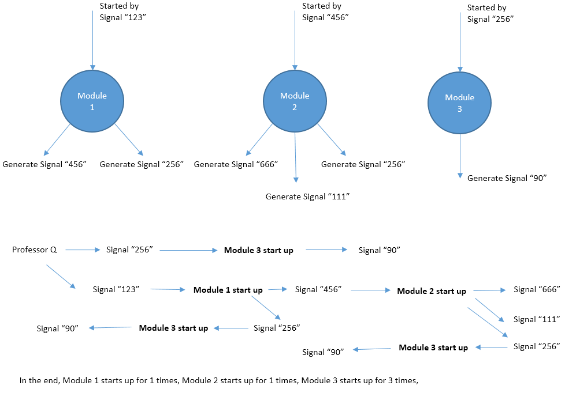

输入

The first line contains an integer T, the number of test cases. T test cases follows.

For each test case, the first line contains contains two numbers N and M, indicating the number of modules and number of signals that Professor Q generates initially.

The second line contains M integers, indicating the signals that Professor Q generates initially.

Line 3~N + 2, each line describes an module, following the format S, K, E1, E2, ... , EK. S represents the signal that start up this module. K represents the total amount of signals that are generated during the lifecircle of this module. And E1 ... EK are these signals.

For 20% data, all N, M <= 10  
For 40% data, all N, M <= 103  
For 100% data, all 1 <= T <= 5, N, M <= 105, 0 <= K <= 3, 0 <= S, E <= 105.

**Hint: HUGE input in this problem. Fast IO such as scanf and BufferedReader are recommended.**

输出

For each test case, output a line with N numbers Ans1, Ans2, ... , AnsN. Ansi is the number of times that the i-th module is started. In case the answers may be too large, output the answers modulo 142857 (the remainder of division by 142857).

**样例输入**

3

3 2

123 256

123 2 456 256

456 3 666 111 256

256 1 90

3 1

100

100 2 200 200

200 1 300

200 0

5 1

1

1 2 2 3

2 2 3 4

3 2 4 5

4 2 5 6

5 2 6 7

**样例输出**

1 1 3

1 2 2

1 1 2 3 5

暴力，利用队列和相互映射一边过……

#include <iostream>

#include<sstream>

#include<iomanip>

#include<string>

#include<vector>

#include<stack>

#include<queue>

#include<algorithm>

#define hash 997

#define MAX 100005

#define ll long long

using namespace std;

vector<vector<int>>signal_module;

vector<vector<int>>module_signal;

vector<int>module_start;

queue<int>signal_list;

void reset(int num)

{

signal_module.clear();

module_signal.clear();

module_start.clear();

signal_module.resize(MAX);

module_signal.resize(num);

module_start.resize(num,0);

}

int main()

{

int time;

int module_num, signal_num;

cin >> time;

while (time--)

{

scanf("%d %d", &module_num, &signal_num);

reset(module_num);

for (int i = 0; i < signal_num; i++)

{

int temp;

scanf("%d", &temp);

signal_list.push(temp);

}

for (int i = 0; i < module_num; i++)

{

int temp,signal;

cin >> signal;

signal_module[signal].push_back(i);

cin >> temp;

for (int j = 0; j < temp; j++)

{

cin >> signal;

module_signal[i].push_back(signal);

}

}

//input

while (!signal_list.empty())

{

if (signal_module[signal_list.front()].size())

{

for (int i = 0; i < signal_module[signal_list.front()].size(); i++)

{

int target = signal_module[signal_list.front()][i];

module_start[target]++;

module_start[target] %= 142857;

if (module_signal[target].size())

{

for (int i = 0; i < module_signal[target].size(); i++)

{

signal_list.push(module_signal[target][i]);

}

}

}

}

signal_list.pop();

}

//process

if (module_num)

cout << module_start[0];

for (int i = 1; i < module_num; i++)

{

cout << " " << module_start[i];

}

cout << endl;

}

}