**Manual for Document Management System(DMS)**

University of Sharjah

Dusko Vlacina

16/12/2018

1. **Registration:**

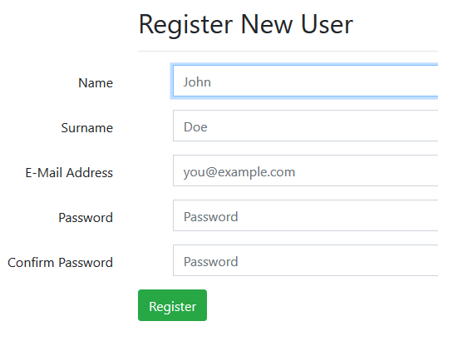

Creating new user is available through register page in DMS and all fields are mandatory.

After registration new user will receive email to verify account.

New user needs verify his account through email if he wants to use DMS!

1. **Toolbar:**



1. Home page
2. Workspace with list of files and buttons to work with files
3. Page for uploading files. It is possible to upload multiple files at the same time!
4. Page for changing information about user
5. Sign out from the system
6. **Workspace:**

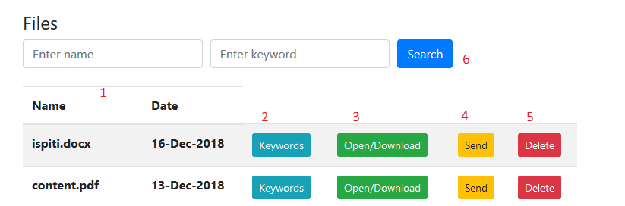

1. **File information**
2. **Keywords** are used to tag files and make them easier to find. Number of keywords is unlimited and connected with file ID

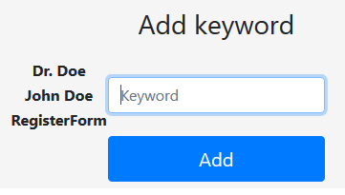

1. New pop-up window with possibility to **open or download** file

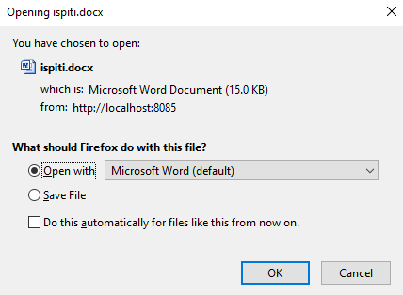

1. Option to **send email** with attached file

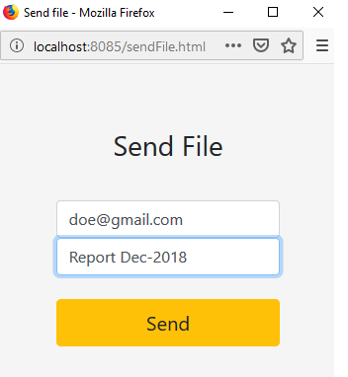

All fields are mandatory!

1. **Delete file**
2. **Search** is possible with file name, keyword or combined

**Suggestions:**

* Add subject and description while uploading files
* Print button
* View button
* Check box to mark more files and manage with them
* Messaging system between users
* Admin role
* Improve UI