Homework-7

**Out date:** March 06, 2020

**Due date:** March 15, 2020 at 11:59PM

Team#: 15

Team Member-1:___Ryan Leveille____________Member’s Contribution (in %) _50_

Team Member-2:___Dustin Vasquez__________Member’s Contribution (in %) _50_

**Submission**

1. Answer the following questions.
2. Submit your Tableau file in **twbx** format (e.g., Homework7_Team1.twbx).
3. Upload the file to the blackboard system.

**Problem-1 [20 points]**

The following table shows the ***percentage of people holding BA degrees*** ***(or higher)***, and the ***percentage of people who are obese*** per state. How would you encode the data so readers can see the relationship, or lack thereof, between your two variables?

**In particular, sketch two most appropriate visualizations that show the relationship between the two variables for every state [10 points per vis].**

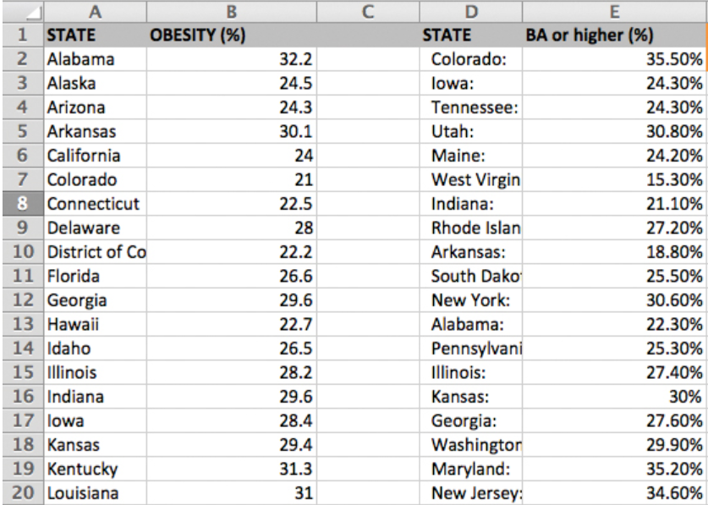

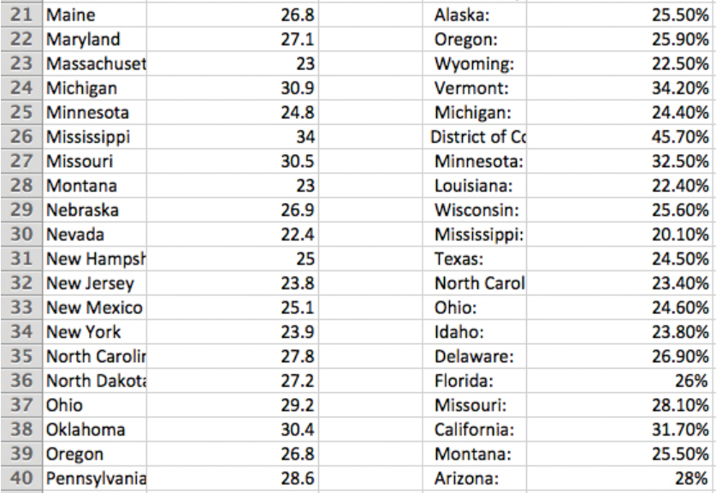

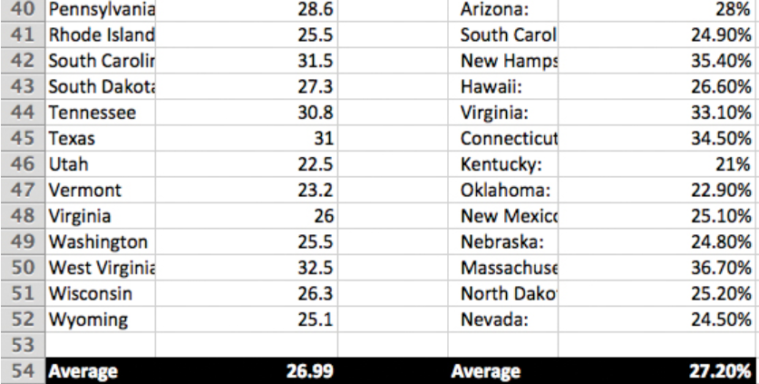

**Problem-2 [80 points]**

This is an extension of the fertility rate data visualization. Create a dashboard which should show 1) a map (symbol map) which encodes the average fertility rate of a country via the size of the circle, and 2) a line graph that shows the fertility rates over the period for all countries and the world average (you may use homework-5 and homework-6 visualizations) **[20 points]**. Add filters and highlights to provide better user experience **[20 points]**. For instance, when a country on the map is selected, the line graph should highlight that country and vice versa. Proper annotations should be provided to clearly state the selected country’s name and the average fertility rate of that country. The annotations should be updated (name of the country and the average fertility rate) as the user selects different countries **[20 points]**.

Provide a title and short description of the dashboard. Also provide information on how to use the dashboard. Add a logo of your choice (UH logo or a company logo) **[10 points]**.

Filter the fertility rate on the map by the time-period such that as the user changes the time-period, various components (map, annotations, etc…) in the dashboard get updated to reflect the latest average fertility rates. Use slider GUI control for this **[10 points]**.