Homework-4

**Out date:** February 14, 2020

**Due date:** February 23, 2020 at 11:59PM

Team#: 15

Team Member-1:___Ryan Leveille____________Member’s Contribution (in %) _50_

Team Member-2:___Dustin Vasquez__________Member’s Contribution (in %) _50_

**Submission**

1. Answer the following questions
2. Submit your Tableau file in **twbx** format (e.g., Homework4_Team1.twbx).
3. Upload the file to the blackboard system

**Problem-1 [20 points]**

Take a look at this data that shows undergraduate students’ interest in scientific research before and after attending REU (Research Experiences for Undergraduate) program:

|  |  |  |
| --- | --- | --- |
| Student Interest | Research Interest before the REU program | Research Interest after the REU program |
| Most interested | 20 | 30 |
| Above average | 10 | 15 |
| Average | 30 | 20 |
| Below average | 15 | 8 |
| Least interested | 5 | 7 |

**Question-1: Sketch three most appropriate visualizations for this data. The visualization should clearly demonstrate the intervention of the REU program on the students’ interest in research. [15 points]**

Answer:

**Question-2: Provide analytics from the visualization. In particular, what interesting patterns are emerging from the visualizations? [5 points]**

Answer:

**Problem-2 [25 points]**

Look at the visualization available at the following website: <http://www.nytimes.com/interactive/2008/02/23/movies/20080223_REVENUE_GRAPHIC.html?_r=0>

**Note:** The link does not work in Google Chrome but it does work for Internet Explorer.

Answer the following Questions:

**Problem 1.1: Who is the intended audience? Justify your Answer. [5 points]**

Answer:

**Problem 1.2: What questions does this visualization answer? 5 points]**

Answer:

**Problem 1.3: How the data (or each variable) is visually encoded? [5 points]**

Answer:

**Problem 1.4: What do you like or dislike about this visualization? [5 points]**

Answer:

**Problem-3 [55 points]**

You are hired by a non-profit organization to produce **interactive visualizations** of countries’ fertility rates over the period of past 60 years (1950 – 2010). In order to meet the organization’s requirements, you have outlined the following tasks and decided to execute them:

1. Download the **total fertility rate** (children per woman) data from the UN website (<http://data.un.org/>). Store the data in the Excel format. Reorganize the data and clean the data so that it can be imported to Tableau.Import the data to Tableau. **[15 points]**

**Data Information**

Use this dataset for homework-2: [Total **fertility** **rate** (live births per woman)](http://data.un.org/Data.aspx?q=fertility+rate&d=PopDiv&f=variableID%3a54)

<http://data.un.org/Data.aspx?q=fertility+rate&d=PopDiv&f=variableID%3a54>

**Use the data for the time period of 1950 till 2015. Discard the data after 2015 because these are just projections.**

1. **Visulization-3.1:** Compare fertility rate of the countries via boxplot. Plot a boxplot per country. The boxplot should show fertility rates of a country between years 1950 and 2010. The dataset provides the fertility rate in the step of 5 years. **[30 points].**

A Sample solution is give n below:

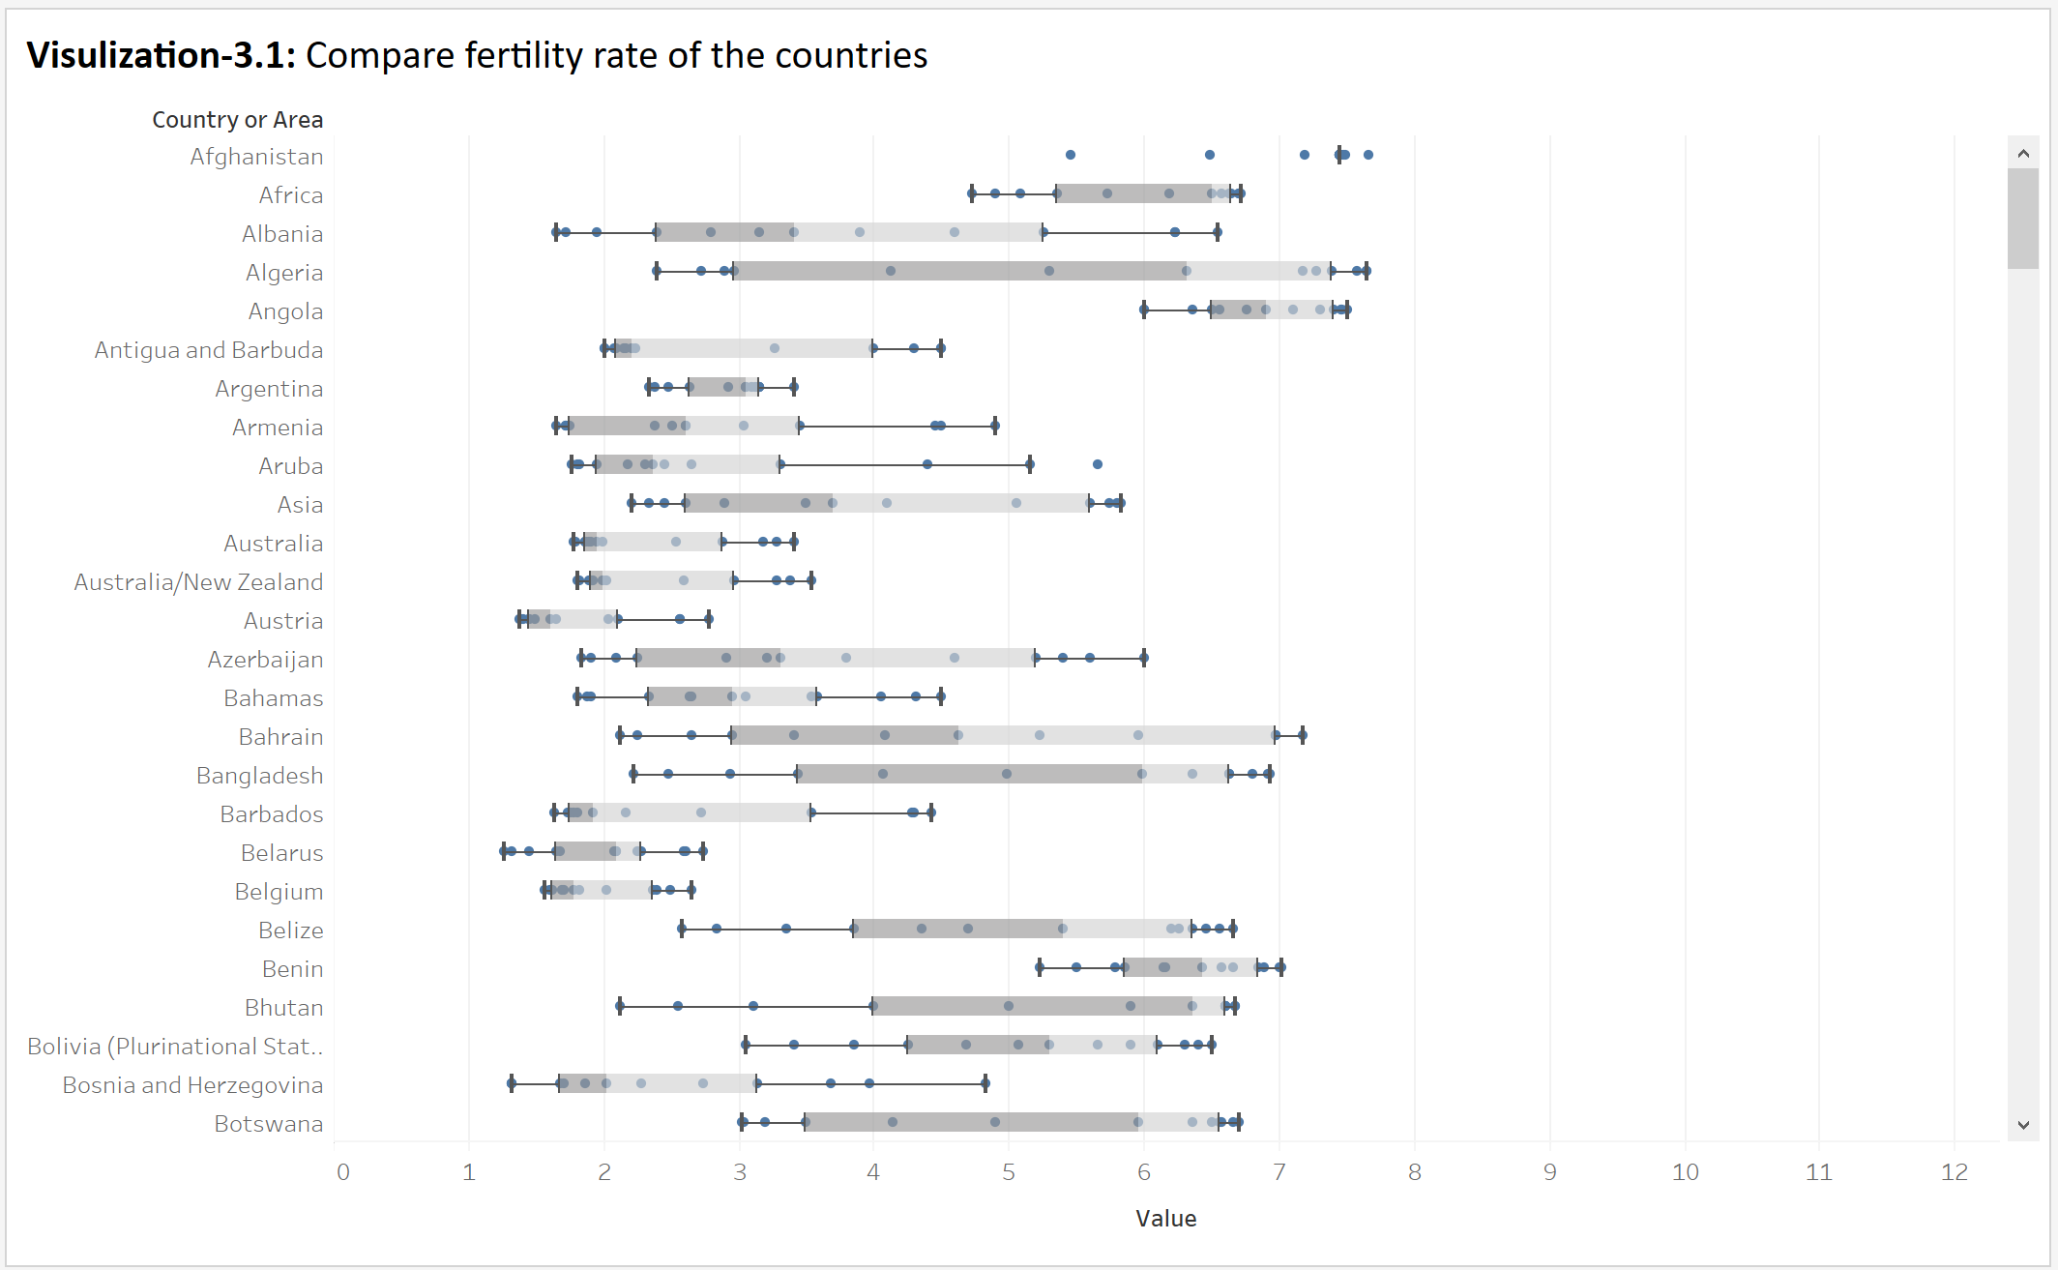

1. **Visulization-3.2:** Use filter to let the user select **country (or countries)** of his/her choice. As user select countries, the visualization should add boxplots for those countries. **[10 points]**

A Sample solution is give n below:

