Homework-6

**Out date:** February 28, 2020

**Due date:** March 08, 2020 at 11:59PM

Team#: 15

Team Member-1:___Ryan Leveille____________Member’s Contribution (in %) _50_

Team Member-2:___Dustin Vasquez__________Member’s Contribution (in %) _50_

**Submission**

1. Answer the following questions
2. Submit your Tableau file in **twbx** format (e.g., Homework6_Team1.twbx).
3. Upload the file to the blackboard system

**Problem-1 [25 points]**

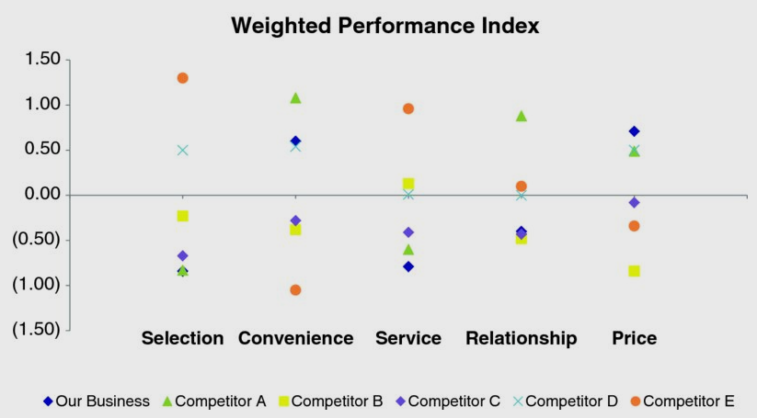Imagine you work for a U.S. retailer and want to understand how your customers feel about various dimensions of their shopping experience in your store compared to your competitors. You have conducted a survey to collect this information and are now trying to understand what it tells you. You have created a weighted performance index to summarize each category of interest (the higher the index, the better the performance, and vice versa). You don’t need to worry about the details of how this is calculated, but rather understand that this is a summary performance metric that we’d like to compare across various categories. The figure on the right shows the weighted performance index across categories for your company and five competitors. So many things are competing for our attention that it is hard to know where to look. **Proposal a most appropriate visualization that can effectively illustrate shopping experience in your store compared to your competitors.**

**Problem-2 [25 points]**

Consider the following visualization. It shows monthly unemployment rate change in Spain. It may be effective in presenting an abstract information such as southeast suffers more from the unemployment problem than that of northwest and west.

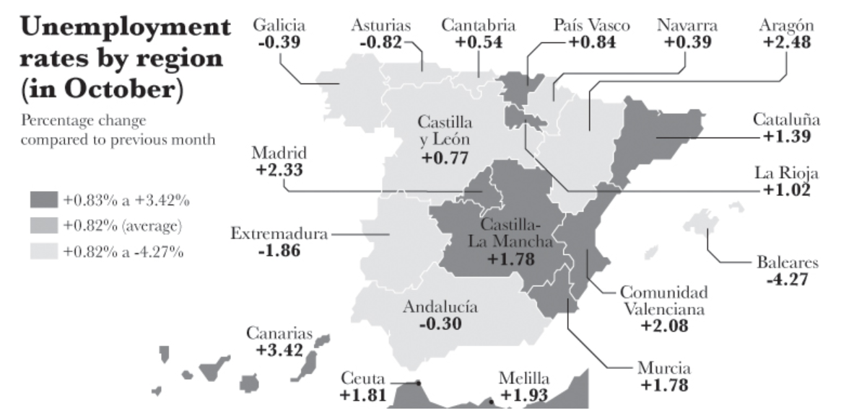

Yet, the visualization is not very effective in answering the questions such as the following:

1. Which state has unemployment grown the most?
2. Which state has it dropped the most?
3. Has the unemployment change been bigger in Madrid, La Rioja, or Canarias?
4. Has unemployment dropped more in Extremadura, Andalucía, or Baleares?

**Sketch a most appropriate visualization that can effectively answer the questions such as listed above.**

**Problem-3 [50 points]**

This homework is built upon the last homework (homework-5).

Create a copy of the **Problem-1.1** visualization of homework-5. Use the control chart concept of CD chapter-7 to highlight the **Trend** (using color encoding) and **Shift (**using shape/marker encoding**)**. **Trend** is defined as 6 or more points either all ascending or descending. **Shift** is defined as 9 or more points either all above or below the average line. Use the replacement line as the average line for the **Shift** calculation. In the ideal case the replacement rate for a country should hover around 2.1. However, most counties are far off the rate.

Develop a visualization to allow the user to select a country (one country at a time) of his/her choice. The visualization should show the time-series of the country’s fertility rate and highlight the data points that represent the **Trend** (orange color) and the **Shift** (a different marker; e.g., triangle marker). Note that many points will represent both, **Trend** and **Shift**.

**Sample Visualizations**

