X86 has hardware context switch support

* Will switch to kernel stack from user stack from syscall/interrupt for you (going from blue to red has hardware support, done automatically)

Recall:

* Kernel stack associated with user stack.
* Returning from switch and changing stacks executes a different thread
* Kernel stack, user stack, registers are restorable snapshot of thread 🡺 swap in virtual program counter (set hardware counter to this value)

1. syscall/interrupt changes IP and SP to point to kernel code and kernel stack
2. Registers from user code pushed into kernel stack (by kernel)
3. Kernel loads its own registers, performs computation/processing
4. Restore user code registers… pop off kernel stack
5. Interrupt return syscall switches IP and SP to point to user code and user stack

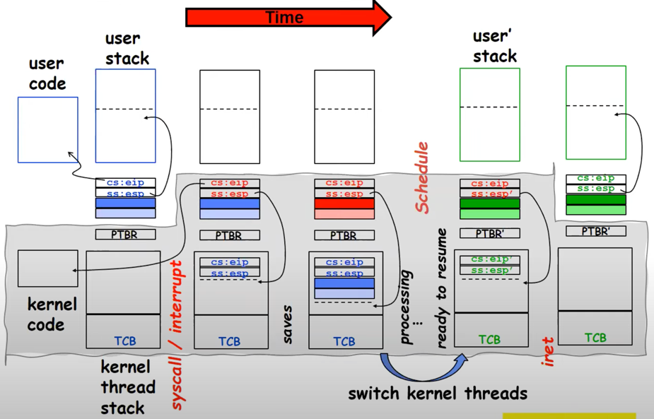

🡸 Scheduling

(New PTBR and user code registers loaded in🡺 created on the fly by interrupt handler 🡺new IP and SP values set)

Dispatcher Problem: Infinite loop due to yield

* Timer Interrupt to Return Control
* Solution to dispatcher problem
  + User timer interrupt to force scheduling decisions

TimerInterrupt(){

DoPeriodicHouseKeeping();

run_new_thread();

}

* Interrupt controller disables everything as soon as interrupt taken 🡺 kernel enters interrupt routine 🡺 disables timer interrupts

Recall: Fixing banking problems with locks

* When one thread acquires lock, all other threads trying to acquire lock are put to sleep

Producer-Consumer with a Bounded Buffer

* Problem Defn:
  + Producer put things into shared buffer (finite buffer)
  + Consumer takes them out
  + Need synchronization to coordinate producer/consumer
  + Need synchronization to keep buffer consistent
* Don’t want producer and consumer to have to work in lockstep, so put a fixed-size buffer between them
  + Need to synchronize access to this buffer (don’t want buffer to get screwed up)
  + Producer needs to wait if buffer is full
  + Consumer needs to wait if buffer is empty
* Circular Buffer Data Structure

typdef struct buf{

int write_index;

int read_index;

<type> *entries[BUFSIZE]

} buf_t;

Insert: write and bump write ptr (enqueue)

Remove: read and bump read ptr (dequeue)

How to tell if Full (on insert) or Full (on remove)?

What needs to be atomic?

Read and Write Indexes need to be consistent (many producers and consumers)

Mutex buf_lock;

Producer(item){

Acquire(&buf_lock)

while(buffer full){}

enqueue(item);

release(&buf_lock)

}

Consumer(){

Acquire(&buf_lock)

while(buffer empty){}

item = dequeue();

release(&buf_lock)

return item

}

Will we ever come out of the wait loop?

Producer acquires lock 🡺 Buffer is full so it waits 🡺 Consumer can’t dequeue because Producer has lock 🡺 Buffer stays full 🡺 Producer spins forever

Mutex buf_lock;

Producer(item){

Acquire(&buf_lock)

while(buffer full){ release(&buf_lock); acquire(&buf_lock);}

enqueue(item);

release(&buf_lock)

}

Consumer(){

Acquire(&buf_lock)

while(buffer empty){ release(&buf_lock); acquire(&buf_lock }

item = dequeue();

release(&buf_lock)

return item

}

No more deadlock.. but its bad. If producer arrives with full buffer and no consumers 🡺 Producer spins for long time 🡺 Wasted cycles

Higher Primitives than Locks

* What is the right abstraction for synchronizing threads that share memory?
  + Want as high level primitive as possible
* Good primitives and practices are important!
  + Since execution isn’t entirely sequential, really hard to find bugs since they happen rarely
* Synchronization is way of coordinating multiple concurrent activities that are shared state

Recall: Semaphores

* Semaphores are a kind of generalized lock
* Defn: Semaphore has a non-negative integer value and supports the following two operations
  + Down or P(): an atomic operation that waits for semaphore to become positive and then decrements it by 1
    - Think of this as a wait() operations
  + Up or V(): an atomic operation that increments the semaphore by 1, waking up a waiting P if any
    - Think of this as the signal() operation
* Semaphores are like integers except…
  + No negative values
  + Only operations are allowed are P and V 🡺 Can’t read or write value
  + Operations must be atomic
    - Two P’s together can’t decrement value below 0
    - Thread going to sleep in P won’t miss wakeup from V – even if both happen at same time
  + Two uses:
    - Mutual exclusion: Binary Semaphore (initial value = 1)
      * Binary Semaphore or Mutex
      * Can be used for mutual exclusion

SemaP(&mysem);

//Critical Section

SemaV(&mysem);

* + - Schedule constraints (initial value = 0)
      * Allow thread 1 to wait for a signal from thread 2
        + Thread 2 schedules thread 1

Init val semaphore = 0

ThreadJoin{

semaP(&mysem);

}

ThreadFinish{

semaV(&mysem);

}

Revisted Bounded Buffer: Correctness constrains for solution

* Correctness Constraints:
  + Consumer must wait for producer to fill buffers, if non full
  + Producer must wait for consumer to empty buffers, if all full
  + Only on thread can manipulate buffer queue at a time
* Remember why need mutual exclusion
  + Computers are stupid
* General rule of thumb: Use separate semaphore for each constraint
  + Semaphore fullSlots = 0 //Consumer Constraint
  + Semaphore emptySlots = bufSize //Producer Constraint
  + Semaphore mutex = 1

Producer(item) {  
 semaP(&emptySlots); // Wait until space  
 semaP(&mutex); // Wait until machine free  
 Enqueue(item);  
 semaV(&mutex);  
 semaV(&fullSlots); // Tell consumers there is  
 // more coke  
}

Consumer() {  
 semaP(&fullSlots); // Check if there’s a coke  
 semaP(&mutex); // Wait until machine free  
 item = Dequeue();  
 semaV(&mutex);  
 semaV(&emptySlots); // tell producer need more  
 return item;  
}

Order of P’s is important!

Producer(){

semaP(&mutex); // Wait until machine free

semaP(&emptySlots); // Wait until space

…

}

Consumer(){

semaP(&fullSlots);

semaP(&mutex);

item = Dequeue()

…

}

Will cause a deadlock! Buffer full 🡺 Producer acquires lock 🡺 Producer attempts to decrement emptySlots = 0 b/c buffer full 🡺 Producer sleeps 🡺 Consumer decrements fullSlots 🡺 Consuemr an’t acquire lock to dequeue 🡺 Deadlock

Where are we going with synchronization?

* We are going to implement various higher-level synchronization primitives (locks, semaphores, monitors) using atomic operations
  + A list of milk

    Description automatically generated with low confidenceEverything is pretty painful if only atomic primitives are load and store
  + Need to provide primitives at user-level
* Motivating example: “Too Much Milk”

Can fix the milk problem by putting a key on the refrigerator

* Lock it and take key if you are going go buy milk
* Fixes too much: roommate angry if only wants OJ
* Of course 🡺 We don’t know how to make a lock yet

Correctness Proprties:

* Need to be careful about concurrent programs
  + Write down correctness behavior first 🡺 Then code
* Correctness properties for “too much milk”
  + Never more than one person buys
  + Someone buys if needed
* First attempt: Restrict ourselves to use only atomic load and store operations as building block

Too Much Milk: Solution #1

* Use not to avoid buying too much milk
  + Leave Note before Buying (lock)
  + Remove Note after Buying (unlock)
  + Don’t buy if note (wait)
* Suppose a computer tries this:
  + if(noMilk){

if(noNote){

leaveNote

buyMilk

remove note;

}

}

Result?

* Still too much milk
* Thread can get context switched after checking milk but before buying milk

Possible Solution:

Solution #3 (labeled notes):

Correct Solution:

Solution #3 works but…

* Complicated, asymmetrical code (A code different from B) 🡺 What if many threads?
* While A is waiting, it is consuming CPU time 🡺 A is spinning
* Must be better way!
  + Have hardware provide higher-level primitives than atomic load & store
  + Build even higher-level programming abstractions on this hardware support

Recall our target lock interface:

* acquire(&milklock) – wait until lock is free, then grab
* release(&milklock) – Unlock, waking up anyone waiting
* Uniform interface for arbitrary number of threads
* These must be atomic operations – if two threads are waiting for the lock and both see it’s free, only one succeeds to grab the lock
* Then, our milk problem is easy,

acquire(&milklock);

if (nomilk)

buy milk;

release(&milklock);

Remember, sleep is different from waiting! Sleep means thread is taken off ready queue onto sleep queue and so scheduler doesn’t give it CPU time.

How to implement locks?

* Hardware lock instruction
  + Is this a good idea?
  + What about putting task to sleep?
    - Putting thread to sleep requires knowledge of current OS, how threads look on stack, where to place thread
    - OS specific version of sleep required
  + How can we build multi-instruction atomic operations?
  + Naïve use of Interrupt Enable/Disable
    - Interrupt Enable/Disable controlled by a single bit
    - Recall: dispatcher gets control two ways 🡺 Internal, External Events
    - On a uniprocessor can avoid context-switching by:
      * Avoiding internal events
      * Preventing external events by disabling interrupts
    - Naïve Implementation:

LockAcquire { disableInts}

LockRelease { enableInts}

* + - Problems with this approach:
      * Can’t let user do this (can crash machine):
        + LockAcquire();

While(TRUE) {;}

* + - Real-time system
      * No guarantees on time 🡺 Critical sections might be arbitrarily long
    - What happens with I/O or other important events
    - Only one lock allowed 🡺 THE LOCK that disables interrupts

Can still use disable interrupts… (no longer THE LOCK but can be used IN A LOCK)

Key idea: maintain a lock variable and impose mutual exclusion only during operations on that variable

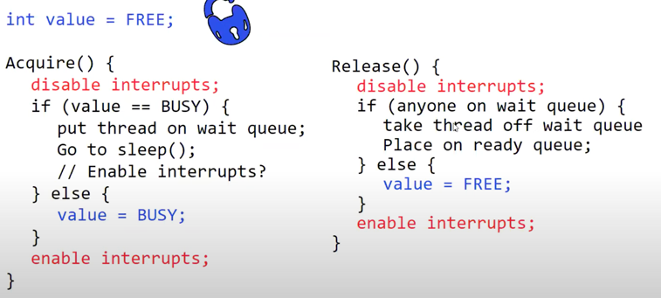

Only disable interrupts for a short time

* Acquire() waits just long enough to see what state of lock is (and possibly alter state of lock)
* Release() waits just long enough to see if anyone is on wait queue and remove them off queue (otherwise set value to FREE and enable interrupts)
* Using interrupt to implement lock
* Short critical section

Why do we need to disable interrupts at all?

* Avoid interruption between checking and setting lock value
* Otherwise two threads could think they both have lock
* What about re-enabling ints when going to sleep?
  + Before putting thread on wait queue?
    - Re-enable interrupts before wait queue 🡺 Scheduler calls other thread which releases 🡺 Place thread on wait queue even though lock is free
  + After putting the thread on the wait queue?
    - Same problem 🡺 Other thread releases lock 🡺 Thread is placed on wait queue and goes to sleep but lock is free
  + Interrupt enabling needs to be placed AFTER on wait queue AND AFTER sleeping 🡺 Is this possible?
  + Solution after thread A is placed on wait queue and goes to sleep 🡺 thread B re-enables interrupts

This is an “in-kernel” lock because interrupt disabling/re-enabling can not be give to the user

*In-Kernel Lock Simulation*

* Note timer can’t go off while interrupts are disabled because timer is a type of interrupt 🡺 External event
* Interrupts are deferred when disabled (ie if timer goes off while interrupts disabled)

Recall: Mulithreaded Server

* Bounded pool of worker threads
  + Allocate in advace: no thread creation overhead
  + Diagram

    Description automatically generatedQueue of pending requests

Simple Performance Model:

* Given that the overhead of a critical section is X
  + User ->