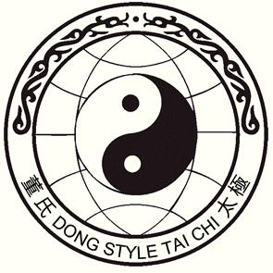***Tai Chi Chuan***

# 3-Day Camp Intensive in New York’s Hudson Valley

with 4th Generation Master

### ***Alex Dong***

# Oct. 26th to 28th, 2018

Lifebridge Sanctuary, Rosendale New York

(about 90 miles north of New York City)

**Cost for the 3 day camp, $475, includes:**

**2 nights lodging, shared rooms and bath**

*Bed linens, towels & liquid soap are provided, but not shampoo*

**6 classes: Friday 3:00 pm & 7:00 pm**

**Saturday - 10:00 am, 3:00 pm & 7:00 pm**

**Sunday – 10:00 am**

*Classes will include a mixture of forms and Qigong*

**Commuter option: $385, includes:**

**All classes, meals and facility charge (no lodging)**

***Register by Sept. 30***

***After OCT. 1, add 10%***

***20% charge for cancellations***

***Registration close and***

***No Refund after Oct. 20.***

**Saturday only options:**

**Morning and afternoon class with lunch**

**$110 (1st and 2nd section of Slow Set)**

**Morning class with lunch**

**$75 (1st section and fundamentals)**

*Price includes a facility charge from Lifebridge*

###### Send payment to Alex Dong,

###### PO Box 750962 Forest Hills, NY 11375

###### [alexdongtaiji@gmail.com](mailto:mcheo@hvc.rr.com)

###### (checks payable to Alex Dong) OR PayPal (friends & family) to [alexdongtaiji@hotmail.com](mailto:alexdongtaiji@hotmail.com)

***Please register me for Alex Dong’s Hudson Valley Intensive, Oct. 26-28, 2018***

Name________________________________________ Phone_________________________

Address______________________________________ City_________________________

State________ Zip__________________ Email_____________________________________

Diet preference and allergies__________________________________