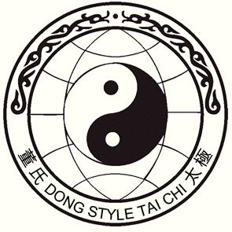***Tai Chi Chuan***

# 3-Day Camp Intensive in New York’s Hudson Valley

with 4th Generation Master

### ***Alex Dong***

# Nov. 3rd to 5th, 2017

Lifebridge Sanctuary, Rosendale New York

(about 90 miles north of New York City)

**Cost for the 3 day camp, $475, includes:**

**2 nights lodging, shared rooms and bath**

*Students must*

*know the whole*

*Slow Set to attend*

*the whole*

*weekend camp.*

*Bed linens, towels & liquid soap are provided, but not shampoo*

**7 classes: Friday 3:00 pm & 7:00 pm**

**Saturday - 10:00 am, 3:00 pm & 7:00 pm**

**Sunday – 10:00 am and 2:00 pm**

*Classes will include a mixture of forms and Qigong*

**Commuter option: $395, includes:**

**All classes, meals and facility charge (no lodging)**

***Register by Sept. 30***

***After Oct. 1, add 10%***

***10-20% charge***

***for cancellations***

***No Refund after Oct. 25.***

**Saturday only options:**

**Morning and afternoon class with lunch**

**$110 (1st and 2nd section of Slow Set)**

**Morning class with lunch**

**$65 (1st section and fundamentals)**

*Price includes a facility charge from Lifebridge*

###### Send payment to Martha Cheo,

###### 115 Springtown Rd., New Paltz, NY 12561

###### 845-256-9316, [mcheo@hvc.rr.com](mailto:mcheo@hvc.rr.com)

###### (checks payable to Martha Cheo) OR PayPal (friends & family) to mcheo@hvc.rr.com

***Please register me for Alex Dong’s Hudson Valley Intensive, November 3-5, 2017***

Name________________________________________ Phone_________________________

Address______________________________________ City_________________________

State________ Zip__________________ Email_____________________________________