  Moncton, New Brunswick Tai Chi Chuan Workshop  with Master Alex Dong  November 10, 11 & 12, 2017 | 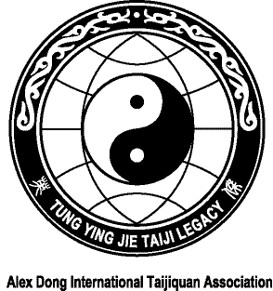  REGISTRATION FORM  Master Alex Dong  Moncton, New Brunswick Tai Chi Chuan Workshop  November 10, 11 & 12, 2017
Sessions: Friday, November 10, 2017  7:00-9:00 pm – Bouctouche  Saturday and Sunday, November 11 & 12  9:30 am to 12:00 pm and 1:30 to 4:00 pm  Moncton – Details to follow  Practice will focus on the Slow Form, Family Fast Set, Knife Set and Push Hands  For accommodations or additional information, please contact:  Claire LeBlanc  claire14@nb.sympatico.ca  Telephone: (506) 855-6609  Web Site: www.alexdongtaichi.com | Name
 | Address
 | Telephone
 | Email
Dates of attendance Full Workshop □ $290
Friday □ $60
(lunch included) Saturday □ $135
(lunch included) Sunday □ $135

 | Dietary Requirements
Please send your registration to:

Claire LeBlanc
273 Freeman St.
Moncton, NB E1E 0H7

