  Moncton, New Brunswick Tai Chi Chuan Workshop  with Master Alex Dong  October 21, 22 & 23, 2016 | 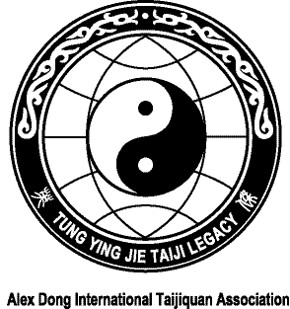  REGISTRATION FORM  Master Alex Dong  New Brunswick Tai Chi Chuan Workshop  October 21, 22 & 23, 2016
Sessions: Friday, October 21, 2016  7:00-9:00 pm – Bouctouche, NB  Saturday and Sunday, October 22 & 23  9:30 am to 12:00 pm and 1:30 to 4:00 pm  École Saint Henri (School)  101 Gross Ave, Moncton, NB  Practice will focus on the Slow Form, Family Fast Set, Knife Set and Push Hands  For accommodations or additional information, please contact:  Claire LeBlanc  claire14@nb.sympatico.ca  Telephone: (506) 855-6609  Web Site: www.alexdongtaichi.com | Name
 | Address
 | Telephone
 | Email
 | Dietary Requirements
Please send your registration to:

Claire LeBlanc
273 Freeman St.
Moncton, NB E1E 0H7

