A multi-layer artificial neural network (ANN) with logistic activation function was implemented to identify hand-written letters of the English alphabet (A-Z). The ANN was trained with 15,000 feature instances (T) and validated with 5,000 instances (V). Note that the instance distribution gives a uniform distribution of each letter A-Z across T and V.

A description of the data itself, as wells as the process of training the ANN can be found by examining the associated inline source-code documentation and will not be discussed here.

The ANN’s classification accuracy was tested with the following learning rates (μ): 0.5, 0.1, 0.01, 0.001.

For each learning rate, 1,000 training iterations were completed before validation.

CONSTANTS: Perceptron Bias = -1

Initial Bias Weight = 0.5,

Parameter Weights = Randomly initialized to a value of type double between -1 and 1.

CONTROL: The perceptron was validated with V prior to any training with T, resulting in extremely poor (less than 1%) letter classification accuracy.

RESULTS: After training the perceptron with T over 1000 training epochs, validation with V produced overall accuracy per learning rate as follows (figure 1):  
  
Figure 1. Note: Overall accuracy is defined as sum(PERCENT_CORRECTLY_CLASSFIED_PER_LETTER) / 26)

Best Result

BEST CASE:   
Specifying a μ of 0.01 produced the highest accuracy after 1000 training iterations. In the process of training with those values, the RMS error of the output layer neurons evolved per training iteration as shown in figure 2. As the RMS Error decreased, classification accuracy improved. Final classification accuracy is shown in Figure 3.

Figure 2.

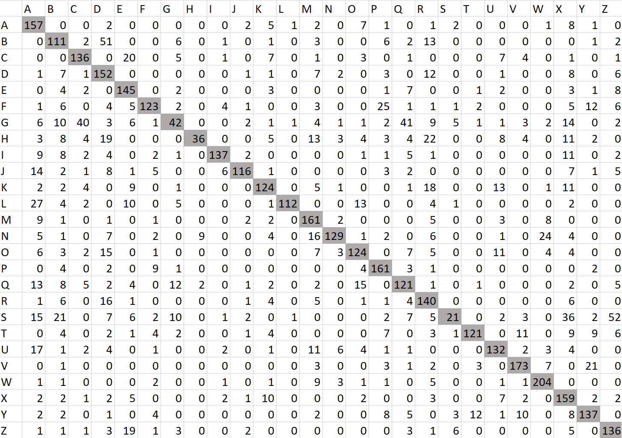  
Figure 3.