Project 2 – Function Utilization

In this project, I tested out the different functions built into BLAS on C and CUDA. I used Ddot, and Daxpy with the CPU and cudablasDdot and cudablasDaxpy with the GPU. The goal of this project is testing the efficiency of different functions. First, we wrote the base function to do matrix multiplication. Then, I implemented the Ddot and Daxpy. I did the exact same procedure for the GPU. Finally, I created a time vs. Mesh size to compare the efficiency.

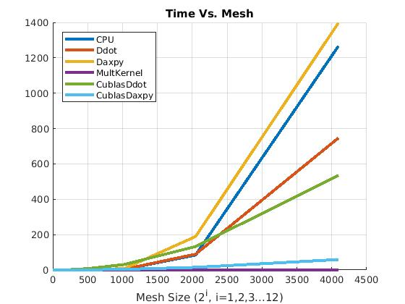

Figure 1 Time Vs. Mesh for 6 different methods of matrix multiplication

In figure 1. You can see that multKernel is the most efficient form to compute matrix multiplication. On the other hand, level cblas Daxby does not improve in efficiency. This graph does not look exactly like the one provided in the project 2 descriptions.