This is a groovy paper!

Dustin Michels

Nov 2017

## Abstract

This is text that I’m writing and there’s lots in there and that’s cool!

## Introduction

Lorem ipsum dolor sit amet, consectetur adipisicing elit, sed do eiusmod tempor incididunt ut labore et dolore magna aliqua. Ut enim ad minim veniam, quis nostrud exercitation ullamco laboris nisi ut aliquip ex ea commodo consequat. Duis aute irure dolor in reprehenderit in voluptate velit esse cillum dolore eu fugiat nulla pariatur. Excepteur sint occaecat cupidatat non proident, sunt in culpa qui officia deserunt mollit anim id est laborum.

Lorem ipsum dolor sit amet, consectetur adipisicing elit, sed do eiusmod tempor incididunt ut labore et dolore magna aliqua. Ut enim ad minim veniam, quis nostrud exercitation ullamco laboris nisi ut aliquip ex ea commodo consequat. Duis aute irure dolor in reprehenderit in voluptate velit esse cillum dolore eu fugiat nulla pariatur. Excepteur sint occaecat cupidatat non proident, sunt in culpa qui officia deserunt mollit anim id est laborum.

## Another section

1. item
2. item
   1. item
3. item

## A quote that is nice.

Research is what I’m doing when I don’t know what I’m doing. - Wernher von Braun

# Here’s another section

Here is a citation [1].

## A Figure

This is a figure.

## Equations

Inline equations $π$

Block equations

$$π=3.14 (1)$$

## A Figure

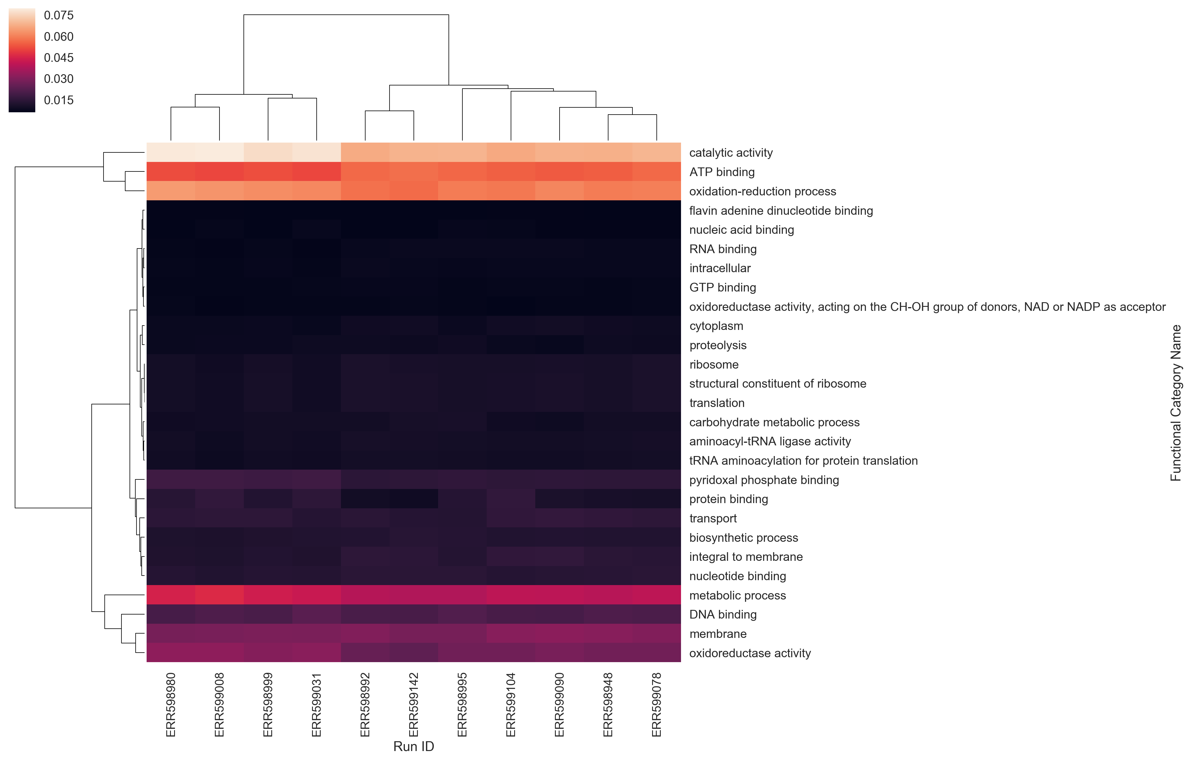

Figure 1: A really good figure

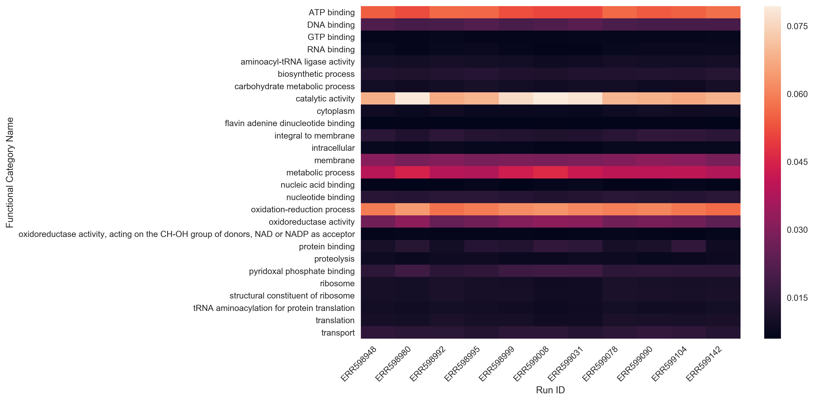

Figure 2: Another one!

# References

1. Sunagawa S, Coelho LP, Chaffron S, Kultima JR, Labadie K, Salazar G, et al. Structure and function of the global ocean microbiome. Science. 2015;348: 1261359. doi:[10.1126/science.1261359](https://doi.org/10.1126/science.1261359)