Simple Linear Regression Analysis Report

1. Introduction and Objective
This report presents a simple linear regression analysis examining the relationship between hours spent studying and exam performance. The goal is to quantify the strength and direction of the association, assess model fit, and evaluate whether the underlying assumptions of the regression model are supported by the data.

2. Data Description
The dataset consists of 40 observations, each representing an individual student. The response variable is exam score, measured on a 0–100 scale. The predictor variable is the number of hours spent studying in the week prior to the exam. Both variables are treated as continuous.

3. Statistical Methodology
A simple linear regression model was fit using ordinary least squares. The model assumes a linear relationship between hours studied and exam score, independent observations, constant error variance, and approximately normally distributed errors.

4. Results
The fitted regression equation is:
Exam Score = 48.57 + 2.77 × Hours Studied.
The slope estimate indicates that each additional hour of studying is associated with an average increase of approximately 2.77 points on the exam. The model explains 68.07% of the variability in exam scores, indicating a strong linear association in this sample.

5. Diagnostic Evaluation
Model diagnostics were examined to assess the validity of the regression assumptions. The scatterplot with fitted regression line suggests a clear positive linear trend. The residuals versus fitted values plot shows no systematic pattern, supporting the assumption of linearity and constant variance. The normal Q–Q plot indicates that residuals are approximately normally distributed, with only minor deviations in the tails. The scale–location plot does not suggest substantial heteroskedasticity.
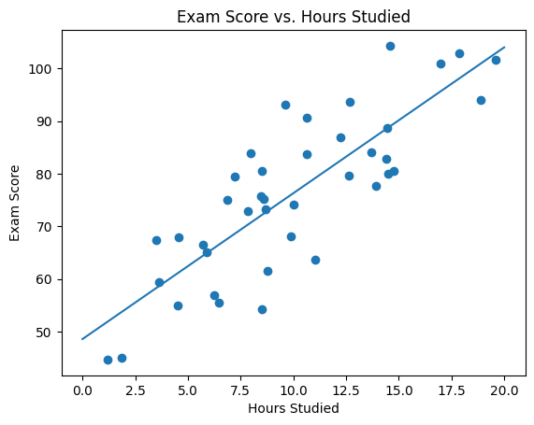
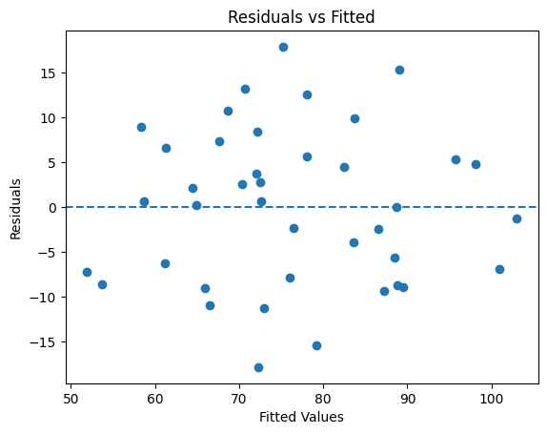
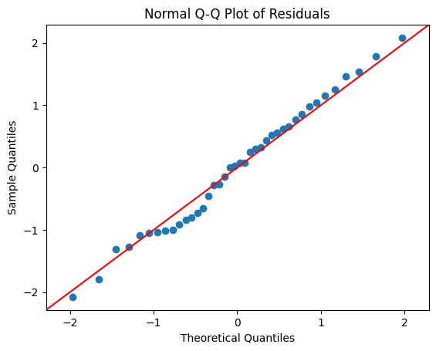
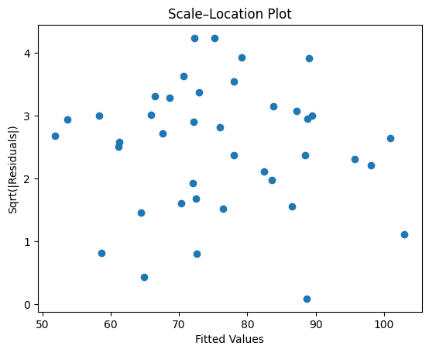

6. Conclusions
In conclusion, the simple linear regression model provides strong evidence of a positive association between study time and exam performance. Diagnostic analyses do not reveal serious violations of model assumptions, supporting the validity of statistical inference. While the analysis is observational and does not establish causality, the results suggest that increased study time is meaningfully associated with improved exam outcomes.

