Multivariate Multiple Regression Analysis of Adolescent Pulmonary Function
This report presents a multivariate multiple regression analysis of adolescent pulmonary function, focusing on joint modeling of forced expiratory volume in one second (FEV1), forced vital capacity (FVC), and peak expiratory flow (PEF). The presentation and organization follow conventions typical of Biometrics-style applied statistical reports.

1. Data and Exploratory Analysis
The study includes 220 adolescents aged 12–18 years. Pulmonary outcomes were strongly correlated, motivating a multivariate modeling approach.
Table 1. Descriptive statistics for outcomes and covariates.
 | mean | std | min | max
FEV1 | 2.196 | 0.481 | 1.042 | 3.397
FVC | 3.021 | 0.508 | 1.955 | 4.313
PEF | 4.218 | 0.866 | 2.261 | 6.297
Age | 15.020 | 1.602 | 12.016 | 17.977
Height | 172.355 | 10.931 | 148.048 | 200.732
Activity | 5.283 | 2.085 | 0.000 | 10.533
Table 2. Correlation matrix of pulmonary outcomes.
 | FEV1 | FVC | PEF
FEV1 | 1.000 | 0.962 | 0.958
FVC | 0.962 | 1.000 | 0.980
PEF | 0.958 | 0.980 | 1.000
Figure 1. Pairwise scatterplots and marginal distributions of pulmonary outcomes.
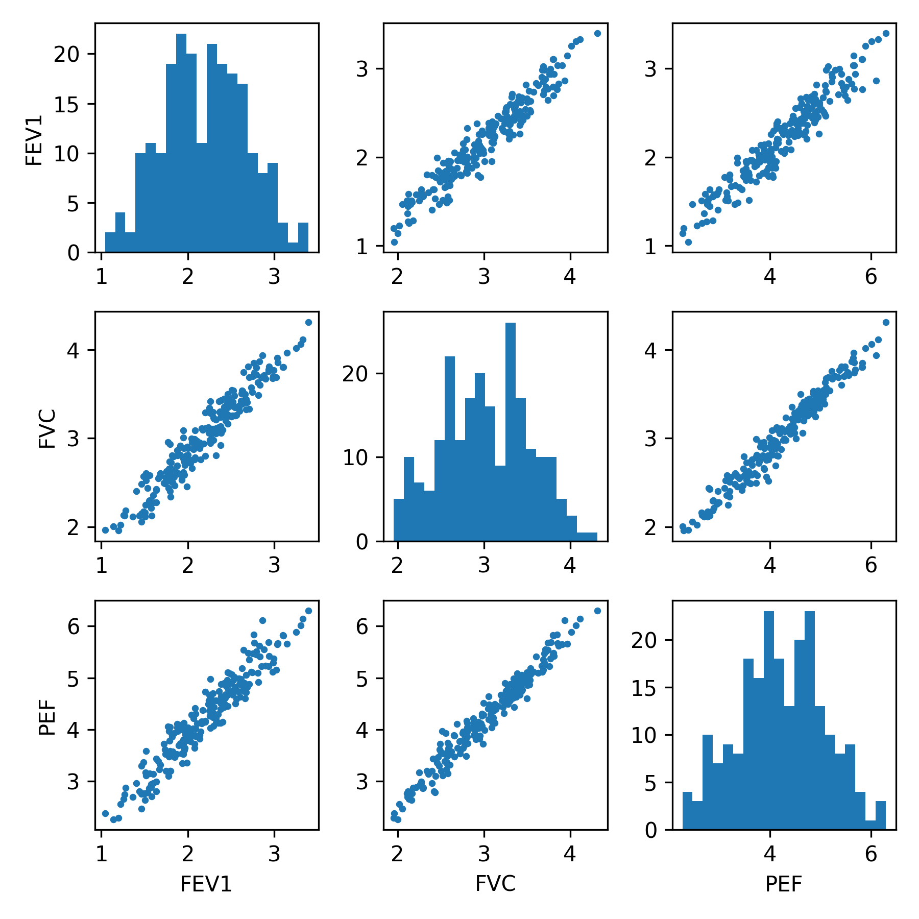
Figure 2. Relationship between height and FEV1.
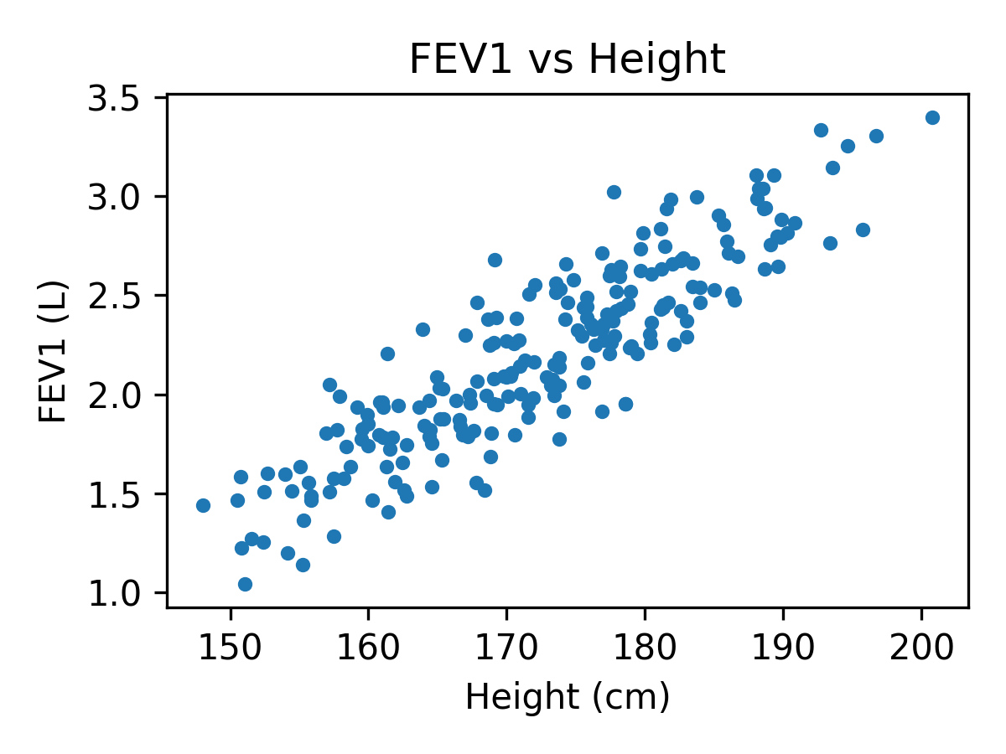

2. Multivariate Regression Analysis
A multivariate multiple regression model was fitted with age, height, sex, smoking status, and physical activity as predictors. Inference focuses on joint effects across the pulmonary outcome vector.

3. Discussion
The results illustrate the efficiency and interpretability gains of multivariate multiple regression relative to separate univariate analyses. Several predictors exhibited coordinated effects across pulmonary outcomes that are naturally summarized in the multivariate framework.

4. Conclusions
Multivariate multiple regression provides a principled approach for analyzing correlated biomedical outcomes. When supported by appropriate diagnostics and graphical summaries, it yields coherent and efficient inference suitable for Biometrics-style reporting.

