Validator

Programming I Final Project

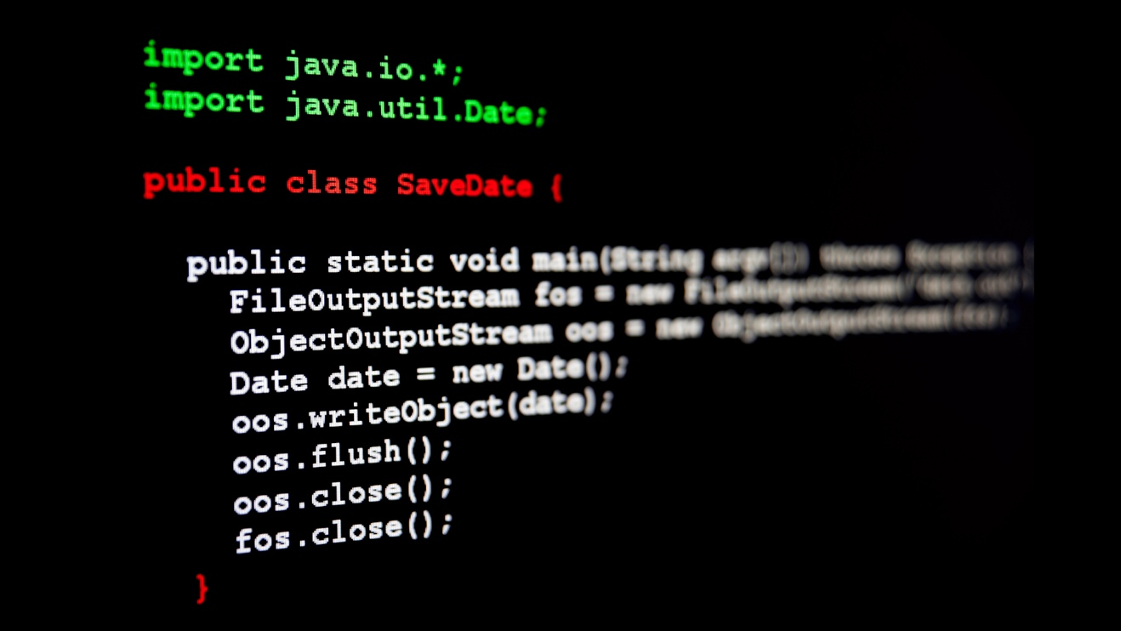

FSD-08:

Fawzi Latosh

Dustin Ruck

TAble of  
Contents

OVERVIEW 1

Planning & Development 1

Meetings 1

Individual Team Assignments 1

Workload 1

Difficulty & Comprehension 2

METHODS 2

Method 1 2

Method 2 2

Method 3 2

Method 4 2

Method 5 2

Method 6 3

Method 7 3

Method 8 3

Method 9 3

Method 10 3

Method 11 3

Method 12 3

# OVERVIEW

## Planning & Development

## 

## Meetings

We planned for and expected the project to be completed Tuesday, March 7. This gave us 5 days to work with (Beginning Friday March 3). Scrum meetings were scheduled daily for 6pm. Following our scrum on day 3, 4, and 5, we allocated about 30mins for code review.

## Individual Team Assignments

Fawzi – Methods 1-7, Testing

Dustin – Methods 8-12, Documentation

## Workload

Workload for this project was substantial in comparison the previous course’s final project, however it was very manageable.

## Difficulty & Comprehension

# 

# METHODS

## Method 1

**isAlphaNum()**

**Check if a character is alphanumeric.**

## Method 2

**isSpecialChar()**

**Check if a character is an acceptable special character.**

## Method 3

**isPrefixChar()**

**Check there are only alphanumeric characters, dashes, periods, or underscores in prefix.**

## Method 4

**isDomainChar()**

**Domain can contain only alphanumeric characters, dashes, or periods.**

## Method 5

**singleAtSign()**

**Check if an email contains a single at sign (@).**

## Method 6

**fetchBeforeAt()**

**Get the beginning (local part) of an email address.**

## Method 7

**fetchAfterAt()**

**Get the ending (domain name) of an email address.**

## Method 8

**isPrefix()**

**Check if the start of a string is a valid email prefix.**

## Method 9

**isDomain()**

**Check if the end of a String is a valid email domain.**

## Method 10

**isEmail**

**Check if a string is a valid email address.**

## Method 11

**isUsername**

**Check if a string is a valid username.**

## Method 12

**safePassword()**

**Check if a string is considered a safe password.**

safePassword takes a single String “password” and returns a boolean value. The method checks whether the given password meets certain criteria for being considered a safe password. It does this by going through each character in the password and setting boolean variables of the password requirements to true if the password meets the requirements. The method keeps track of whether the password contains more than two consecutive characters. Finally, the method returns true if the password has a length between 7 and 15 characters, contains at least one lowercase letter, at least one uppercase letter, at least one digit, at least one of three special character, is alphanumeric, and does not have more than two consecutive characters.

|  |  |  |
| --- | --- | --- |
|  |  |  |