Dusty Argyle (1,3,5,7)

Scott Hoge (2,4,6,7)

December 1, 2016

CS 4300 - Artificial Intelligence

**A9**

**1. Introduction**

Briefly summarize the nature of the system, the basic numerical or other algorithm,  
 and the interesting or relevant questions.

**2. Method**

The Perceptron Learning algorithm separates images based on threshold that is developed. The threshold helps to differentiate one image from another and has a binary output of one or zero, this is the image or this is not the image.

**3. Verification of Program**

Confirm that your program is not incorrect by considering special cases and by  
 giving at least one comparison to a hand calculation or known result.

**4. Data and Analysis**

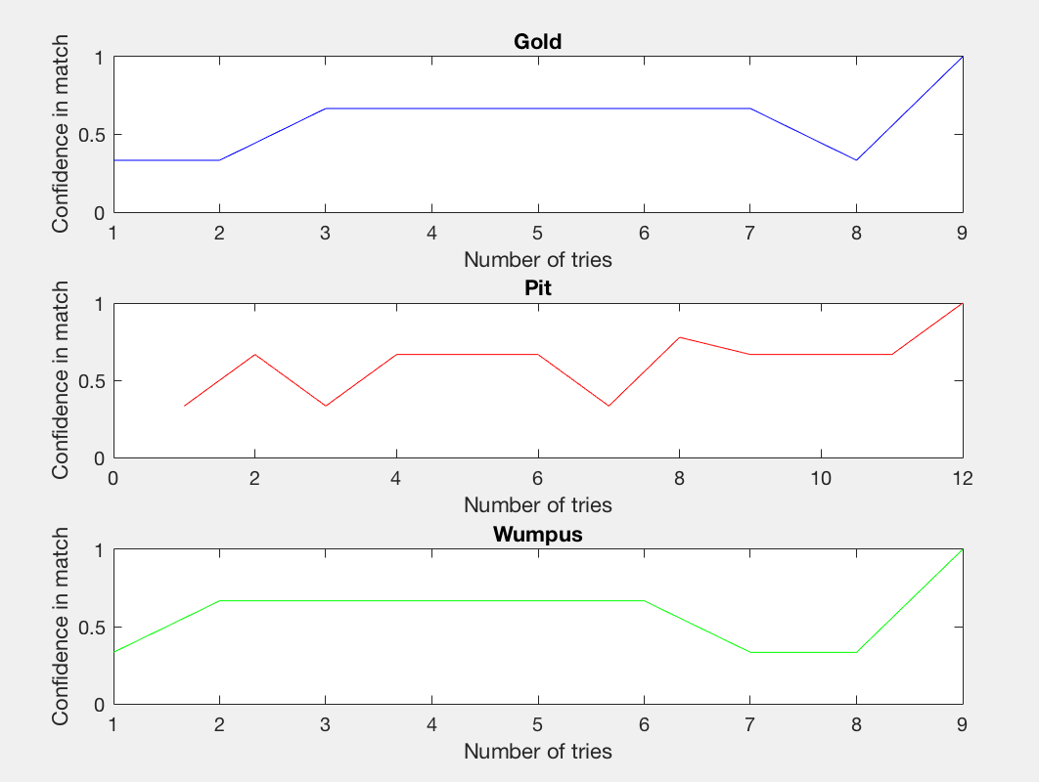

**5. Interpretation**

Summarize your results and explain them in simple physical terms whenever possible.  
 Specific questions that were raised in the assignment should be addressed here.  
 Also, give suggestions for future work or possible extensions.

**6. Critique**

This assignment was very interesting and cool application of Artificial Intelligence. I think it would be interesting to see a sort of movie of it going through the process of matching and rejecting.

**7. Log**

Dusty:

Scott: