Lab 2: Friction Factors in Pipes

  - Course Number: CE 3105-00X <= section number
  - Course Title: Mechanics of Fluids Laboratory
  - Experiment Name: Friction Factors in Pipes
  - Date Completed:
  - Date Submitted:
  - Report Author:
  - File Name: LastName_FirstName_ExperimentName.pdf

Table of Contents
Lab 2: Friction Factors in Pipes 1
Objective 3
Theory 3
Energy Equation for Pressurized Pipe Flow 3
Flow Regimes and Reynolds Number 3
Frictional Head Loss 4
Darcy–Weisbach Equation 4
Alternative Friction Models 4
Determination of Friction Factor 5
Experimental Relevance 5
Apparatus 5
Experimental Procedure 7
Results 7
Discussion 10
Conclusion 11
References 11
Appendix 12

List of Figures
Figure 1. Annotated photograph of Laboratory Set-Up for Pipeline Friction Factors 6
Figure 2. H-7 Apparatus Physical Dimensions 6
Figure 3. Fluid Properties Database values used in calculations 8
Figure 4 Friction Factor vs. Reynolds Number 10

List of Tables

Table 1. Friction Factor in a Pipe (experimental and computed results) 9

Objective

Investigate how changes in velocity and Reynolds number affect flow behavior and frictional losses in a pipeline.

Specifically, the experiment:
- Measures pressure drop across two locations on a pipeline for varying flow rates
- Analyzes results to evaluate the relationship between friction factor and Reynolds number in a small pipeline.
- Develops hands-on experience with data acquisition techniques, including manual flow rate measurements and manometer readings for relatively low flow rates.
- Validates experimental findings by comparing measured loss coefficients to standard tabulated values reported in the literature.
- Encourages critical thinking by requiring:
  - Explanation of probable sources of experimental error
  - Using visualization to support findings and condense tabular results

Theory

Energy Equation for Pressurized Pipe Flow
Energy relationships in closed conduits are described by the steady-flow energy equation:
$$\frac{p_{1}}{γ}+\frac{V_{1}^{2}}{2g}+z_{1}=\frac{p_{2}}{γ}+\frac{V_{2}^{2}}{2g}+z_{2}+h_{L}$$
where:
- $\frac{p}{γ}$= pressure head
- $\frac{V^{2}}{2g}$= velocity head
- $z$= elevation head
- $h_{L}$= head loss between sections
For a horizontal pipeline without pumps or turbines, changes in total head represent energy losses due to friction.

Flow Regimes and Reynolds Number
Pipe flow behavior depends on the relative importance of inertial and viscous forces, expressed by the Reynolds number:
$$Re=\frac{VD}{ν}$$
where $V$is velocity, $D$is pipe diameter, and $ν$is kinematic viscosity.

Typical classifications for smooth pipes are:
- Laminar flow: $Re<2000$
- Transitional flow: $2000<Re<4000$
- Turbulent flow: $Re>4000$
Laminar flow is orderly and dominated by viscous forces, while turbulent flow is characterized by mixing and velocity fluctuations. Reynolds’ dye experiments demonstrated this transition and established the Reynolds number as a fundamental similarity parameter.

Velocity is obtained from continuity:
$$V=\frac{Q}{A}$$

Frictional Head Loss
Head loss in pipes results from viscous shear and wall roughness. The relationship between velocity and head loss depends on the flow regime:
- Laminar flow: $h_{L}∝V$
- Turbulent flow: $h_{L}∝V^{n}$, where $n≈1.75\text{–}2$
Because these relationships differ, the flow regime can be inferred experimentally by plotting measured head loss versus velocity (or velocity squared). A linear relationship between head loss and velocity suggests laminar behavior, whereas a nonlinear relationship approaching proportionality with $V^{2}$indicates turbulent flow. Deviations between these trends may indicate transitional conditions.

Darcy–Weisbach Equation

Frictional head loss in pipes is described by the Darcy–Weisbach equation:
$$h_{L}=f\frac{L}{D}\frac{V^{2}}{2g}$$
where $f$is the Darcy friction factor, $L$is pipe length, and $D$is pipe diameter.
The friction factor depends on Reynolds number and relative roughness:
- Laminar flow: $f=\frac{64}{Re}$
- Turbulent flow: obtained from the Moody diagram or Colebrook relation.

Alternative Friction Models
Other empirical equations are used in specific applications:
- Chezy–Manning equation: used for open-channel flow.
- Hazen–Williams equation: widely used for turbulent water flow in distribution systems.
The Darcy–Weisbach formulation is the most general and is applicable to all fluids and flow regimes.

Determination of Friction Factor

In this experiment, head loss is measured for varying flow rates and the Darcy friction factor is computed from:
$$f=\frac{2gD}{L}\frac{h_{L}}{V^{2}}$$
Water properties corresponding to the measured temperature are used when computing Reynolds number.

Experimental Relevance
By varying flow velocity, the experiment illustrates the transition between flow regimes and quantifies frictional losses in a pipeline.

Apparatus
The experiment was conducted using the H1-D hydraulic bench, a header tank, a test pipe, and both manual measurement devices. Flow rate was measured using the time-to-fill method.

A labeled photo of the apparatus used in Pipe Loss component of the experiment is displayed below in Figure 1.
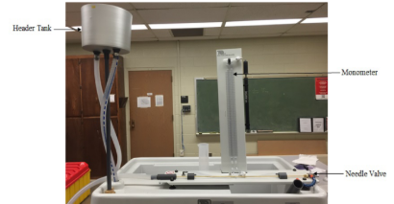
Figure 1. Annotated photograph of Laboratory Set-Up for Pipeline Friction Factors

The specific items employed are listed below:
- H1-D Hydraulic bench connected to a header tank
- H-7 Test pipe and manometer panel.
- 250 mL beaker (for time-to-fill flow rates)
- Stopwatch (for time-to-fill flow rates)

Pipe internal diameter and distance between pressure ports are shown in the user manual referenced in the H-7 Friction Loss in a Pipe (User Manual) which is linked in the course web page. The relevant portion is depicted below in Figure 2.

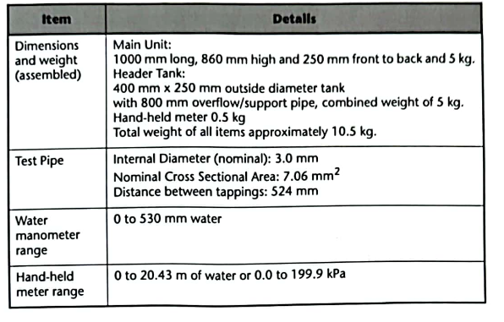
Figure 2. H-7 Apparatus Physical Dimensions

Experimental Procedure

The experiment was conducted using a hydraulic bench, a header tank, a test pipe, and both manual and automated measurement devices. Flow rate was measured using the stopwatch and bucket method. Pressure drop was measured with manometers. Each manual measurement was repeated in triplicate to ensure reliability.

The measurement(s) procedure is:

- Verify (locate) manometer free surfaces
- Start pump and adjust flow valve until constant overflow in head tank.
- Record manometer readings (zero flow values)
- Open needle valve completely (count number of turns to open)
- Measure time-to-fill 3 times, record water temperature.
- Record head differences in manometers.
- Repeat with needle valve at about 4/5 of fully open
- Repeat with needle valve at about 3/5 of fully open
- Repeat with needle valve at about 2/5 of fully open
- Repeat with needle valve at about 1/5 of fully open
- Close needle valve completely
- Verify manometers returned to zero-flow values.
- Stop pump and close flow valve.

The data reduction procedure(s) is/are:

- Use time-to-fill to compute flow rates (either average computed rates, or the three times for each needle valve setting)
- Compute the nominal velocity from the pipe diameter/area data.
- Use the measured water temperature to look up the water viscosity (cite data source used)
- Compute the Reynolds number for each of the 5 needle valve settings.

Results

Table 1. lists the experimental measurements, and computed values. Relevant “notes” regarding the tabulated contents are:

- Temperature of water was 17 degrees Celsius on the experiment date. Fluid properties for 15 degrees were used (alternately 20C would work sufficiantly too)
- The kinematic viscosity used for Reynolds number calculation(s) is 1.14e-06 ()
- 1st row is reference (datum) conditions
- Mean time is time-to-fill an 80.0 mL beaker.
- 1 = 1000 (Conversion implicit in data table below, used to calculate velocity)
- 1 m == 1000 mm (Conversion implicit in data table below, used to calculate gradient)
- Second to last column is Modified Bernoulli rearranged to find friction factor; it is an experimental result
- Last column is theoretical friction factor for laminar flow in a pipe
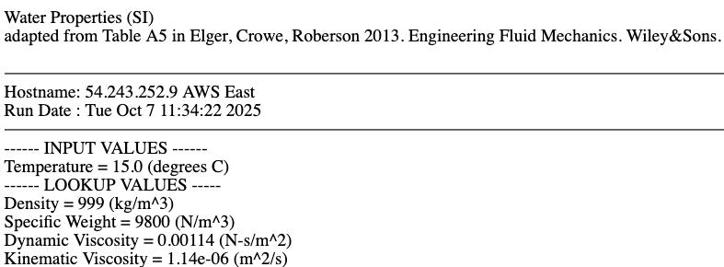
Figure 3. Fluid Properties Database values used in calculations

Table 1. Friction Factor in a Pipe (experimental and computed results)
The calculations used for computing the friction factors were based on the manometer readings. Plots of the observed (measured) friction factor versus Reynolds' number, and theoretical friction factor versus Reynolds' number are shown on Figure 4 below - in laminar flow we anticipate the relationship to be $f=\frac{64}{Re}$, so a log-log plot should appear as a straight line.
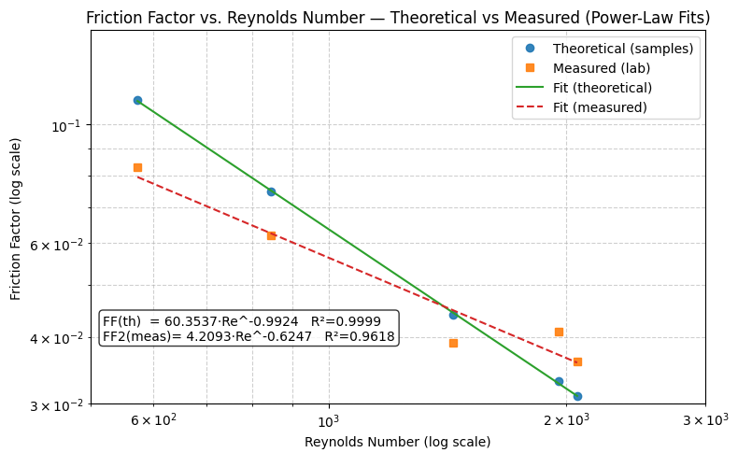
Figure 4 Friction Factor vs. Reynolds Number
The script to generate the plot is listed in the appendix and plot below visually compares the observed and theoretical friction factors for the experimental conditions.

Discussion

The experimental results display the correct sign on the fitted exponent in agreement with laminar flow theory. The magnitude is such that the plotted line has a lower slope than anticipated. The constant (slope) is 16 times too small, suggesting considerable experimental error.

Sources of error likely to be significant include:
- Reading uncertainty on the manometer – the smallest division is 2 mm, which limits resolution. Readings that are too low would underpredict head loss and can explain the low friction factor values as compared to theoretical values.
- Variability in time‐to‐fill measurements – this component is vital to computing velocity which is squared in the computations. A tipping‐bucket type flow measurement device would improve precision and repeatability. If the velocities are computed as too large (calling "stop" too soon) that too would lead to low friction factor values.
- Use of tabulated fluid properties are not corrected for the actual temperature - this component would affect the computation of Re in the tables, and also produce off-theory friction factors. This source of error is probably the least significant, as the literature tabulated values change by less than 0.1% in the 5-degree temperature range near the laboratory temperature.

Despite these issues, the measured results follow the anticipated trend (in fact if the last two measurements are ignored the fitted lines would be parallel) reinforcing the theory that head loss in a pipe in laminar flow is proportional to the inverse of the Reynolds number.

Conclusion
The experimental work successfully demonstrated that theoretical friction factors for laminar flow can be reproduced using small‐scale apparatus and relatively basic measurement techniques. Although exact numerical agreement with theoretical values was not achieved, the observed trends closely followed the expected behavior. When the identified sources of experimental uncertainty are considered, the results fall well within a reasonable range of agreement. These findings support the reliability of published friction factor correlations and indicate that laboratory‐scale validation is feasible even with modest instrumentation.

References
- Holman, J.P. (2012) Experimental Methods for Engineers, 8th Ed. (Chapters 1-3)
- H-7 Friction Loss in a Pipe (User Manual)
- Head Loss in Pipes (UT Arlington) Video
- Energy Losses in Pipes - Hydraulics Series by Bogart Alcala Video

Appendix
# Python script to ingest pipe loss inputs and produce plot of friction factor vs Reynolds number

import numpy as np
import matplotlib.pyplot as plt

# ----------------------------
# Data
# ----------------------------
RE = np.array([573, 845, 1437, 1953, 2063])
# FF = theoretical; FF2 = measured (fill in your measured values)
FF = np.array([0.111, 0.075, 0.044, 0.033, 0.031]) # theoretical (~64/RE)
FF2 = np.array([0.083 , 0.062 , 0.039 , 0.041 , 0.036]) # <<< lab measured/computed

# ----------------------------
# Prototype Functions
# ----------------------------
def fit_powerlaw(x_val, y_val):
"""
Fit y = a * x^b via log-log linear regression.
Returns: a, b, r2, y_pred
"""
x = np.log(x_val)
y = np.log(y_val)
b, ln_a = np.polyfit(x, y, 1)
a = np.exp(ln_a)

y_pred = a * x_val**b
ss_res = np.sum((y_val - y_pred)**2)
ss_tot = np.sum((y_val - y_val.mean())**2)
r2 = 1 - ss_res/ss_tot
return a, b, r2, y_pred

# ----------------------------
# Fits
# ----------------------------
a1, b1, r2_1, FF_pred = fit_powerlaw(RE, FF)
a2, b2, r2_2, FF2_pred = fit_powerlaw(RE, FF2)

# Smooth curve for plotting
RE_fit = np.linspace(RE.min(), RE.max(), 400)
FF_fit = a1 * RE_fit**b1
FF2_fit = a2 * RE_fit**b2

# Equation strings
eqn1 = f"FF(th) = {a1:.4f}·Re^{b1:.4f} R²={r2_1:.4f}"
eqn2 = f"FF2(meas)= {a2:.4f}·Re^{b2:.4f} R²={r2_2:.4f}"

print(eqn1)
print(eqn2)

# ----------------------------
# Plot (log–log)
# ----------------------------
fig, ax = plt.subplots(figsize=(8, 5))

# Data
ax.plot(RE, FF, 'o', label='Theoretical (samples)', alpha=0.9)
ax.plot(RE, FF2, 's', label='Measured (lab)', alpha=0.9)

# Fits
ax.plot(RE_fit, FF_fit, '-', label='Fit (theoretical)')
ax.plot(RE_fit, FF2_fit, '--', label='Fit (measured)')

# Axes scaling and limits
ax.set_xscale('log')
ax.set_yscale('log')
ax.set_xlim(500, 3000)
ax.set_ylim(0.03, 0.15)

# Labels, grid, legend
ax.set_xlabel('Reynolds Number (log scale)')
ax.set_ylabel('Friction Factor (log scale)')
ax.set_title('Friction Factor vs. Reynolds Number — Theoretical vs Measured (Power-Law Fits)')
ax.grid(True, which='both', linestyle='--', alpha=0.6)
ax.legend()

# Annotation
ax.text(
0.02, 0.24,
eqn1 + "\n" + eqn2,
transform=ax.transAxes, va='top', ha='left',
bbox=dict(boxstyle='round', facecolor='white', alpha=0.8)
)

plt.tight_layout()
plt.show()

# ----------------------------
# (Optional) If you want to overlay the canonical laminar theory f=64/Re:
# ----------------------------
# FF_theory_curve = 64.0 / RE_fit
# ax.plot(RE_fit, FF_theory_curve, ':', label='f = 64 / Re')
# ax.legend()
# plt.show()

