Title Page
  - Course Number: CE 3105-00X <= section number
  - Course Title: Mechanics of Fluids Laboratory
  - Experiment Name: Pump Performance Curve
  - Date Completed:
  - Date Submitted:
  - Report Author:
  - File Name: LastName_FirstName_ExperimentName.pdf

Table of Contents

Table of Figures 2
List of Tables 2
Objective 3
Theory 3
Energy Equation and Total Dynamic Head 3
Flow Measurement 4
Electrical Power Input 4
Reynolds Number and Friction Factor 5
Roughness Height 5
Apparatus 5
Procedure 7
Results 8
Discussion 10
Conclusion 10
References 11
Appendix 12
Python script for analyses 12
Spreadsheet (version) for Analysis 15

Table of Figures

Figure 1. Micro-Pump Apparatus in Operation (annotated photograph) 6
Figure 2. DC Power Supply (annotated photograph) 7
Figure 3. Pump performance curves 9
Figure 4. Spreadsheet (as formulas) Left portion 15
Figure 5. Spreadsheet (as formulas) Right portion 15

List of Tables

Table 1. Experimental and Computed Values 9

Objective

To experimentally determine the relationship between discharge (Q), head (H), and power input (P) for a small DC pump operating at variable discharge elevations. Students will produce a pump curve (H vs Q) and evaluate power consumption.

Theory

The purpose of this experiment is to characterize the performance of a small centrifugal pump by determining the relationship between discharge $Q$, head added by the pump $H$, and electrical input power $P$. These relationships are commonly summarized using a pump performance curve, which shows how the head generated by a pump varies with flow rate. Pump curves are essential tools for selecting pumps and evaluating whether a pump can satisfy the head requirements of a given hydraulic system.

Energy Equation and Total Dynamic Head

The head supplied by the pump is determined using the modified Bernoulli equation applied between two sections of the pipeline:
$$\frac{p_{1}}{ρg}+\frac{v_{1}^{2}}{2g}+z_{1}+h_{p}=\frac{p_{2}}{ρg}+\frac{v_{2}^{2}}{2g}+z_{2}+f\frac{L}{D}\frac{V^{2}}{2g}$$
where
$p/ρg$= pressure head
$v^{2}/2g$= velocity head
$z$= elevation head
$h_{p}$= head added by the pump
$f$= Darcy friction factor
$L$= pipe length
$D$= pipe diameter

For the experimental apparatus, the pipe diameter is constant and the discharge is to the atmosphere. Under these conditions the pressure heads at the inlet and outlet are approximately equal, allowing the equation to be simplified to
$$h_{p}=(z_{2}-z_{1})+\left(1 + f\frac{L}{D}\right)\frac{V^{2}}{2g}$$
The velocity $V$in the pipe is determined from the measured discharge and pipe diameter. Expressing velocity in terms of discharge for a circular conduit gives
$$h_{p}(Q)=(z_{2}-z_{1})+\left(1 + f\frac{L}{D}\right)\frac{8Q^{2}}{π^{2}gD^{4}}$$
This relationship shows that the head required by the system increases as discharge increases due to friction losses.

Flow Measurement

Discharge is measured using the time-to-fill method, in which a container of known volume is filled while the elapsed time is recorded. The discharge is then computed as
$$Q=\frac{\text{Volume}}{\text{Time}}$$
Measured values are typically reported in L/min.

Electrical Power Input

The electrical power supplied to the DC pump is determined from the measured voltage and current:
$$P=VI$$
where
$V$= applied voltage
$I$= electrical current
Pump Efficiency
The hydraulic power delivered to the fluid is
$$P_{hydraulic}=ρgQH$$
where
$ρ$= density of water
$g$= gravitational acceleration
The pump efficiency is estimated as
$$η=\frac{ρgQH}{P}$$
In small laboratory pumps the efficiency is typically low, but the calculation illustrates the relationship between electrical input and hydraulic output.

Reynolds Number and Friction Factor
To evaluate friction losses, the Reynolds number for pipe flow is computed as
$$Re_{D}=\frac{4ρQ}{μπD}$$
where

$μ$= dynamic viscosity of water.

The Darcy friction factor may be estimated using the explicit Swamee–Jain approximation:
$$f=\frac{0.25}{{\left[{log⁡}_{10}\left(\frac{k_{s}/D}{3.7} + \frac{5.74}{Re_{D}^{0.9}}\right)\right]}^{2}}$$
where $k_{s}$is the equivalent sand roughness height of the pipe.

Roughness Height

Values for pipe roughness height are obtained from engineering reference tables. A convenient reference for this experiment is the Roughness Height Database located at http://54.243.252.9/toolbox/Databases/RoughnessHeight/RoughnessHeight.html

Apparatus

The experimental components are:
- H1F Hydraulic Bench (just as a tabletop)
- 5-gallon polyethylene vessel (a Homer bucket)
- Riser staff (to clamp the outlet)
- 3.3V DC pump (the pump can operate at higher input voltages if needed)
- Variable power supply (current limited)
- Flexible discharge pipe (I.D. = 0.3 inches (~7.62 mm), L = 43 inches (~100 cm))
- Thermometer
- Ruler or measuring tape
- Beaker (200 mL) for time-to-fill
- Stopwatch

A photograph of the system in operation is shown in Figure 1

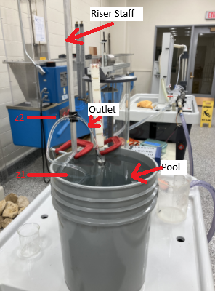
Figure 1. Micro-Pump Apparatus in Operation (annotated photograph)
Typical Setup (Initial run)
- Connect pump to water reservoir.
- Attach flexible pipe.
- Elevate discharge outlet to some convenient height.
- Measure and record the water temperature.
- Measure Q (by time-to-fill; 3 measurements - compute average)
- Measure H the distance from the water surface to the outlet elevation.
- Record power supply voltage V and current I. Make note if current limiting light is illuminated.

Figure 2 is a close-up of the power supply. In the figure the voltage is read from the left display, and current from the right display. The current can be limited by the experimenter - in current limited conditions a small red indicator appears in the display.

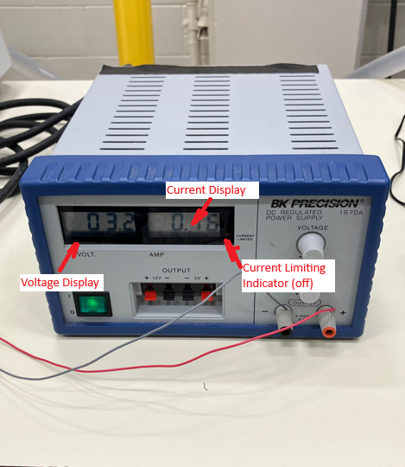
Figure 2. DC Power Supply (annotated photograph)

Procedure

The following steps outline the process for measuring pump performance by observing discharge at increasing outlet elevations while recording electrical input and flow rate.

- Fix power supply voltage (3.3 - 5.5V).
- Set current limiter to 0.0 A then slowly increase until flow begins. Continue to increase until current limiting light is off.
- Begin with lowest discharge height that you can fit a beaker underneath to make a time-to-fill reading.
- Measure Q (by time-to-fill; 3 measurements - compute average)
- Measure H the distance from the water surface to the outlet elevation.
- Record power supply voltage V and current I. Make note if current limiting light is illuminated.
- Increase height and repeat steps 4-6.
- Obtain at least 5 heights, stop when you reach shutoff height or highest possible elevation that the riser staff allows.

Results

Table 1 presents the experimentally determined values. Measured values are shown with a blue background, literature look-up values with a green background, and computed values with an orange background.

The column $\overset{ˉ}{t}$ represents the arithmetic mean of the time required to fill a 200 mL beaker for each discharge height. The discharge is computed from this value using
$$Q=\frac{0.2 L}{\overset{ˉ}{t}}$$
The electrical input power is calculated as the product of the voltage and current reported by the power supply. The resulting units are watts.

The Reynolds number is computed using the measured discharge and temperature-corrected fluid properties for water:
$$Re=\frac{4ρQ}{μπD}$$
The friction factor is estimated using the Jain explicit representation of the Colebrook–White relationship:
$$f=\frac{0.25}{{\left[{log⁡}_{10}\left(\frac{\frac{k_{s}}{D}}{3.7} + \frac{5.74}{Re_{d}^{0.9}}\right)\right]}^{2}}$$
The pipe roughness height used in this computation is listed in Table 1. The total dynamic head (TDH) is computed from the modified Bernoulli equation
$$h_{p}(Q)=(z_{2}-z_{1})+\left(1 + f\frac{L}{D}\right)\frac{8Q^{2}}{π^{2}gD^{4}}$$
Hydraulic power is then computed from
$$P=γQ TDH$$
with units of watts. Wire-to-water efficiency is calculated as the ratio of hydraulic power to electrical input power
Table 1. Experimental and Computed Values

Results Discussion

Figure 3 presents plots of experimental $TDH$versus $Q$and efficiency versus $Q$. The measured values are shown as markers, while fitted models are shown as solid lines. Line colors correspond to the associated variable, and the equations of the fitted models are shown directly on the chart.

The coefficient of determination for the $TDH$–$Q$ fit is $R^{2}=0.94$, indicating a strong correlation between discharge and total dynamic head over the tested range. Although the physical relationship between head and discharge is expected to be slightly nonlinear, polynomial fits typically represent hydraulic behavior well over a limited operating range.

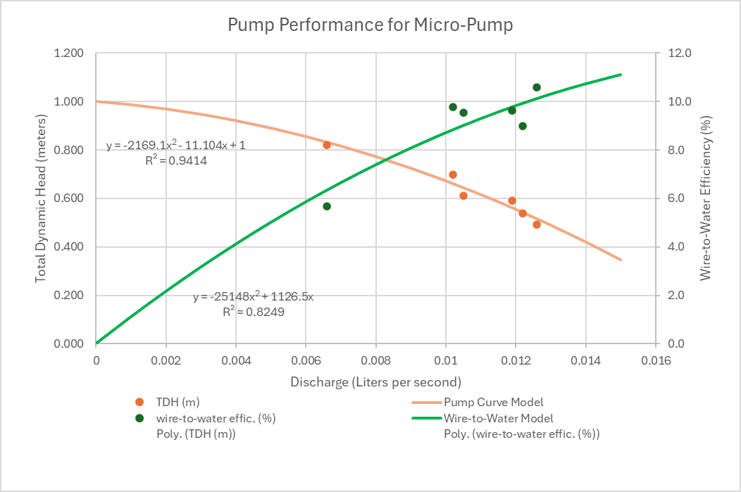
Figure 3. Pump performance curves
The efficiency model has $R^{2}=0.83$, indicating greater variability in the measured efficiency values. This is not unexpected because the pump was operated under relatively inefficient conditions throughout the experiment. Small variations in flow measurement and electrical input can therefore produce larger apparent variation in computed efficiency.

Discussion

Several sources of uncertainty may influence the measured and computed values reported in Table 1. The discharge measurements were obtained using a time-to-fill method with a 200 mL beaker. Small variations in human reaction time when starting and stopping the stopwatch introduce uncertainty into the measured time values and therefore into the computed discharge.

Additional uncertainty may arise from reading the water level in the beaker and ensuring that the beaker is positioned correctly beneath the outlet during each measurement. Because the flow rates are relatively small, even minor timing errors can produce noticeable differences in computed discharge.

The elevation difference used to compute total dynamic head was measured manually from the water surface in the reservoir to the outlet elevation. Small alignment or reading errors in this measurement may affect the computed head values.

Electrical input power was determined from the voltage and current readings displayed on the power supply. These values represent instantaneous readings and may fluctuate slightly during operation. In addition, the current limiting feature of the power supply may influence the electrical input under certain operating conditions.

The friction factor used in the head calculation is estimated from empirical correlations based on Reynolds number and pipe roughness. Although widely accepted, these correlations represent approximations and may introduce minor additional uncertainty into the computed head values.

Finally, the pump used in this experiment is a small laboratory pump operating over a limited range of conditions. The pump may not reach a stable best-efficiency operating point within the tested range, contributing to the variability observed in the efficiency calculations.

Despite these limitations, the experimental results exhibit consistent trends between discharge, head, and efficiency that are characteristic of pump performance behavior.

Conclusion

The experiment successfully characterized the performance of a small centrifugal pump by measuring discharge, total dynamic head (TDH), and electrical input power at several operating conditions. The results demonstrate the expected relationship between discharge and head, with total dynamic head generally increasing as discharge decreases toward the pump shutoff condition.

The experimental results show that TDH decreases as the flow rate $Q$increases. This behavior is consistent with typical centrifugal pump performance curves, where higher flow rates correspond to lower developed head.

Electrical input power remained approximately constant during the experiment because the power supply voltage was held fixed. However, the mechanical (hydraulic) power delivered by the pump varied with discharge and head, as expected. The computed efficiency exhibited the anticipated behavior for this type of pump operating at low efficiency. Under these conditions, a nearly constant electrical input is not surprising because much of the input energy is dissipated rather than converted into useful hydraulic work.

At the experimental supply voltage range of 3.3–5.5 V, the pump would not be suitable for a system requiring a head of 1.2 m, as this value exceeds the measured shutoff head under the tested conditions. However, the pump is capable of operating at higher voltages, and under those conditions it may be able to provide usable flow at that head.

Potential sources of measurement error include timing uncertainty in the time-to-fill discharge measurements, small errors in elevation measurements used to determine head, and fluctuations in the electrical readings from the power supply. These factors are discussed in more detail in the Data Quality and Experimental Limitations section.

The fitted relationship between discharge and total dynamic head exhibited a strong correlation ($R^{2}=0.94$), indicating that the measured data are consistent with typical pump behavior over the range of tested conditions. The efficiency relationship showed greater variability ($R^{2}=0.83$), which is reasonable given the relatively small scale of the apparatus and the sensitivity of efficiency calculations to measurement uncertainty.

Overall, the results demonstrate the characteristic performance trends of centrifugal pumps and illustrate how experimental measurements of flow rate, head, and electrical input can be combined to evaluate pump efficiency and operating performance.

Pump performance curves relating head, discharge, and efficiency allow engineers to determine whether a pump can meet the hydraulic requirements of a system and to identify the operating range where the pump will perform most effectively.

References
  - List of references cited in the report

Appendix

Python script for analyses

import math
import pandas as pd
from pathlib import Path
import numpy as np
from scipy.optimize import curve_fit # pip install scipy if needed

# --------- CONSTANTS (edit as needed) ---------
KS = 7.0e-6 # pipe roughness [m] (your table lookup)
NU = 1.06e-6 # kinematic viscosity [m^2/s]
D = 0.006 # pipe diameter [m]
L = 1.0 # pipe length [m]
G = 9.81 # gravity [m/s^2]

# --------- HYDRAULIC FUNCTIONS ---------
def fricf(ks, Re, D):
"""Jain friction factor."""
temp1 = ks / (3.7 * D)
temp2 = 5.74 / (Re ** 0.9)
temp3 = (math.log10(temp1 + temp2)) ** 2
return 0.25 / temp3

def reynolds(Q, D, nu):
"""Reynolds number for circular conduit.
Q in m^3/s.
"""
return 4.0 * Q / (math.pi * nu * D)

def added_head(dz, L, D, ff, Q, g):
"""Pump total dynamic head added."""
temp1 = (1.0 + ff * L / D)
temp2 = 16.0 / ((math.pi ** 2) * (D ** 4) * 2.0 * g)
return dz + temp1 * temp2 * Q ** 2

# --------- ROW-WISE TDH COMPUTATION ---------
def compute_tdh_row(row):
"""
Expects columns:
'Q (LPS)' – flow in L/s
'DH (z2-z1)'– elevation difference in m
Returns TDH [m] for that row.
"""
q_lps = row["Q (LPS)"] # L/s
dz = row["DH (z2-z1)"] # m

# Convert L/s -> m^3/s
Q = q_lps / 1000.0

# Hydraulics
Re = reynolds(Q, D, NU)
ff = fricf(KS, Re, D)
tdh = added_head(dz, L, D, ff, Q, G)

return tdh

import matplotlib.pyplot as plt

def plot_tdh_curve(df, output_file="tdh_curve.png"):
# Sort for nicer plotting
df_sorted = df.sort_values("Q (LPS)")

Q_data = df_sorted["Q (LPS)"].values
TDH_data = df_sorted["TDH (m)"].values

# Fit the model
shutoff, K, exponent = fit_tdh_model(df_sorted)

# Generate smooth curve for the fitted model
Q_fit = np.linspace(Q_data.min(), Q_data.max(), 200)
TDH_fit = tdh_model(Q_fit, shutoff, K, exponent)

plt.figure(figsize=(8, 5))

# Measured data
plt.plot(Q_data, TDH_data, "o", label="Measured TDH")

# Fitted model
plt.plot(Q_fit, TDH_fit, "-", label=f"Fit: TDH = {shutoff:.2f} - {K:.2f}·Q^{exponent:.2f}")

plt.xlabel("Flow Rate Q (LPS)", fontsize=12)
plt.ylabel("Total Dynamic Head TDH (m)", fontsize=12)
plt.title("Pump Performance Curve (TDH vs Q)", fontsize=14)
plt.grid(True, linestyle="--", alpha=0.6)
plt.legend()
plt.tight_layout()
plt.savefig(output_file, dpi=300)
plt.show()

def tdh_model(Q, shutoff, K, exponent):
"""Model: TDH(Q) = shutoff - K * Q**exponent."""
return shutoff - K * (Q ** exponent)

def fit_tdh_model(df):
df_clean = df.dropna(subset=["Q (LPS)", "TDH (m)"])
Q = df_clean["Q (LPS)"].values
TDH = df_clean["TDH (m)"].values

shutoff0 = TDH.max()
exponent0 = 2.0 # initial guess at the upper bound
K0 = (shutoff0 - TDH.min()) / (Q.max() ** exponent0)

popt, pcov = curve_fit(
tdh_model,
Q,
TDH,
p0=[shutoff0, K0, exponent0],
bounds=([0, 0, 0], [np.inf, np.inf, 5.0])
)

shutoff, K, exponent = popt
print(f"Fitted model: TDH = {shutoff:.3f} - {K:.3f}·Q^{exponent:.3f}")
return shutoff, K, exponent

# --------- TABLE INGEST / OUTPUT ---------
def process_table(input_path, output_path):
input_path = Path(input_path)
output_path = Path(output_path)

# Your sample is tab-separated; delim_whitespace=True will also work
df = pd.read_csv(input_path, sep=",")

# Fill / overwrite the TDH column
df["TDH (m)"] = df.apply(compute_tdh_row, axis=1)

# Write full table back out
df.to_csv(output_path, sep="|", index=False)

# --- Plot TDH vs Q ---
plot_tdh_curve(df)

# Optional: show first few rows in the console
print(df.head().to_string(index=False))

if __name__ == "__main__":
# Change filenames as needed
process_table("pump_data.csv", "pump_data_with_TDH.csv")

Spreadsheet (version) for Analysis

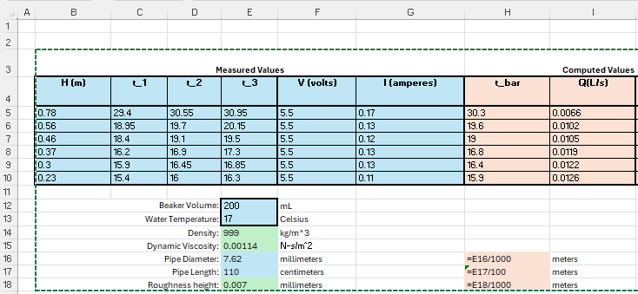
Figure 4. Spreadsheet (as formulas) Left portion

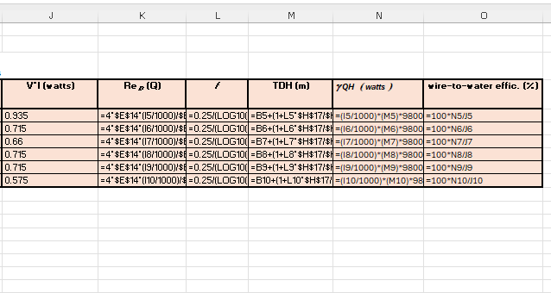
Figure 5. Spreadsheet (as formulas) Right portion

