Lab 3: Momentum Transfer in a Jet

  - Course Number: CE 3105-00X <= section number
  - Course Title: Mechanics of Fluids Laboratory
  - Experiment Name: Momentum Transfer in a Jet
  - Date Completed:
  - Date Submitted:
  - Report Author:
  - File Name: LastName_FirstName_ExperimentName.pdf

Table of Contents
Lab 3: Momentum Transfer in a Jet 1
Objective 3
Theory 3
Conservation of Linear Momentum 3
Experimental Force Determination 4
Apparatus 4
Flat Plate Vane 4
Hemispherical Vane 5
Experimental Procedure 5
Results 6
Discussion 10
Conclusion 10
References 10
Appendix 11

List of Figures
Figure 1. Photograph of Flat Plate Configuration in Operation 5
Figure 2. Photograph of Hemispherical Cup Condition in Operation 5
Figure 3. Online Database Fluid Properties used for momentum calculations. 7
Figure 4 Plot of Force vs Momentum for a Flat Plate Target. 9
Figure 5. Force versus Momentum for Hemispherical Cup. 9

List of Tables

Table 1. Apparatus Physical Dimensions 6
Table 2. Experimental Measurements for Flat Plate 7
Table 3. Experimental Measurements for Hemispherical Cup 7
Table 4. Reduced Data for Flat Plate 8
Table 5. Reduced Data for Hemispherical Cup 8

Objective

The objective of this experiment is to analyze the forces generated when a jet of water impacts flat and curved surfaces (vanes) by applying the principles of conservation of linear momentum. Reaction forces produced by the change in fluid momentum will be measured experimentally and compared with theoretical predictions obtained from the momentum equation.

Students will gain hands-on experience measuring flow rates using multiple methods and will use a balance apparatus to quantify momentum transfer from the jet to the target surface. The experiment also investigates how flow rate, jet velocity, and vane geometry (flat plate versus hemispherical cup) influence the magnitude of the resulting force.

Through this investigation, students will strengthen their understanding of practical engineering applications of momentum transfer, including the operation and design of hydraulic machinery such as turbines and energy dissipation devices. Finally, students will critically evaluate their experimental results and identify sources of error that may affect the accuracy of force measurements and flow rate determinations.

Theory
Moving fluids exert forces on surfaces they encounter in both natural and engineered systems. These forces can be analyzed by selecting a control volume around the flow and applying conservation principles. In fluid mechanics, the net force exerted by a flowing fluid is determined from the rate of change of momentum within the control volume, consistent with Newton’s Second Law. The momentum equation is therefore used to predict forces generated when a fluid jet strikes a surface.

This principle is widely applied in engineering practice. For example, in hydropower systems, water jets strike turbine blades, producing forces that generate torque and rotational motion used to produce electricity. Understanding jet impact forces is also important in hydraulic machinery, erosion control, and energy dissipation structures.
The objective of this experiment is to measure the reaction force produced when a jet of water strikes a flat plate or curved vane and to compare the measured force with theoretical predictions obtained using the momentum equation.

Conservation of Linear Momentum

When a jet of fluid strikes a vane, its velocity changes in magnitude and direction. According to the impulse–momentum principle, the force exerted on the vane equals the rate of change of linear momentum of the fluid.

For a jet issuing vertically from a nozzle with velocity $V$and volumetric flow rate $Q$, the incoming momentum rate is
$$ρQV$$
After striking the vane, the jet is deflected at an angle $θ$, altering the vertical component of velocity. The force exerted on the vane in the vertical direction equals the difference between incoming and outgoing momentum rates.

A modified Bernoulli equation applied between the nozzle exit and vane accounts for elevation difference and velocity changes, allowing the jet velocity to be related to nozzle head. Substituting this velocity into the momentum balance yields a practical expression relating jet velocity, vane geometry, and impact force. Theoretical forces differ depending on vane shape; a flat plate redirects flow laterally, while a hemispherical vane reverses flow direction, producing a larger force.

Experimental Force Determination

The jet force is measured using a pivoted beam apparatus. The jet force acts upward on the vane at a known lever arm distance from the pivot. A jockey weight provides a balancing downward force. Under equilibrium conditions, moments about the pivot are balanced, allowing the jet force to be determined from
$$F×a=W×b$$
where $F$is the jet force, $a$is the moment arm to the vane, $W$is the applied weight, and $b$is the distance from the pivot to the weight.
By measuring the balancing weight position for different flow rates, the experimental force can be determined and compared with theoretical predictions based on momentum principles.

Apparatus

The apparatus employed are:

- H1F Hydraulic Bench (with built-in flow meter)
- H-8 Jet Impact Apparatus
- H-34 Pipe Work Energy Loss (flow measuring panel)
- H1D Hydraulic bench (for the flow panel)
- Flow measuring panel: Venturi meter, Orifice plate meter, Rotameter
- Mass Flow Meter (with Raspberry Pi Zero Datalogger)

The two experimental configurations (flat-plate and hemispherical cup) are described in the sub-sections that follow:

Flat Plate Vane

The arrangement of the system is shown on Figure 1 below for the flat plate condition.
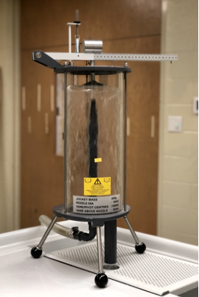
Figure 1. Photograph of Flat Plate Configuration in Operation

Not shown are the RPi (external) mass flow meter, the H1F meter (built-in), and the flow measurement device panel (Laboratory 1) used to measure the discharge through the jet.

Hemispherical Vane

The arrangement of the system is shown on Figure 2 below for the hemispherical vane (cup) condition.

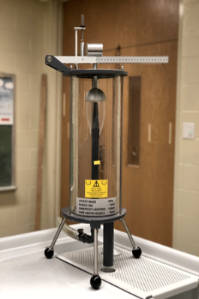
Figure 2. Photograph of Hemispherical Cup Condition in Operation

Experimental Procedure

The experimental procedure is to:
- Install the appropriate Vane
- Establish repeatable zero for the weight beam balance
- Start the hydraulic bench and adjust flow (work from high flow to low flow)
- Move the jockey weight until the beam balances at the repeatable zero
  - Record distance, y, from the zero position
  - Record the flow rate using the hydraulic bench H1F readout
  - Record the flow rate using the RPi external flowmeter (Lab 1 meter constant)
  - Record the flow rate using the Rotameter (Lab 1meter constant)
- Change the hydraulic bench flow rate and repeat step 4. Try to obtain relatively equal increments for a total of 5 different flow rates, including lowest possible to produce constant deflection.
- Return to step 1 and use the other vane. (A total of 10 measurements will be completed)

Results
Several measured physical dimensions are required to compute jet velocity, momentum flux, and impact force. These include the jet diameter, the vertical distance from the nozzle to the vane, the jockey mass used in the balance system, and the distance from the vane attachment point to the pivot. These values are used together with the measured flow rate and balance readings to determine theoretical and experimental forces.

Table 1. Apparatus Physical Dimensions
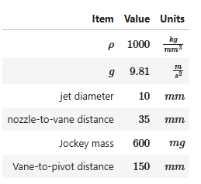

Tables 2 and 3 contain the experimental measurements for the flat plate and hemispherical cup, respectively.

Table 2. Experimental Measurements for Flat Plate
Flat Plate Target
Trial | y(m) | H1F (L/min) | RPi (L/min) | Rotameter (mm) | Rotameter Flow Rate (L/min)
1 | 102 | 35.9 | 35.5 | 149 | 37.3
2 | 86 | 31.6 | 28.4 | 127 | 31.8
3 | 68 | 27.5 | 27.2 | 111 | 27.7
4 | 42 | 22.9 | 22.6 | 98 | 24.5
5 | 19 | 17.5 | 17.3 | 73 | 18.2

Table 3. Experimental Measurements for Hemispherical Cup
Hemispherical Target
Trial | y(m) | H1F (L/min) | RPi (L/min) | Rotameter (mm) | Rotameter Flow Rate (L/min)
1 | 188 | 33.5 | 33.1 | 137 | 34.2
2 | 140 | 30.1 | 29.8 | 131 | 32.7
3 | 90 | 24.6 | 24.3 | 107 | 26.7
4 | 50 | 18.4 | 18.2 | 81 | 20.2
5 | 20 | 12.7 | 12.6 | 55 | 13.6

Data reduction then proceeds by converting the measured volumetric flow rate to mass flow rate using the fluid density. The density for the laboratory water (at 17 C) are obtained from an online database shown in Figure 3.

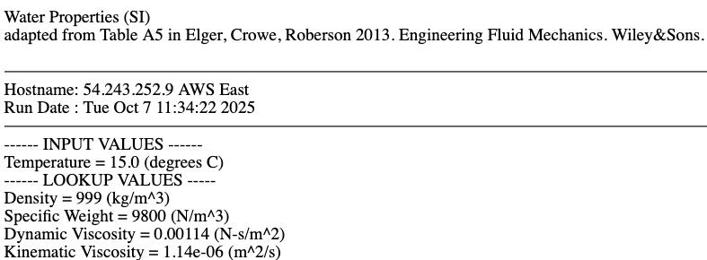
Figure 3. Online Database Fluid Properties used for momentum calculations.

The jet velocity at the nozzle exit is then calculated from the continuity relationship using the nozzle diameter. Because the jet travels upward from the nozzle to the vane, some kinetic energy is converted to gravitational potential energy; therefore, the velocity at impact is adjusted to account for the elevation rise between the nozzle and vane.

Using the impact velocity and mass flow rate, the rate of momentum delivery of the jet is computed. The theoretical force exerted on the vane equals the rate of change of momentum of the fluid stream. The momentum flux values are reported in column 7 in Tables 4 and 5.

The experimental force is determined from the balance apparatus using a moment equilibrium about the pivot. The upward force exerted by the jet at the vane is balanced by the moment produced by the jockey weight. Using the measured weight position, pivot distance to the vane, and jockey mass, the jet force can be calculated. The force values are reported in column 8 of Tables 4 and 5.

Table 4. Reduced Data for Flat Plate
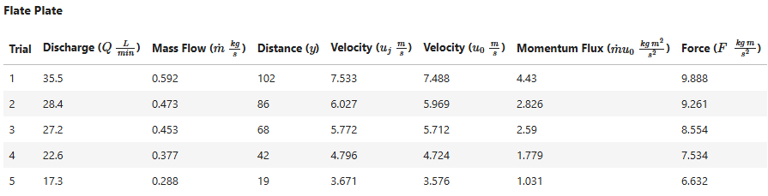

Table 5. Reduced Data for Hemispherical Cup
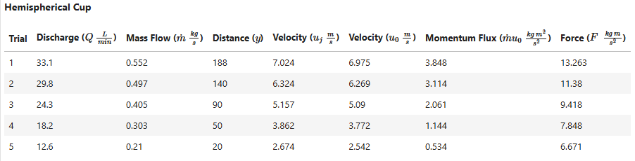

To demonstrate agreement between theory and experiment, the calculated force values from change in momentum are plotted against the rates of momentum delivery. A trendline fitted to the data provides a slope representing the experimental force coefficient.

The plot of Force vs. Momentum for the flat plate is shown on Figure 4 with a fitted line in red.

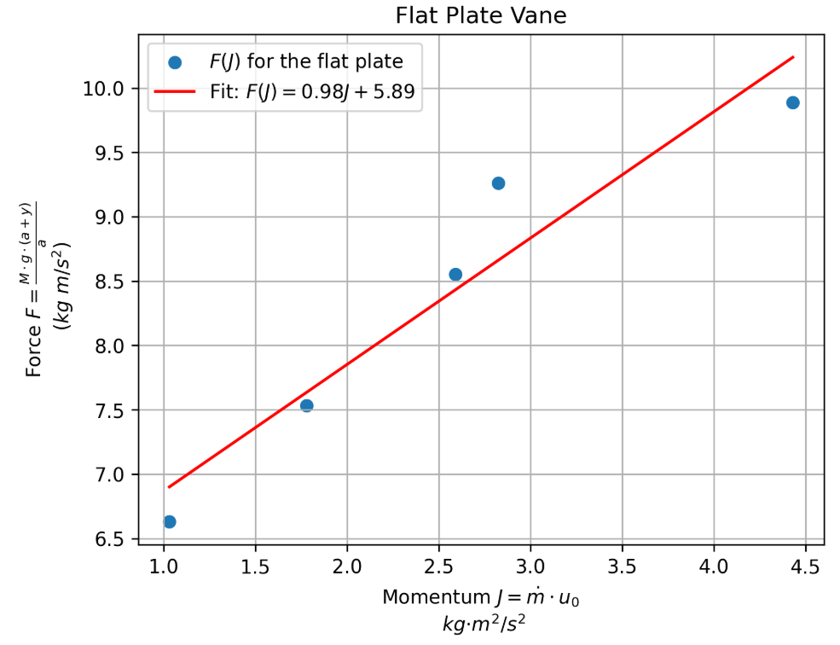
Figure 4 Plot of Force vs Momentum for a Flat Plate Target.

The slope of the line is 0.98. This corresponds to a deflection angle of $\frac{π}{2.03}$, which is very close to the ideal value of $\frac{π}{2}$.

The Force vs. Momentum data for the hemispherical cup is shown on Figure 5, again with a red fitted line. The code used to generate the figure is also in the appendix.

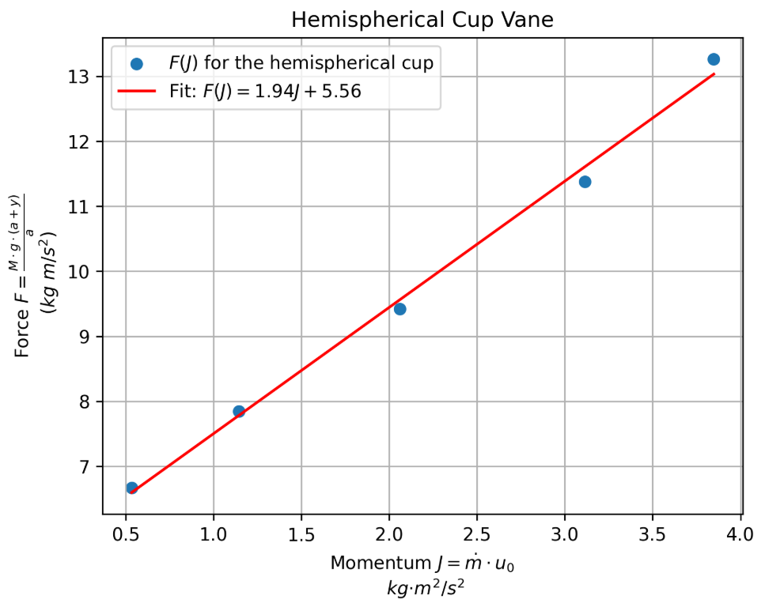
Figure 5. Force versus Momentum for Hemispherical Cup.

For this case, the slope is 1.94. That corresponds to a deflection angle of $\frac{π}{1.12}$, which is close to the theoretical value of $\frac{π}{1}$ .

Python prototype functions and supporting data analysis routines used to populate the tables and plots are provided in the appendix.

Discussion

The experimental results produced deflection angles close to the theoretically anticipated values.

Several sources of error may have influenced the measurements:

- Flow measurement limitations: At low flow rates, the H1F flow meter occasionally displayed zero even when flow was visible. The RPi mass flow meter was able to detect these low flows. For most runs, the two meters agreed within approximately 2%, with the RPi readings slightly lower. A third method (rotameter) was used to verify that the flow rates were of the correct order of magnitude.
- Jockey weight readings: Small errors may have occurred when reading the jockey weight position or ensuring the system returned to the same zero reference point each time. These effects were likely negligible at higher flow rates.
- Flow instability: The pump produced slight pressure fluctuations, resulting in unsteady flow. This may have introduced uncertainty in both force and flow measurements, particularly at lower flow rates.

Despite these uncertainties, the measured results follow the anticipated behavior.

Conclusion
Overall, the experimental values agreed closely with theoretical predictions. The method used in this lab can be applied to vane shapes for which the theoretical force is difficult to compute directly. The results demonstrate that an effective deflection angle can be determined from measurements and used to inform engineering design.

References
- H8-Impact of a Jet (user manual)
- DF Elger, BC Williams, Crowe, CT and JA Roberson, Engineering Fluid Mechanics 10th edition, John Wiley & Sons, Inc., 2013. (Momentum Equation pp. 208-238)
- http://54.243.252.9/engr-1330-webroot/engr1330notes/_build/html/examples/7graphing/example05.html
- http://54.243.252.9/engr-1330-webroot/engr1330notes/_build/html/examples/10datamodels/datamodels.html
- Holman, J.P., (2012) Experimental Methods for Engineers, 8th Ed. (Chapters 1-3)
- Holman, J.P., (2012) Experimental Methods for Engineers, 8th Ed. (Chapter 15 Report Writing)

Appendix
# Python analysis scripts

def mass_flow(rho,Q):
'''function to return mass flow in kg/s
rho == density kg/m^3
Q == flow rate m^3/s
user must make unit conversions in parameter list
'''
mass_flow = rho*Q
return(mass_flow)

def appliedF(mass,g,a,y):
'''function to return applied force in Newtons
'''
appliedF=mass*g*(a+y)/a
return(appliedF)

import math
# Data from tables
y_plate=[102,86,68,42,19]
q_plate=[35.5,28.4,27.2,22.6,17.3]
y_cup =[188,140,90,50,20]
q_cup =[33.1,29.8,24.3,18.2,12.6]

# Constants
rho = 1000 #kg/m^3
g = 9.81 #m/s^2
diameter = 0.010 #m nozzle diameter
s = 0.035 #m distance between nozzle-vane
Mass = 600/1000 #kg the jockey mass
a = 0.150 # m vane-pivot distance

# Calculations
# - allocate memory locations
mdot_plate = [] # mass flow plate
mdot_cup = [] # mass flow cup
vj_plate=[] # jet velocity plate
vj_cup=[] # jet velocity cup
vd_plate=[] # deflection velocity plate
vd_cup=[] # deflection velocity cup
mom_plate = [] # momentum entering at plate
mom_cup = [] # momentum entering at cup
f_plate = []
f_cup = []
# - populate vectors
for i in range(len(y_plate)):
mdot_plate.append(mass_flow(1000,q_plate[i]/1000/60))
mdot_cup.append(mass_flow(1000,q_cup[i]/1000/60))
vj_plate.append(4*(q_plate[i]/1000/60)/(math.pi*diameter**2))
vj_cup.append(4*(q_cup[i]/1000/60)/(math.pi*diameter**2))
vd_plate.append(math.sqrt(vj_plate[i]**2 - 2*g*s))
vd_cup.append(math.sqrt(vj_cup[i]**2 - 2*g*s))
mom_plate.append(mdot_plate[i]*vd_plate[i])
mom_cup.append(mdot_cup[i]*vd_cup[i])
f_plate.append(appliedF(Mass,g,a,y_plate[i]/1000))
f_cup.append(appliedF(Mass,g,a,y_cup[i]/1000))
# - print results for tabulation
print("plate")
for i in range(len(y_plate)):
print("|",i+1,"|",q_plate[i],"|",round(mdot_plate[i],3),"|",y_plate[i],"|"\
,round(vj_plate[i],3),"|",round(vd_plate[i],3),"|",round(mom_plate[i],3),"|",round(f_plate[i],3),"|")
print("cup")
for i in range(len(y_cup)):
print("|",i+1,"|",q_cup[i],"|",round(mdot_cup[i],3),"|",y_cup[i],"|"\
,round(vj_cup[i],3),"|",round(vd_cup[i],3),"|",round(mom_cup[i],3),"|",round(f_cup[i],3),"|")

# Python Flat Plate Plotting

import matplotlib.pyplot as plt
import numpy as np

# Fit a linear model: F = m*x + b
m, b = np.polyfit(mom_plate, f_plate, 1)
fit_line = m * np.array(mom_plate) + b

# Scatter plot of original data
plt.scatter(mom_plate, f_plate, label="$F(J)$ for the flat plate")

# Plot fitted line
plt.plot(mom_plate, fit_line,
label=f"Fit: $F(J) = {m:.2f}J + {b:.2f}$",
linestyle='-',color="red")

# Labels, title, legend, and grid
plt.xlabel("Momentum $J=\\dot{m}\\cdot u_0$ \n ${kg·m^2}/{s^2}$")
plt.ylabel("Force $F=\\frac{M\\cdot g \\cdot (a+y)}{a}$\n $(kg~m/s^2)$")
plt.title("Flat Plate Vane")
plt.legend()
plt.grid(True)
plt.savefig("plate_plot.png", dpi=300, bbox_inches="tight")
plt.show()

# Python Hemispherical Cup Plotting

import matplotlib.pyplot as plt
import numpy as np

# Fit a linear model: F = m*x + b
m, b = np.polyfit(mom_cup, f_cup, 1)
fit_line = m * np.array(mom_cup) + b

# Scatter plot of original data
plt.scatter(mom_cup, f_cup, label="$F(J)$ for the hemispherical cup")

# Plot fitted line
plt.plot(mom_cup, fit_line,
label=f"Fit: $F(J) = {m:.2f}J + {b:.2f}$",
linestyle='-',color="red")

# Labels, title, legend, and grid
plt.xlabel("Momentum $J=\\dot{m}\\cdot u_0$ \n ${kg·m^2}/{s^2}$")
plt.ylabel("Force $F=\\frac{M\\cdot g \\cdot (a+y)}{a}$\n $(kg~m/s^2)$")
plt.title("Hemispherical Cup Vane")
plt.legend()
plt.grid(True)
plt.savefig("cup_plot.png", dpi=300, bbox_inches="tight")
plt.show()

