CE 3372 Exercise Set 3 – Solution Sketch

1) Use EPANET to compute the discharge in each pipe and the pressure at each junction node for the 8-pipe system shown in Figure 1.

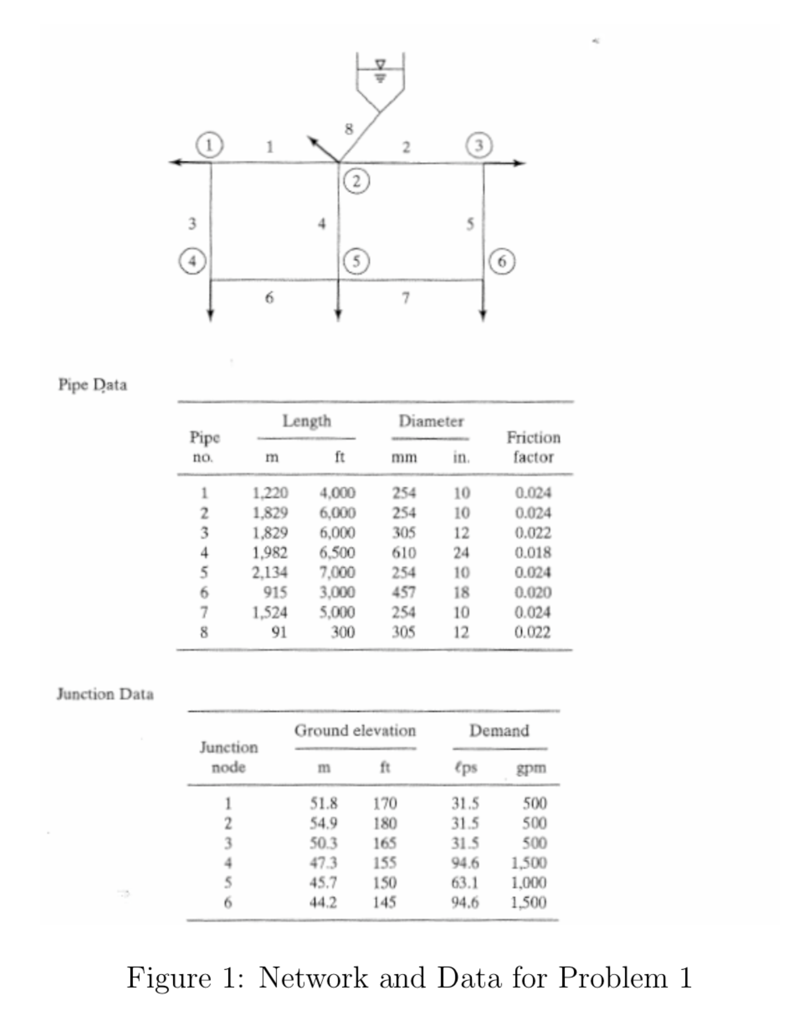

Figure 1. Copy of Figure 1 from Problem Statement

The water surface elevation in the storage tank is 315.0 ft. Prepare your solution using EPA-NET. Report your results in U.S. Customary units. Include a screen capture of the working simulation and the EPANET generated summary report.

Explain how you used the friction factors1

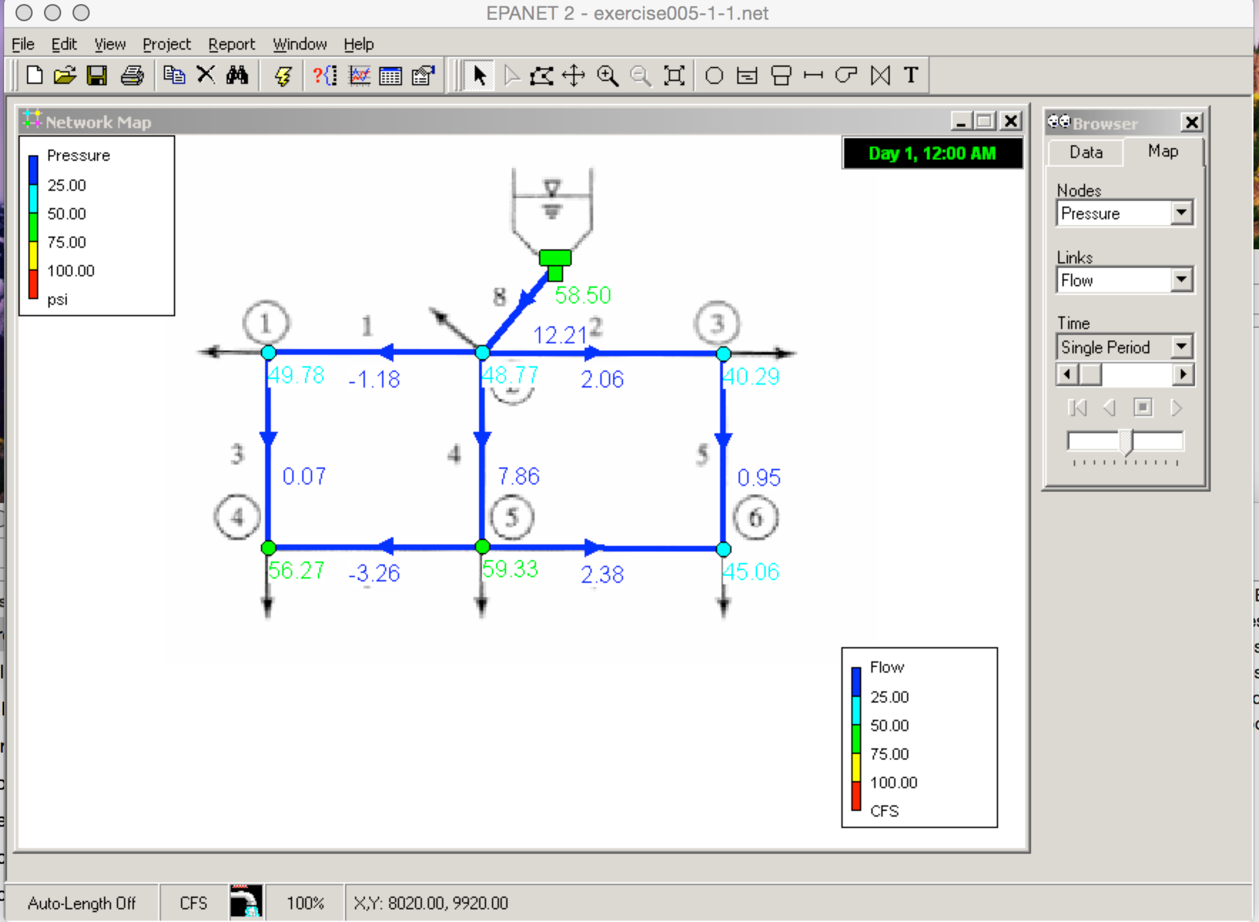

Figure 2. Screen Capture Completed EPANET simulation showing node pressures in pounds per square inch, and pipe discharge in cubic feet per second.

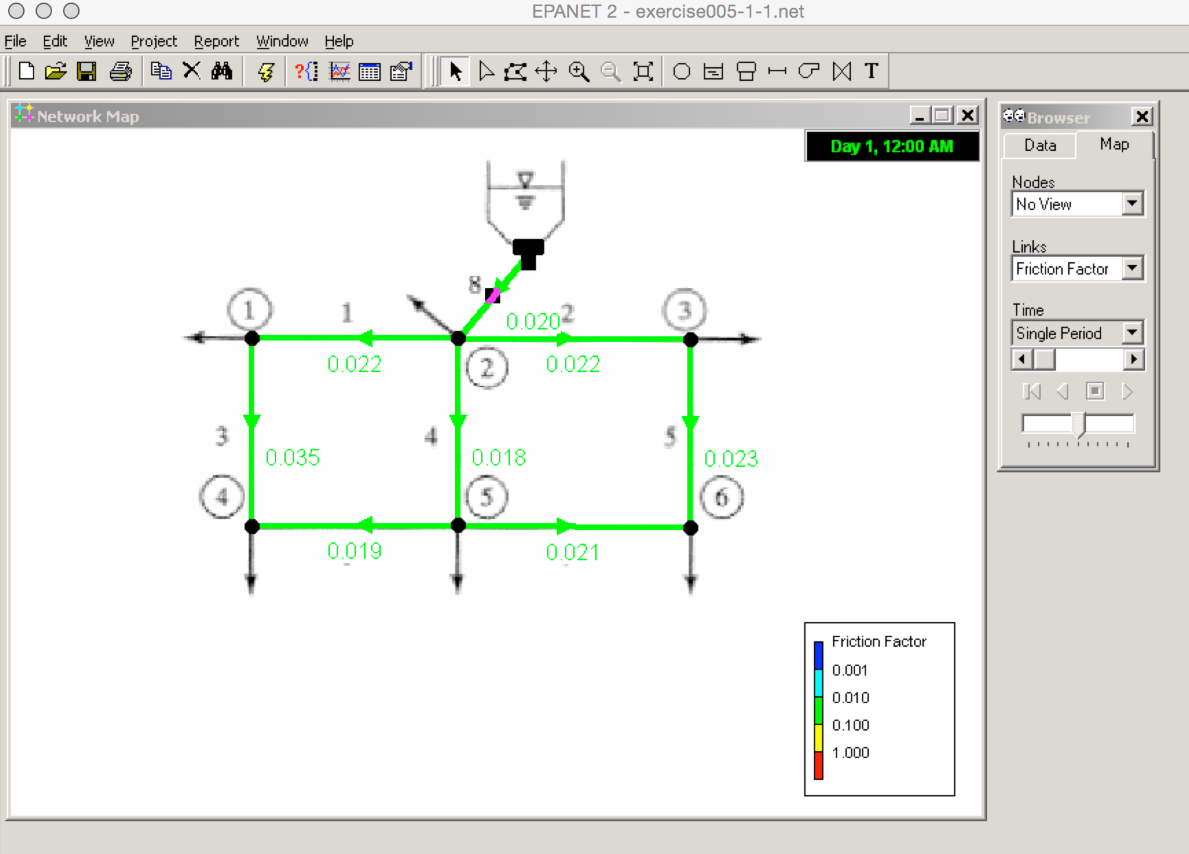

Figure 3. Screen capture of EPANET simulation showing computed friction factors for each pipe.

Friction factors supplied in the problem statement were matched (as best as possible) by adjusting roughness height in EPANET then running the simulation. Table 1 below is a listing of the supplied values and computed values.

Table 1. Supplied and Computed Friction Factors



Summary Report (Generated by EPANET)

Page 1 2/9/2015 6:16:38 PM

\*\*\*\*\*\*\*\*\*\*\*\*\*\*\*\*\*\*\*\*\*\*\*\*\*\*\*\*\*\*\*\*\*\*\*\*\*\*\*\*\*\*\*\*\*\*\*\*\*\*\*\*\*\*\*\*\*\*\*\*\*\*\*\*\*\*\*\*\*\*

\* E P A N E T \*

\* Hydraulic and Water Quality \*

\* Analysis for Pipe Networks \*

\* Version 2.0 \*

\*\*\*\*\*\*\*\*\*\*\*\*\*\*\*\*\*\*\*\*\*\*\*\*\*\*\*\*\*\*\*\*\*\*\*\*\*\*\*\*\*\*\*\*\*\*\*\*\*\*\*\*\*\*\*\*\*\*\*\*\*\*\*\*\*\*\*\*\*\*

Input File: exercise005-1-1.net

Link - Node Table:

----------------------------------------------------------------------

Link Start End Length Diameter

ID Node Node ft in

----------------------------------------------------------------------

1 2 3 4000 10

2 3 4 6000 10

3 2 5 6000 12

4 3 6 6500 24

5 4 7 7000 10

6 5 6 3000 18

7 6 7 5000 10

8 9 3 300 12

Node Results:

----------------------------------------------------------------------

Node Demand Head Pressure Quality

ID CFS ft psi

----------------------------------------------------------------------

2 1.11 284.88 49.78 0.00

3 1.11 292.57 48.77 0.00

4 1.11 258.00 40.29 0.00

5 3.33 284.86 56.27 0.00

6 2.22 286.92 59.33 0.00

7 3.33 249.00 45.06 0.00

9 -12.21 315.00 58.50 0.00 Tank

Link Results:

----------------------------------------------------------------------

Link Flow VelocityUnit Headloss Status

ID CFS fps ft/Kft

----------------------------------------------------------------------

1 -1.18 2.15 1.92 Open

2 2.06 3.79 5.76 Open

3 0.07 0.08 0.00 Open

4 7.86 2.50 0.87 Open

5 0.95 1.75 1.29 Open

6 -3.26 1.85 0.69 Open

7 2.38 4.36 7.58 Open

8 12.21 15.55 74.78 Open