interoffice memorandum

|  |  |
| --- | --- |
| to: | Dr. Cleveland |
| from: | team ##. Members: name1; name2; name3; name4;name5 |
| subject: | es-3 solution |
| date: | January 21, 2016 |
| cc: |  |
|  |  |

This memorandum is a solution to ES-##, presented as an extended memorandum with appendices.

**Problem Statement:**

Use EPANET to compute the discharge in each pipe and the pressure at each junction node for the 8-pipe system shown in Figure 1.

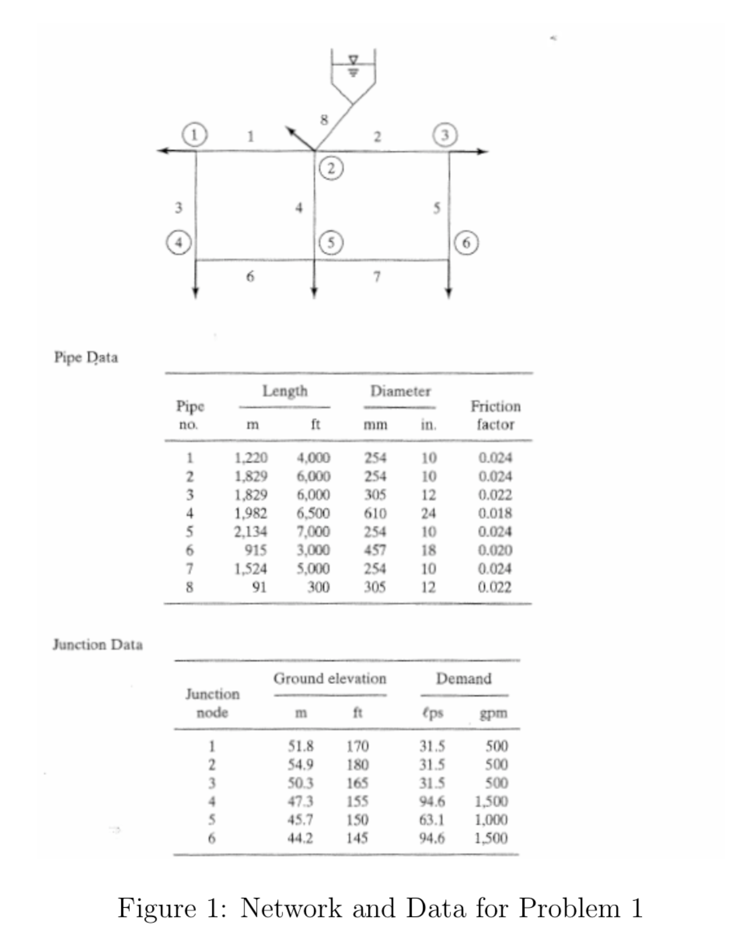

Figure 1. Copy of Figure 1 from Problem Statement

The water surface elevation in the storage tank is 315.0 ft. Prepare your solution using EPA-NET. Report your results in U.S. Customary units. Include a screen capture of the working simulation and the EPANET generated summary report. Explain how you used the friction factors in the pipe data portion of the Figure.

**Solution:**

The network in Figure ## was replicated using EPANET. The tank was represented as [tank or reservoir – explain which and why]. The flow units selected were […].

Figure ## is a screen capture of [complete the sentence]. Then describe the figure; what do the arrows mean? What do the colors indicate? What units are displayed for the pipes? What units are displayed for the nodes? Don't just answer as a list, but work into a narrative.

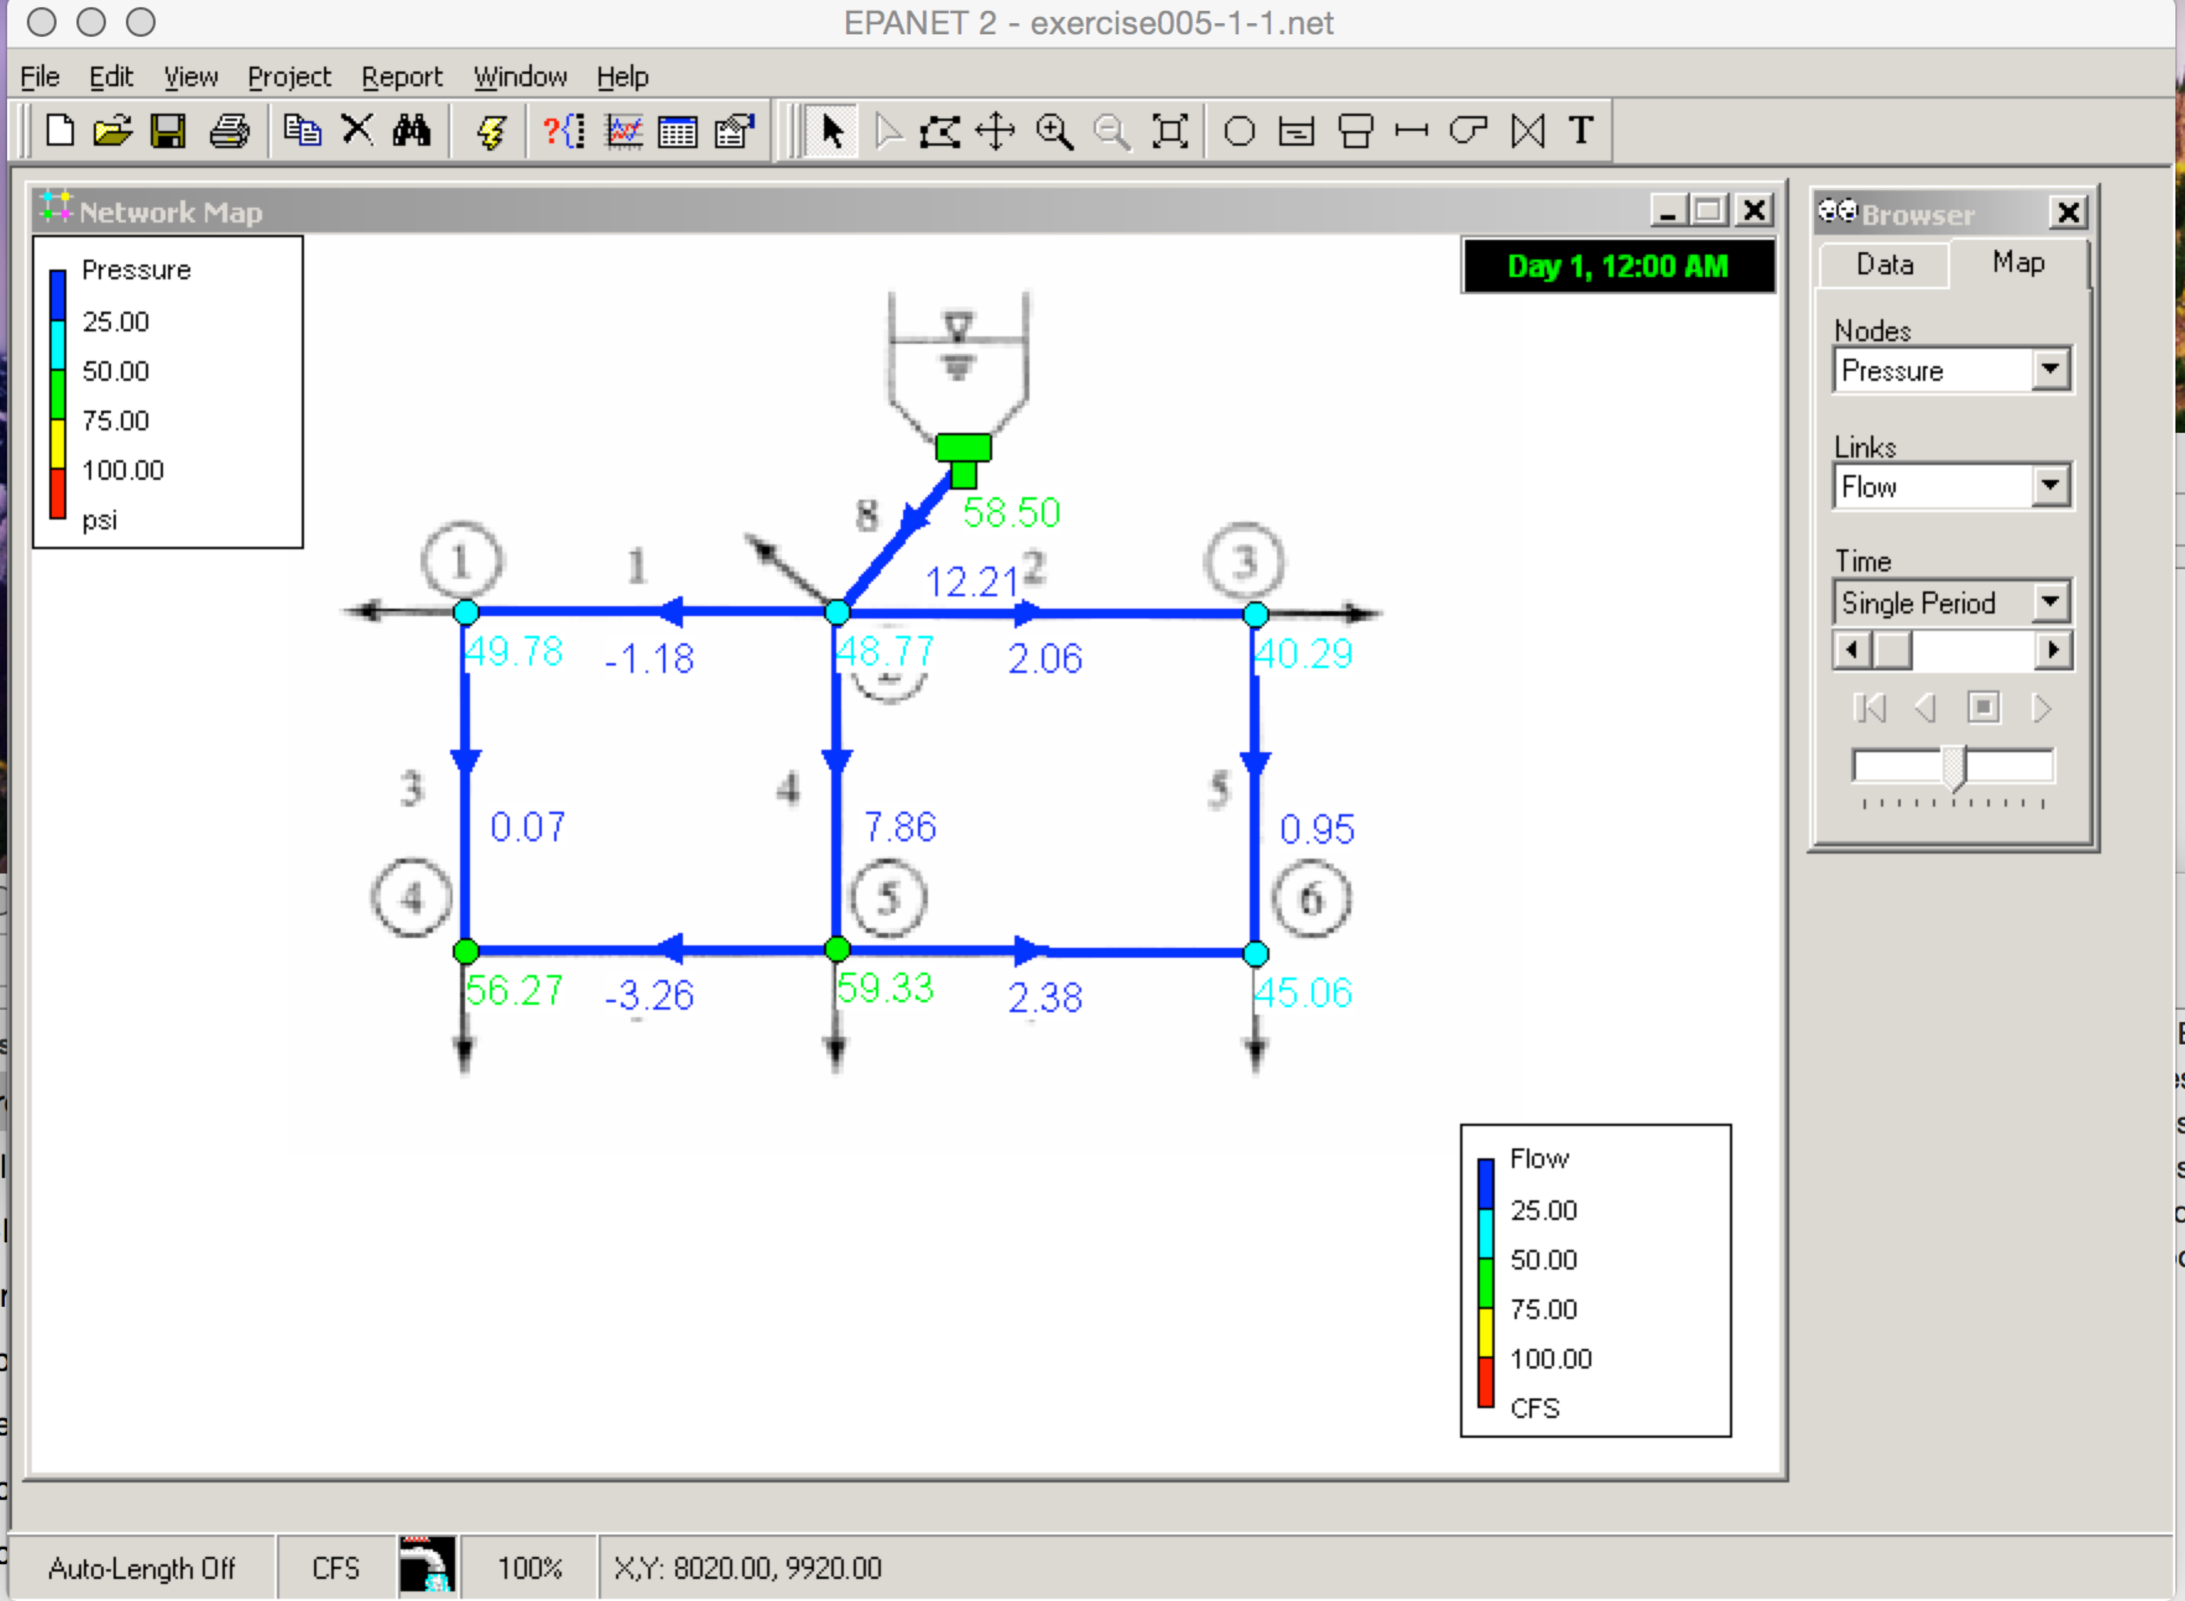

Figure 2. Screen Capture of …..[complete the caption] – also figure should use entire available page width for reader clarity.

Figure ## is a screen capture of [complete the sentence]. Then describe the figure.

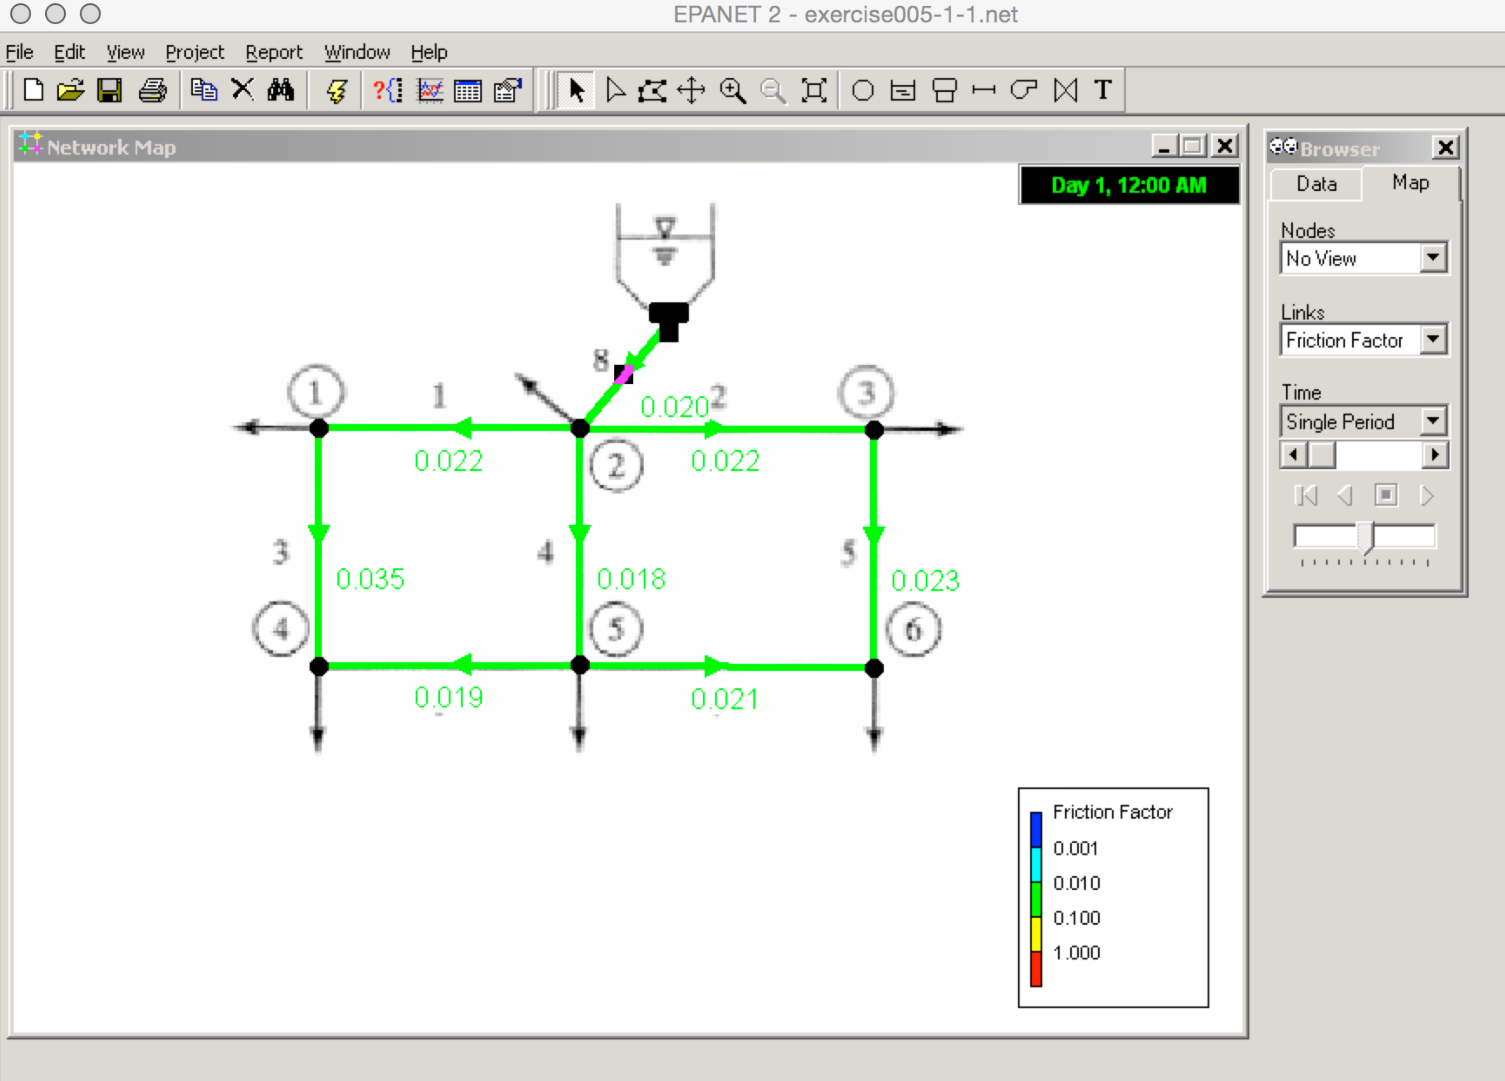

Figure 3. Screen capture of … [complete the caption]

Friction factors supplied in the problem statement were matched (as best as possible) by adjusting [what] in EPANET then running the simulation. A trial-and –adjustment procedure were used to …[ ].

Table 1 is a listing of the [….]. Describe the table; explain what each column represents.

**Table 1. Supplied and Computed Friction Factors**

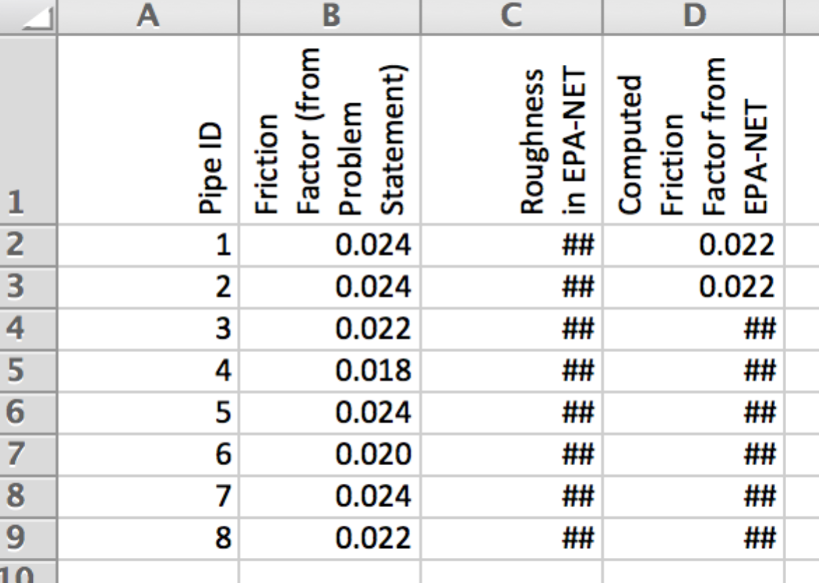

The EPANET summary report is attached (last two pages) with the low-pressure node identified.

**Discussion:**

Discussion here. Discuss friction factors, try to elaborate why cannot get exact match. Discuss low pressure node. Compare pressure to minimum pressure guidelines.

**Summary Report (Generated by EPANET):**

Page 1 2/9/2015 6:16:38 PM

**********************************************************************

* E P A N E T *

* Hydraulic and Water Quality *

* Analysis for Pipe Networks *

* Version 2.0 *

**********************************************************************

Input File: exercise005-1-1.net

Link - Node Table:

----------------------------------------------------------------------

Link Start End Length Diameter

ID Node Node ft in

----------------------------------------------------------------------

1 2 3 4000 10

2 3 4 6000 10

3 2 5 6000 12

4 3 6 6500 24

5 4 7 7000 10

6 5 6 3000 18

7 6 7 5000 10

8 9 3 300 12

Node Results:

----------------------------------------------------------------------

Node Demand Head Pressure Quality

ID CFS ft psi

----------------------------------------------------------------------

2 1.11 284.88 49.78 0.00

3 1.11 292.57 48.77 0.00

4 1.11 258.00 40.29 0.00 🡸 LOW PRESSURE

5 3.33 284.86 56.27 0.00

6 2.22 286.92 59.33 0.00

7 3.33 249.00 45.06 0.00

9 -12.21 315.00 58.50 0.00 Tank

Link Results:

----------------------------------------------------------------------

Link Flow VelocityUnit Headloss Status

ID CFS fps ft/Kft

----------------------------------------------------------------------

1 -1.18 2.15 1.92 Open

2 2.06 3.79 5.76 Open

3 0.07 0.08 0.00 Open

4 7.86 2.50 0.87 Open

5 0.95 1.75 1.29 Open

6 -3.26 1.85 0.69 Open

7 2.38 4.36 7.58 Open

8 12.21 15.55 74.78 Open